Three flavonoids biomarkers of Carrot resistance to Alternaria leaf blight: ACCUMULATION PATTERN AT DIFFERENT PHENOLOGICAL STAGES AND CONSISTENCY ACROSS DIVERSE GENETIC BACKGROUNDS

Molecular breeding

Marie Louisa Ramaroson*¹, Claude Emmanuel Koutouan*¹, Angelina El Ghaziri¹, Raymonde Baltenweck², Patricia Claudel², Philippe Hugueney², Sébastien Huet¹, Anita Suel¹, Linda Voisine¹, Mathilde Briard¹, Jean Jacques Helesbeux³, Latifa Hamama¹, Valérie le Clerc¹, Emmanuel Geoffriau^{1,§}

1 Institut Agro, Université d’Angers, INRAE, IRHS, SFR 4207 QUASAV, Angers, France
2 Université de Strasbourg, INRAE, SVQV UMR-A 1131, F-68000 Colmar, France
3 Université de Strasbourg, INRAE, SVQV UMR-A 1131, F-68000 Colmar, France
§ Correspondence: emmanuel.geoffriau@institut-agro.fr; Tel : +33-(0)2 41 22 54 31
* The first two authors contributed equally to the paper

Online Resource 7: Correlations between molecules

Correlation between Api7R, Lut7R and Chry7R contents for all data of Trial 1, Trial 2, Trial 3 and Trial 4. The larger and the darker the blue circle, the higher the correlation between metabolite contents. The Pearson correlation coefficients are denoted by 'r,' and the calculated p-values associated with the null hypothesis (that the correlation is zero) are denoted by 'p.'




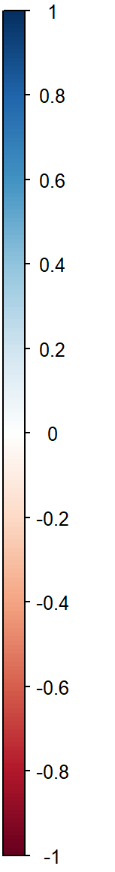
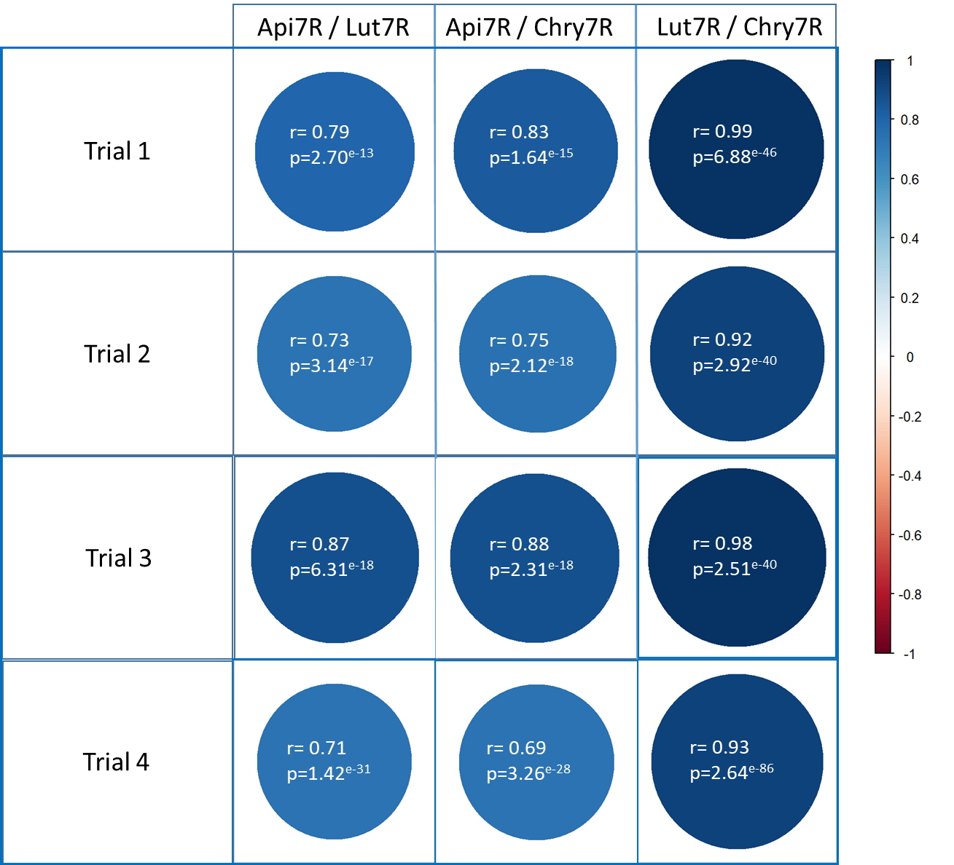
Api7R / Lut7R
Api7R / Chry7R
Lut7R / Chry7R
r= 0.79
p=2.70^{e-13}
r= 0.83
p=1.64^{e-15}
r= 0.99
p=6.88^{e-46}

