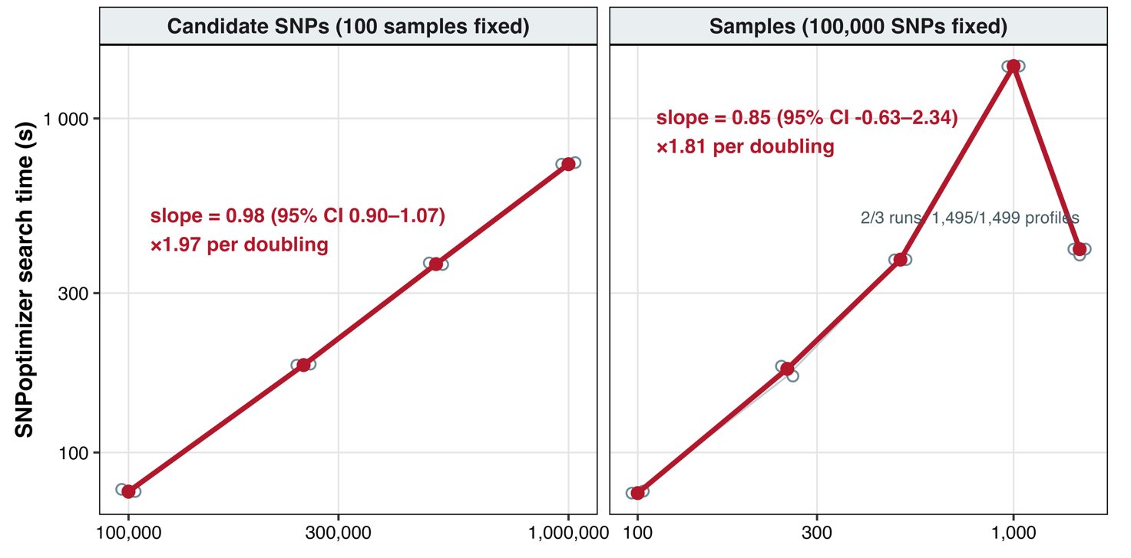
Supplementary Figure 2. Runtime scaling of SNPoptimizer on Dataset III (Hybrid search, k = 17). Search time (seconds; log-scaled) was plotted against candidate-SNP number (left; 100 samples fixed) and sample number (right; the same 100,000 SNPs fixed). Panels were exactly nested, and three runs per condition were conducted using identical hardware and software. Grey points and lines show individual runs; red points and lines show condition medians. Slopes and HC3 95% confidence intervals were from log–log models fitted to condition medians.

