Supplementary photographs and captions
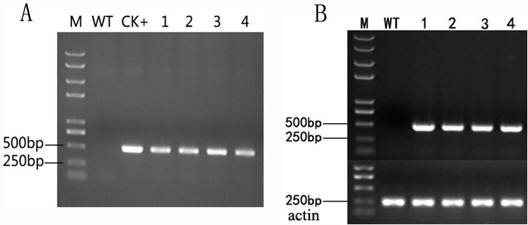
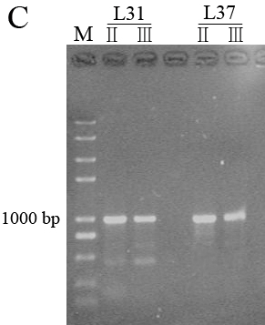

Supplementary figure 1 Identification of transgenic Arabidopsis with MsHSP17.7 by PCR (A), RT-PCR (B) and TAIL-PCR (C). Lane M DNA marker trans2000 plusII, lane WT wild-type Arabidopsis, lane CK+ pBI121-MsHSP17.7 vector, lane 1-4 transgenic lines, actin represent an internal reference control. In figure C, each set of two lanes contains products from secondary (II) and tertiary (III) reactions. The BLAST results showed that MsHSP17.7was intergrated in chromosomes 1 (GenBank: CP002684.1; range, 258,118,99-258,124,42, 99%) of L31 and chromosomes 4 (GenBank: CP002687.1; range, 167,073,28-167,085,36, 99%) of L37.

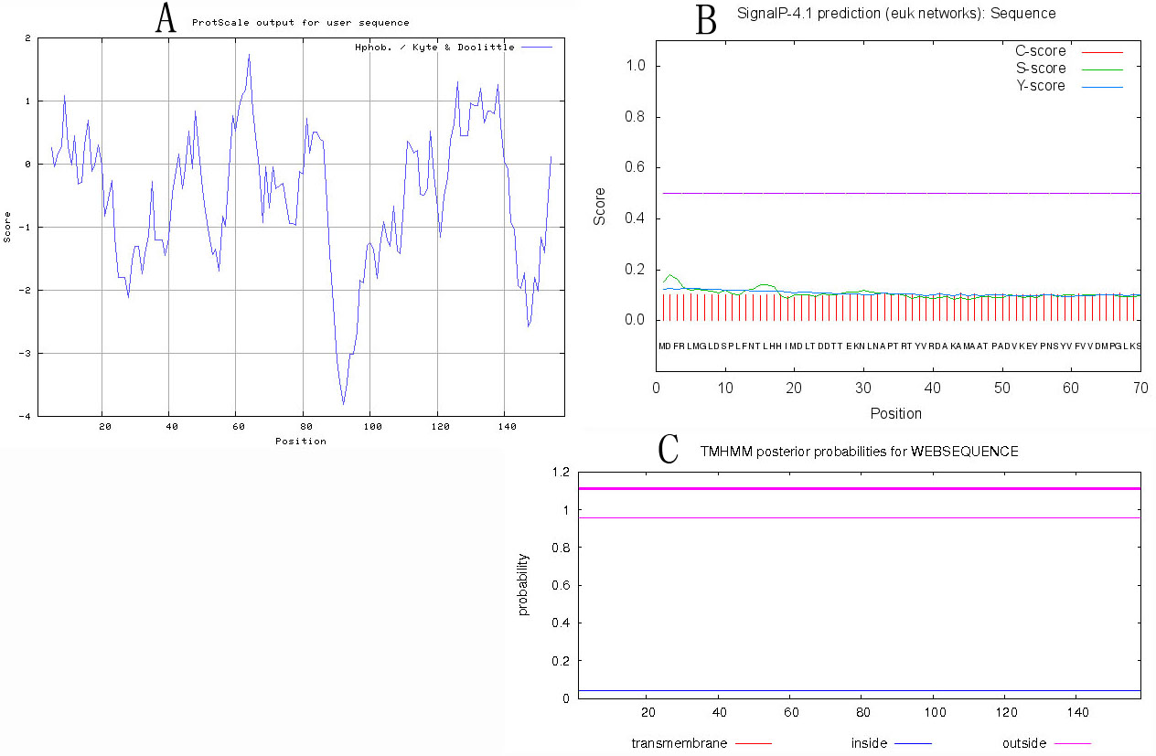
Supplementary figure 2 The bioinformatic analysis of MsHSP17.7 hydrophobicity, signal prediction and transmembrane motif prediction. A represents the prediction of MsHSP17.7’s hydrophilicity, negative value indicates polar amino acids and positive value indicates nonpolar amino acids. ProtScale analysis indicated that MsHSP17.7 was a hydrophilic protein. B represents prediction of signal peptide. C-score (raw cleavage site score), S-score (signal peptide score) and Y-score (combined cleavage site score) determined there is no signal peptides in MsHSP17.7. C represents transmembrane structure prediction by TMHMM. The red line denotes the possibility of transmembrane amino acids; the blue line denotes the possibility of amino acid within membrane; the purple line denotes the possibility of amino acid outside membrane. Taken together, these analyses indicate that MsHSP17.7 is not a membrane-binding protein.

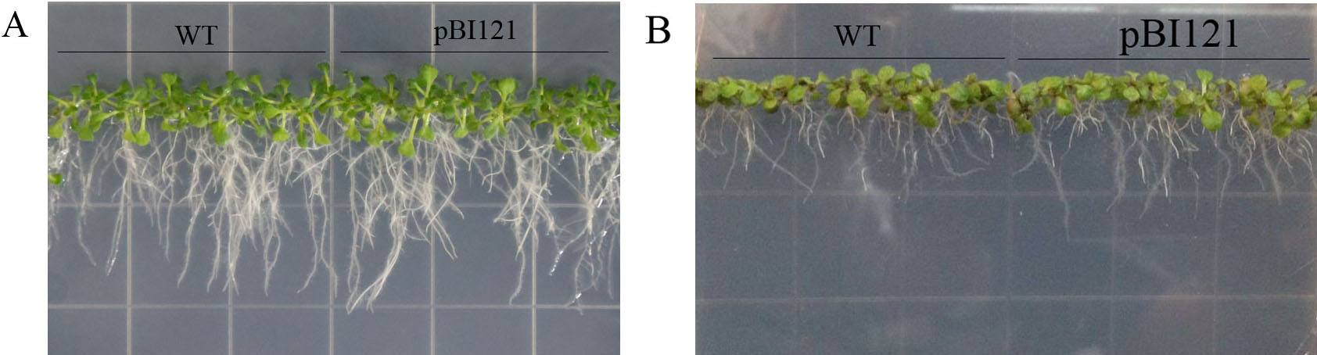

Supplementary figure 3 20-day seedlings of WT and transgenic Arabidopsis with empty vector under normal condition (A) and 100 mM NaCl treatment (B). were exhibited in the figure. WT indicates wild type Arabidopsis thaliana, pBI121 indicates the transgenic Arabidopsis with empty vector.

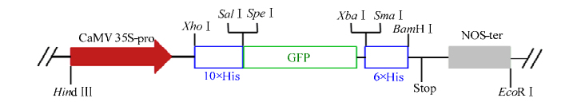
Supplementary figure 4 The pA7-GFP, 4.9 kb, contains CaMV 35S-promoter, histidines and the green fluorescent protein (GFP) gene. The insertion of the Hind Ⅲ/EcoR Ⅰ fragment from vector pBI-35s-10H-GFP-JFH1 is inserted into pUC18.

