Table 1. Primer sequence
Gene | Sequence
LIMT  GAPDH | F: 5’-CGAATGGACAATCTTTCCTTCTGTC  R:3’-GCTAGAGGTTGAGGGCCTGAGT  F:5’- TGTTGCCATCAATGACCCCTT  R:3’- CTCCACGACGTACTCAGCG

Table 2. siRNA sequence
Gene | Sense(5’-3’) | Antisense(3’-5’)
LINC01089-homo-177  LINC01089-homo-295  LINC01089-homo-888  NC | CCAUUCAUGUCAGCAGUUATT  GCAGAACGUGAGGGUGUAATT  GCUUCCAACCUCCAUUGCATT  UUCUCCGAACGUGUCACGUdTdT | UAACUGCUGACAUGAAUGGTT  UUACACCCUCACGUUCUGCTT  UGCAAUGGAGGUUGGAAGCTT  ACGUGACACGUUCGGAGAAdTdT

Table 3 the information of antibodies used.
Antibody name | company | Cat. #
E-Cadherin  Vimentin  ZO-1  Fibronectin  β-actin  GAPDH | CST  CST  CST  Proteintech  CST  CST | 3195s  3390S  8193T  66042  4970  2118S

Supplementary figure 1
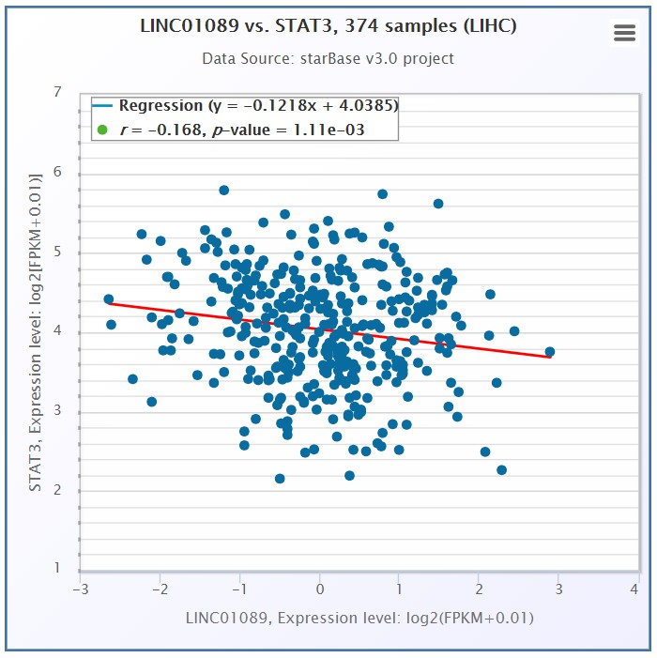
Figure S1 LIMT is negative associated with STAT3.

