Enhancement of mesenchymal stem cells’ chondrogenic potential by type II collagen-based bioscaffolds
Zoi Piperigkou^{1,2}, Dimitra Bainantzou¹, Nadia Makri¹, Eleni Papachristou³, Aglaia Mantsou³, Theodora Choli-Papadopoulou³, Achilleas D. Theocharis^{1,∗}, Nikos K. Karamanos^{1,2,∗}

¹Biochemistry, Biochemical Analysis and Matrix Pathobiology Research Group, Laboratory of Biochemistry, Department of Chemistry, University of Patras, Greece.
²Foundation for Research and Technology-Hellas (FORTH)/Institute of Chemical Engineering Sciences (ICE-HT), Patras, Greece.
³Laboratory of Biochemistry, Department of Chemistry, Aristotle University of Thessaloniki, Greece.

Supplementary Figure 1.
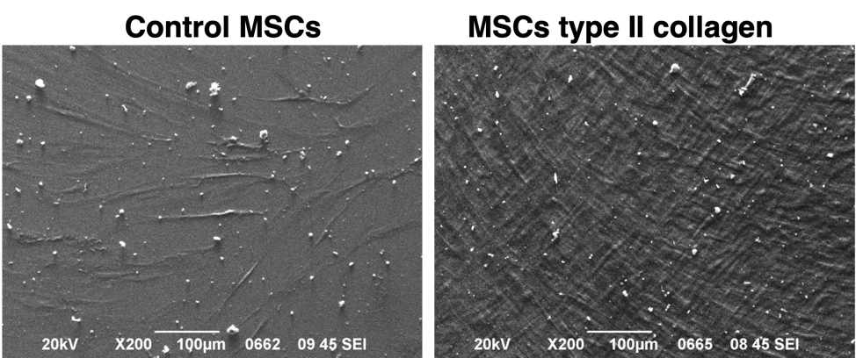

Supplementary Figure Legend. Scanning electron microscopy (SEM) images of dental pulp-derived mesenchymal stem cells cultured in plastic culture flasks (control) and in flasks coated with type II collagen, where the collagen fibers can be observed.

