Figure 1.The original western blot for COL-I and COL-III in Fig.3
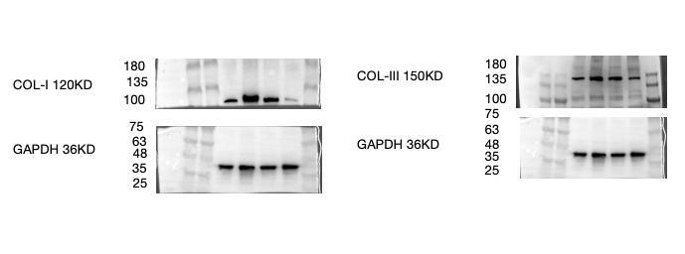
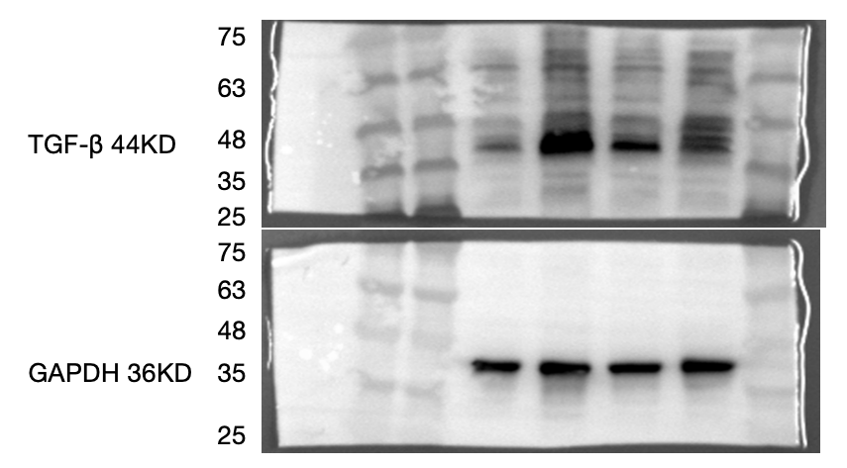

Figure 2.The original western blot for TN-C and IL-6 in Fig.4
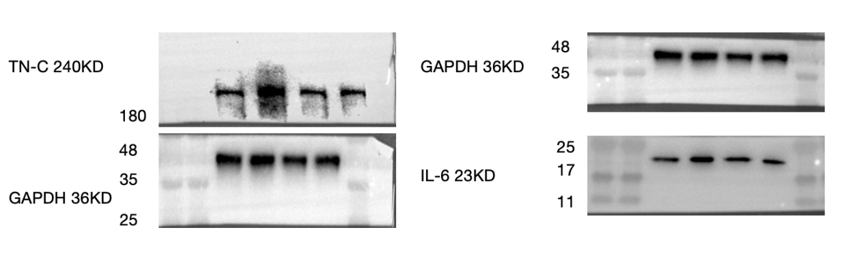
Figure 3.The original western blot for COL-I， COL-III，TN-C，p-PI3K/PI3K and p-Akt/Akt in Fig.6
