Supplementary Information
Journal: Molecular Biology Reports

The complete mitochondrial genome of Pleurocorallium inutile (Octocorallia: Scleralcyonacea: Coralliidae)
Kenji Takata¹, Masanori Nonaka², Fei Xia³, Taisei Kikuchi³, Kodai Gibu¹, Nina Yasuda¹
1, Graduate School of Agricultural and Life Sciences, The University of Tokyo, Yayoi, Tokyo, Japan
2, Okinawa Churashima Foundation Research Institute, Motobu, Okinawa, Japan
3, Graduate School of Frontier Sciences, The University of Tokyo, Kashiwa, Chiba, Japan

Corresponding author
Nina Yasuda: ninayausda@gmail.com

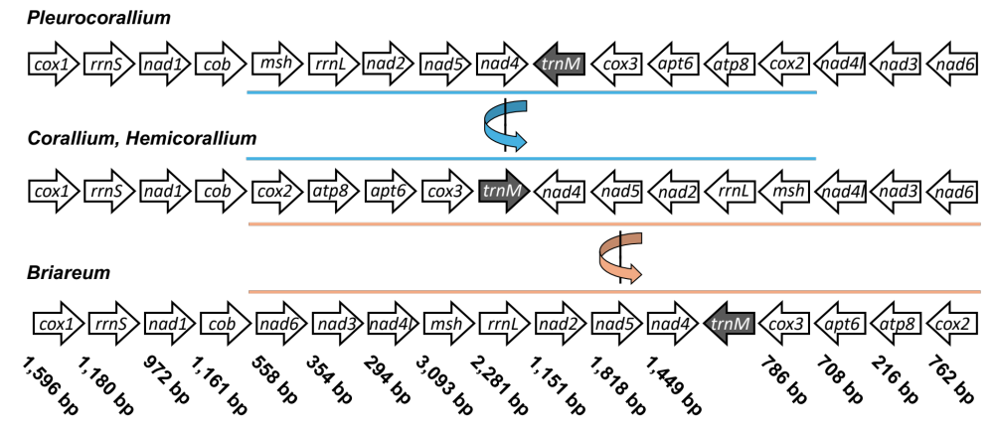
Fig. S1| Nucleotide length of each gene and the process of aligning and concatenating genes in the order and orientation matching that of Briareum.
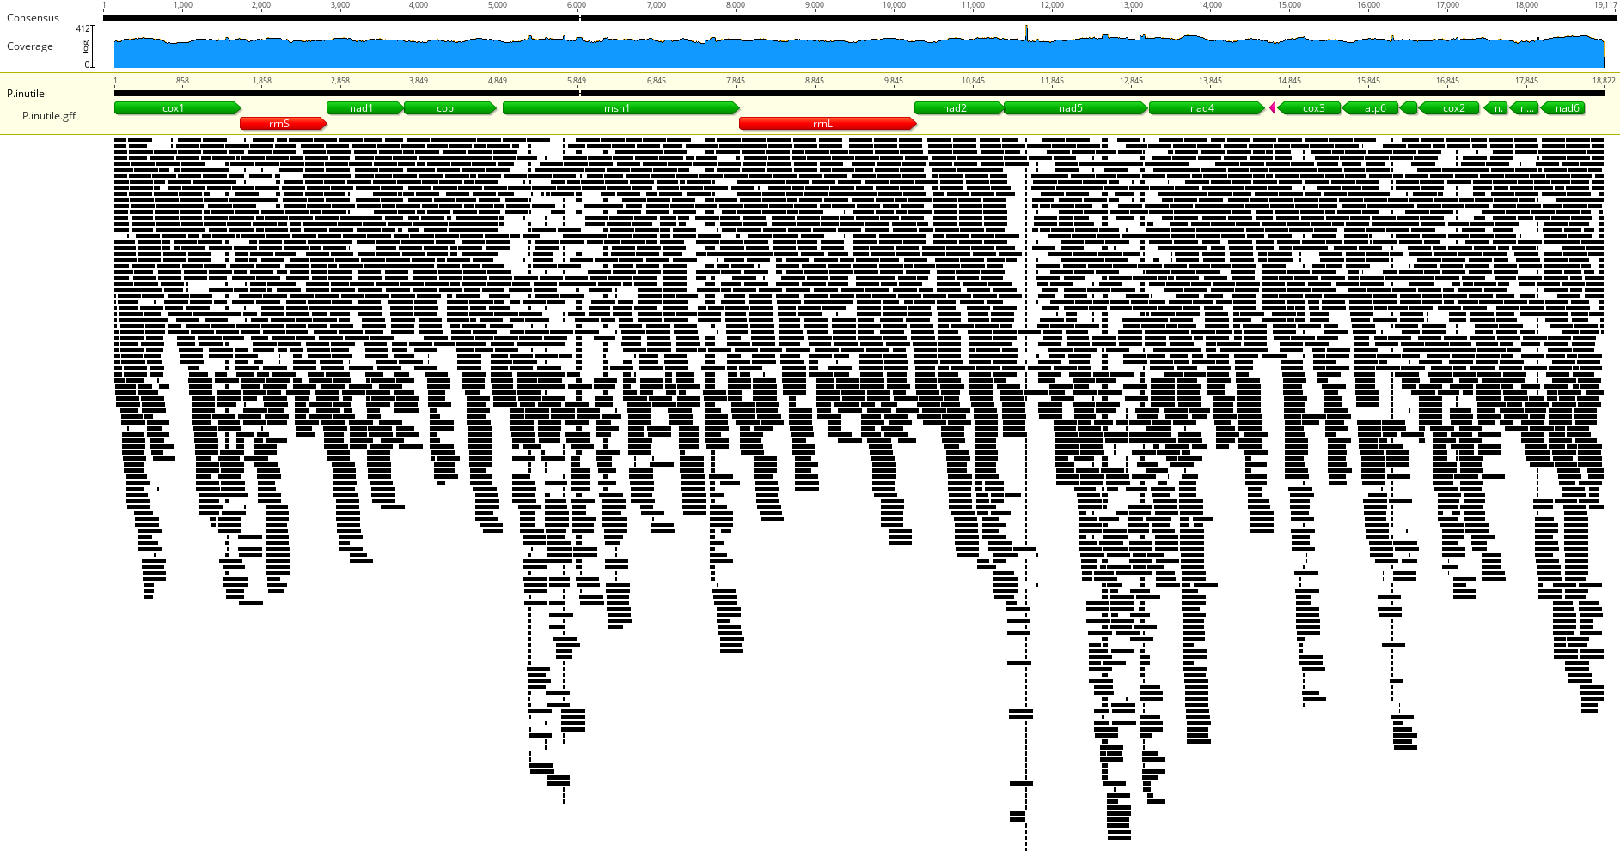
Fig. S2| Read coverage depth map of Pleurocorallium inutile created using Geneious Prime 2024.0.7 (https://www.geneious.com).

