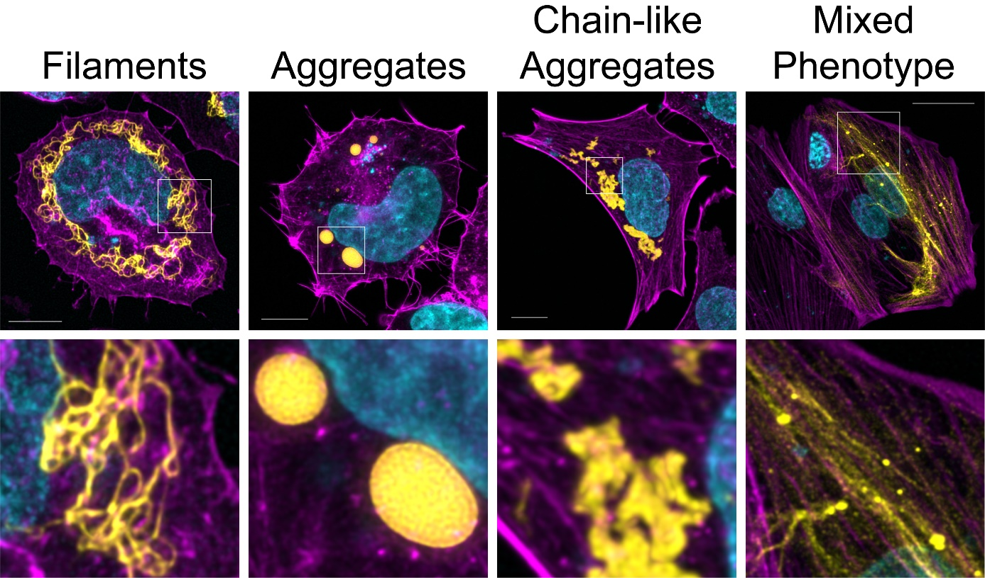
Figure S1. Four phenotypic cellular prototypes were defined. Cells containing exclusively desmin filaments of varying size and length (‘Filaments’); cells with cytoplasmic, isolated aggregates (‘Aggregates’); cells with ‘Chain-like Aggregates’ and cells displaying filaments and aggregates (“Mixed Phenotype”).

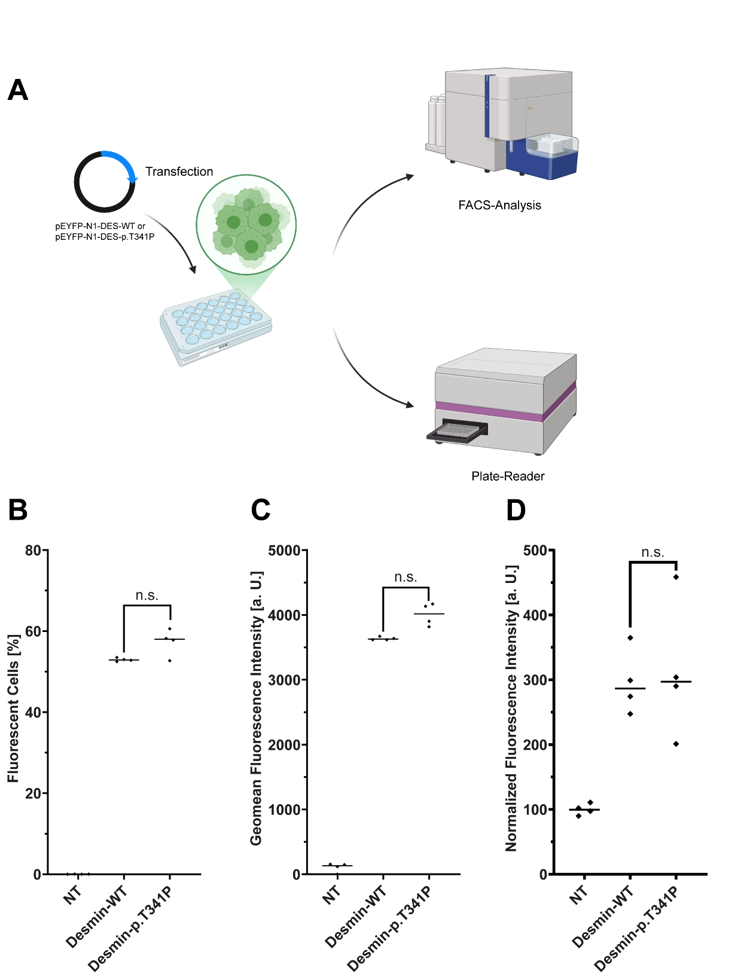
Figure S2. Expression analysis. (A) Desmin-EYFP expression analysis of transiently transfected cells was quantified by fluorescence activated cell sorting (FACS) and by fluorescence analysis using a plate reader. (B) Percentage of transiently transfected SW-13 cells expressing desmin-WT or -p.T341P. (C) FACS analysis. The geomean of the fluorescence intensity is shown in arbitrary units (a. U.). (D) Normalized fluorescence intensities of SW-13 cells (48 well plate, 1 cm² growth area) transfected with pEYFP-N1-DES-WT and pEYFP-N1-DES-p.T341P (n=4; n.s.= not signicifant, non-parametric Kruskal-Wallis test). NT= not transfected.
Table S1. In silico prediction of DES-p.T341P.
Name of the variant |  | DES-p.T341P (NP_001918.3)
 |  | DES-c.1021A>C (NM_001927.4)
Chromosomal position |  | 2:219420951A>C
Affected protein domain |  | Rod domain (Coil-2)
Database Information | ClinGen (Gene Disease Validity), 2nd February 2026 | Dilated Cardiomyopathy – Definitive  Arrhythmogenic Right Ventricular Cardiomyopathy – Moderate  Myofibrillar Myopathy – Moderate Actionability | https://search.clinicalgenome.org/kb/genes/HGNC:2770
Database Information | OMIM (Online Mendelian Inheritance in Man), 2nd February 2026 | Cardiomyopathy, dilated, 1I  Myopathy, myofibrillar, 1 | #604765  #601419
Database Information | gnomAD v4.1.0 (Minor Allele Frequency), 2nd February 2026 | - | https://gnomad.broadinstitute.org/
Database Information | RGC Million Exome Variant Brower (Alternate Allele Frequency), 2nd February 2026 | - | https://rgc-research.regeneron.com/
Database Information | ClinVar, 2nd February 2026 | Not listed | https://www.ncbi.nlm.nih.gov/clinvar/
In Silico Predictors (Individual Predictions) | AlphaMissense | Deleterious Moderate (0.965)
In Silico Predictors (Individual Predictions) | REVEL | Deleterious Moderate (0.9)
In Silico Predictors (Individual Predictions) | EVE | Deleterious (0.720)
In Silico Predictors (Individual Predictions) | MutationTaster | Deleterious (1)
In Silico Predictors (Individual Predictions) | DANN | Deleterious (1)
In Silico Predictors (Individual Predictions) | MetaLR | Deleterious (0.92)
In Silico Predictors (Individual Predictions) | BayesDel | Deleterious Moderate (0.33)
In Silico Predictors (Individual Predictions) | SIFT | Uncertain (0.018)
In Silico Predictors (Individual Predictions) | FATHMM | Uncertain (-3.82)
In Silico Predictors (Individual Predictions) | Aggregated Prediction (https://franklin.genoox.com, 10th February 2026) | Deleterious (0.87)

