Supplementary Information

Contents
Supplementary Figure S1. Effect of cisplatin on HEK-293 cell viability
Supplementary Table S1. Combination index values following combinatorial treatment for 24 hours
Supplementary Table S2. Combination index values following combinatorial treatment for 48 hours

Supplementary Figure
Supplementary Figure S1
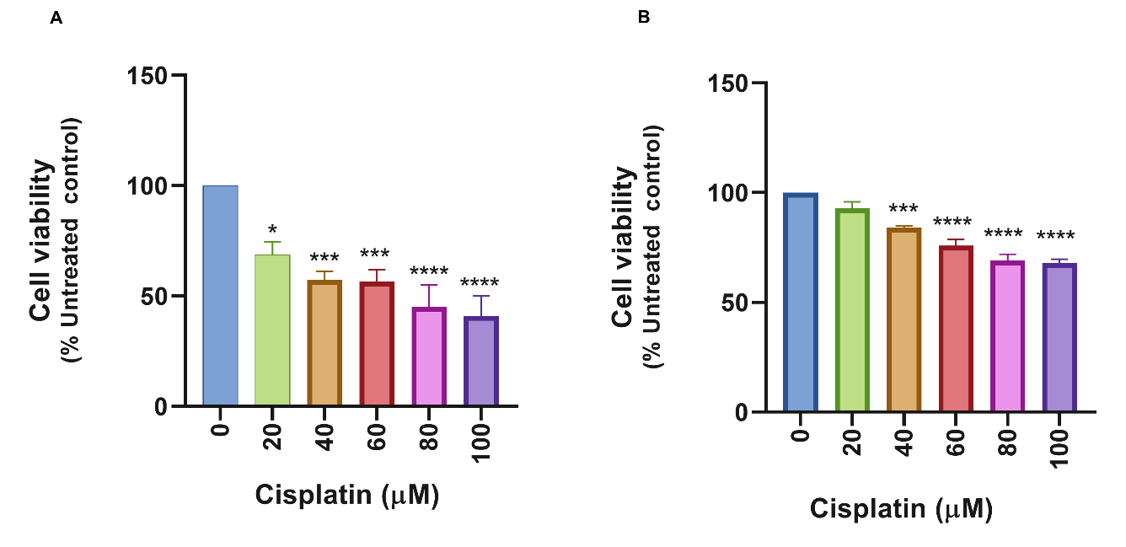
Figure S1. Effect of cisplatin on HEK-293 cell viability at 24 (A) and 48 (B) hours of treatment. Data are presented as mean ± standard error of the mean (SEM) from three independent experiments performed in duplicate. Data were expressed as the standard error of the mean (SEM) from three independent experiments conducted in duplicates. *p ˂ 0.01 and ***p ≤ 0.0001, ****p < 0.0001 indicate significant differences from untreated control. #p < 0.01, ##p ≤ 0.001, ###p ≤ 0.001, and ####p < 0.0001 denote significant differences relative to cisplatin treated cells.

Supplementary Tables
Supplementary Table S1: Combination index values following combinatorial treatment of HEK-293 cells for 24 hours
HEK-293 treatment at 24 hours
MBAE (µg/ml) | Fa | CI | Interpretation
200 | 0.428 | 1.31 | Antagonism
400 | 0.388 | 1.55 | Antagonism
600 | 0.291 | 2.39 | Antagonism
800 | 0.178 | 4.52 | Antagonism
1000 | 0.180 | 4.48 | Antagonism

Supplementary Table S2: Combination index calculated following combinatorial treatment of HEK-293 cells for 48 hours
HEK-293 treatment at 48 hours
MBAE (µg/ml) | Fraction affected (Fa) | Combination index (CI) | Interpretation
200 | 0.256 | 2.17 | Antagonism
400 | -0.017 | Undefined | No inhibition resulting from Negative Fa
600 | -0.146 | Undefined | No inhibition resulting from Negative Fa
800 | -0.384 | Undefined | No inhibition resulting from Negative Fa
1000 | -0.314 | Undefined | No inhibition resulting from Negative Fa

CI < 0.9 indicates synergy
CI = 1 indicates additive
CI > 1.1 indicates antagonism

