Supporting Materials - Appendices

Appendix A: Questionnaire used for implementation technique comparison
Q1. How often do you play video games?
- Very often
- Often
- Not very often
- Not at all
The following image (Figure 1) shows the video thumbnail and description for the pre-fracturing technique shown to participants taking the questionnaire. This video can be found on YouTube.
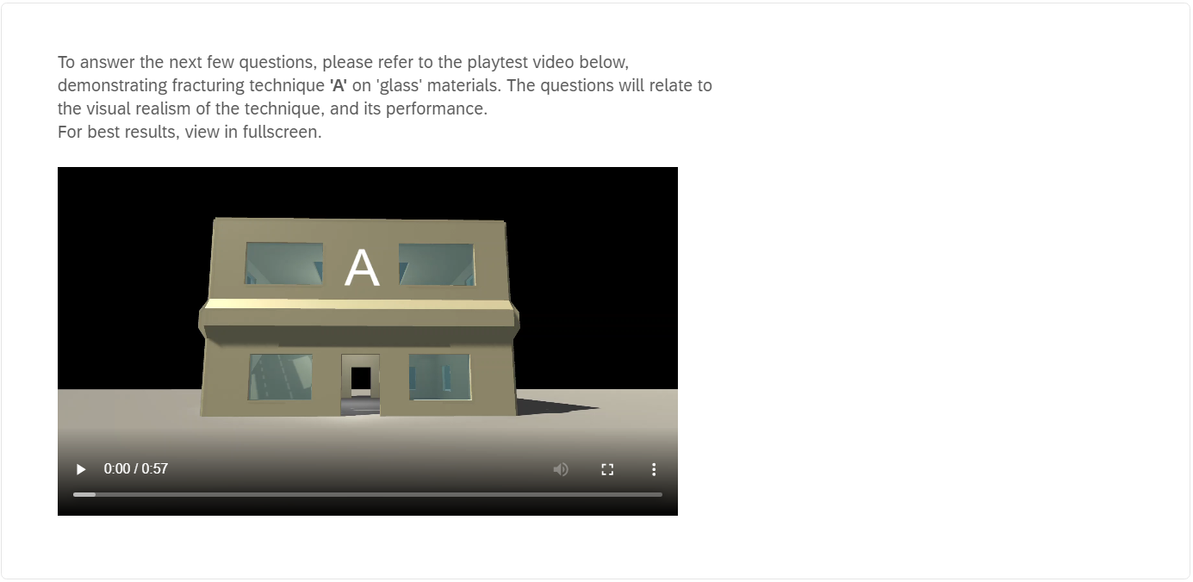
Figure 1 Appendix A: Image of video for Technique 'A' shown to participants

Q2. a) In terms of visual realism, how realistic was the destruction using technique 'A'?
- Very realistic
- Somewhat realistic
- Not at all realistic
Additional Comments (optional): _______

Q2. b) How accurately did this destruction technique represent the material it was used on?
- Very accurately
- Somewhat accurately
- Not very accurately
- Not at all accurately
Additional Comments (optional): _______

Q2. c) To the best of your observation, in terms of performance, how fast/slow did technique ‘A’ seem to perform?
- Very fast
- Moderately fast
- Slow
- Very slow
Additional Comments (optional): _______

The following image (Figure 2) shows the video thumbnail and description for the real-time fracturing technique shown to participants taking the questionnaire. This video can be found on YouTube.
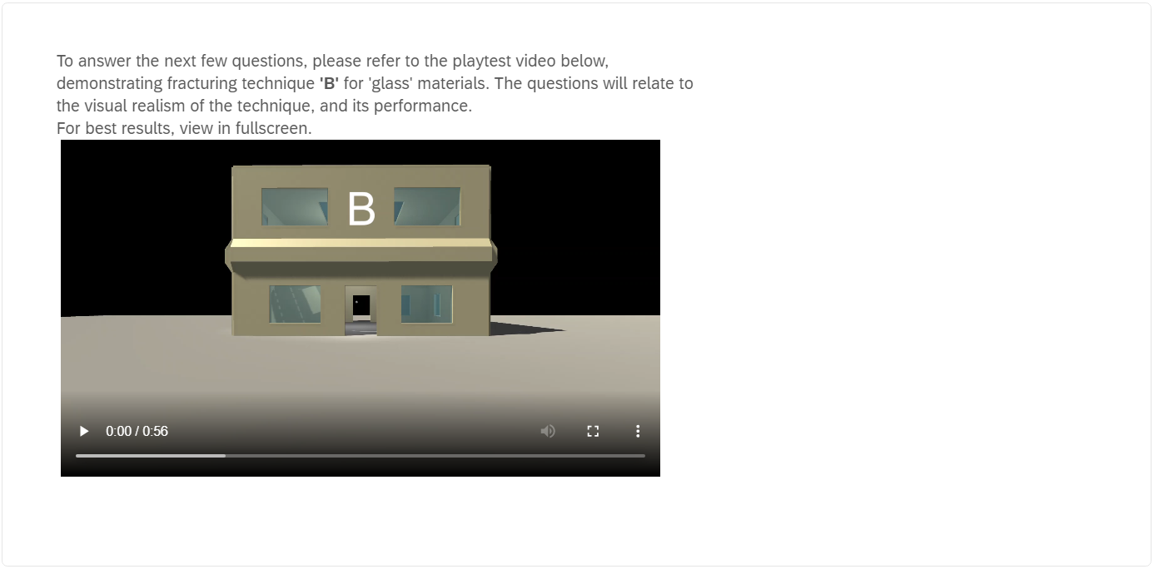
Figure 2 Appendix A: Image of video for Technique 'B' shown to participants
Q3. a) In terms of visual realism, how realistic was the destruction using technique 'B'?
- Very realistic
- Somewhat realistic
- Not at all realistic
Additional Comments (optional): _______

Q3. b) How accurately did this destruction technique represent the material it was used on?
- Very accurately
- Somewhat accurately
- Not very accurately
- Not at all accurately
Additional Comments (optional): _______

Q3. c) To the best of your observation, in terms of performance, how fast/slow did technique ‘B’ seem to perform?
- Very fast
- Moderately fast
- Slow
- Very slow
Additional Comments (optional): _______

Q4. Out of techniques ‘A’ and ‘B’, in your opinion, which technique provided the best overall results for destruction (taking both visual and performance into account)? Please give reasons for your answer.

Q5. In your opinion, would any of these techniques be suitable for use in video games? Any particular reasons why or why not?

Appendix B: Questionnaire responses
Q1. How often do you play video games? (Responses in (Table 1))
Table 1 Appendix B: Responses for Q.1
Choices | Number of Responses | Percentage (20 respondents in total)
Very often | 13 | 65%
Often | 6 | 30%
Not very often | 1 | 5%
Not at all | 0 | 0%

Q2. a) In terms of visual realism, how realistic was the destruction using technique 'A'? (Responses in (Table 2))
Table 2 Appendix B: Responses for Q2. (a)
Choices | Number of Responses | Percentage (20 respondents in total)
Very realistic | 3 | 15%
Somewhat realistic | 16 | 80%
Not at all realistic | 1 | 5%

Additional comments for Q2. a) (Table 3)
RC – Respondent Choice: The choice chosen for the related question.
VR – Very realistic SR – Somewhat realistic NR – Not at all realistic
Table 3 Appendix B: Additional comments for Q2. (a)
RC | Q2. a) Additional Comments (optional)
SR | The more glass that was shot/shattered, the more the pattern of the shattering became obvious.
SR | When the glass brakes you can tell its the same fracture every time but still somewhat realistic
SR | The effect looks cool and suitable for a game, One note however (not on a technical performance level), I feel that in the real world there would be a lot more smaller glass shards accompanying the larger shards, but the effect still met my expectations.
SR | The windows seemed to shatter in the same way and didn’t break when I shot them again which would’ve make it more realistic.
SR | Broke rather realistically but the same pattern could be seen when broke
SR | The direction of shattered glass corresponding to the impact direction is a bit confusing in some cases
NR | I feel glass doesn't break that way and the technique is too simple to be realistic. It does the job of representing glass breaking but is not realistic.

Q2. b) How accurately did this destruction technique represent the material it was used on? (Responses in (Table 4))
Table 4 Appendix B: Responses for Q2. (b)
Choices | Number of Responses | Percentage (20 respondents in total)
Very accurately | 1 | 5%
Somewhat accurately | 16 | 80%
Not very accurately | 3 | 15%
Not at all accurately | 0 | 0%

Additional comments for Q2. b) (Table 5)
RC – Respondent Choice: The choice chosen for the related question.
VA – Very accurately SA – Somewhat accurately NVA – Not very accurately NA – Not at all accurately
Table 5 Appendix B: Additional comments for Q2. (b)
RC | Q2. b) Additional Comments (optional)
SA | I think certainly in video games it would be perfectly acceptable.
SA | Feel like glass should have broken into smaller pieces, and break a second time when it impacted with the floor
NVA | When someone plays this it will look realistic at the start but you will notice that they are the same.
SA | You can tell it’s meant to be glass but the pieces were quite big.
SA | Acted the same as glass but did not have a center point where the shattered effect originated
NVA | The glass looked very thick.

Q2. c) To the best of your observation, in terms of performance, how fast/slow did technique ‘A’ seem to perform? (Responses in (Table 6))
Table 6 Appendix B: Responses for Q2. (c)
Choices | Number of Responses | Percentage (20 respondents in total)
Very fast | 10 | 50%
Moderately fast | 10 | 50%
Slow | 0 | 0%
Very Slow | 0 | 0%

Additional comments for Q2. c) (Table 7)
RC – Respondent Choice: The choice chosen for the related question.
VF – Very fast MF – Moderately fast S – Slow VS – Very Slow
Table 7 Appendix B: Additional comments for Q2. (c)
RC | Additional Comments (optional)
MF | There was no evident drop in frame rate
VF | It broke almost instantly when hit.
MF | Somewhere between moderately fast and slow, I believe I perceived some slowdown, particularly when the ceiling glass fell down.
VF | I didn’t see any noticeable performance issues.
MF | The speed was frame perfect and there was no delay
MF | I did not notice any performance issues.

Q3. a) In terms of visual realism, how realistic was the destruction using technique 'B'? (Responses in (Table 8))
Table 8 Appendix B: Responses for Q3. (a)
Choices | Number of Responses | Percentage (20 respondents in total)
Very realistic | 12 | 60%
Somewhat realistic | 7 | 35%
Not at all realistic | 1 | 5%

Additional comments for Q3. a) (Table 9)
RC – Respondent Choice: The choice chosen for the related question.
VR – Very realistic SR – Somewhat realistic NR – Not at all realistic
Table 9 Appendix B: Additional comments for Q3. (a)
RC | Q3. a) Additional Comments (optional)
VR | Much more realistic, no evident pattern to the destruction.
VR | It continues to shatter even after first breaking, it also breaks on point of contact.
SR | Compared to technique A, I liked that there were smaller fragments of glass present in technique B. Sometimes though I felt the entire glass pane did not behave well leaving larger chunks of glass still intact inside the frame, it was mixed in this regard for me because sometimes it looks natural as if a ball has gone through a window and taken some of the glass, but other times large amounts of glass which felt like should have been taken with the impact remain intact. That being said I still enjoyed this effect and felt it could belong in a game.
SR | technique B is closer to realism than A as it has smaller chunks of glass being broken off instead of them just being huge slabs of glass best example of this would be when the skylight glass is broken.
VR | The windows broke at the point where they’re hit by the ball and the broken pieces could be broken again.
VR | It shattered in different patterns every time and was very realistic in appearance.
SR | This is better than the previous example although with this technique the chunks of glass were still quite large but the way that the glass broke was more realistic.

Q3. b) How accurately did this destruction technique represent the material it was used on? (Responses in (Table 10))
Table 10 Appendix B: Responses for Q3. (b)
Choices | Number of Responses | Percentage (20 respondents in total)
Very accurately | 9 | 45%
Somewhat accurately | 10 | 50%
Not very accurately | 0 | 0%
Not at all accurately | 1 | 5%

Additional comments for Q3. b) (Table 11)
RC – Respondent Choice: The choice chosen for the related question.
VA – Very accurately SA – Somewhat accurately NVA – Not very accurately NA – Not at all accurately
Table 11 Appendix B: Additional comments for Q3. (b)
RC | Q3. b) Additional Comments (optional)
VA | It shatters randomly which is exactly how glass would react to being broken.
VA | The glass could break over and over and this version was able to do that, and again it shattered at the area it was hit by the ball.
VA | There was a center point for when the glass broke which portrays glass very accurately.

Q3. c) To the best of your observation, in terms of performance, how fast/slow did technique ‘B’ seem to perform? (Responses in (Table 12))
Table 12 Appendix B: Responses for Q3. (c)
Choices | Number of Responses | Percentage (20 respondents in total)
Very fast | 9 | 45%
Moderately fast | 8 | 40%
Slow | 3 | 15%
Very Slow | 0 | 0%

Additional comments for Q3. c) (Table 13)
RC – Respondent Choice: The choice chosen for the related question.
VF – Very fast MF – Moderately fast S – Slow VS – Very Slow
Table 13 Appendix B: Additional comments for Q3. (c)
RC | Q3. c) Additional Comments (optional)
VF | Again, despite the extra calculations, no discernible loss of frame rate.
VF | Was very fast and shattered instantly
MF | Again I seemingly perceived some slowdown, particularly when jumping from the first floor to the ground floor though I could not gauge if it was severe or minor.
MF | Pretty fast, I think there were frame drops around when the skylight was being broken though.
MF | I feel like it started to run a bit slower as more glass that was broken towards the end.
VF | There was no delay when the glass broke and the extra models did not cause lag.
MF | I think I saw a little fps slow down but it wasn't very noticeable.

Q4. Out of techniques ‘A’ and ‘B’, in your opinion, which technique provided the best overall results for destruction (taking both visual and performance into account)? Please give reasons for your answer. (Responses in (Table 14))
TC – Technique of Choice. This is based on what is said in the answers as no multiple choice was provided for this question. A – Technique A B – Technique B NP – No Preference
Table 14 Appendix B: Responses for Q4.
Q4 Answers | TC
B. Far more in-line to what I would expect from destruction physics in a modern game. | B
B- as the glass broken with specific targeting which will give players controls over how the glass will break. | B
I think it's B as it shatters randomly, breaks at the point of contact and can be broken multiple times. | B
I would say Technique A won for me, I believe I perceived slightly better performance, and felt it shattered the different glass more consistently (though it did lack the effect of smaller glass shards like in Technique B). | A
B, sometimes call parts dont just break all together depending on the glass type they will still to the wall or the building and need to be shot again | B
I would say B, mainly because here the glass can break off into very small pieces along with the bigger chunks which I think sells the effect better and the performance wasn’t too bad only when breaking the skylight might there have been a little stutter. | B
I believe that technique B provided more accurate results. The technique seemed to have more fractural components to make the glass more realistic when impacted. The effect was very fast and did not seem to affect performance. | B
I prefer B as it was more realistic and you could break the glass after it was already broken, and it seemed to perform well. | B
The best technique was B as it broke differently everytime and where the ball hit is where the shatter would originate making a very realistic glass effect. | B
B was slightly better as it was more realistic than A, performance was good for both techniques | B
Personally found that ‘B’ proved the best destruction both visually and performance wise. The glass shattered on impact and and seem d to fall naturally on the upper Windows and ceiling. | B
B | B
A appeared to be more realistic in terms of glass breaking. More specifically, windows in a house breaking as different glass breaks differently. It appeared to be quicker to fall to the floor too | A
Relatively similar, I guess it depends on the properties of the glass you are emulating - for instance some glass is designed not to shatter and to fall out in one large sheet when broken. Other glass has no protection and forms shards, so I guess it's a case of choosing what material you want to emulate. | NP
Technique A. Speed of throw and impact on glass seem faster and looked realistic enough. Glass shatter (secondary shatter) from contact with the floor looked minimal, there were chunky bits falling on floor. | A
B. The whole action within itself was so much smoother and realistic compared to that of A where it was sort of a delayed reaction in a way which took away from the effect of it | B
B | B
B - overall seems more realistic and detailed | B
B. It looks better and I didn't notice much slow down. This may be different when "playing" the game though. | B
B, much more detailed glass breakage | B

Q5. In your opinion, would any of these techniques be suitable for use in video games? Any particular reasons why or why not? (Responses in (Table 15))
Table 15 Appendix B: Responses for Q5.
Q5 Answers
Both would, depending on the level of realism desired or needed. B would be better, but would have be be levied overall with other game design choices and how much resources are being used. It could also lead to a worse experience for lower-end gaming set-ups.
The concept of the techniques would be suitable, however without seeing more performance information and PC spec, I don't know if their will work. I believe having low performance impact is more importance then realism
I do believe technique B will be very useful in games to simulate glass or if repurposed can simulate other materials too.
I suppose both could be suitable, But Technique A seems it would scale better as the game expanded, I think B would tax system resources more. So overall I feel A would be more effective and easier to maintain.
They would be useful to use in games as it brings some realism to the game itself when shooting glass and I feel that it could also be used for other games, To be honest this feature is already existing in some current games.
I think both are suitable for video games, with the right optimisations any stutter could be reduced.
Absolutely yes, this is a very impressive implementation and can definitely be used in video games for realistic glass window fracturing
I think both techniques would be ok to use in video games. Technique A would be ok if realism wasn’t a main factor in the game as people may not notice it’s not very realistic. Technique B would be the best option as long as the amount of broken pieces it makes doesn’t get too much and cause heavy lag.
I believe technique B would be a great addition to games design as it would allow for more realistic material effects.
B due to the extra realisim compared to A.
Yes I think so, had a similar feel to glass shatters in SUPERHOT
(no response)
Yes, A would work best for realism but I suspect it takes a lot more processing power to create in relation to B. But the level of detail and realism needed, as well as performance of the hardware, would determine which to use.
Yes, both would be at home in any realistic game environment. Other games get away with a lot less realism in terms of emulating glass.
I think both could work but the best one to use should look more realistic. Good Primary shatter ( impact from ball) and secondary shatter (impact on floor) makes it look real.
Both techniques would be good in games really, just B is a bit more visually pleasing than A due to the smoothness of when the glass shatters upon impact of the ball compared to the delayed shatter in A.
(no response)
Both would be good enough in my opinion
If the performance is good enough then both could be used in games. I do prefer B but as mentioned A still represents breaking glass even though it is now as realistic as B.
Both would be feasible but i think that B would be more realistic due to the realism of the glass shattering

Appendix C: Visual realism bar charts for technique A and B
Technique A (Figure 3):
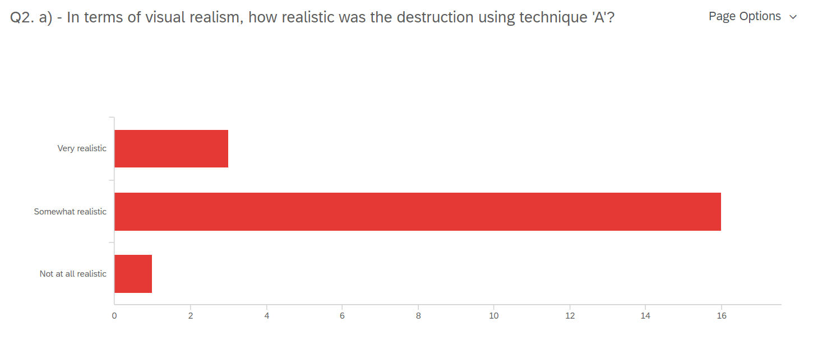
Figure 3 Appendix C: Technique 'A' visual realism bar chart from questionnaire

Technique B (Figure 4):
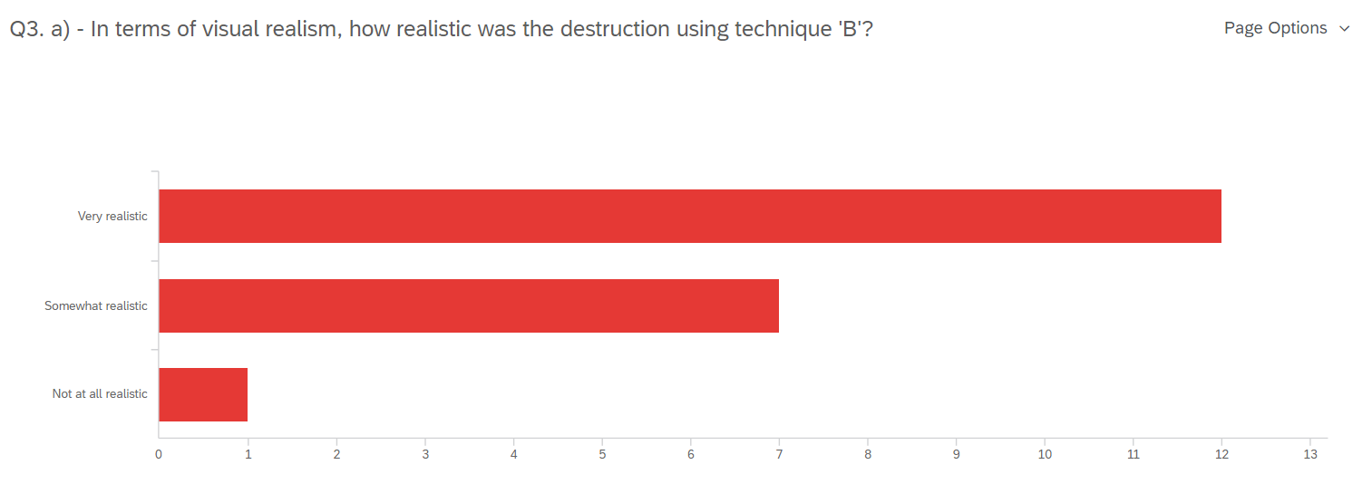
Figure 4 Appendix C: Technique 'B' visual realism bar chart from questionnaire

Appendix D: Material accuracy bar charts for technique A and B
Technique A (Figure 5):
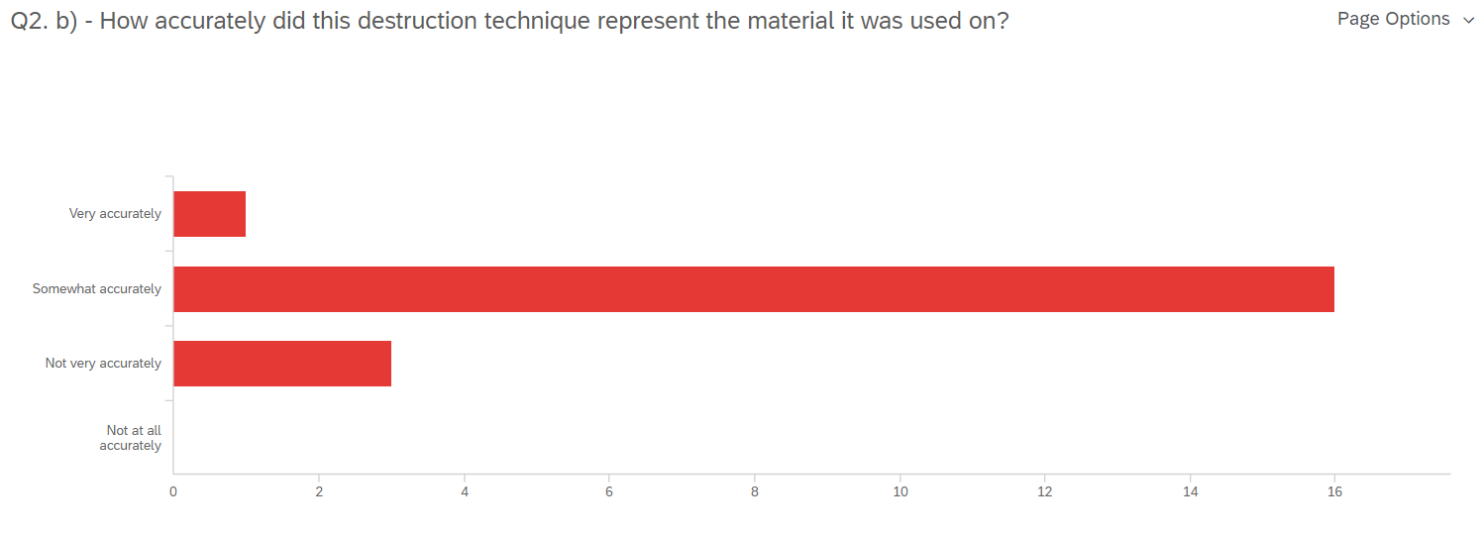
Figure 5 Appendix D: Technique 'A' material accuracy bar chart from questionnaire
Technique B (Figure 6):
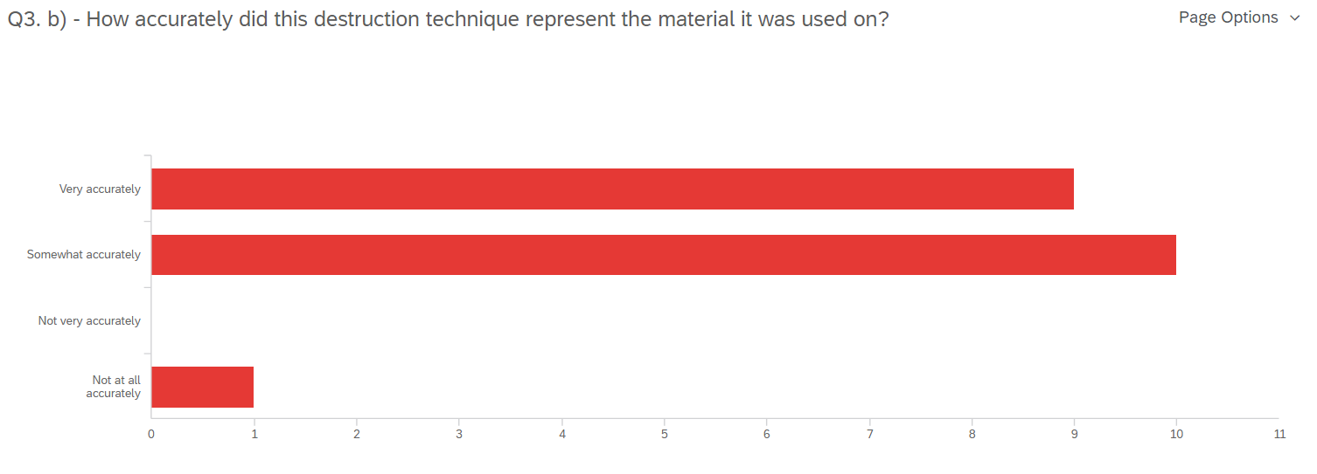
Figure 6 Appendix D: Technique 'B' material accuracy bar chart from questionnaire

Appendix E: Perceived performance bar charts for technique A and B
Technique A (Figure 7):
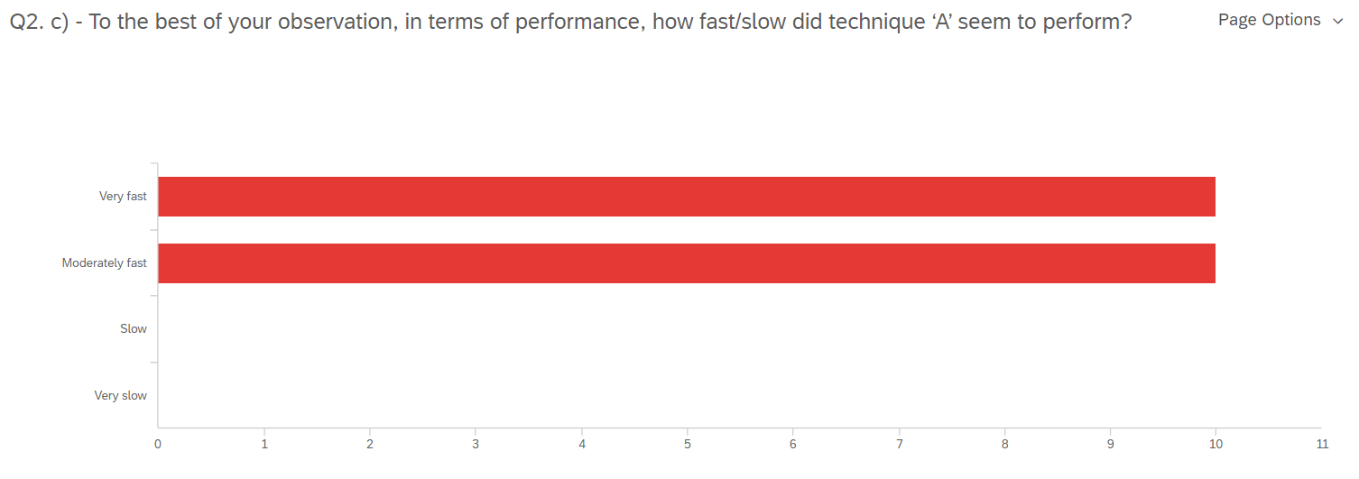
Figure 7 Appendix E: Technique 'A' perceived performance bar chart from questionnaire
Technique B (Figure 8):
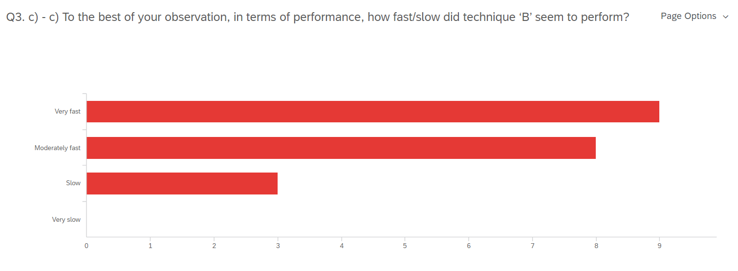
Figure 8 Appendix E: Technique 'B' perceived performance bar chart from questionnaire

Appendix F: Question 4 technique A or B pie chart
A breakdown of respondent’s answers for: Q4 Out of techniques ‘A’ and ‘B’, in your opinion, which technique provided the best overall results for destruction (taking both visual and performance into account)? (Figure 9)
One respondent stated both techniques were similar, as such, this is listed in the chart as ‘No Preference’.
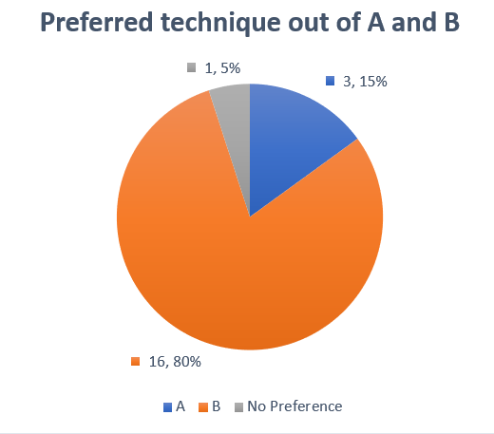
Figure 9 Appendix F: Q4 technique A or B pie chart

https://youtu.be/j3wWyEIffVU
https://youtu.be/OIz7wRzmvx8

