Supplementary Information
Revisiting Thermorheological Simplicity in Crumb Rubber Modified Bitumen Using Fractional Maxwell Modelling

List of Tables
Table 1S Goodness of Fit of the Fractional Maxwell Model to the Measured Storage and Loss Moduli 9
Table 2S STA Samples fractional maxwell parameter variation 10
Table 3S LTA Samples Fractional Maxwell Parameter Variation 11
List of Figures
Figure 1S Experimental and Predicted G’ and G” for CRMB-5 (Unaged Condition) 2
Figure 2S Experimental and Predicted G’ and G” for CRMB-10 (Unaged Condition) 2
Figure 3S Experimental and Predicted G’ and G” for CRMB-15 (Unaged Condition) 3
Figure 4S Experimental and Predicted G’ and G” for CRMB-22 (Unaged Condition) 3
Figure 5S Experimental and Predicted G’ and G” for CRMB-30 (Unaged Condition) 4
Figure 6S Experimental and Predicted G’ and G” for CRMB-5 (STA Condition) 4
Figure 7S Experimental and Predicted G’ and G” for CRMB-10 (STA Condition) 5
Figure 8S Experimental and Predicted G’ and G” for CRMB-15 (STA Condition) 5
Figure 9S Experimental and Predicted G’ and G” for CRMB-22 (STA Condition) 6
Figure 10S Experimental and Predicted G’ and G” for CRMB-5 (LTA Condition) 6
Figure 11S Experimental and Predicted G’ and G” for CRMB-10 (LTA Condition) 7
Figure 12S Experimental and Predicted G’ and G” for CRMB-15 (LTA Condition) 7
Figure 13S Experimental and Predicted G’ and G” for CRMB-22 (LTA Condition) 8

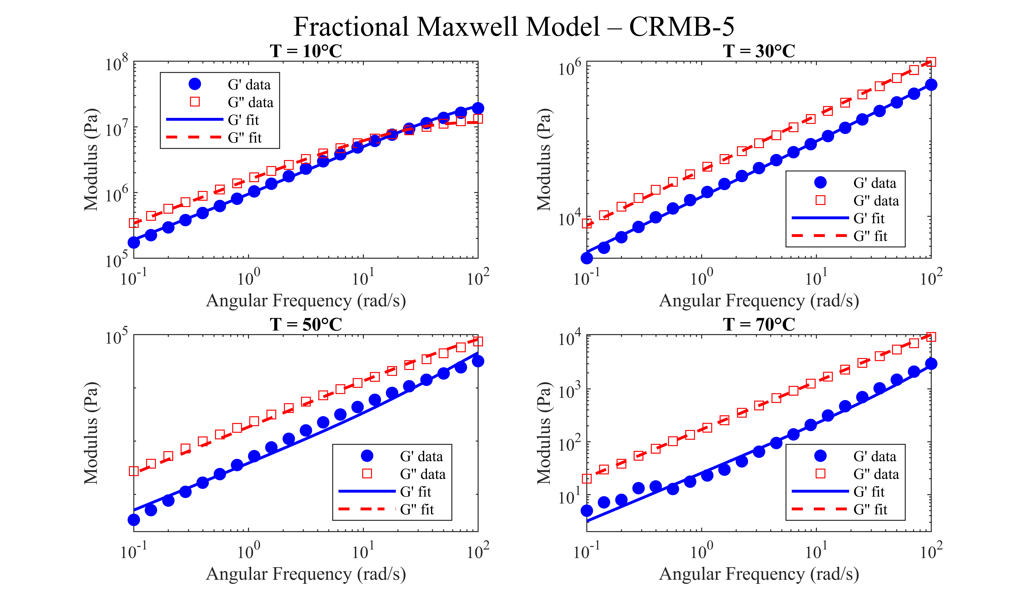
Figure 1S Experimental and Predicted G’ and G” for CRMB-5 (Unaged Condition)

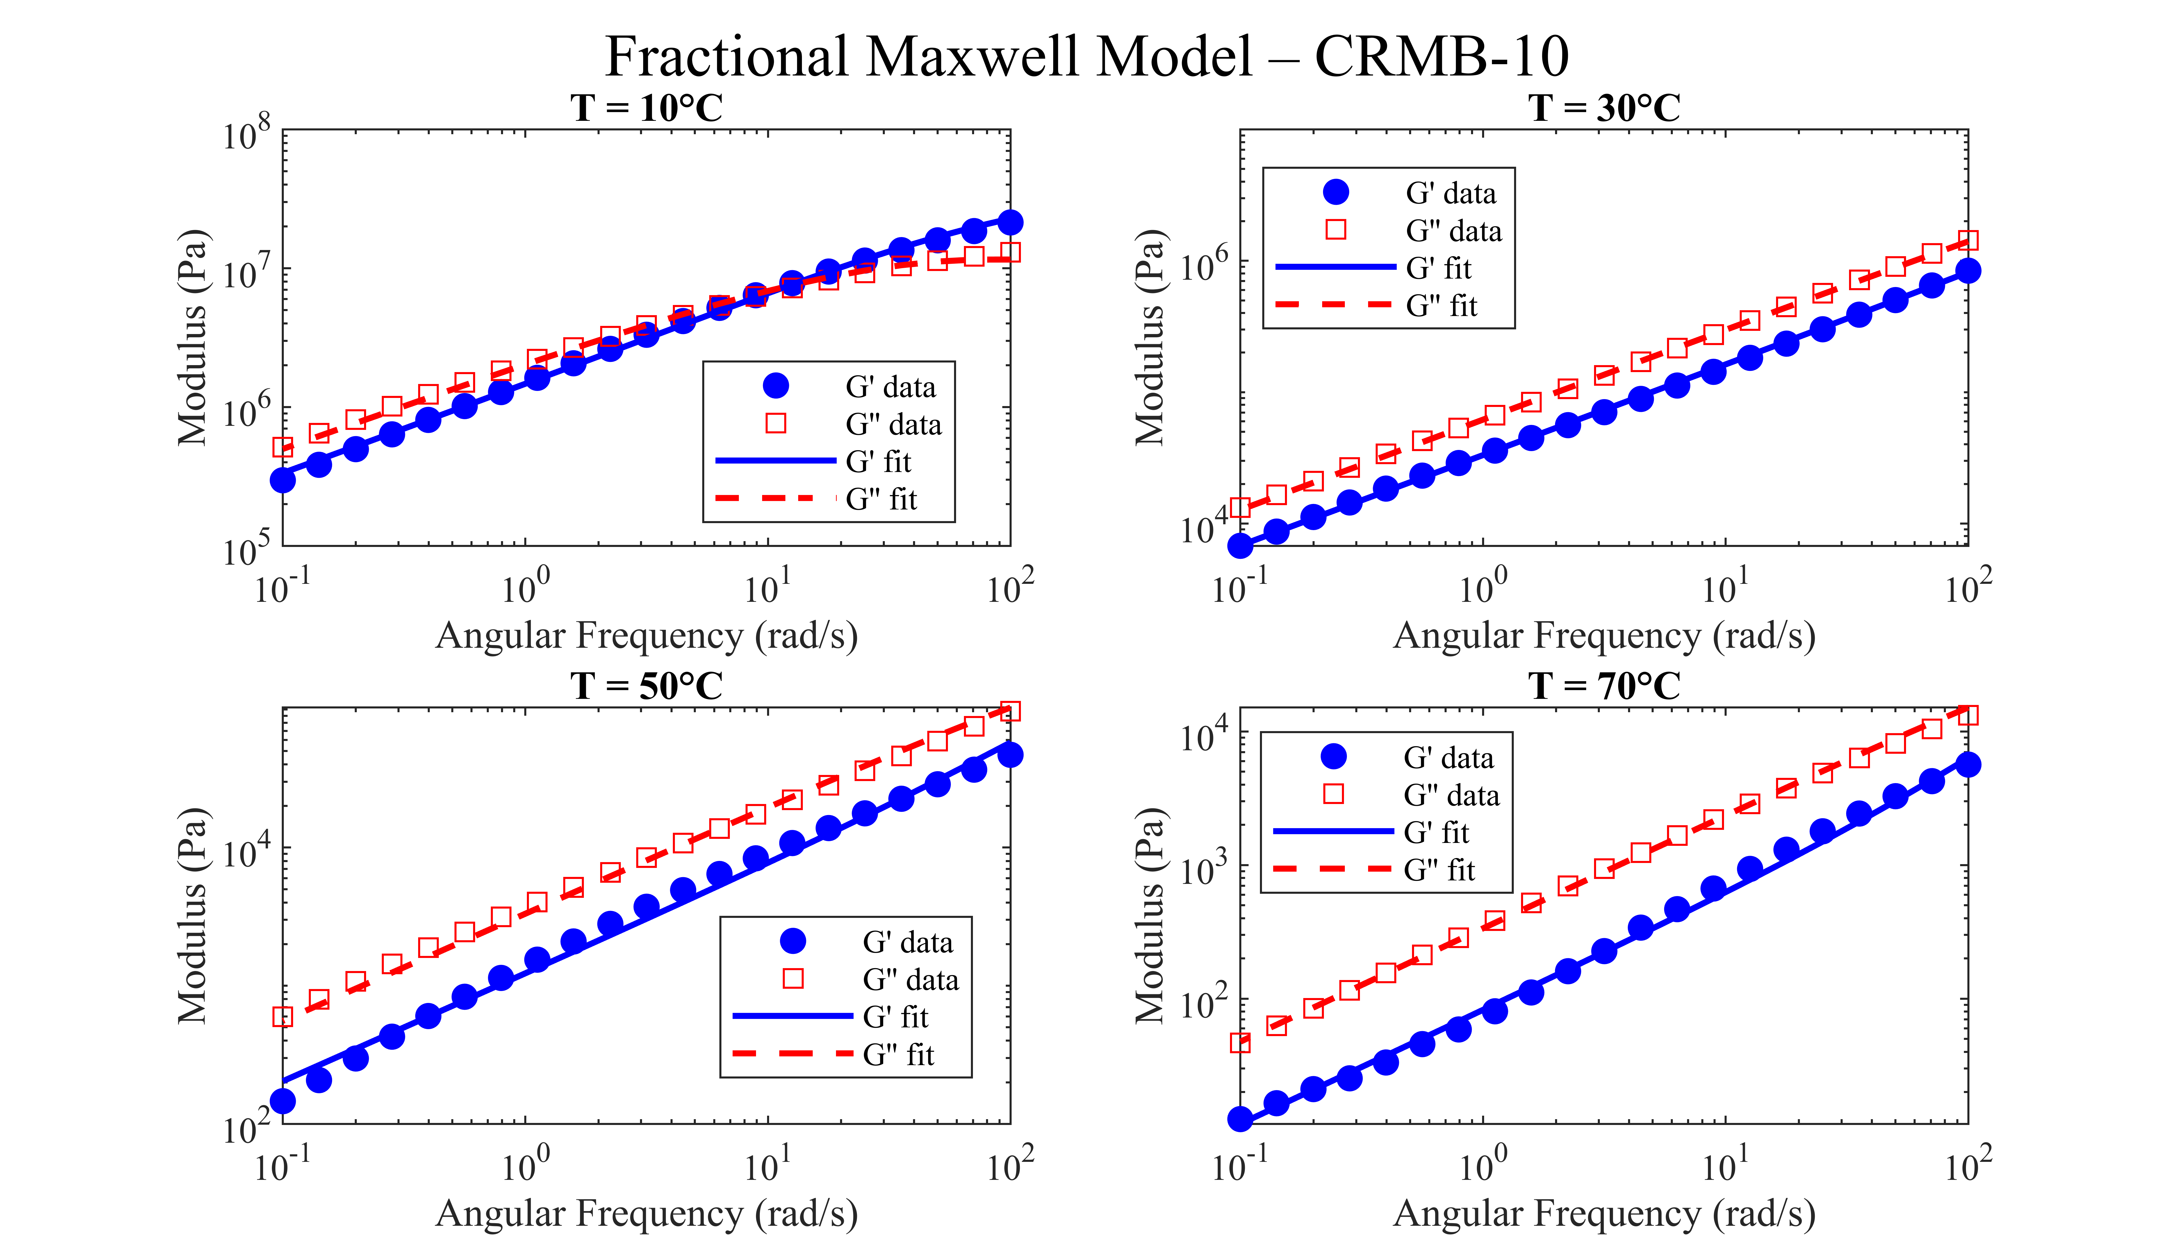
Figure 2S Experimental and Predicted G’ and G” for CRMB-10 (Unaged Condition)

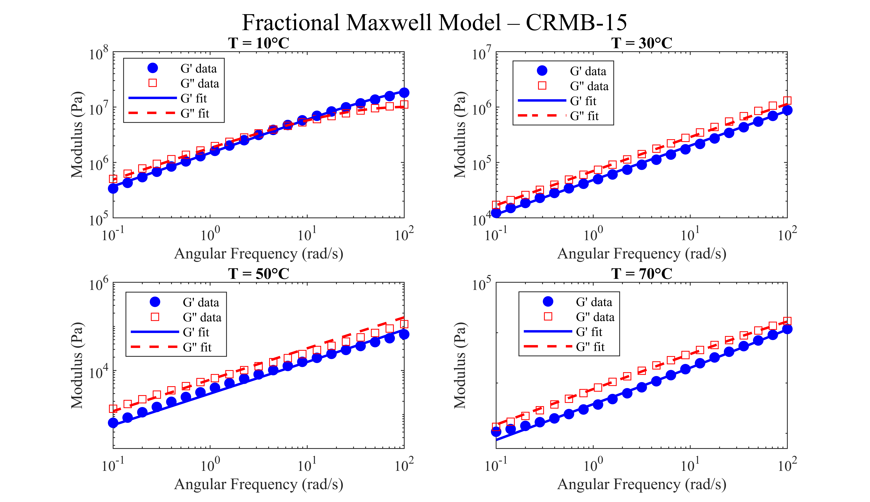
Figure 3S Experimental and Predicted G’ and G” for CRMB-15 (Unaged Condition)

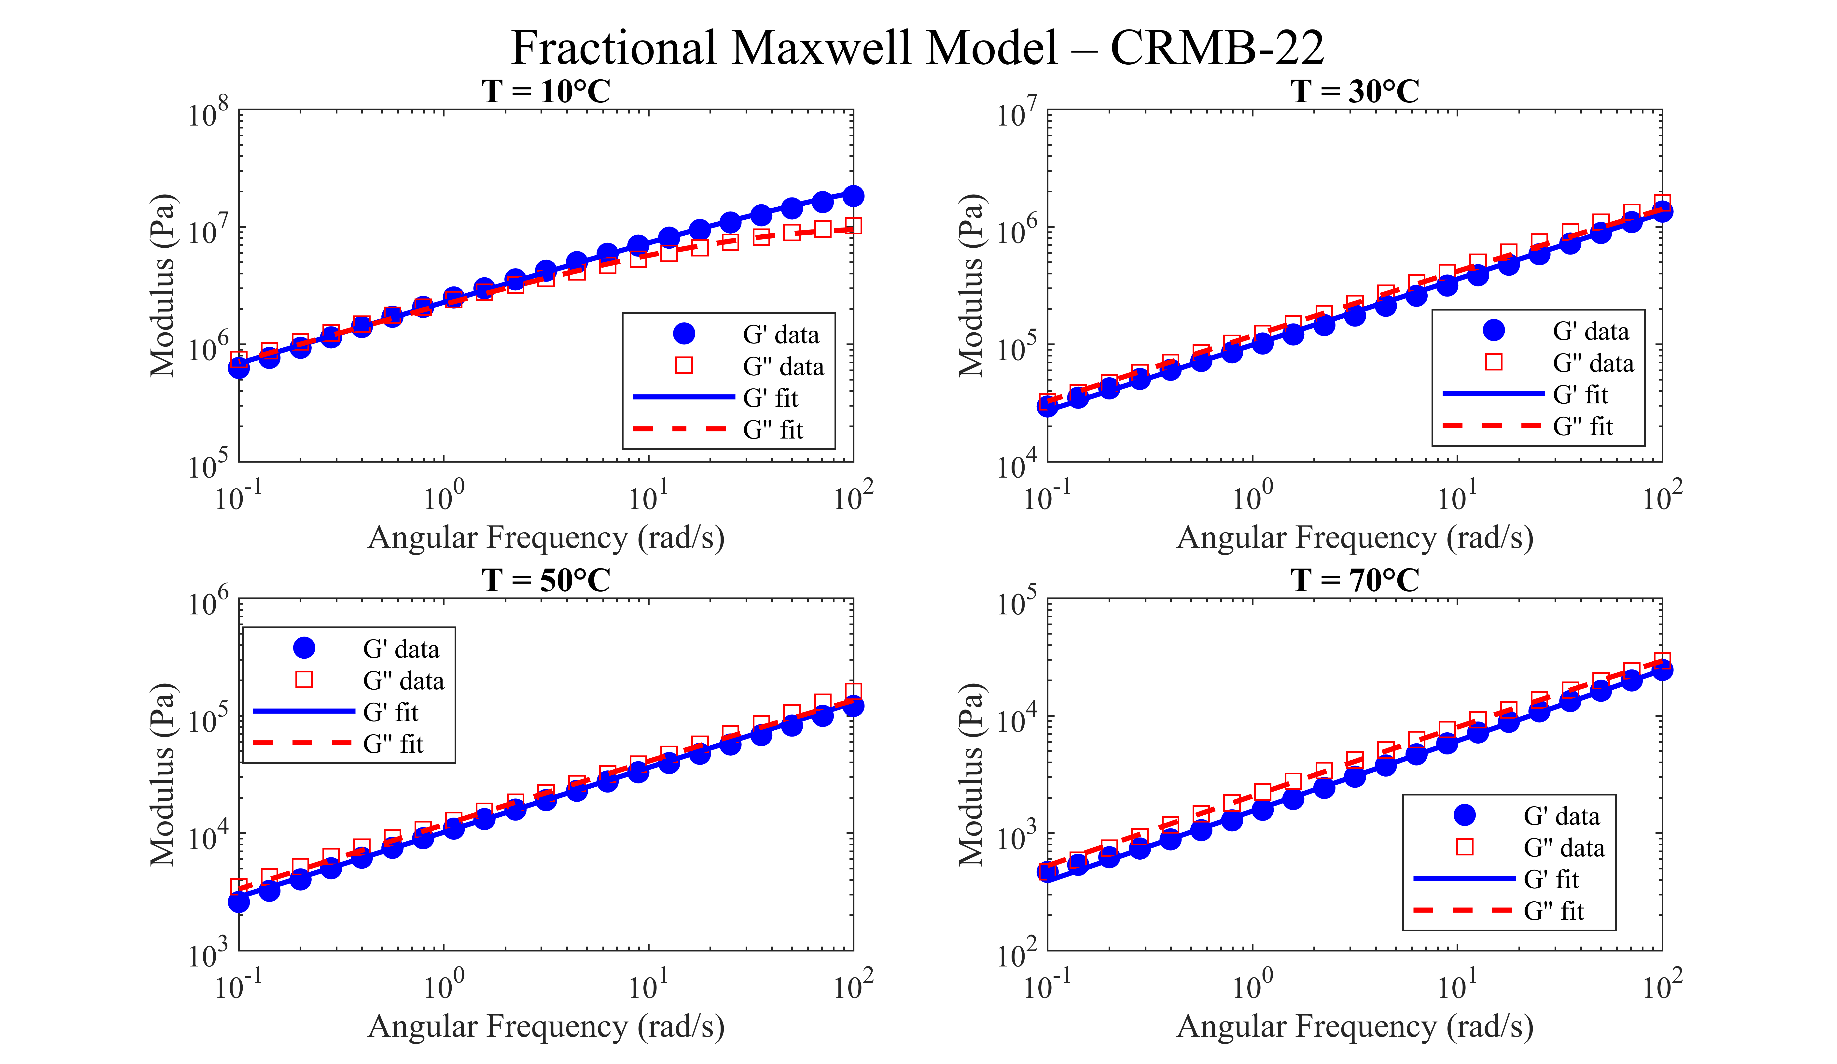
Figure 4S Experimental and Predicted G’ and G” for CRMB-22 (Unaged Condition)

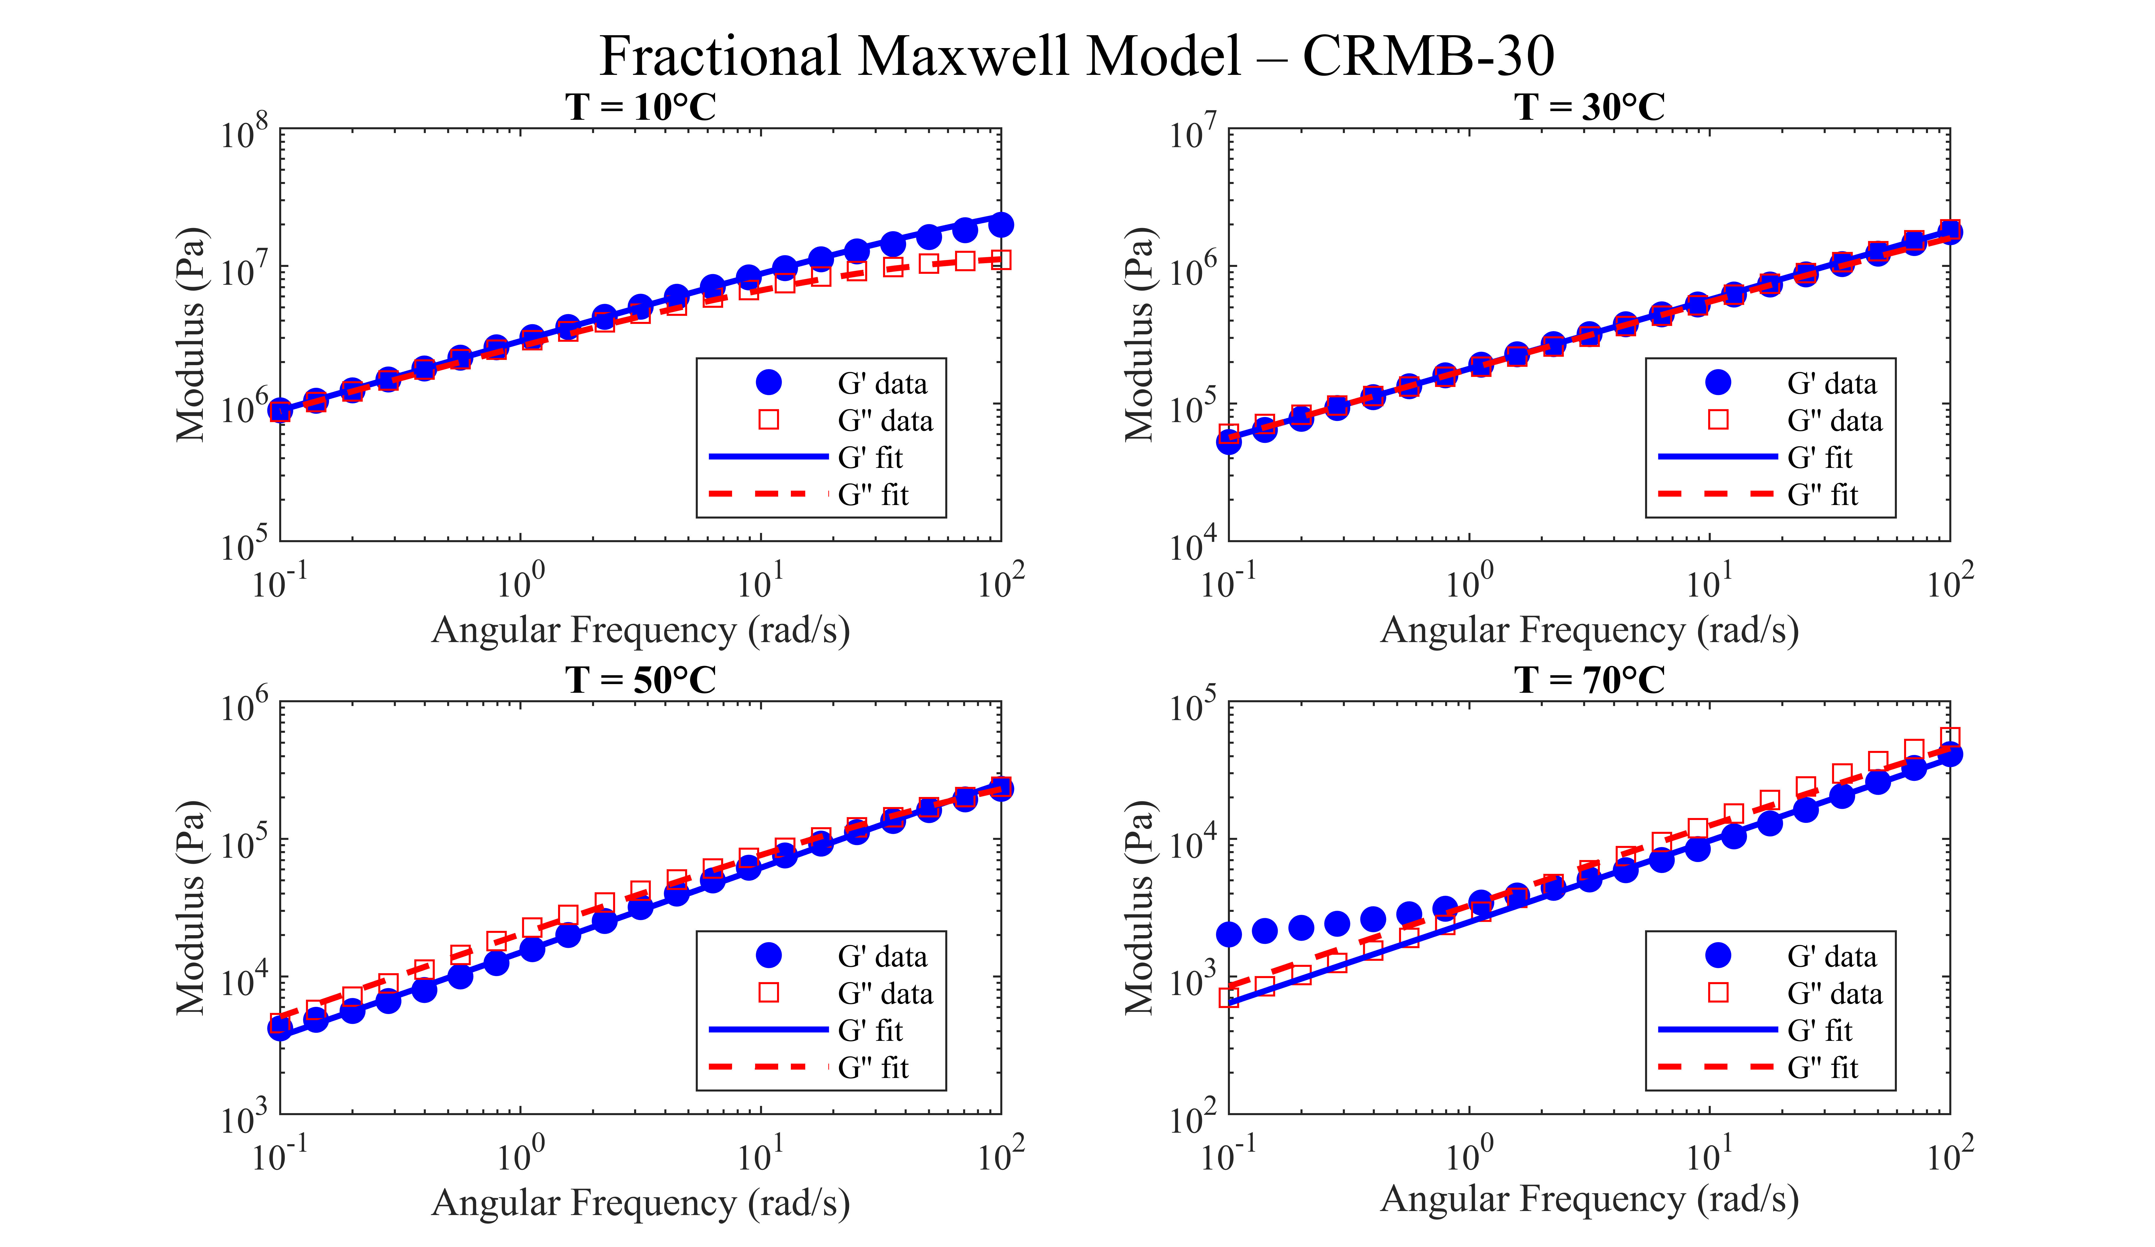
Figure 5S Experimental and Predicted G’ and G” for CRMB-30 (Unaged Condition)

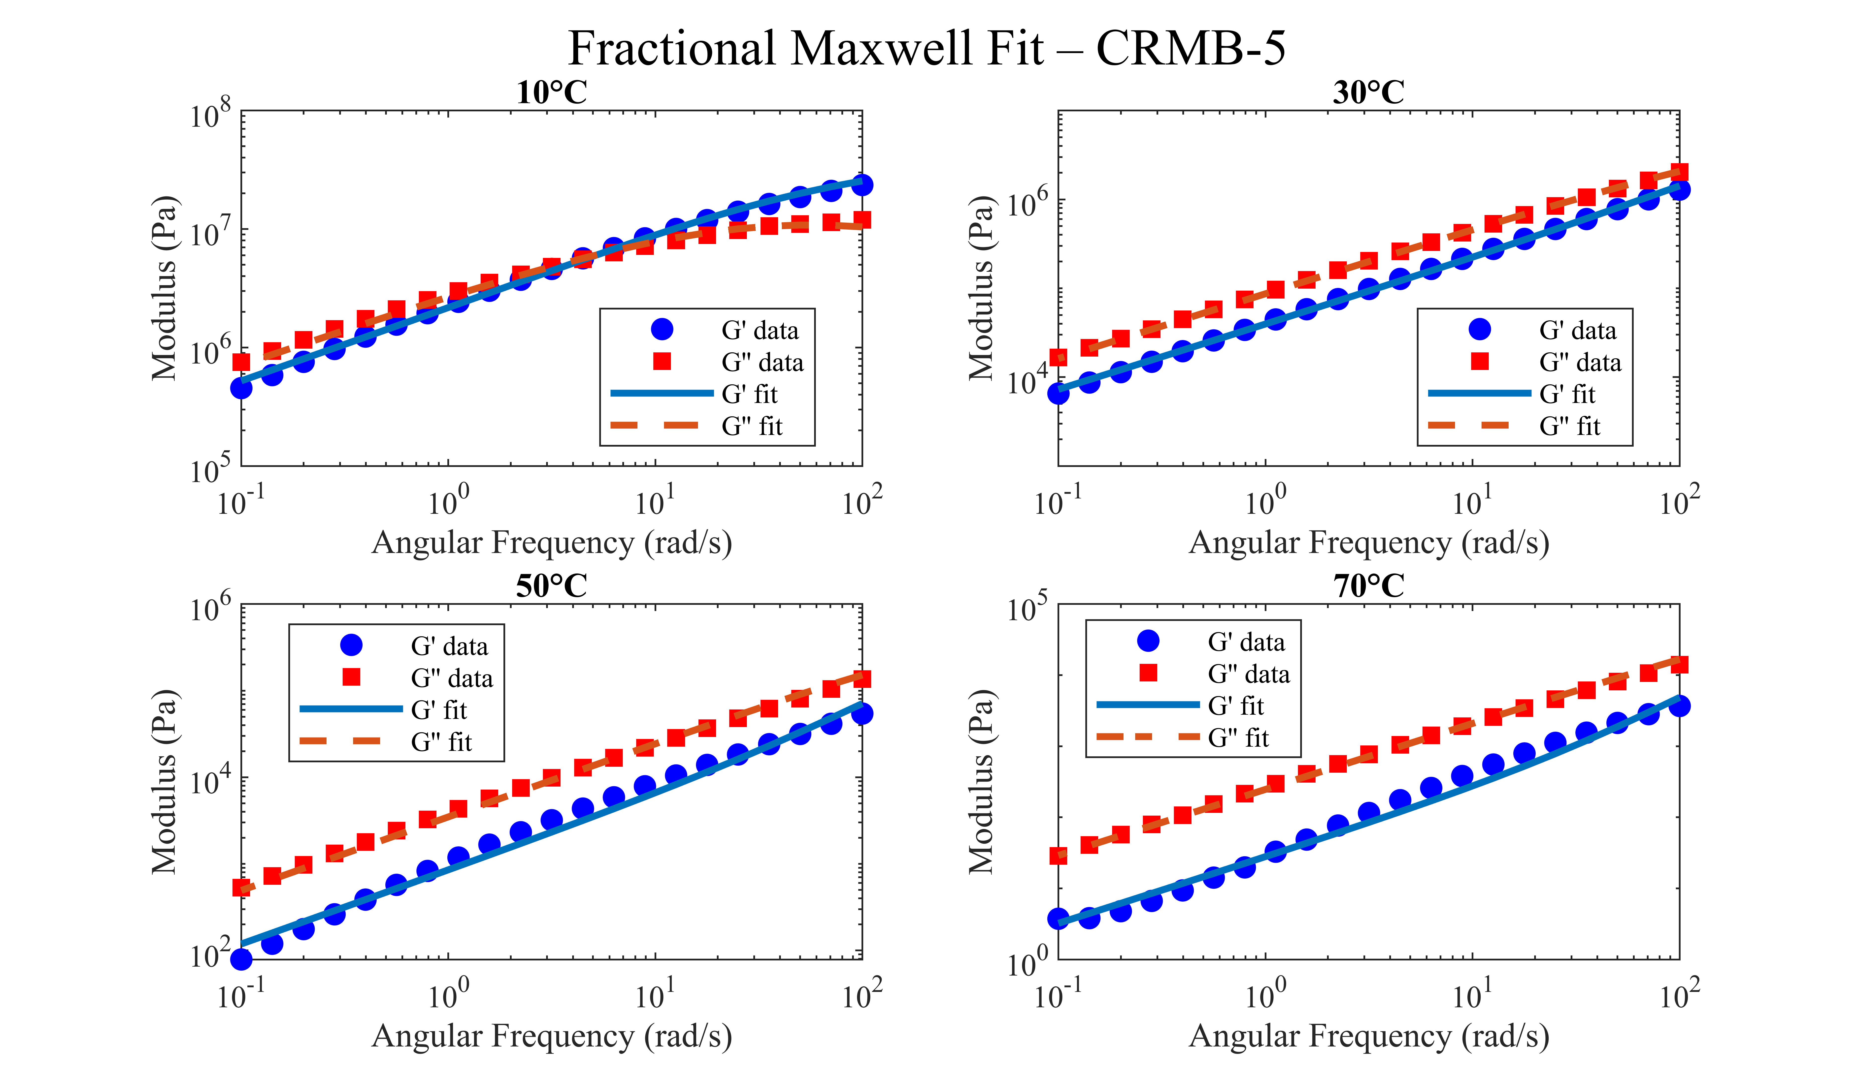
Figure 6S Experimental and Predicted G’ and G” for CRMB-5 (STA Condition)

Figure 7S Experimental and Predicted G’ and G” for CRMB-10 (STA Condition)

Figure 8S Experimental and Predicted G’ and G” for CRMB-15 (STA Condition)
Figure 9S Experimental and Predicted G’ and G” for CRMB-22 (STA Condition)
Figure 10S Experimental and Predicted G’ and G” for CRMB-5 (LTA Condition)

Figure 11S Experimental and Predicted G’ and G” for CRMB-10 (LTA Condition)

Figure 12S Experimental and Predicted G’ and G” for CRMB-15 (LTA Condition)

Figure 13S Experimental and Predicted G’ and G” for CRMB-22 (LTA Condition)

Table 1S Goodness of Fit of the Fractional Maxwell Model to the Measured Storage and Loss Moduli
Bitumen | Condition | Temp (ºC) | R² (G′) | R² (G′′) | NRMSE G′ (%) | NRMSE G′′ (%) | Max deviation (log units)
CRMB-5 | Unaged | 10 | 0.9986 | 0.9987 | 1.16 | 1.14 | 0.0568
CRMB-5 | Unaged | 30 | 0.9985 | 0.9991 | 1.15 | 0.91 | 0.0089
CRMB-5 | Unaged | 50 | 0.9837 | 0.9951 | 3.90 | 2.11 | 0.1568
CRMB-5 | Unaged | 70 | 0.9841 | 0.9996 | 3.92 | 0.58 | 0.0437
CRMB-5 | STA | 10 | 0.9978 | 0.9947 | 1.44 | 2.27 | 0.0587
CRMB-5 | STA | 30 | 0.9990 | 0.9998 | 0.97 | 0.43 | 0.0428
CRMB-5 | STA | 50 | 0.9861 | 0.9969 | 3.55 | 1.68 | 0.1154
CRMB-5 | STA | 70 | 0.9855 | 0.9984 | 3.97 | 1.23 | 0.1213
CRMB-5 | LTA | 30 | 0.9993 | 0.9998 | 0.80 | 0.44 | 0.0352
CRMB-5 | LTA | 50 | 0.9941 | 0.9985 | 2.31 | 1.18 | 0.0782
CRMB-5 | LTA | 70 | 0.9885 | 0.9978 | 3.34 | 1.43 | 0.1377
CRMB-10 | Unaged | 10 | 0.9985 | 0.9979 | 1.21 | 1.44 | 0.0523
CRMB-10 | Unaged | 30 | 0.9995 | 0.9998 | 0.70 | 0.38 | 0.0103
CRMB-10 | Unaged | 50 | 0.9914 | 0.9964 | 2.79 | 1.79 | 0.0883
CRMB-10 | Unaged | 70 | 0.9963 | 0.9991 | 1.93 | 0.93 | 0.0573
CRMB-10 | STA | 10 | 0.9917 | 0.9899 | 2.67 | 3.09 | 0.0382
CRMB-10 | STA | 30 | 0.9992 | 0.9992 | 0.88 | 0.88 | 0.0249
CRMB-10 | STA | 50 | 0.9832 | 0.9940 | 3.85 | 2.32 | 0.0832
CRMB-10 | STA | 70 | 0.9820 | 0.9879 | 3.91 | 3.21 | 0.1030
CRMB-10 | LTA | 30 | 0.9997 | 0.9998 | 0.49 | 0.48 | 0.0210
CRMB-10 | LTA | 50 | 0.9982 | 0.9992 | 1.25 | 0.88 | 0.0351
CRMB-10 | LTA | 70 | 0.9920 | 0.9975 | 2.75 | 1.50 | 0.1100
CRMB-15 | Unaged | 10 | 0.9988 | 0.9983 | 1.05 | 1.29 | 0.0434
CRMB-15 | Unaged | 30 | 0.9982 | 0.9978 | 1.27 | 1.44 | 0.0634
CRMB-15 | Unaged | 50 | 0.9649 | 0.9750 | 5.62 | 4.69 | 0.1466
CRMB-15 | Unaged | 70 | 0.9938 | 0.9990 | 2.49 | 0.99 | 0.0123
CRMB-15 | STA | 10 | 0.9891 | 0.9867 | 3.00 | 3.36 | 0.0689
CRMB-15 | STA | 30 | 0.9996 | 0.9990 | 0.62 | 0.98 | 0.0051
CRMB-15 | STA | 50 | 0.9899 | 0.9964 | 2.99 | 1.80 | 0.0625
CRMB-15 | STA | 70 | 0.9913 | 0.9899 | 2.84 | 2.94 | 0.1178
CRMB-15 | LTA | 30 | 0.9997 | 0.9999 | 0.52 | 0.25 | 0.0232
CRMB-15 | LTA | 50 | 0.9989 | 0.9995 | 1.00 | 0.71 | 0.0289
CRMB-15 | LTA | 70 | 0.9938 | 0.9980 | 2.41 | 1.34 | 0.0967
CRMB-22 | Unaged | 10 | 0.9983 | 0.9974 | 1.27 | 1.56 | 0.0347
CRMB-22 | Unaged | 30 | 0.9983 | 0.9978 | 1.26 | 1.42 | 0.0548
CRMB-22 | Unaged | 50 | 0.9984 | 0.9967 | 1.18 | 1.71 | 0.0777
CRMB-22 | Unaged | 70 | 0.9982 | 0.9989 | 1.32 | 0.99 | 0.0010
CRMB-22 | STA | 10 | 0.9991 | 0.9983 | 0.93 | 1.23 | 0.0310
CRMB-22 | STA | 30 | 0.9993 | 0.9982 | 0.83 | 1.29 | 0.0476
CRMB-22 | STA | 50 | 0.9968 | 0.9985 | 1.70 | 1.15 | 0.0596
CRMB-22 | STA | 70 | 0.9509 | 0.9777 | 6.84 | 4.48 | 0.1553
CRMB-22 | LTA | 10 | 0.9986 | 0.9982 | 1.15 | 1.31 | 0.0301
CRMB-22 | LTA | 30 | 0.9986 | 0.9988 | 1.12 | 1.06 | 0.0426
CRMB-22 | LTA | 50 | 0.9148 | 0.9741 | 8.71 | 4.83 | 0.1070
CRMB-22 | LTA | 70 | 0.9991 | 0.9992 | 0.96 | 0.85 | 0.0353
CRMB-30 | Unaged | 10 | 0.9975 | 0.9980 | 1.55 | 1.44 | 0.0613
CRMB-30 | Unaged | 30 | 0.9992 | 0.9974 | 0.83 | 1.55 | 0.0629
CRMB-30 | Unaged | 50 | 0.9979 | 0.9983 | 1.45 | 1.26 | 0.0403
CRMB-30 | Unaged | 70 | 0.7634 | 0.9867 | 15.15 | 3.58 | 0.0798
CRMB-30 | STA | 10 | 0.9817 | 0.9885 | 4.34 | 3.28 | 0.1990
CRMB-30 | STA | 30 | 0.9979 | 0.9921 | 1.40 | 2.73 | 0.0942
CRMB-30 | STA | 50 | 0.9977 | 0.9989 | 1.43 | 1.00 | 0.0409
CRMB-30 | STA | 70 | 0.9928 | 0.9951 | 2.68 | 2.13 | 0.0190
CRMB-30 | LTA | 10 | 0.9986 | 0.9982 | 1.15 | 1.31 | 0.0301
CRMB-30 | LTA | 30 | 0.9986 | 0.9988 | 1.12 | 1.06 | 0.0426
CRMB-30 | LTA | 50 | 0.9148 | 0.9741 | 8.71 | 4.83 | 0.1070
CRMB-30 | LTA | 70 | 0.9991 | 0.9992 | 0.96 | 0.85 | 0.0353

Table 2S STA Samples Fractional Maxwell Parameter Variation
Bitumen | Temp. (°C) | G(Pa) | τ (s) | α | Log c
CRMB-5 | 10 | 4.19×10⁷ | 1.77×10⁻² | 0.6071 | 6.56
CRMB-5 | 30 | 1.28×10⁷ | 1.24×10⁻³ | 0.7316 | 4.98
CRMB-5 | 50 | 8.14×10⁵ | 1.69×10⁻³ | 0.8498 | 3.55
CRMB-5 | 70 | 1.00×10⁵ | 1.58×10⁻³ | 0.9297 | 2.40
CRMB-10 | 10 | 4.04×10⁷ | 1.30×10⁻² | 0.5595 | 6.55
CRMB-10 | 30 | 1.56×10⁷ | 7.85×10⁻⁴ | 0.6786 | 5.09
CRMB-10 | 50 | 1.37×10⁶ | 7.75×10⁻⁴ | 0.7463 | 3.82
CRMB-10 | 70 | 1.00×10⁵ | 2.29×10⁻³ | 0.8418 | 2.78
CRMB-15 | 10 | 6.11×10⁷ | 3.09×10⁻³ | 0.5459 | 6.42
CRMB-15 | 30 | 3.45×10⁷ | 1.19×10⁻⁴ | 0.6380 | 5.03
CRMB-15 | 50 | 3.57×10⁶ | 1.02×10⁻⁴ | 0.6623 | 3.91
CRMB-15 | 70 | 7.11×10⁵ | 1.09×10⁻⁴ | 0.7132 | 3.03
CRMB-22 | 10 | 4.43×10⁷ | 3.46×10⁻³ | 0.5429 | 6.31
CRMB-22 | 30 | 2.41×10⁷ | 1.00×10⁻⁴ | 0.5867 | 5.04
CRMB-22 | 50 | 2.37×10⁶ | 1.06×10⁻⁴ | 0.5864 | 4.04
CRMB-22 | 70 | 9.45×10⁵ | 1.01×10⁻⁴ | 0.6933 | 3.21
CRMB-30 | 10 | 2.87×10⁷ | 8.50×10⁻³ | 0.4915 | 6.44
CRMB-30 | 30 | 1.94×10⁷ | 1.00×10⁻⁴ | 0.5098 | 5.25
CRMB-30 | 50 | 2.65×10⁶ | 1.01×10⁻⁴ | 0.5171 | 4.36
CRMB-30 | 70 | 7.09×10⁵ | 1.01×10⁻⁴ | 0.5569 | 3.63

Table 3S LTA Samples Fractional Maxwell Parameter Variation
Bitumen | Temp. (°C) | G (Pa) | τ(s) | α | Log c
CRMB-5 | 10 | 8.12×10⁷ | 9.92×10⁻² | 0.5342 | 7.37
CRMB-5 | 30 | 1.97×10⁷ | 1.04×10⁻³ | 0.6588 | 5.33
CRMB-5 | 50 | 1.48×10⁶ | 1.31×10⁻³ | 0.7712 | 3.95
CRMB-5 | 70 | 1.37×10⁵ | 2.02×10⁻³ | 0.8805 | 2.76
CRMB-10 | 10 | 5.34×10⁷ | 1.92×10⁻² | 0.5232 | 6.83
CRMB-10 | 30 | 1.72×10⁷ | 9.83×10⁻⁴ | 0.6272 | 5.35
CRMB-10 | 50 | 3.96×10⁶ | 2.87×10⁻⁴ | 0.6991 | 4.12
CRMB-10 | 70 | 1.81×10⁵ | 1.63×10⁻³ | 0.8070 | 3.01
CRMB-15 | 10 | 3.39×10⁷ | 9.11×10⁻² | 0.5276 | 6.98
CRMB-15 | 30 | 1.69×10⁷ | 7.24×10⁻⁴ | 0.6312 | 5.25
CRMB-15 | 50 | 4.83×10⁶ | 1.52×10⁻⁴ | 0.6905 | 4.05
CRMB-15 | 70 | 2.21×10⁵ | 1.01×10⁻³ | 0.7858 | 2.99
CRMB-22 | 10 | 4.26×10⁷ | 4.46×10⁻³ | 0.5121 | 6.39
CRMB-22 | 30 | 2.34×10⁷ | 1.01×10⁻⁴ | 0.5769 | 5.06
CRMB-22 | 50 | 4.45×10⁶ | 1.02×10⁻⁴ | 0.6592 | 4.02
CRMB-22 | 70 | 5.42×10⁵ | 1.46×10⁻⁴ | 0.6011 | 3.43

