Rigid-body averaging measure
The AvgM represents the mean value of multiple weighted tri-directional linear kinematic measures. Constraining the AvgM can be physically interpreted as the static equilibrium position between multiple linear springs acting in different directions, but please notice that the measure implements kinematics only; it does not add elastic forces to the system. Calculation of an AvgM requires the kinematic linear measures as well as the relevant coefficient matrices.
The i’th kinematic measure, denoted as $x_{i}$, represents a vector connecting two nodes ($n_{i}$ and $m_{i}$) located on separate segments, computed within the coordinate system, in which the AvgM is defined (Fig 9). This coordinate system will usually be the local reference frame of one of the segments, though it can alternatively be a global reference frame. The weights, $w_{i}$, are represented as $3×3$ diagonal matrices. The system is in static equilibrium when the potential energy
$E= \sum{{\frac{1}{2} w}_{i} x_{i}^{2}}=0$ (1)
is minimal.
The Karush-Kuhn-Tucker (KKT) conditions lead to the following equation for each entry of vector $q_{j}$ representing the rigid-body coordinates:
$AvgM=\sum{w_{i} {\left[{{dx}_{i}}/{{dq}_{j}}\right]}^{T} x_{i}}=0$ (2)
Note that $q_{j}$ contains segmental translation ($r_{j}$) and rotation ($θ_{j}$). To calculate translation DOFs for the $AvgM$:
For translation DOFs ${\left[{{dx}_{i}}/{{dr}_{j}}\right]}^{T}= I_{3×3}$ (3)
To account for segmental rotation, the measure can be calculated by taking the cross product with the vector connecting the measure’s point ($n_{i}$) and the rotation center. We denote this vector $s_{i}$ and define the $3×3$ skew-symmetric-matrix, $S_{ij}^{s}$, composed from the elements of $s_{i}$ to be applied to the linear measures used in the averaging measure. Consequently, to calculate rotational DOFs for the $AvgM$:
For rotational DOFs ${\left[{{dx}_{i}}/{{dθ}_{j}}\right]}^{T}= S_{ij}^{s}$ (4)

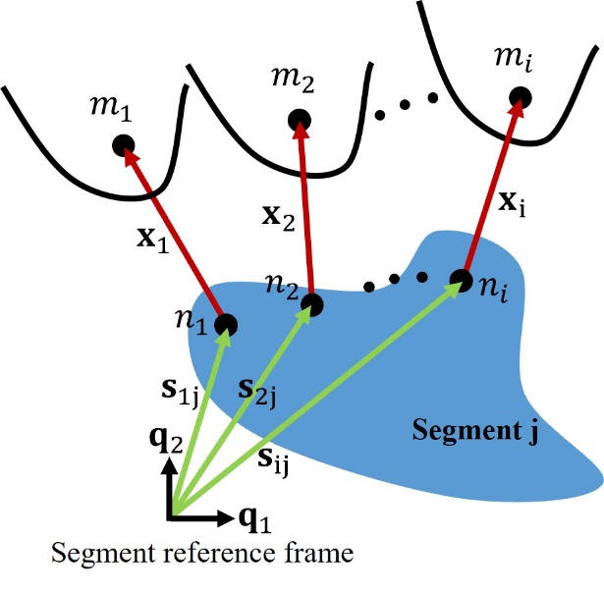
Fig 9 Schematic of the rigid-body averaging measure calculation. Point $n_{i}$ is the i’th measurement point located on the segment with the position vector $s_{i}$, calculated from the segment reference frame. Point $m_{i}$ is the i’th measurement point located on surrounding segments. The i’th kinematic linear measure, $x_{i}$, is the vector between $n_{i}$ and $m_{i}$.

