Supplementary material
Ergosterol-dependent Membrane Stress and Calcineurin-HSP90 Signaling Govern Fluorinated Sulfone-Induced Cell Death in Candida albicans
Anna Staniszewska¹, Łukasz Kuryk^{2,4}, Deepak Kala³, Zbigniew Ochal⁴, Monika Staniszewska⁴
¹Medical University of Lublin, Lublin, Poland
²National Institute of Public Health NIH – National Research Institute, Warsaw, Poland
³CENTERA Laboratories, Institute of High Pressure Physics, Polish Academy of Sciences, Warsaw, Poland
⁴Warsaw University of Technology, Warsaw, Poland

*Corresponding author: Centre for Advanced Materials and Technologies, Warsaw University of Technology, Poleczki 19, Warsaw 02-822, Poland, Monika Staniszewska, e-mail address: monika.staniszewska@pw.edu.pl

Supplementary material
Synthesis of 15, 24, 32 (general procedure)
To the solution of 10 mL 15% NaOH and 10mL of 1,2-dichloroethane, sulfone 1,2 or 3 (3.0 mmol) and equimolar amount of proper phenol was added. The mixture was stirred at 80 °C. The progress of the reaction was monitored by TLC using hexane/ethyl acetate (5:3 v/v) as the eluent. When the conversion of the substrate reached 100% (after 4 h) the reaction was stopped, cooled to room temperature, the organic layer was separated and water solution was extracted by chloroform ( 3 x 10 mL). The combined organic phases were washed with water and dried over anhydrous MgSO₄. After evaporation of 1,2-dichloroethane the crude product was crystallized from ethanol. Yield of 15 88% (1.0 g) m.p. = 159-160 ºC. 1H-NMR (500 MHz CDCl₃) δ ppm: 5.20 (d, J_{H-F} = 45Hz, 2 H) 7.01 - 7.06 (m, 1 H) 7.15 - 7.19 (m, 1 H) 7.29 (d, J=2.69 Hz, 1 H) 7.56 (d, J=8.80 Hz, 1 H) 8.04 - 8.10 (m, 1 H) 8.53 - 8.57 (m, 1 H) 13C-NMR (126 MHz. CDCl₃) δ ppm: 92.12 (d _{JC-F} = 222Hz 1C), 119.81 (s, 1 C) 119.97 (s, 1 C) 122.69 (s, 1 C) 127.80 (s, 1 C) 130.78 (s, 1 C) 131.06 (s, 1 C) 132.22 (s, 2 C) 134.65 (s, 1 C) 134.95 (s, 1 C) 152.66 (s, 1 C) 155.37 (s, 1 C), HRMS (ESI/MS): m/z calculated for C₁₃H₈Cl₂FNO₅S [M + H]+ 379.9557, found 379.9584.
Yield of 24 = 84% (1.2g), ) m.p. = 180-181 ºC. 1H-NMR (500 MHz CDCl₃) δ ppmm 7.07 (dd, J=8.68, 2.81 Hz, 1 H) 7.11 - 7.19 (m, 1 H) 7.32 - 7.36 (m, 1 H) 7.59 (d, J=8.80 Hz, 1 H) 8.18 - 8.31 (m, 1 H) 8.67 - 8.81 (m, 1 H) 13C-NMR (126 MHz. CDCl₃) δ ppm: m 87.66 (s, 1 C) 118.33 (s, 2 C) 120.02 (s, 2 C) 122.79 (s, 1 C) 123.83 (s, 1 C) 130.98 (s, 1 C) 131.17 (s, 1 C) 132.08 (s, 1 C) 138.17 (s, 1 C) 151.88 (s, 1 C) 156.10 (s, 1 C). HRMS (ESI/MS): m/z calculated for C₁₃H₇BrCl₃NO₅S [M + H]+ 473.8366, Found 473.8376.

Yield of 32 = 78% (0.85g), m.p. = 176-177ºC. 1H-NMR (500 MHz CDCl₃) δ ppm: 6.26 (t, J_{H-F} = 55 Hz, 1H) 7.09 - 7.16 (m, 3 H) 7.43 - 7.52 (m, 2 H) 8.03 (dd, J=8.80, 2.20 Hz, 1 H) 8.55 (d, J=2.20 Hz, 1 H). 13C-NMR (126 MHz. CDCl₃) δ ppm: 114.54 (t _{JC-F} = 287Hz 1C) 118.76 (s, 1C), 122.01 (s, 2C), 123.85 (s, 1C), 125.51 (s, 1C), 129.09 (s, 1C), 130.87 (s, 2C), 132.33 (s, 1C), 135.91 (s, 1C), 151.69 (s, 1C), 156.80 (s, 1C). HRMS (ESI/MS): m/z calculated for C₁₃H₉F₂NO₅S₂ [M + H]+ 361.9962, Found 361.9943.

Synthesis of 5a, 5b (general procedure)
To the solution of toluene (10 mL ) and formalin (2 mL), sodium carbonate ( 9.4 mmol), and proper sulfone 4a or 4b (3 mmol) was added. The mixture was stirred and heated to the solvent's boiling point. The progress of the reaction was monitored by TLC, using hexane/ethyl acetate (5:2 v/v) as the eluent. When the conversion of the substrate reached 100% (after 2 h) the reaction was stopped, cooled to room temperature, the solid precipitate was filtered out. After evaporation of toluene the crude product was crystallized from 2-propanol. Yield of 5a 84%, (0.95g), m.p. = 112-113ºC. HRMS (ESI/MS): m/z calculated for C₈H₇Br₂ClO₃S [M + H]+ 376.8243, Found 376.8254. Yield of 5b 86% ( 0.75g), m.p. = 92-93ºC. HRMS (ESI/MS): m/z calculated for C₈H₇Cl₃O₃S [M + H]+ 288.9254, Found 288.9216.

Synthesis of 26

The solution of sulfone 5a ( 3 mmol) in dry dioxane ( 10 mL) (dried with 5A molecular sieves) and 3-trifluoromethylphenylizocyanate (3 mmol) was stirred and heated at 100 ºC for 5 hours. The progress of the reaction was monitored by TLC, using hexane/ethyl acetate (5:3 v/v) as the eluent. After cooling and evaporation of dioxane the crude product was crystallized from 2-propanol. Yield of 26 90%, (1.52g), m.p. = 112 - 113ºC. 1H-NMR (500 MHz CDCl₃) δ ppm 5.01 (s, 2 H) 7.11 ( s, 1 H) 7.37 (d, J=7.83 Hz, 1 H) 7.46 (t, J=7.95 Hz, 1 H) 7.56 - 7.65 (m, 3 H) 7.73 (s, 1 H) 8.00 - 8.06 (m, 2 H). 13C-NMR (126 MHz. CDCl₃) δ ppm: 66.85 ( s, 1 C) 94.83 (s, 1 C) 112.33, 116.31, 120.46, 125.15 (q, J_{C-F} = 504 Hz,1 C) 129.22 (s, 2 C) 129.47 (s, 2 C) 130.33 (s, 1 C) 131.26 (s, 1 C) 131.52 (s, 1 C) 133.05 (s, 1 C) 133.17 (s, 2 C) 134.35 (s, 1 C) 142.67 (s, 1 C). HRMS (ESI/MS): m/z calculated for C₁₆H₁₁Br₂ClF₃NO₄S [M + H]+ 563.8488, Found 563.8465.

Synthesis of 28
To the solution of sulfone 5b ( 3 mmol) in methylene chloride ( 10 mL) propionyl chloride (3 mmol) and triethylamine were added. The solution was refluxed for 4 hours. The progress of the reaction was monitored by TLC, using hexane/ethyl acetate (5:3 v/v) as the eluent. After cooling and evaporation of solvent, the crude product was washed by water and crystallized from 2- propanol. Yield of 28 92%, (0.94g), m.p. = 99 - 100ºC. 1H-NMR (500 MHz CDCl₃) δ:1.17 (t, J = 7.58 Hz, 3 H) 2.38 (q, J=7.58 Hz, 2 H) 4.89 (s, 2 H) 7.58 - 7.64 (m, 2 H) 7.99 - 8.04 (m, 2 H). 13C-NMR (126 MHz. CDCl₃) δ ppm: 8.59 (s, 1 C) 26.98 (s, 1 C) 66.09 (s, 1 C) 95.28 (s, 1 C) 129.10 (s, 2 C) 130.64 (s, 1 C) 133.19 (s, 2 C) 142.50
(s, 1 C) 172.45 (s, 1 C). HRMS (ESI/MS): m/z calculated for C₁₁H₁₁Cl₃O₄S [M + H]+ 344.9516, Found 344.9527.

Synthesis of 31
The solution of toluene (10 mL ), formalin (2 mL), sodium carbonate ( 9.4 mmol) and benzimidazole 6 (3 mmol) was stirred and heated at the boiling point of the solvent. The progress of the reaction was monitored by TLC, using hexane/ethyl acetate (5: 3 v/v) as the eluent. When the conversion of the substrate reached 100% (after 3 h) the reaction was stopped, cooled to room temperature, the solid precipitate was filtered out. After evaporation of toluene the crude product was crystallized from 2-propanol. Yield of 31 87%, (0.99g), m.p. = 162-163ºC. 1H-NMR (500 MHz CDCl₃) δ ppm: 4.06 (s, 3 H) 4.40 (d, J=6.85 Hz, 2 H) 7.69 (dd, J=8.80, 0.49 Hz, 1 H) 8.15 (dd, J=8.80, 1.71 Hz,
1 H) 8.66 (d, J=1.71 Hz, 1 H). 13C-NMR (126 MHz. CDCl₃) δ ppm: 25.59 (s, 1 C) 31.71 (s, 1 C) 68.46 (s, 1 C) 97.91 (s, 1C) 110.25,, 113.78 116.33, 119.79 (q, J _{C-F} = 378 Hz, 1 C) 111.04 (s, 1 C) 127.45 (s, 1 C) 127.80 (s, 1 C) 128.25 (s, 1 C) 140.51 (s, 1 C) 140.63 (s, 1 C). HRMS (ESI/MS): m/z calculated for C₁₁H₉Cl₂O₄S [M + H]+ 344.9516, Found 344.9527.

Synthesis of 36
The solution of ester 7 (10 mmol) and acetophenone 8 ( 10 mmol) in toluene (10 mL) and cyclohexane (10 mL) was stirred and heated to 50ºC. At this temperature, sodium hydride ( 10 mmol) ( 60% dispersion in paraffin liquid) was added portionally . The reaction mixture was stirred and heated at 80 ºC for 2 hours. The progress of the reaction was monitored by TLC, using hexane/ethyl acetate (5:2 v/v) as the eluent. After this time, the mixture was cooled to room temperature and the solvents were evaporated. The product was purified by bulb to bulb distillation. Yield of 31 82%, (3.05g), m.p. = 141-142ºC. 1H-NMR (500 MHz CDCl₃) δ ppm: 1.68 (d, J=6.85 Hz, 3 H) 4.30 (s, 2H) 4.78 (q, J=6.85 Hz, 1 H) 6.56 (s, 1 H) 6.82 (d, J=8.80 Hz, 1 H) 7.16 (dd, J=8.80, 2.45 Hz, 1 H) 7.40 - 7.46 (m, 2 H) 7.78 - 7.84 (m, 2 H), 13C-NMR (126 MHz. CDCl₃) δ ppm: 19.14 (s, 1 C) 77.61 (s, 1 C) 92.10 (s, 1 C) 115.59 (s, 1 C) 124.32 (s, 1 C) 126.93 (s, 1 C) 127.76 (s, 1 C) 128.48 (s, 2 C) 129.04 (s, 2 C) 130.36 (s, 1 C) 132.47 (s, 1 C) 139.08 (s, 1 C) 151.84 (s, 1 C) 182.10 (s, 1 C) 197.00 (s, 1 C), HRMS (ESI/MS): m/z calculated for C₁₇H₁₃Cl₃O₃ [M + H]+ 371.0003, Found 371.0016.

1H-NMR and 13C-NMR spectra of the synthesized compounds

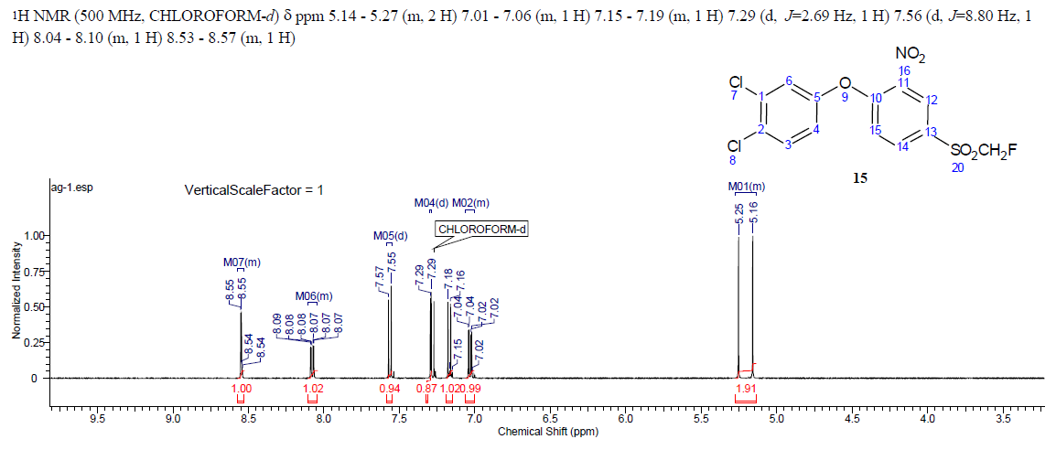

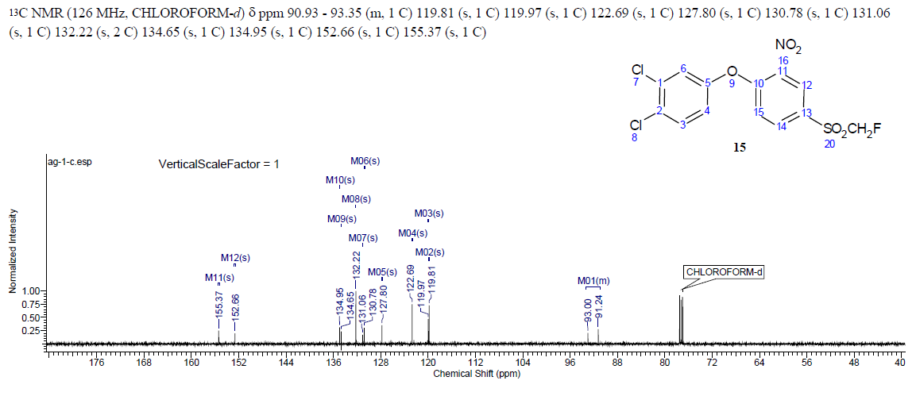
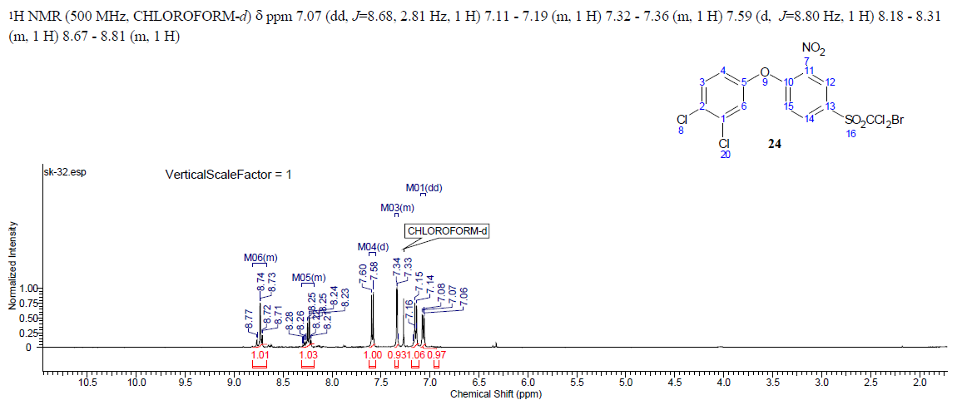
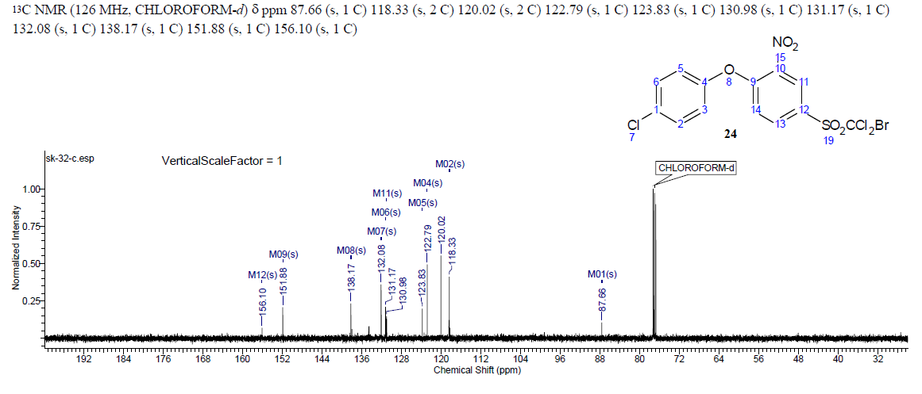
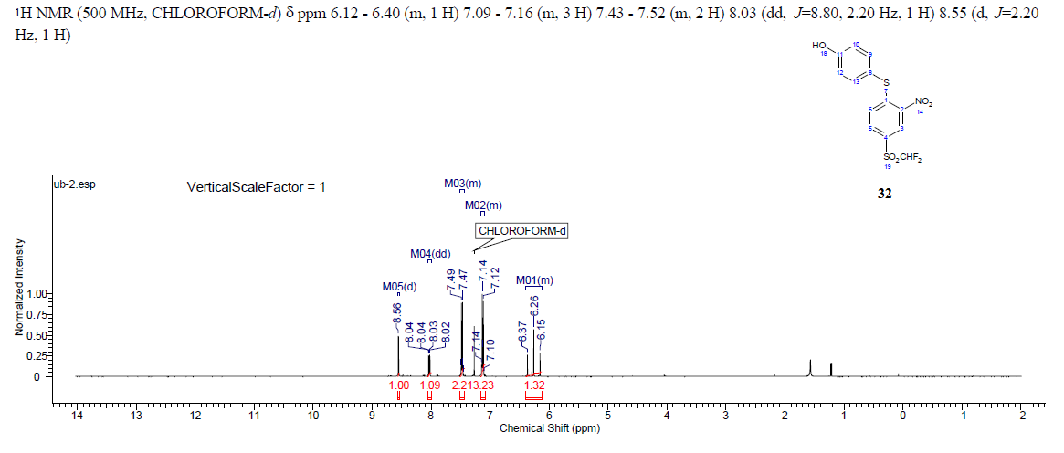
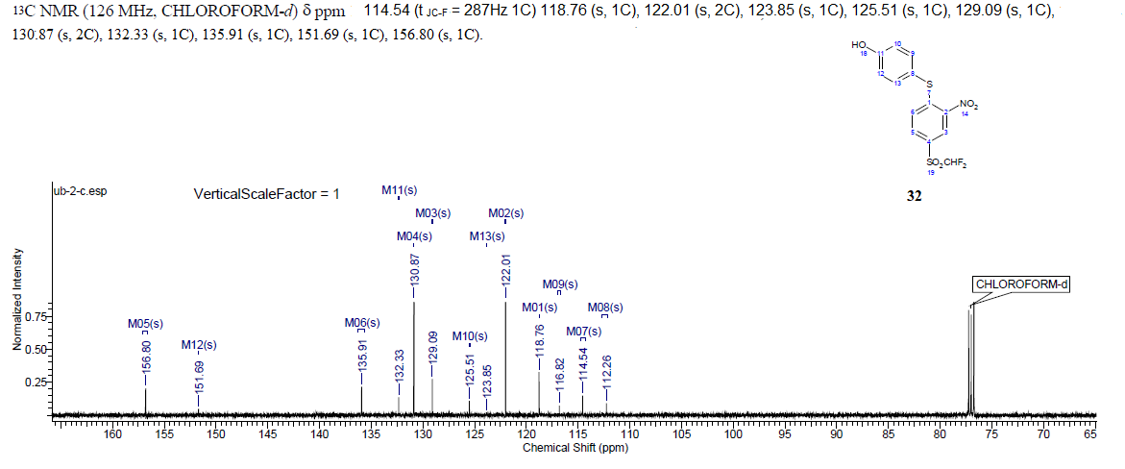
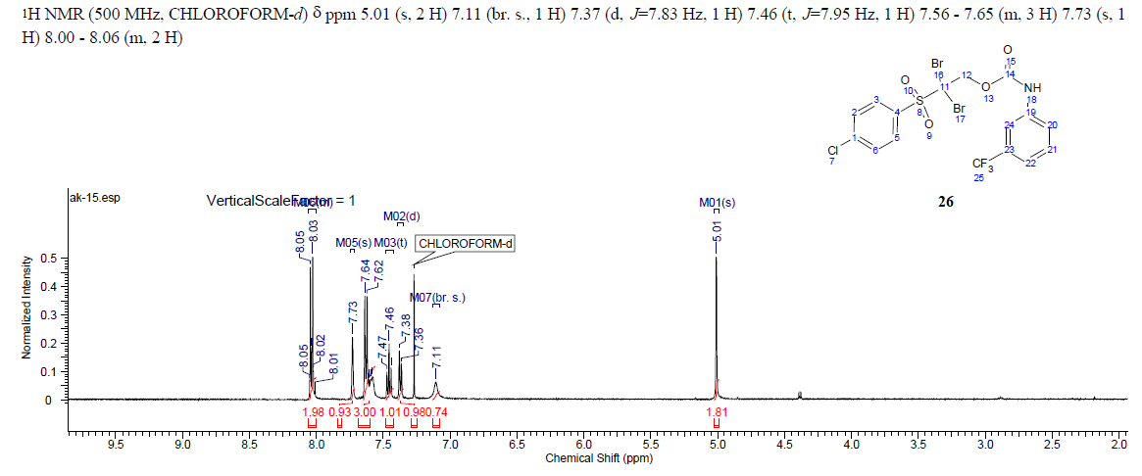
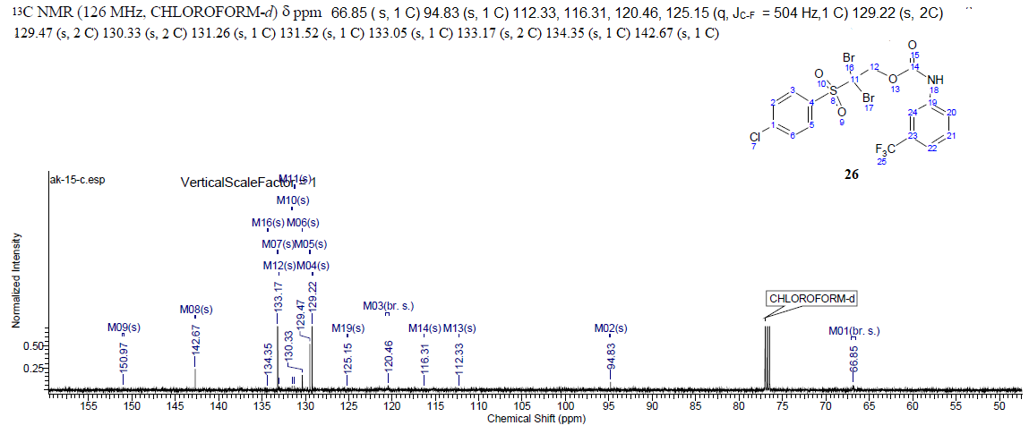
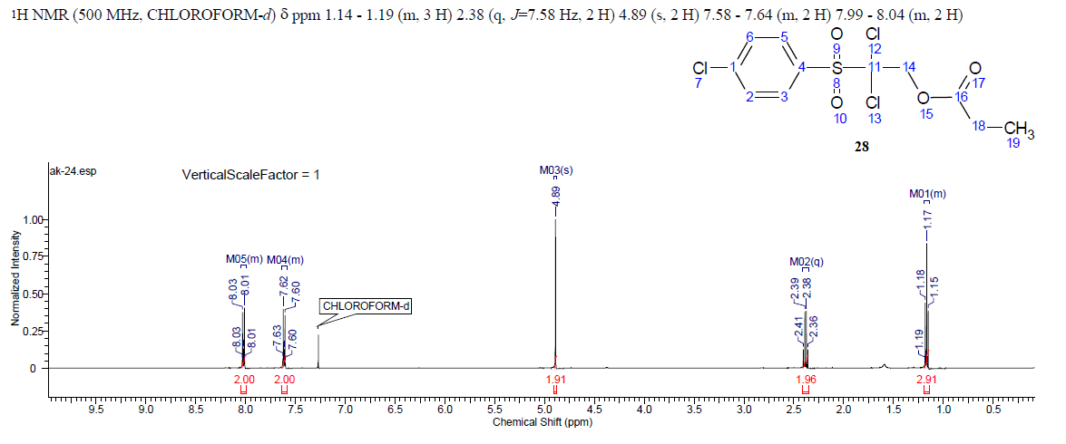
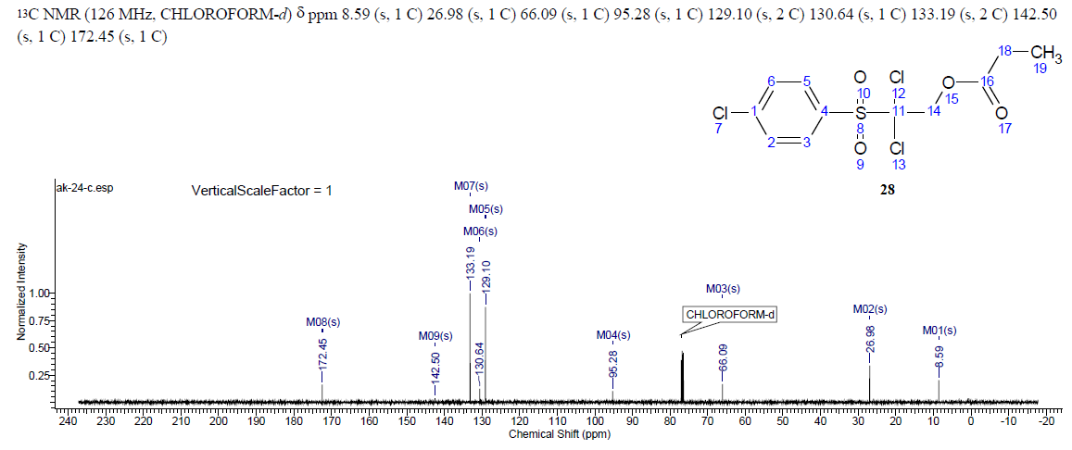
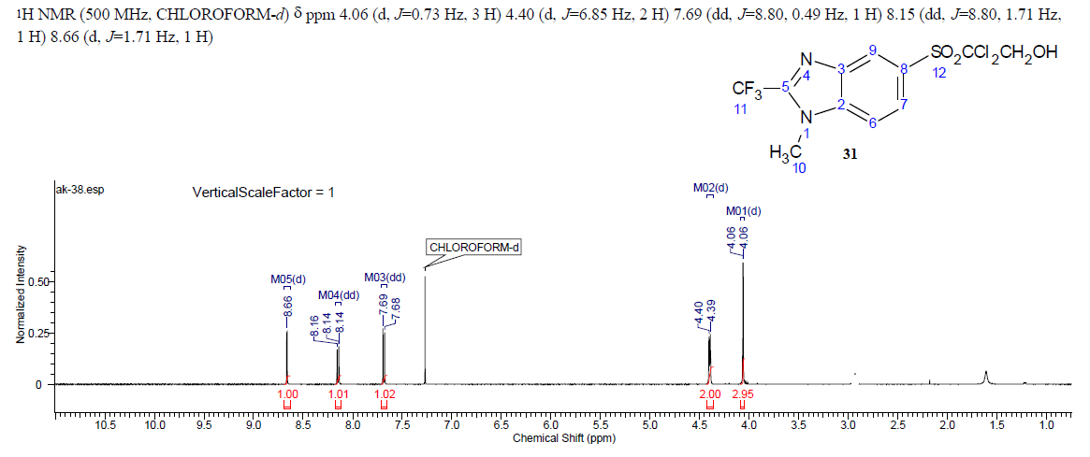
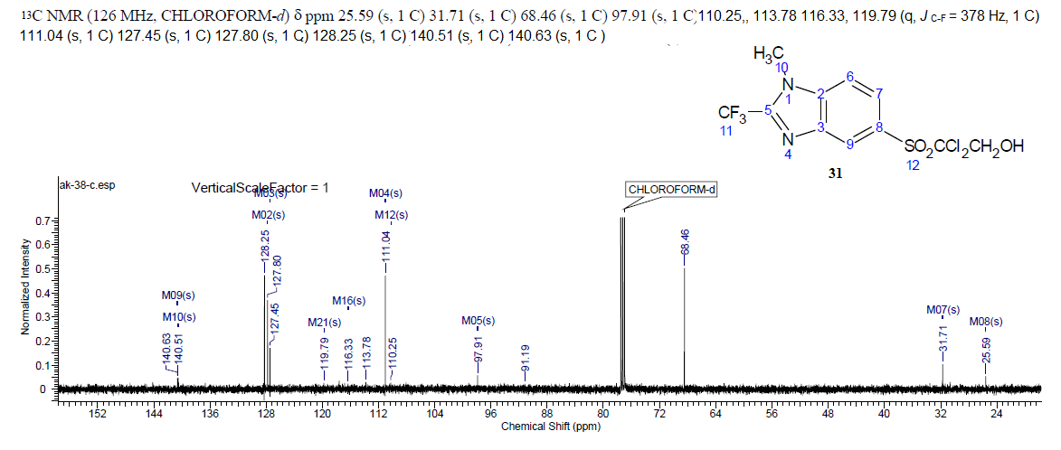
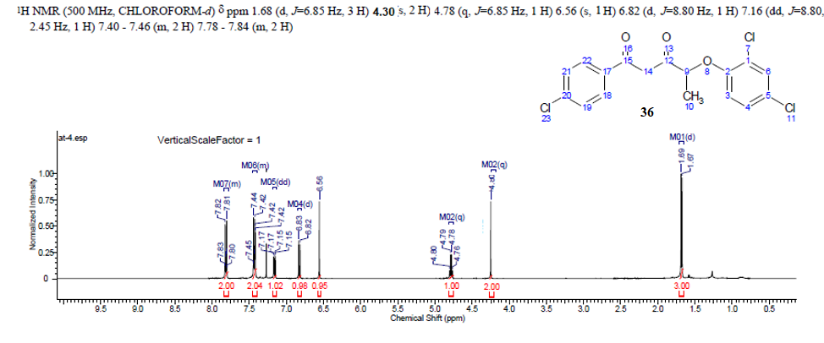
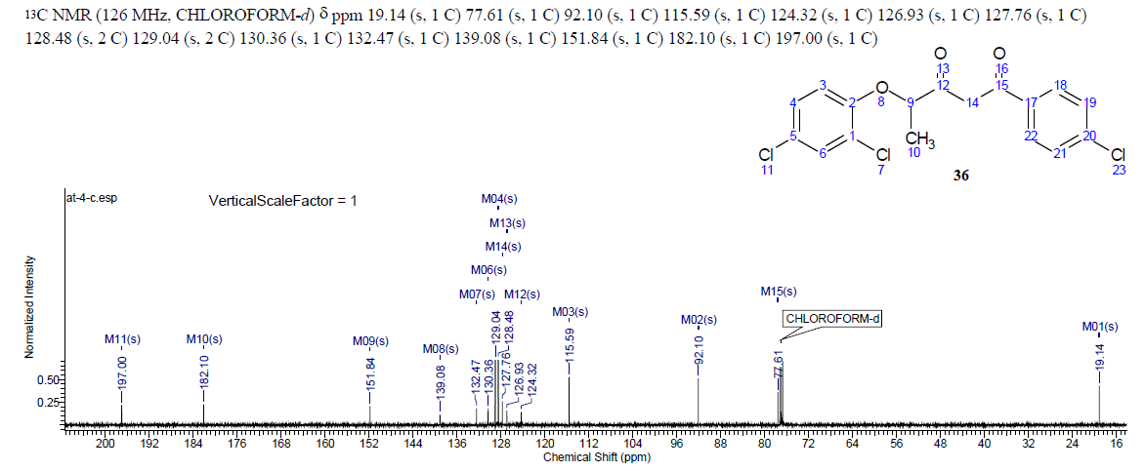

Table S1. Antifungal activity against C. albicans strain ATCC 90028 expressed as the degree of growth inhibition (%)
derivative | time | Concentration (µg/mL)
derivative | time | 16 |  | 8 | 4 | 2 | 1 | 0.5 | 0.25
4 | 18 |  | 99.70±0.08 | 99.55±0.16 | 99.44±0.06* | 99.26±0.26 | 98.86±0.38 | 99.02±0.26 | 98.57±0.22
4 | 48 |  | 99.41±0.11 | 99.33±0.29* | 99.31±0.09 | 99.20±0.15 | 98.95±0.32 | 99.16±0.21 | 98.82±0.20
5 | 18 |  | 98.88±0.44 | 98.85±0.24 | 98.84±0.15 | 98.70±0.06 | 98.93±0.39 | 98.71±0.17 | 98.88±0.31
 | 48 |  | 98.81±0.43 | 98.76±0.24 | 98.81±0.10 | 98.67±0.09 | 98.87±0.30 | 98.69±0.14 | 98.80±0.23
6 | 18 |  | 99.32±0.13 | 99.40±0.18 | 98.98±0.23 | 99.20±0.19 | 99.28±0.20 | 98.91±0.16 | 98.67±0.18
 | 48 |  | 99.32±0.12 | 99.29±0.14 | 98.97±0.11 | 99.13±0.19 | 99.21±0.15 | 98.94±0.17 | 98.77±0.12
7 | 18 |  | 98.72±0.18 | 99.06±0.37 | 98.88±0.33 | 98.85±0.12 | 99.00±0.27 | 99.13±0.09 | 99.16±0.34
 | 48 |  | 98.81±0.14 | 99.09±0.33 | 98.93±0.27 | 98.88±0.08 | 98.98±0.23 | 99.10±0.07 | 99.11±0.29
8 | 18 |  | 98.74±0.01 | 98.46±0.17 | 98.96±0.05 | 99.06±0.05 | 98.28±0.16 | 99.03±0.21 | 98.87±0.09
 | 48 |  | 98.82±0.07 | 98.54±0.18 | 98.96±0.06 | 99.10±0.05 | 98.36±0.13 | 99.00±0.19 | 98.86±0.08
9 | 18 |  | 98.79±0.35 | 99.29±0.27 | 99.11±0.34 | 98.88±0.28 | 98.91±0.10 | 99.41±0.13 | 98.94±0.26
 | 48 |  | 98.78±0.30 | 99.19±0.24 | 99.11±0.20 | 98.91±0.20 | 98.97±0.12 | 99.31±0.08 | 98.98±0.16
10 | 18 |  | 99.02±0.20 | 98.67±0.15 | 98.75±0.29 | 98.64±0.20 | 98.82±0.03 | 98.63±0.14 | 98.57±0.13
 | 48 |  | 98.97±0.18 | 98.57±0.24 | 98.70±0.24 | 98.55±0.12 | 98.78±0.10 | 98.63±0.04 | 98.52±0.12
13 | 18 |  | 98.18±0.09 | 98.05±0.12 | 98.45±0.13 | 98.59±0.26 | 98.73±0.02 | 98.62±0.16 | 98.88±0.07
 | 48 |  | 97.99±0.07 | 98.21±0.13 | 98.56±0.17 | 98.65±0.22 | 98.82±0.06 | 98.70±0.07 | 98.89±0.05
14 | 18 |  | 98.41±0.26 | 98.97±0.07 | 98.74±0.17 | 98.64±0.18 | 98.63±0.19 | 98.81±0.15 | 98.65±0.01
 | 48 |  | 98.55±0.17 | 98.98±0.00 | 98.81±0.14 | 98.77±0.16 | 98.72±0.08 | 98.81±0.17 | 98.63±0.05
15 | 18 |  | 100.00±0.00 | 100.00±0.00 | 100.03±0.01 | 99.91±0.08* | 98.59±0.15 | 98.42±0.09 | 98.01±0.15
15 | 48 |  | 100.00±0.00 | 100.00±0.00 | 99.98±0.01* | 99.25±0.04 | 99.35±0.01 | 99.10±0.28 | 98.95±0.32
16 | 18 |  | 99.83±0.09 | 99.89±0.04 | 99.90±0.01 | 99.15±0.19 | 99.98±0.03 | 98.52±0.34 | 98.53±0.15
16 | 48 |  | 97.97±0.17 | 98.07±0.23 | 97.64±0.18 | 97.63±0.25 | 99.99±0.01 | 98.03±0.48 | 98.57±0.15
18 | 18 |  | 98.54±0.30 | 98.78±0.12 | 99.27±012 | 99.26±0.31 | 98.78±0.05 | 98.71±0.17 | 96.88±0.31
18 | 48 |  | 98.62±0.25 | 98.87±0.10 | 99.20±0.09 | 99.04±0.26 | 98.74±0.18 | 98.59±0.14 | 97.80±0.13
19 | 18 |  | 98.85±0.28 | 99.17±0.18 | 98.82±0.23 | 99.07±0.16 | 98.89±0.17 | 98.64±0.17 | 99.01±0.12
 | 48 |  | 98.84±0.22 | 99.16±0.13 | 98.88±0.18 | 99.08±0.11 | 98.93±0.15 | 98.67±0.13 | 98.93±0.06
24 | 18 |  | 100.03±0.01 | 99.97±0.03 | 99.33±0.28 | 99.01±0.24 | 98.31±0.06 | 98.79±0.06 | 99.06±0.20
 | 48 |  | 99.97±0.05 | 99.14±0.55 | 99.03±0.25 | 98.90±0.12 | 98.47±0.16 | 98.85±0.04 | 99.07±0.18
26 | 18 |  | 100.02±0.01 | 99.99±0.01 | 99.95±0.01* | 98.86±0.14 | 98.40±0.03 | 97.95±0.07 | 96.07±0.32
 | 48 |  | 99.98±0.02 | 99.99±0.02 | 99.37±0.40* | 99.31±0.10 | 99.22±0.03 | 98.98±0.08 | 97.12±0.25
28 | 18 |  | 99.16±0.28 | 99.29±0.23 | 98.65±0.10 | 98.57±0.35 | 98.58±0.17 | 98.93±0.18 | 98.69±0.05
 | 48 |  | 100.00±0.01 | 100.00±0.01 | 100.00±0.00 | 100.00±0.01 | 100.00±0.00 | 99.85±0.10 | 99.95±0.16
30 | 18 |  | 97.95±0.28 | 98.48±0.19 | 98.79±0.20 | 100.00±0.01 | 100.01±0.00 | 99.95±0.05 | 99.72±0.14
30 | 48 |  | 98.14±0.23 | 98.69±0.18 | 98.85±0.21 | 99.99±0.00 | 99.04±0.92 | 99.35±0.25 | 99.18±0.08
31 | 18 |  | 100.00±0.02 | 99.99±0.01 | 100.00±0.01 | 99.99±0.01 | 98.77±0.10* | 98.15±0.07 | 97.07±0.32
 | 48 |  | 99.99±0.01 | 100.00±0.01 | 100.00±0.01 | 99.40±0.43* | 99.04±0.05 | 99.98±0.08 | 98.12±0.25
32 | 18 |  | 100.00±0.00 | 100.00±0.00 | 99.99±0.00 | 99.26±0.28 | 98.56±0.08 | 98.48±0.09 | 98.32±0.01
32 | 48 |  | 100.00±0.00 | 99.99±0.00 | 97.89±0.13 | 97.78±0.17 | 98.13±0.12 | 98.49±0.15 | 98.59±0.09
33 | 18 |  | 98.71±0.11 | 99.95±0.05 | 98.60±0.14 | 99.03±0.46 | 98.92±0.03 | 97.93±0.18 | 96.69±0.05
33 | 48 |  | 98.78±0.15 | 98.88±0.42 | 98.65±0.10 | 99.03±0.38 | 98.85±0.07 | 98.25±0.10 | 98.15±0.16
35 | 18 |  | 99.02±0.19 | 98.60±0.24 | 99.10±0.18 | 99.06±0.22 | 98.84±0.13 | 98.64±0.17 | 99.01±0.12
35 | 48 |  | 98.92±0.19 | 98.65±0.20 | 99.00±0.12 | 99.03±0.18 | 98.80±0.11 | 98.67±0.13 | 98.93±0.06
36 | 18 |  | 98.88±0.10 | 98.95±0.12 | 98.97±0.11 | 98.83±0.23 | 99.11±0.14 | 99.23±0.10 | 99.09±0.18
36 | 48 |  | 100.00±0.12 | 98.98±0.06 | 98.94±0.10 | 98.85±0.20 | 99.04±0.15 | 99.18±0.09 | 99.06±0.14
40 | 18 |  | 99.04±0.18 | 99.01±0.21 | 99.06±0.13 | 99.08±0.27 | 99.38±0.06 | 98.95±0.07 | 99.07±0.32
40 | 48 |  | 98.88±0.17 | 98.99±0.19 | 99.06±0.11 | 99.17±0.12 | 99.31±0.08 | 98.98±0.08 | 99.12±0.25
41 | 18 |  | 99.14±0.25 | 98.62±0.04 | 99.17±0.36 | 98.73±0.36 | 99.06±0.31 | 99.06±0.17 | 98.78±0.03
41 | 48 |  | 98.91±0.21 | 98.54±0.10 | 98.99±0.28 | 98.65±0.30 | 99.01±0.21 | 98.93±0.18 | 98.69±0.05
48 | 18 |  | 99.00±0.36 | 99.16±0.19 | 99.16±0.15 | 99.12±0.10 | 99.36±0.41 | 98.85±0.10 | 98.95±0.16
48 | 48 |  | 99.01±0.33 | 99.11±0.19 | 99.17±0.13 | 99.11±0.08 | 98.54±0.19 | 98.88±0.08 | 98.99±0.22
55 | 18 |  | 99.45±0.17 | 99.25±0.24 | 99.30±0.12 | 99.36±0.17 | 99.11±0.36 | 99.27±0.28 | 98.88±0.08
55 | 48 |  | 99.50±0.28 | 99.14±0.23 | 99.18±0.16 | 99.22±0.17 | 99.04±0.39 | 99.20±0.23 | 98.93±0.09
62 | 48 |  | 99.97±0.05 | 99.14±0.55 | 99.03±0.25 | 98.90±0.12 | 98.47±0.16 | 98.23±0.18 | 98.39±0.05
62 | 18 |  | 99.83±0.09 | 99.89±0.04 | 99.90±0.01 | 99.15±0.19 | 99.98±0.03 | 99.82±0.10 | 97.94±0.16
65 | 18 |  | 98.72±0.04 | 98.89±0.36 | 98.41±0.10 | 98.79±0.31 | 98.71±0.23 | 98.85±0.16 | 98.89±0.36
65 | 48 |  | 98.70±0.07 | 98.80±0.31 | 98.43±0.09 | 98.74±0.27 | 98.68±0.19 | 98.83±0.16 | 98.79±0.31
AmB | 48 |  | 100±0.00 | 100±0.00 | 100±0.00 | 100±0.00 | 100±0.00 | 100±0.00 | 100±0.00
Legend: Working compound concentrations were prepared in 0.96% DMSO. The percentage of Candida’s growth inhibition after 18h and 48h incubation was calculated with the following equation: %inhibition = 100 – (OD₆₂₅ CTW – OD₆₂₅ SCW)/ (OD₆₂₅ GCW – OD₆₂₅ SCW); where CTW means compound test wells, SCW sterility control wells, GCW growth control wells, and was prepared using DMSO or ethanol as appropriate. OD (optical density) measurements were made with a spectrophotometer at 625 nm. Data were presented as mean ±SD for free independent experiments. *Visually, MIC (minimum inhibitory concentration) was assessed after 18 and 48 hours.

DMSO cytotoxicity
measurement
 | conc. | 32 | 16 | 8 | 4 | 2 | 1 | 0,5 | 0,25 | 0,125 | 0,0625 | 0,03125 | 0,015
DMSO | 475nm | 0,1518 | 0,3779 | 0,568 | 0,6272 | 0,7148 | 0,6834 | 0,8213 | 0,84 | 0,7917 | 0,9626 | 0,6578 | 0,9129
 |  | 0,1575 | 0,3471 | 0,5018 | 0,5485 | 0,6321 | 0,6585 |  | 0,6569 | 0,5486 | 0,7148 | 0,733 | 0,689
 |  | 0,1785 | 0,4715 | 0,4589 | 0,5709 | 0,697 | 0,7527 | 0,8856 | 0,8899 | 0,5832 | 0,9589 | 0,8027 | 1,0499
 | Mean | 0,1626 | 0,398833 | 0,509567 | 0,5822 | 0,6813 | 0,6982 | 0,85345 | 0,7956 | 0,641167 | 0,878767 | 0,731167 | 0,883933
 | SD | 0,014062 | 0,064788 | 0,054963 | 0,040549 | 0,043528 | 0,048813 | 0,045467 | 0,122682 | 0,131509 | 0,142011 | 0,072467 | 0,182185
 | 660nm | 0,0549 | 0,0664 | 0,0572 | 0,0667 | 0,0575 | 0,0614 | 0,0586 | 0,0553 | 0,0539 | 0,0383 | 0,0711 | 0,0543
 |  | 0,0626 | 0,0517 | 0,0541 | 0,0671 | 0,0564 | 0,0539 | 0,2377 | 0,0519 | 0,0695 | 0,0555 | 0,0505 | 0,0542
 |  | 0,0629 | 0,0572 | 0,0422 | 0,0742 | 0,0591 | 0,0659 | 0,0583 | 0,0594 | 0,0815 | 0,0627 | 0,0581 | 0,064
 | Mean | 0,060133 | 0,058433 | 0,051167 | 0,069333 | 0,057667 | 0,0604 | 0,1182 | 0,055533 | 0,0683 | 0,052167 | 0,0599 | 0,0575
 | SD | 0,004535 | 0,007427 | 0,007919 | 0,004219 | 0,001358 | 0,006062 | 0,10349 | 0,003755 | 0,013839 | 0,012537 | 0,010417 | 0,005629
ΔAbs |  | -0,05267 | 0,163 | 0,3617 | 0,402233 | 0,496133 | 0,465233 | 0,6023 | 0,625033 | 0,577733 | 0,765133 | 0,4243 | 0,6968
 |  | -0,05467 | 0,1469 | 0,2986 | 0,323133 | 0,414533 | 0,447833 |  | 0,445333 | 0,319033 | 0,500133 | 0,5201 | 0,473
 |  | -0,03397 | 0,2658 | 0,2676 | 0,338433 | 0,476733 | 0,530033 | 0,6669 | 0,670833 | 0,341633 | 0,737033 | 0,5822 | 0,8241
 | Mean | -0,0471 | 0,1919 | 0,3093 | 0,3546 | 0,462467 | 0,481033 | 0,57485 | 0,5804 | 0,4128 | 0,667433 | 0,508867 | 0,664633
 | SD | 0,011418 | 0,064504 | 0,047954 | 0,041955 | 0,04263 | 0,043318 | 0,045679 | 0,119192 | 0,143283 | 0,145566 | 0,079547 | 0,177747
DMSO Blank | 475nm | 0,1479 | 0,145 | 0,1522 | 0,1576 | 0,1678 | 0,1576 | 0,1577 | 0,1595 | 0,1561 | 0,1519 | 0,1611 | 0,1616
 |  | 0,1509 | 0,1473 | 0,1521 | 0,1632 | 0,1555 | 0,1548 | 0,1619 | 0,1572 | 0,1647 | 0,1573 | 0,1598 | 0,1593
 |  | 0,1499 | 0,1532 | 0,143 | 0,154 | 0,1602 | 0,1579 | 0,1616 | 0,1623 | 0,1594 | 0,1683 | 0,1663 | 0,1645
 | Mean | 0,149567 | 0,1485 | 0,1491 | 0,158267 | 0,161167 | 0,156767 | 0,1604 | 0,159667 | 0,160067 | 0,159167 | 0,1624 | 0,1618
 | SD | 0,001528 | 0,00423 | 0,005283 | 0,004636 | 0,006207 | 0,00171 | 0,002343 | 0,002554 | 0,004339 | 0,008358 | 0,003439 | 0,002606
 | 660nm | 0,0556 | 0,0476 | 0,0462 | 0,0467 | 0,0561 | 0,0454 | 0,0452 | 0,047 | 0,0387 | 0,0458 | 0,0479 | 0,0473
 |  | 0,0571 | 0,0467 | 0,0462 | 0,0477 | 0,0474 | 0,049 | 0,0457 | 0,0459 | 0,0464 | 0,0447 | 0,0469 | 0,0463
 |  | 0,0581 | 0,0544 | 0,0245 | 0,0458 | 0,0492 | 0,0477 | 0,0472 | 0,0485 | 0,0465 | 0,0512 | 0,0483 | 0,0521
 | Mean | 0,056933 | 0,049567 | 0,038967 | 0,046733 | 0,0509 | 0,047367 | 0,046033 | 0,047133 | 0,043867 | 0,047233 | 0,0477 | 0,048567
 | SD | 0,001258 | 0,00421 | 0,012529 | 0,00095 | 0,004592 | 0,001823 | 0,001041 | 0,001305 | 0,004475 | 0,003479 | 0,000721 | 0,003101
ΔAbs |  | 0,0923 | 0,0974 | 0,106 | 0,1109 | 0,1117 | 0,1122 | 0,1125 | 0,1125 | 0,1174 | 0,1061 | 0,1132 | 0,1143
blank |  | 0,0938 | 0,1006 | 0,1059 | 0,1155 | 0,1081 | 0,1058 | 0,1162 | 0,1113 | 0,1183 | 0,1126 | 0,1129 | 0,113
 |  | 0,0918 | 0,0988 | 0,1185 | 0,1082 | 0,111 | 0,1102 | 0,1144 | 0,1138 | 0,1129 | 0,1171 | 0,118 | 0,1124
 | Mean | 0,092633 | 0,098933 | 0,110133 | 0,111533 | 0,110267 | 0,1094 | 0,114367 | 0,112533 | 0,1162 | 0,111933 | 0,1147 | 0,113233
 | SD | 0,001041 | 0,001604 | 0,007246 | 0,003691 | 0,001909 | 0,003274 | 0,00185 | 0,00125 | 0,002893 | 0,00553 | 0,002862 | 0,000971
 | stężenie | 32 | 16 | 8 | 4 | 2 | 1 | 0,5 | 0,25 | 0,125 | 0,0625 | 0,03125 | 0,015
 | Cytotoxicity% | 123,7764 | 89,40713 | 57,62085 | 50,91264 | 34,98195 | 40,12996 | 17,2119 | 13,3133 | 21,44687 | -10,3734 | 47,44016 | 1,17574
 |  | 124,1037 | 92,06913 | 68,25073 | 64,2694 | 48,73145 | 43,05756 |  | 43,70862 | 65,4777 | 34,40457 | 31,17648 | 39,07521
 |  | 120,7164 | 72,41005 | 73,47302 | 61,68586 | 38,25082 | 29,22716 | 6,251161 | 5,566474 | 61,63117 | -5,6252 | 20,63396 | -20,3819
 | Mean | 122,8655 | 84,62877 | 66,4482 | 58,95597 | 40,65474 | 37,47156 | 21,86937 | 20,8628 | 49,51858 | 6,13534 | 33,08353 | 6,623013
 | SD | 1,868352 | 10,6651 | 8,078346 | 7,084488 | 7,183055 | 7,288368 | 7,750415 | 20,16065 | 24,38677 | 24,59671 | 13,50447 | 30,10053
 | SEM | 1,078693 | 6,157501 | 4,664035 | 4,090231 | 4,147139 | 4,207941 | 5,480371 | 11,63976 | 14,07971 | 14,20092 | 7,796809 | 17,37855

Figure S1 DMSO cytotoxicity
Table S2. In vivo examination demonstrated a high health score for larvae at 8 μg/mL, comparable to the control group, with a daily survival rate of 100%.
15 at 8 μg/mL
 | survival (%) |  |  |  |  | melanization (%) |  |  |  |  | cocoon formation (%) |  |  |  |  | activity (%) |  |  |  |  | health score (%)
time (h) | 18 | 48 | 72 | 96 | 120 | 18 | 48 | 72 | 96 | 120 | 18 | 48 | 72 | 96 | 120 | 18 | 48 | 72 | 96 | 120 | 18 | 48 | 72 | 96 | 120
 | 100,00 | 100,00 | 100,00 | 100,00 | 100,00 | 100,00 | 100,00 | 100,00 | 100,00 | 100,00 | 100,00 | 80,00 | 60,00 | 0,00 | 10,00 | 100,00 | 96,67 | 100,00 | 100,00 | 100,00 | 100,00 | 94,17 | 90,00 | 75,00 | 77,50
 | 100,00 | 100,00 | 100,00 | 100,00 | 100,00 | 100,00 | 100,00 | 100,00 | 92,50 | 92,50 | 100,00 | 90,00 | 40,00 | 50,00 | 30,00 | 100,00 | 100,00 | 100,00 | 100,00 | 100,00 | 100,00 | 97,50 | 85,00 | 85,63 | 80,63
 | 100,00 | 100,00 | 100,00 | 100,00 | 100,00 | 100,00 | 95,00 | 95,00 | 95,00 | 95,00 | 50,00 | 20,00 | 50,00 | 85,00 | 85,00 | 96,67 | 93,33 | 93,33 | 93,33 | 93,33 | 86,67 | 77,08 | 84,58 | 93,33 | 93,33
Mean | 100,00 | 100,00 | 100,00 | 100,00 | 100,00 | 100,00 | 98,33 | 98,33 | 95,83 | 95,83 | 83,33 | 63,33 | 50,00 | 45,00 | 41,67 | 98,89 | 96,67 | 97,78 | 97,78 | 97,78 | 95,56 | 89,58 | 86,53 | 84,65 | 83,82
SD | 0,00 | 0,00 | 0,00 | 0,00 | 0,00 | 0,00 | 2,36 | 2,36 | 3,12 | 3,12 | 23,57 | 30,91 | 8,16 | 34,88 | 31,71 | 1,57 | 2,72 | 3,14 | 3,14 | 3,14 | 6,29 | 8,94 | 2,46 | 7,52 | 6,85
SEM | 0,00 | 0,00 | 0,00 | 0,00 | 0,00 | 0,00 | 1,18 | 1,18 | 1,56 | 1,56 | 11,79 | 15,46 | 4,08 | 17,44 | 15,86 | 0,79 | 1,36 | 1,57 | 1,57 | 1,57 | 3,14 | 4,47 | 1,23 | 3,76 | 3,42
AK-55 8 μg/mL + Candida (+1h)
 | survival (%) |  |  |  |  | melanization (%) |  |  |  |  | cocoon formation (%) |  |  |  |  | activity (%) |  |  |  |  | health score (%)
time (h) | 18 | 48 | 72 | 96 | 120 | 18 | 48 | 72 | 96 | 120 | 18 | 48 | 72 | 96 | 120 | 18 | 48 | 72 | 96 | 120 | 18 | 48 | 72 | 96 | 120
 | 100,00 | 80,00 | 80,00 | 80,00 | 80,00 | 90,00 | 75,00 | 75,00 | 70,00 | 65,00 | 80,00 | 60,00 | 60,00 | 80,00 | 60,00 | 80,00 | 73,33 | 80,00 | 73,33 | 73,33 | 87,50 | 72,08 | 73,75 | 75,83 | 69,58
 | 100,00 | 100,00 | 100,00 | 100,00 | 100,00 | 97,50 | 95,00 | 95,00 | 87,50 | 90,00 | 80,00 | 70,00 | 90,00 | 80,00 | 80,00 | 96,67 | 93,33 | 93,33 | 93,33 | 93,33 | 93,54 | 89,58 | 94,58 | 90,21 | 90,83
Mean | 100,00 | 90,00 | 90,00 | 90,00 | 90,00 | 93,75 | 85,00 | 85,00 | 78,75 | 77,50 | 80,00 | 65,00 | 75,00 | 80,00 | 70,00 | 88,33 | 83,33 | 86,67 | 83,33 | 83,33 | 90,52 | 80,83 | 84,17 | 83,02 | 80,21
SD | 0,00 | 10,00 | 10,00 | 10,00 | 10,00 | 3,75 | 10,00 | 10,00 | 8,75 | 12,50 | 0,00 | 5,00 | 15,00 | 0,00 | 10,00 | 8,33 | 10,00 | 6,67 | 10,00 | 10,00 | 3,02 | 8,75 | 10,42 | 7,19 | 10,63
SEM | 0,00 | 5,77 | 5,77 | 5,77 | 5,77 | 2,17 | 5,77 | 5,77 | 5,05 | 7,22 | 0,00 | 2,89 | 8,66 | 0,00 | 5,77 | 4,81 | 5,77 | 3,85 | 5,77 | 5,77 | 1,74 | 5,05 | 6,01 | 4,15 | 6,13
AK-55 8 μg/mL + Candida (-1h)
 | survival (%) |  |  |  |  | melanization (%) |  |  |  |  | cocoon formation (%) |  |  |  |  | activity (%) |  |  |  |  | health score (%)
time (h) | 18 | 48 | 72 | 96 | 120 | 18 | 48 | 72 | 96 | 120 | 18 | 48 | 72 | 96 | 120 | 18 | 48 | 72 | 96 | 120 | 18 | 48 | 72 | 96 | 120
 | 100,00 | 80,00 | 80,00 | 80,00 | 80,00 | 90,00 | 75,00 | 75,00 | 75,00 | 75,00 | 90,00 | 80,00 | 60,00 | 60,00 | 40,00 | 86,67 | 80,00 | 80,00 | 80,00 | 80,00 | 91,67 | 78,75 | 73,75 | 73,75 | 68,75
 | 100,00 | 100,00 | 100,00 | 100,00 | 100,00 | 97,50 | 95,00 | 97,50 | 87,50 | 95,00 | 85,00 | 80,00 | 65,00 | 75,00 | 70,00 | 96,67 | 90,00 | 93,33 | 90,00 | 90,00 | 94,79 | 91,25 | 88,96 | 88,13 | 88,75
Mean | 100,00 | 90,00 | 90,00 | 90,00 | 90,00 | 93,75 | 85,00 | 86,25 | 81,25 | 85,00 | 87,50 | 80,00 | 62,50 | 67,50 | 55,00 | 91,67 | 85,00 | 86,67 | 85,00 | 85,00 | 93,23 | 85,00 | 81,35 | 80,94 | 78,75
SD | 0,00 | 10,00 | 10,00 | 10,00 | 10,00 | 3,75 | 10,00 | 11,25 | 6,25 | 10,00 | 2,50 | 0,00 | 2,50 | 7,50 | 15,00 | 5,00 | 5,00 | 6,67 | 5,00 | 5,00 | 1,56 | 6,25 | 7,60 | 7,19 | 10,00
SEM | 0,00 | 5,77 | 5,77 | 5,77 | 5,77 | 2,17 | 5,77 | 6,50 | 3,61 | 5,77 | 1,44 | 0,00 | 1,44 | 4,33 | 8,66 | 2,89 | 2,89 | 3,85 | 2,89 | 2,89 | 0,90 | 3,61 | 4,39 | 4,15 | 5,77
Negative control
 | survival (%) |  |  |  |  | melanization (%) |  |  |  |  | cocoon formation (%) |  |  |  |  | activity (%) |  |  |  |  | health score (%)
time (h) | 18 | 48 | 72 | 96 | 120 | 18 | 48 | 72 | 96 | 120 | 18 | 48 | 72 | 96 | 120 | 18 | 48 | 72 | 96 | 120 | 18 | 48 | 72 | 96 | 120
 | 100,00 | 100,00 | 100,00 | 100,00 | 100,00 | 100,00 | 100,00 | 100,00 | 100,00 | 100,00 | 5,00 | 5,00 | 0,00 | 0,00 | 25,00 | 100,00 | 100,00 | 100,00 | 100,00 | 100,00 | 76,25 | 76,25 | 75,00 | 75,00 | 81,25
 | 100,00 | 100,00 | 100,00 | 100,00 | 100,00 | 100,00 | 100,00 | 90,00 | 87,50 | 87,50 | 10,00 | 10,00 | 30,00 | 0,00 | 0,00 | 96,67 | 96,67 | 90,00 | 90,00 | 90,00 | 76,67 | 76,67 | 75,00 | 66,88 | 69,38
 | 100,00 | 100,00 | 100,00 | 100,00 | 100,00 | 100,00 | 100,00 | 100,00 | 100,00 | 100,00 | 55,00 | 85,00 | 70,00 | 80,00 | 95,00 | 100,00 | 100,00 | 100,00 | 100,00 | 100,00 | 88,75 | 96,25 | 92,50 | 95,00 | 98,75
 | 100,00 | 100,00 | 100,00 | 100,00 | 100,00 | 100,00 | 100,00 | 97,50 | 97,50 | 97,50 | 60,00 | 0,00 | 40,00 | 75,00 | 100,00 | 100,00 | 100,00 | 100,00 | 100,00 | 100,00 | 90,00 | 75,00 | 84,38 | 93,13 | 99,38
 | 100,00 | 100,00 | 100,00 | 100,00 | 100,00 | 100,00 | 100,00 | 100,00 | 100,00 | 100,00 | 10,00 | 10,00 | 0,00 | 0,00 | 20,00 | 100,00 | 100,00 | 100,00 | 100,00 | 100,00 | 77,50 | 77,50 | 75,00 | 75,00 | 80,00
Mean | 100,00 | 100,00 | 100,00 | 100,00 | 100,00 | 100,00 | 100,00 | 97,50 | 97,00 | 97,00 | 28,00 | 22,00 | 28,00 | 31,00 | 48,00 | 99,33 | 99,33 | 98,00 | 98,00 | 98,00 | 81,83 | 80,33 | 80,38 | 81,00 | 85,75
SD | 0,00 | 0,00 | 0,00 | 0,00 | 0,00 | 0,00 | 0,00 | 3,87 | 4,85 | 4,85 | 24,21 | 31,72 | 26,38 | 38,00 | 41,30 | 1,33 | 1,33 | 4,00 | 4,00 | 4,00 | 6,18 | 8,00 | 7,07 | 11,09 | 11,63
SEM | 0,00 | 0,00 | 0,00 | 0,00 | 0,00 | 0,00 | 0,00 | 1,58 | 1,98 | 1,98 | 9,88 | 12,95 | 10,77 | 15,51 | 16,86 | 0,54 | 0,54 | 1,63 | 1,63 | 1,63 | 2,52 | 3,27 | 2,88 | 4,53 | 4,75
RPMI
 | survival (%) |  |  |  |  | melanization (%) |  |  |  |  | cocoon formation (%) |  |  |  |  | activity (%) |  |  |  |  | health score (%)
time (h) | 18 | 48 | 72 | 96 | 120 | 18 | 48 | 72 | 96 | 120 | 18 | 48 | 72 | 96 | 120 | 18 | 48 | 72 | 96 | 120 | 18 | 48 | 72 | 96 | 120
 | 100,00 | 100,00 | 100,00 | 100,00 | 100,00 | 100,00 | 100,00 | 100,00 | 100,00 | 100,00 | 50,00 | 50,00 | 100,00 | 80,00 | 90,00 | 100,00 | 100,00 | 100,00 | 100,00 | 100,00 | 87,50 | 87,50 | 100,00 | 95,00 | 97,50
 | 100,00 | 100,00 | 100,00 | 100,00 | 100,00 | 100,00 | 100,00 | 100,00 | 100,00 | 100,00 | 70,00 | 90,00 | 90,00 | 10,00 | 0,00 | 100,00 | 100,00 | 100,00 | 100,00 | 100,00 | 92,50 | 97,50 | 97,50 | 77,50 | 75,00
 | 100,00 | 100,00 | 100,00 | 100,00 | 100,00 | 100,00 | 100,00 | 100,00 | 100,00 | 100,00 | 70,00 | 80,00 | 60,00 | 50,00 | 40,00 | 100,00 | 100,00 | 100,00 | 86,67 | 86,67 | 92,50 | 95,00 | 90,00 | 84,17 | 81,67
 | 100,00 | 100,00 | 100,00 | 100,00 | 100,00 | 97,50 | 97,50 | 97,50 | 97,50 | 97,50 | 35,00 | 25,00 | 40,00 | 45,00 | 60,00 | 96,67 | 93,33 | 93,33 | 93,33 | 93,33 | 82,29 | 78,96 | 82,71 | 83,96 | 87,71
 | 100,00 | 100,00 | 100,00 | 100,00 | 100,00 | 100,00 | 100,00 | 100,00 | 100,00 | 100,00 | 65,00 | 20,00 | 60,00 | 80,00 | 100,00 | 100,00 | 100,00 | 100,00 | 100,00 | 100,00 | 91,25 | 80,00 | 90,00 | 95,00 | 100,00
Mean | 100,00 | 100,00 | 100,00 | 100,00 | 100,00 | 99,50 | 99,50 | 99,50 | 99,50 | 99,50 | 58,00 | 53,00 | 70,00 | 53,00 | 58,00 | 99,33 | 98,67 | 98,67 | 96,00 | 96,00 | 89,21 | 87,79 | 92,04 | 87,13 | 88,38
SD | 0,00 | 0,00 | 0,00 | 0,00 | 0,00 | 1,00 | 1,00 | 1,00 | 1,00 | 1,00 | 13,64 | 28,21 | 21,91 | 26,00 | 36,00 | 1,33 | 2,67 | 2,67 | 5,33 | 5,33 | 3,91 | 7,55 | 6,14 | 6,86 | 9,41
SEM | 0,00 | 0,00 | 0,00 | 0,00 | 0,00 | 0,41 | 0,41 | 0,41 | 0,41 | 0,41 | 5,57 | 11,52 | 8,94 | 10,61 | 14,70 | 0,54 | 1,09 | 1,09 | 2,18 | 2,18 | 1,60 | 3,08 | 2,51 | 2,80 | 3,84
0.96% DMSO
 | survival (%) |  |  |  |  | melanization (%) |  |  |  |  | cocoon formation (%) |  |  |  |  | activity (%) |  |  |  |  | health score (%)
time (h) | 18 | 48 | 72 | 96 | 120 | 18 | 48 | 72 | 96 | 120 | 18 | 48 | 72 | 96 | 120 | 18 | 48 | 72 | 96 | 120 | 18 | 48 | 72 | 96 | 120
 | 100,00 | 100,00 | 100,00 | 100,00 | 100,00 | 100,00 | 100,00 | 100,00 | 100,00 | 100,00 | 80,00 | 85,00 | 100,00 | 80,00 | 90,00 | 100,00 | 100,00 | 100,00 | 100,00 | 96,67 | 95,00 | 96,25 | 100,00 | 95,00 | 96,67
 | 100,00 | 100,00 | 100,00 | 100,00 | 100,00 | 100,00 | 100,00 | 95,00 | 95,00 | 95,00 | 40,00 | 40,00 | 20,00 | 20,00 | 20,00 | 100,00 | 100,00 | 93,33 | 93,33 | 93,33 | 85,00 | 85,00 | 77,08 | 77,08 | 77,08
 | 100,00 | 100,00 | 100,00 | 100,00 | 100,00 | 100,00 | 100,00 | 100,00 | 100,00 | 100,00 | 20,00 | 20,00 | 55,00 | 80,00 | 100,00 | 100,00 | 100,00 | 100,00 | 100,00 | 100,00 | 80,00 | 80,00 | 88,75 | 95,00 | 100,00
 | 100,00 | 100,00 | 100,00 | 100,00 | 100,00 | 95,00 | 95,00 | 95,00 | 95,00 | 95,00 | 80,00 | 60,00 | 40,00 | 80,00 | 100,00 | 100,00 | 100,00 | 93,33 | 93,33 | 93,33 | 93,75 | 88,75 | 82,08 | 92,08 | 97,08
Mean | 100,00 | 100,00 | 100,00 | 100,00 | 100,00 | 98,75 | 98,75 | 97,50 | 97,50 | 97,50 | 55,00 | 51,25 | 53,75 | 65,00 | 77,50 | 100,00 | 100,00 | 96,67 | 96,67 | 95,83 | 88,44 | 87,50 | 86,98 | 89,79 | 92,71
SD | 0,00 | 0,00 | 0,00 | 0,00 | 0,00 | 2,17 | 2,17 | 2,50 | 2,50 | 2,50 | 25,98 | 24,08 | 29,45 | 25,98 | 33,45 | 0,00 | 0,00 | 3,33 | 3,33 | 2,76 | 6,21 | 5,93 | 8,58 | 7,43 | 9,11
SEM | 0,00 | 0,00 | 0,00 | 0,00 | 0,00 | 0,97 | 0,97 | 1,12 | 1,12 | 1,12 | 11,62 | 10,77 | 13,17 | 11,62 | 14,96 | 0,00 | 0,00 | 1,49 | 1,49 | 1,24 | 2,78 | 2,65 | 3,84 | 3,32 | 4,08
Candida albicans
 | survival (%) |  |  |  |  | melanization (%) |  |  |  |  | cocoon formation (%) |  |  |  |  | activity (%) |  |  |  |  | health score (%)
time (h) | 18 | 48 | 72 | 96 | 120 | 18 | 48 | 72 | 96 | 120 | 18 | 48 | 72 | 96 | 120 | 18 | 48 | 72 | 96 | 120 | 18 | 48 | 72 | 96 | 120
 | 100,00 | 100,00 | 100,00 | 100,00 | 100,00 | 100,00 | 95,00 | 95,00 | 85,00 | 75,00 | 60,00 | 30,00 | 20,00 | 20,00 | 20,00 | 93,33 | 93,33 | 93,33 | 93,33 | 73,33 | 88,33 | 79,58 | 77,08 | 74,58 | 67,08
 | 100,00 | 80,00 | 80,00 | 80,00 | 70,00 | 95,00 | 77,50 | 72,50 | 55,00 | 55,00 | 75,00 | 50,00 | 45,00 | 15,00 | 30,00 | 93,33 | 73,33 | 70,00 | 60,00 | 53,33 | 90,83 | 70,21 | 66,88 | 52,50 | 52,08
 | 100,00 | 100,00 | 100,00 | 100,00 | 90,00 | 100,00 | 97,50 | 95,00 | 80,00 | 80,00 | 70,00 | 20,00 | 10,00 | 85,00 | 20,00 | 93,33 | 93,33 | 93,33 | 86,67 | 80,00 | 90,83 | 77,71 | 74,58 | 87,92 | 67,50
Mean | 100,00 | 93,33 | 93,33 | 93,33 | 86,67 | 98,33 | 90,00 | 87,50 | 73,33 | 70,00 | 68,33 | 33,33 | 25,00 | 40,00 | 23,33 | 93,33 | 86,67 | 85,56 | 80,00 | 68,89 | 90,00 | 75,83 | 72,85 | 71,67 | 62,22
SD | 0,00 | 9,43 | 9,43 | 9,43 | 12,47 | 2,36 | 8,90 | 10,61 | 13,12 | 10,80 | 6,24 | 12,47 | 14,72 | 31,89 | 4,71 | 0,00 | 9,43 | 11,00 | 14,40 | 11,33 | 1,18 | 4,05 | 4,34 | 14,61 | 7,17
SEM | 0,00 | 4,71 | 4,71 | 4,71 | 6,24 | 1,18 | 4,45 | 5,30 | 6,56 | 5,40 | 3,12 | 6,24 | 7,36 | 15,94 | 2,36 | 0,00 | 4,71 | 5,50 | 7,20 | 5,67 | 0,59 | 2,03 | 2,17 | 7,30 | 3,59

Table S3. Sulfone influence on ergosterol
absorbance (625 nm) |  |  |  |  |  |  |  |  |  |  |  |  |  |  | absorbance (405 nm)
 |  | concentration (μg/mL)
conc. of erg (μg/mL) | time (h) | 512 | 256 | 128 | 64 | 32 | 16 | 8 | 4 | 2 | 1 | 0.5 | 0.25 | 512 |  | 256 | 128 | 64 | 32 | 16 | 8 | 4 | 2 | 1 | 0.5 | 0.25
250 | 18 | 0,526 | 0,139 | 0,112 | 0,084 | 0,075 | 0,076 | 0,072 | 0,086 | 0,077 | 0,083 | 0,180 | 0,147 | 0,846 |  | 0,248 | 0,212 | 0,176 | 0,158 | 0,177 | 0,167 | 0,187 | 0,176 | 0,179 | 0,309 | 0,258
250 |  | 0,202 | 0,002 | 0,010 | 0,003 | 0,007 | 0,007 | 0,001 | 0,015 | 0,010 | 0,016 | 0,116 | 0,087 | 0,570 |  | 0,004 | 0,022 | 0,004 | 0,007 | 0,017 | 0,004 | 0,029 | 0,022 | 0,022 | 0,144 | 0,112
250 | 48 | 0,342 | 0,327 | 0,317 | 0,345 | 0,327 | 0,149 | 0,115 | 0,198 | 0,083 | 0,112 | 0,145 | 0,146 | 0,497 |  | 0,475 | 0,459 | 0,492 | 0,460 | 0,251 | 0,209 | 0,294 | 0,174 | 0,200 | 0,253 | 0,264
250 |  | 0,073 | 0,126 | 0,031 | 0,044 | 0,050 | 0,068 | 0,029 | 0,035 | 0,005 | 0,007 | 0,005 | 0,001 | 0,115 |  | 0,160 | 0,041 | 0,057 | 0,074 | 0,098 | 0,034 | 0,035 | 0,008 | 0,013 | 0,009 | 0,002
125 | 18 | 0,733 | 0,105 | 0,091 | 0,068 | 0,078 | 0,062 | 0,063 | 0,067 | 0,068 | 0,119 | 0,175 | 0,167 | 0,897 |  | 0,208 | 0,193 | 0,165 | 0,171 | 0,157 | 0,160 | 0,166 | 0,172 | 0,235 | 0,298 | 0,289
125 |  | 0,150 | 0,002 | 0,002 | 0,002 | 0,020 | 0,003 | 0,002 | 0,005 | 0,018 | 0,067 | 0,055 | 0,144 | 0,211 |  | 0,002 | 0,002 | 0,003 | 0,025 | 0,007 | 0,002 | 0,007 | 0,030 | 0,084 | 0,062 | 0,180
125 | 48 | 0,437 | 0,438 | 0,432 | 0,483 | 0,324 | 0,320 | 0,185 | 0,163 | 0,128 | 0,095 | 0,109 | 0,179 | 0,616 |  | 0,618 | 0,615 | 0,663 | 0,466 | 0,476 | 0,282 | 0,260 | 0,238 | 0,195 | 0,212 | 0,296
125 |  | 0,020 | 0,054 | 0,106 | 0,102 | 0,049 | 0,073 | 0,001 | 0,035 | 0,060 | 0,002 | 0,002 | 0,002 | 0,014 |  | 0,075 | 0,124 | 0,111 | 0,062 | 0,096 | 0,033 | 0,006 | 0,077 | 0,002 | 0,002 | 0,004
25 | 18 | 0,882 | 0,138 | 0,113 | 0,078 | 0,164 | 0,064 | 0,059 | 0,060 | 0,124 | 0,171 | 0,195 | 0,400 | 1,030 |  | 0,258 | 0,219 | 0,176 | 0,281 | 0,161 | 0,154 | 0,158 | 0,236 | 0,299 | 0,334 | 0,582
25 |  | 0,057 | 0,051 | 0,038 | 0,022 | 0,148 | 0,010 | 0,005 | 0,008 | 0,031 | 0,088 | 0,234 | 0,091 | 0,084 |  | 0,069 | 0,050 | 0,029 | 0,197 | 0,014 | 0,008 | 0,007 | 0,039 | 0,105 | 0,309 | 0,124
25 | 48 | 0,581 | 0,536 | 0,504 | 0,523 | 0,331 | 0,259 | 0,145 | 0,148 | 0,115 | 0,119 | 0,115 | 0,117 | 0,811 |  | 0,760 | 0,730 | 0,740 | 0,488 | 0,395 | 0,255 | 0,247 | 0,217 | 0,222 | 0,228 | 0,232
25 |  | 0,050 | 0,073 | 0,031 | 0,039 | 0,145 | 0,014 | 0,090 | 0,015 | 0,002 | 0,034 | 0,004 | 0,027 | 0,066 |  | 0,097 | 0,035 | 0,051 | 0,178 | 0,018 | 0,107 | 0,000 | 0,000 | 0,045 | 0,001 | 0,001
0 | 18 | 0,353 | 0,100 | 0,080 | 0,069 | 0,119 | 0,062 | 0,058 | 0,091 | 0,207 | 0,265 | 0,270 | 0,285 | 0,488 |  | 0,206 | 0,190 | 0,174 | 0,232 | 0,171 | 0,165 | 0,207 | 0,342 | 0,413 | 0,411 | 0,389
0 |  | 0,083 | 0,014 | 0,003 | 0,004 | 0,022 | 0,005 | 0,011 | 0,033 | 0,040 | 0,059 | 0,078 | 0,040 | 0,039 |  | 0,018 | 0,006 | 0,008 | 0,043 | 0,003 | 0,009 | 0,039 | 0,052 | 0,087 | 0,064 | 0,114
0 | 48 | 0,437 | 0,415 | 0,437 | 0,463 | 0,362 | 0,212 | 0,089 | 0,099 | 0,086 | 0,081 | 0,088 | 0,087 | 0,652 |  | 0,615 | 0,623 | 0,649 | 0,494 | 0,325 | 0,191 | 0,196 | 0,191 | 0,187 | 0,187 | 0,190
0 |  | 0,166 | 0,103 | 0,047 | 0,072 | 0,120 | 0,106 | 0,001 | 0,001 | 0,001 | 0,006 | 0,009 | 0,006 | 0,167 |  | 0,134 | 0,068 | 0,060 | 0,136 | 0,149 | 0,001 | 0,002 | 0,000 | 0,004 | 0,002 | 0,000

Table S4. C. albicans HSP90 expression under 15
C. albicans’ mutants | Growth control |  |  |  |  |  | Cells treated with 15 (2µg/mL)
C. albicans’ mutants | Time | C_{t} ACT1 | C_{t} HSP90 | Δ C_{(t)} | ΔΔC_{t} | 2^{-ΔΔCt} | Time (h) | C_{t} ACT1 | C_{t} HSP90 | Δ C_{(t)} | ΔΔC_{t} | 2^{-ΔΔCt}
C. albicans’ mutants | (h)
BWP17 | 3 | 24,65 ± 0,08 | 23,18 ± 0,25 | -1,47 | 0 | 1,00 | 18 | 28,57 ± 1,13 | 26,48 ± 0,19 | -2,08 | 0 | 1
BWP17 | 8 | 28,22 ± 0,61 | 26,18 ± 0,20 | -2,04 | 0 | 1,00
BWP17 | 18 | 28,10 ± 0,73 | 26,10 ± 0,09 | -2 | 0 | 1,00
cnb1Δ/cnb1Δ | 3 | 38,30 ± 2,45 | 30,88 ± 0,26 | -7,42 | -5,95 | 61,82 | 18 | 33,78 ± 3,16 | 26,09 ± 1,19 | -7,69 | -5,61 | 48,73
cnb1Δ/cnb1Δ | 8 | 36,68 ± 1,22 | 30,27 ± 0,31 | -6,41 | -4,37 | 20,68
cnb1Δ/cnb1Δ | 18 | 31,93 ± 1,65 | 26,35 ± 0,28 | -5,58 | -3,58 | 11,96
cnb1Δ/CNB1 | 3 | 38,19 ± 2,73 | 30,79 ± 0,13 | -7,4 | -5,93 | 61,11 | 18 | 35,75 ± 0,34 | 28,87 ± 0,63 | -6,88 | -4,8 | 27,86
cnb1Δ/CNB1 | 8 | 37,77 ± 3,00 | 30,04 ± 0,22 | -7,73 | -5,69 | 51,63
cnb1Δ/CNB1 | 18 | 34,47 ± 2,76 | 26,46 ± 0,42 | -8,01 | -6,01 | 64,45
BWP17 | 3 | 26,88 ± 0,38 | 25,27 ± 0,20 | -1,61 | 0 | 1,00 | 18 | 27,06 ± 0,24 | 25,37 ± 0,35 | -1,69 | 0 | 1
with Ca ²⁺ in medium | 8 | 27,06 ± 0,27 | 25,27 ± 0,06 | -1,8 | 0 | 1,00
 | 18 | 25,21 ± 0,32 | 23,17 ± 0,11 | -2,04 | 0 | 1,00
cnb1Δ/cnb1Δ | 3 | 36,92 ± 1,49 | 30,65 ± 0,58 | -6,26 | -4,66 | 25,22 | 18 | 35,19 ± 0,47 | 27,36 ± 0,88 | -7,84 | -6,15 | 71,01
with Ca ²⁺ in medium | 8 | 36,28 ± 1,00 | 30,73 ± 0,54 | -5,54 | -3,75 | 13,42
 | 18 | 34,23 ± 2,48 | 27,01 ± 0,36 | -7,22 | -5,18 | 36,25
cnb1Δ/CNB1 | 3 | 37,48 ± 1,08 | 30,74 ± 0,41 | -6,74 | -5,13 | 35,10 | 18 | 36,18 ± 0,68 | 29,52 ± 0,88 | -6,66 | -4,98 | 31,49
with Ca ²⁺ in medium | 8 | 37,26 ± 0,18 | 32,20 ± 0,38 | -5,06 | -3,26 | 9,60
 | 18 | 34,12 ± 3,52 | 27,80 ± 0,27 | -6,32 | -4,28 | 19,47

