Supplementary Information

Copper nitride/silver nanostructures synthesized via wet chemical reduction method for the oxygen reduction reaction
Aleksandra Ścigała¹, Robert Szczęsny (✉)¹, Piotr Kamedulski^{1,2}, Marek Trzcinski³, Edward Szłyk¹
¹ Faculty of Chemistry, Nicolaus Copernicus University in Toruń, Gagarina 7, 87-100 Toruń, Poland
² Centre for Modern Interdisciplinary Technologies, Nicolaus Copernicus University, Wilenska 4, 87-100 Toruń, Poland
³ Institute of Mathematics and Physics, Faculty of Chemical Technology and Engineering, Bydgoszcz University of Science and Technology, Kaliskiego 7, 85-796 Bydgoszcz, Poland
e-mail: roszcz@umk.pl
Synthesis of Cu₃N nanocrystals
Copper(II) nitrate trihydrate 60 mg (0.25 mmol) was placed in a 50 ml reaction flask, followed by the addition of 5 ml OAm (15.2 mmol) and 5 ml ODE (15.6 mmol). The reaction mixture was slowly heated up to 150 °C with stirring, under an Ar gas flow, and kept at 150 °C for 20 min. Meanwhile, the color of the solution changed from navy blue to green and finally turned yellow. Afterwards, the mixture was rapidly heated up to 240 °C and stirred for 15 min under Ar flow, gradually changing color to amber until a dark brown precipitate formed. The reaction mixture was cooled down to room temperature, treated with 30 ml of ethanol, and centrifuged at 4000 rpm for 15 min. The precipitate was washed three times with 40 ml of toluene/ethanol (1:1) solution by centrifugation at 4000 rpm for 5 min. The obtained pellet was dispersed in 5 ml of n-hexane, precipitated by adding 35 ml of ethanol and centrifuged at 4000 rpm for 5 min (repeated two times). Finally, the product was dispersed in n-hexane and stored in an Ar-filled glove box.
Cu₃N/Ag mixture characterization
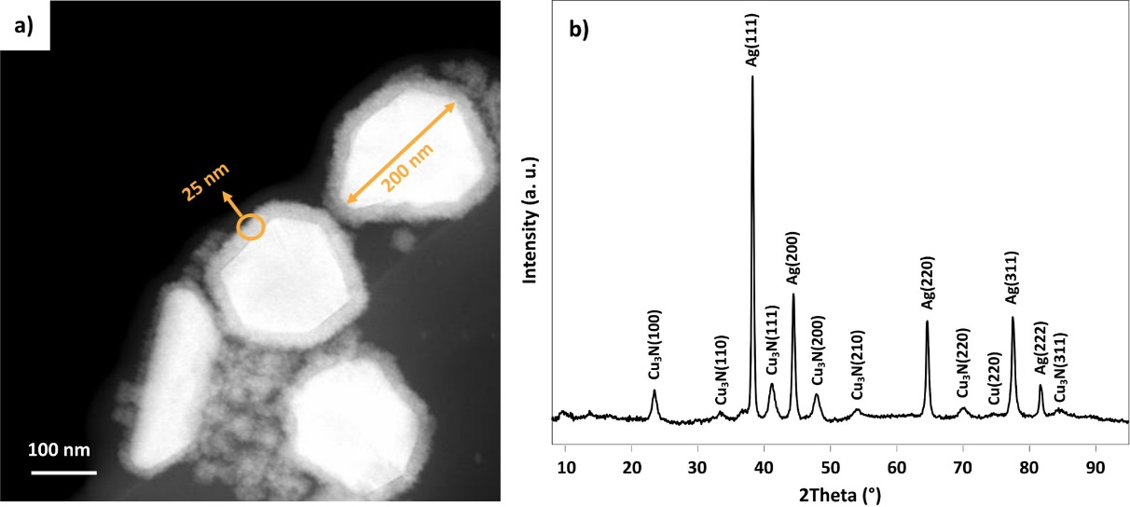
Fig. S1 (a) STEM image and (b) XRD pattern of Cu₃N/Ag mixture
Synthesis of Ag NPs
Silver nitrate (AgNO₃), 150 mg (0,88 mmol) was placed in a 50 ml round bottom flask, followed by the addition of 5 ml OAm (15,2 mmol) and 20 ml ODE (62,5 mmol). The mixture was heated up to 180 °C with constant stirring in an Ar flow for 1 h, cooled to 150 °C, and kept at that temperature for 5 h. During the reaction, the color of the solution changed to yellow and at the end turned to dark brown. The suspension was cooled down to room temperature and centrifuged at 4000 rpm for 30 min using a large excess of ethanol. Then, the pellet was dispersed in a few drops of toluene, precipitated by the addition of ethanol, and centrifuged at 4000 rpm for 30 min (repeated twice), the obtained particles were suspended in 10 ml of toluene.
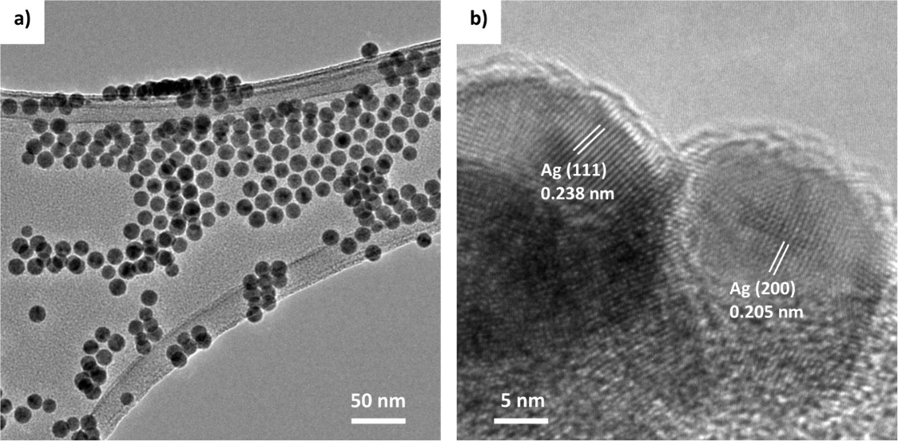
Fig. S2 TEM images of Ag NPs

Substoichiometric Cu₃N:Ag nanostructures
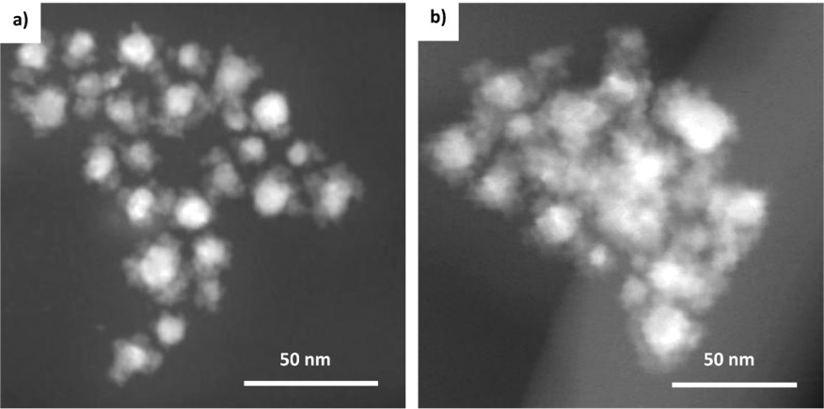
Fig. S3 TEM images of Cu₃N:Ag samples with Cu:Ag ratio of (a) 6:1 and (b) 30:1
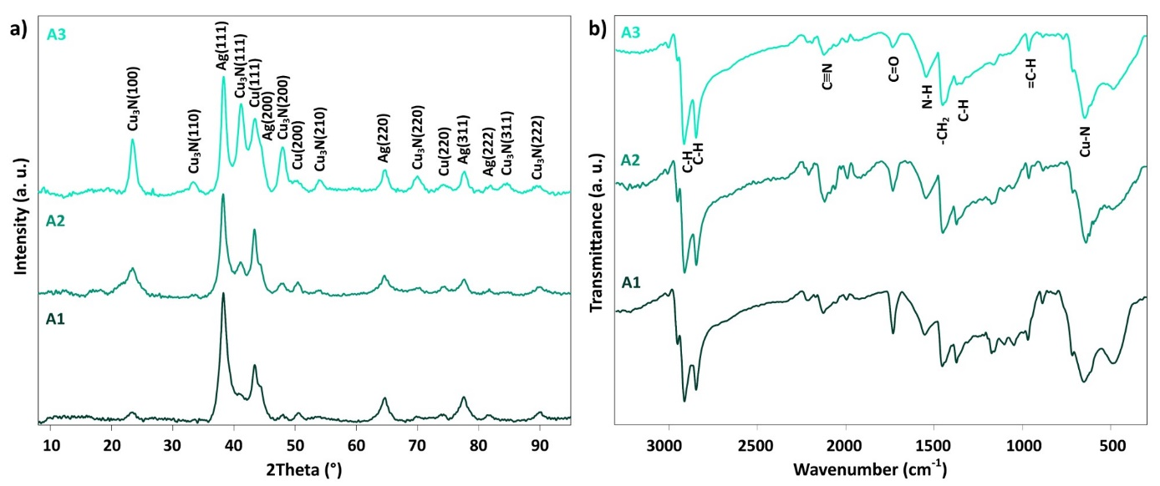
Fig. S4 (a) XRD patterns, (b) FT-IR spectra of Cu₃N:Ag with Cu:Ag ratio of 3:1 (A1), 6:1 (A2), and 30:1 (A3)
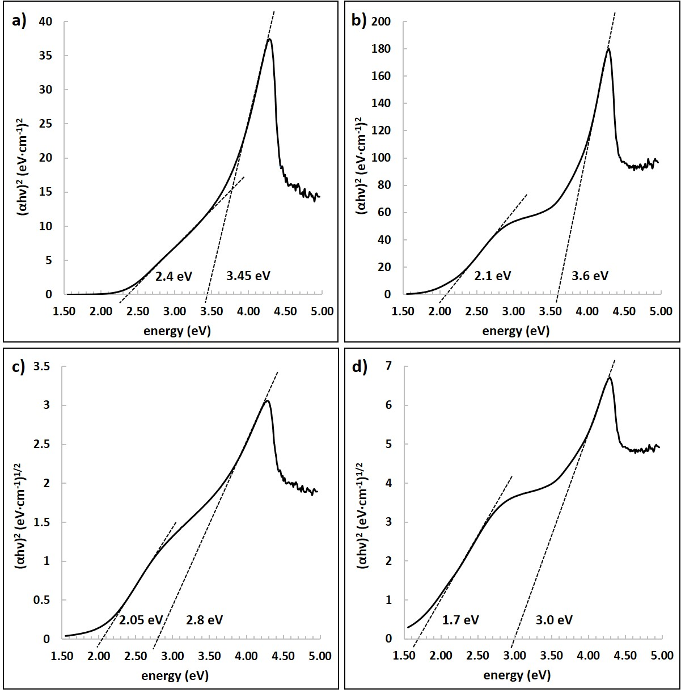
Fig. S5 Tauc’s plots for the direct transitions for (a) Cu₃N and (b) Cu₃N:Ag, and for the indirect transitions for (c) Cu₃N and (d) Cu₃N:Ag
Nitrogen adsorption-desorption isotherms
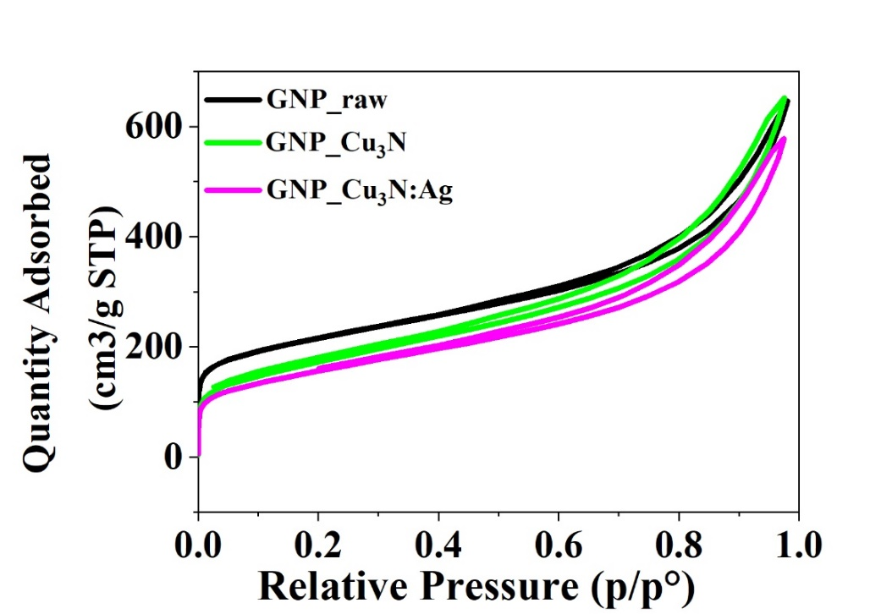
Fig. S6 Nitrogen adsorption-desorption isotherms of investigated samples

