In situ electron microscopy techniques for nanoparticle dispersion analysis of a commercial sunscreen
M Ilett^{1*}, E Naveed¹, T Roncal-Herrero¹, Z Aslam¹, S Micklethwaite¹ and N Hondow¹
¹School of Chemical and Process Engineering, University of Leeds, UK, LS2 9JT
*Corresponding author: m.a.ilett@leeds.ac.uk

Supplementary information

- MATERIALS AND METHODS
1.1 BiO Ma-Tek K kits

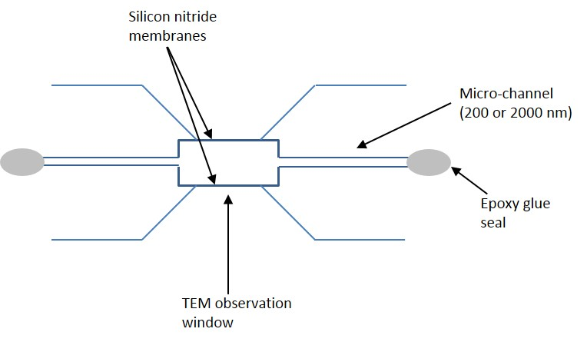
Fig. S1 K-kit schematic
1.2 Bulk analysis
For UV-Visible spectroscopy a Lambda X Park in Elmer UV-Visible spectrometer was used. 1 mL of diluted (0.213 mg/mL) sunscreen was loaded into a quartz cell. De-ionised water was used as the reference background sample and a spectrum across 200 – 900 nm was obtained.
A Malvern Zetasizer was used for DLS size distribution analysis. The sunscreen was diluted to 13.7 mg/mL in de-ionised water. A refractive index of 2.41 and 2.003 and absorption coefficient of 0.002 and 0.001 was used for TiO2, and ZnO, respectively.
XRD measurements were obtained using a Bruker D8 XRD across a 2θ range 10º to 80º using a Vantec detector and a standard wavelength, λ = 1.54 Å. A sample of commercial sunscreen was loaded onto a zero-background silicone sample holder. A rapid thermal processing temperature of 25ºC, step size 0.032º and a scan time of 5 minutes was used. Indexing was carried out according to the ICDD files (04-015-4060) and (04-004-4531).

- RESULTS
2.1 UV-Visible spectroscopy
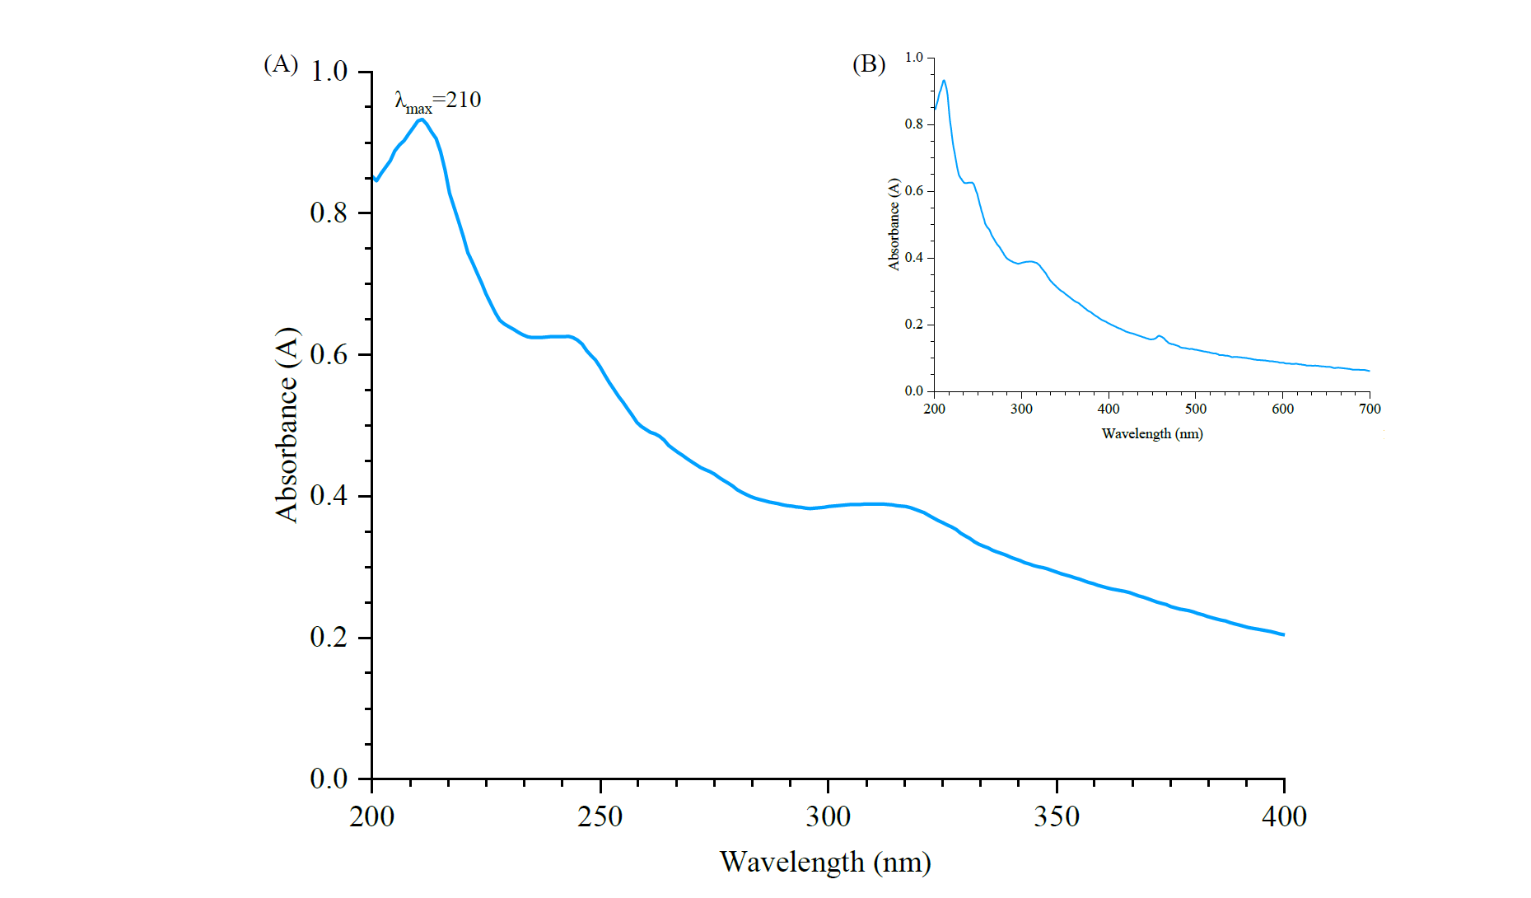
Fig. S2 (A) UV-Visible absorption spectra of commercial sunscreen containing TiO₂ and ZnO nanoparticles. Maximum absorption was observed at 210 nm confirming the presence of TiO₂. Inset (B) shows the entire UV-vis absorbance spectra

2.2 XRD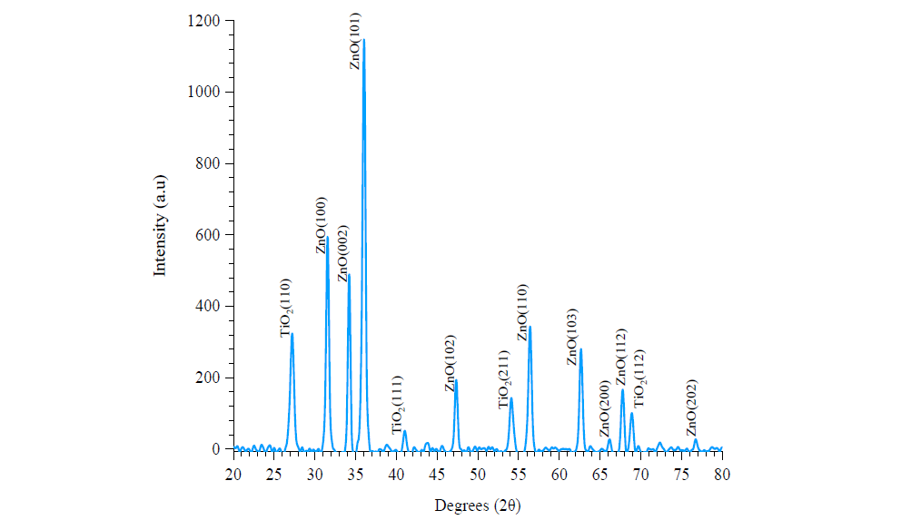
Fig. S3 X-ray diffraction pattern of a commercial sunscreen with rutile TiO₂ and hexagonal ZnO crystal structures. The pattern has been indexed according to ICDD files (04-008-7842) and (04-004-4531)
Table S1 Lattice spacing identified from the X-ray diffraction pattern for TiO₂ and ZnO nanoparticle crystals and crystallite size associated with each in a commercial sunscreen
TiO₂ |  | ZnO
Lattice spacing | Crystal size / nm | Lattice spacing | Crystal size / nm
110 | 29.8 | 100 | 100.4
111 | 21.1 | 002 | 101.1
211 | 42.4 | 101 | 73.1
112 | 35.1 | 102 | 75.9
 |  | 110 | 78.9
 |  | 103 | 81.4
 |  | 200 | 34.5
 |  | 112 | 65.4
 |  | 202 | 36.9

2.3 DLS
Table S2 Z averages of nanoparticles in a diluted suspension of commercial sunscreen determined through DLS

Particle Size / nm
 | Intensity | Number
Run 1 | 164.2 | 91.3
Run 2 | 205.2 | 68.1
Run 3 | 205.2 | 78.8

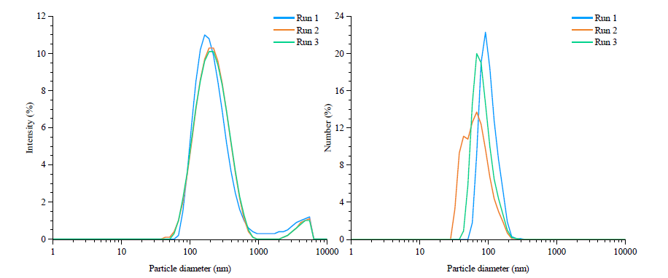
Fig. S4 Intensity and number size distributions obtained from DLS analysis of a commercial sunscreen

2.4 TEM dried sample
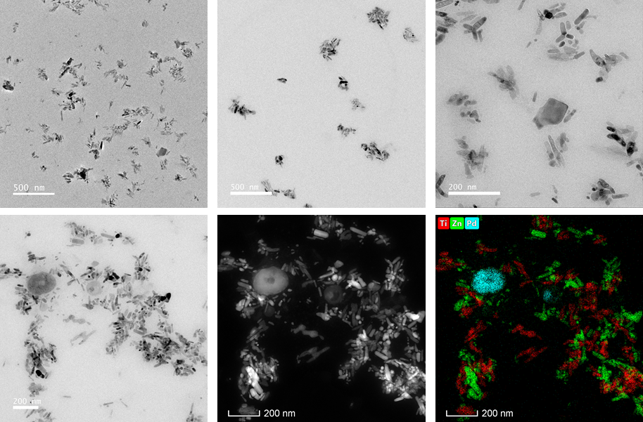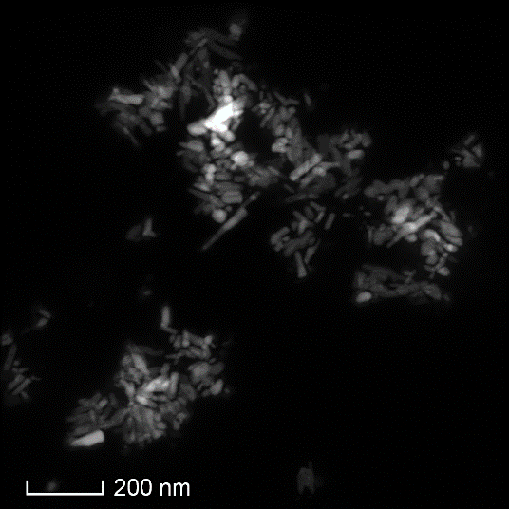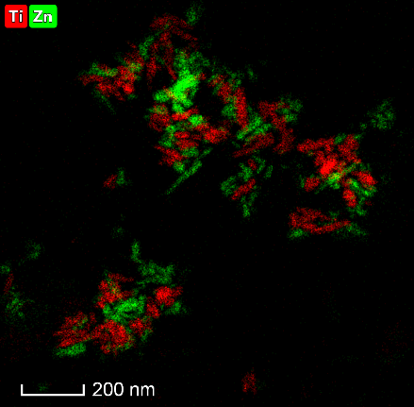
(A)
(B)
(C)
(D)
Fig. S5 (A) and (B) show TEM images of dried sunscreen indicated regions of agglomerated nanoparticles from which primary particle sizes were calculated. A HAADF STEM image (C) shows both TiO₂ and ZnO nanoparticles confirmed through spatial mapping of EDX signals (D) showing titanium in red and Zinc in green
  - EDX analysis
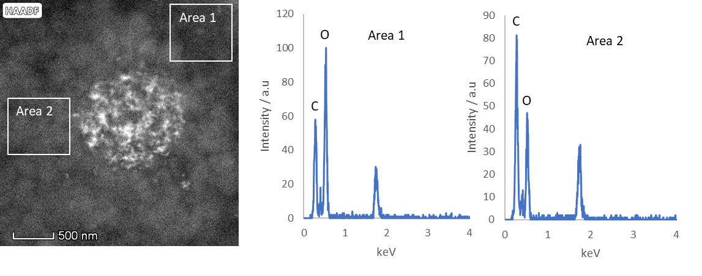
Fig. S6 EDX spectra showing the build up of carbon rich matter around a TiO₂ agglomerate during STEM acquisition

2.6 Overall summary of techniques
Table 3 Overall summary of each technique used in characterising the commercial sunscreen. Showing limitations of bulk techniques for individual size analysis and indicating the need to combine multiple EM techniques to obtain an accurate characterisation of complex nanoparticle dispersions. U and S relate to unsheared and sheared samples and NP agg. refers to combined (TiO₂ and ZnO) nanoparticle agglomerates.
 | EM techniques |  |  |  | Bulk techniques
 | TEM | Cryo-TEM | LCTEM | Cryo-SEM | DLS | XRD | UV-Vis
Chemical composition | TiO₂, ZnO, Si | TiO₂ and ZnO | TiO₂ | TiO₂, ZnO, Si | - | TiO₂ and ZnO | TiO₂
Size / nm | TiO₂  81 ± 11  ZnO  71 ± 32 | TiO₂  57 ± 10  ZnO  42 ± 18 | TiO₂ agg.  250-1000 (median 806) | NP agg.  Small  U 713 – 859  S 252-964  Large  U 4890 ± 1330  S 746 ± 330 | NP agg.  192 ± 86 | TiO₂  30-40  ZnO  30-100 | -

