SI 1. Immunofluorescence images of microtubules at 63X after TiO₂-NF exposure. The nuclei were visualized in blue, microtubules in green, and TiO₂-NF in white. The most representative images were shown of three independent experiments. Scale bar= 50 µm.
SI 2. Immunofluorescence images of actin filaments at 63X after TiO₂-NF exposure. The nuclei were visualized in blue, actin filaments in red, and TiO₂-NF in white. The most representative images were shown of three independent experiments. Scale bar = 50 µm.
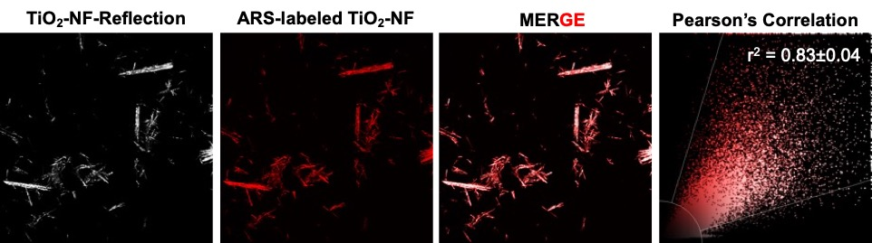
SI 3. Images of ARS-labeled TiO₂-NF and Pearson’s correlation obtained by confocal microscopy. The first image corresponds to TiO₂-NF obtained by reflectance confocal microscopy. After the ARS-labeled TiO₂-NF were observed using a 552 nm laser with an excitation wavelength of 729 nm and emission wavelength of 734 nm. MERGE corresponds to the overlap of TiO₂-NF-Reflection and ARS-labeled TiO₂-NF images. Pearson’s correlation coefficient (r) between channels was calculated from 11 images for each independent experiment using Leica SP8 software. Three independent experiments were performed, and data are presented as mean ± standard deviation (no units).

