Support Material

One-pot Synthesis of Metallic Nanoparticles and Luminescent Materials for Potential Optical Device Applications
Mariana Rigo Passarinª, Brayan Vanderlei Anacleto da Silvaª, Maria Izabel Xavier Scapolanª, Emilson R. Viana Jr.^{b}, Renata Danielle Adatiª, Marcela Mohallem Oliveiraª
ªDepartment of Chemistry and Biology, Federal University of Technology – Paraná, R. Dep. Heitor Alencar Furtado, 5000 - Cidade Industrial de Curitiba, Curitiba – PR, Brazil.
^{b}Physics Department, Universidade Tecnológica Federal do Paraná (UTFPR), Curitiba 80230-901, PR, Brazil

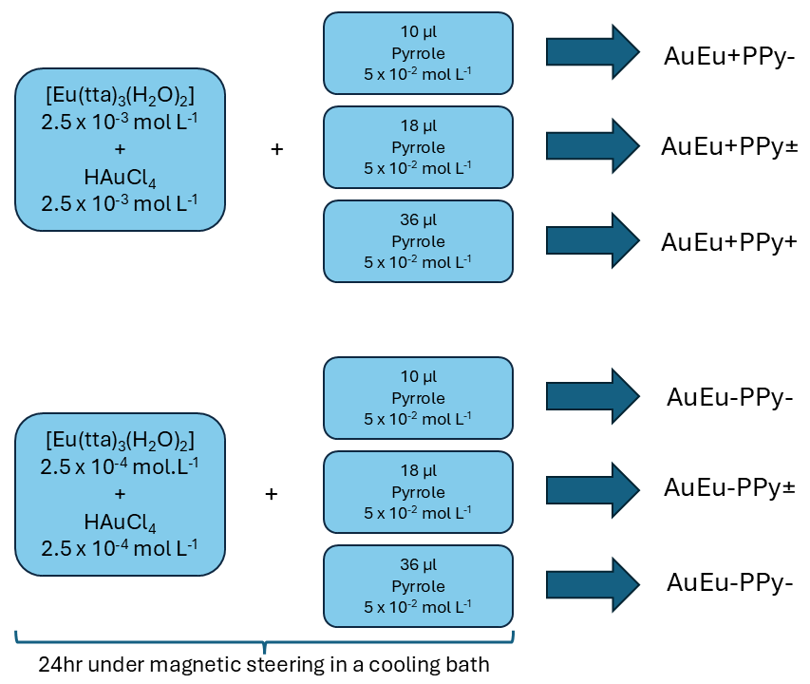
Fig. S1 representative diagram of the synthetic route scheme

Fig. S2 Excitation spectra of samples (a) AuEu+PPy± and AuEu-PPy± and (b) AuEu-PPy+ and AuEu-PPy+.

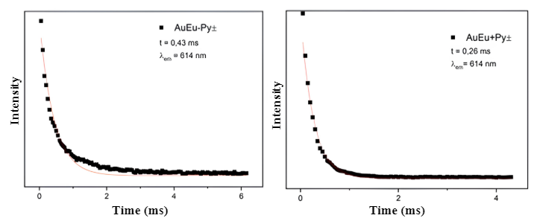
Fig. S3. Emission decay curves of the AuEu-PPy± and AuEu+PPy± samples monitoring the ⁵D₀ → ⁷F₂ transition with excitation at 263 nm.

