An overview of forest loss and restoration in the Brazilian Amazon
Supplementary material
Denis Conrado da Cruz^{a,*}, José Maria Rey Benayasª, Gracialda Costa Ferreira^{b}, Sabrina Ribeiro Santos^{b}, Gustavo Schwartz^{c}
ª University of Alcalá, Department of Life Sciences, Forest Ecology and Restoration Group, 28871 Alcalá de Henares, Spain.
^{b} Institute of Agricultural Sciences, Amazon Rural Federal University, 66.077.830, Belém, Brazil.
^{c} Forest Ecology and Management Embrapa Eastern Amazon, 66.095-100, Belém, Brazil.

⁎ Corresponding author
E-mail address: conrado_denis@hotmail.com, Tel: (+34) 603271445.

Table S1 List of 12 universities and five major environment agencies that were surveyed for projects related to forest recovery areas in the Brazilian Amazon.
States | University
Acre | Federal University of Acre - UFAC (http://www.ufac.br/)
Amapá | Federal University of Amapá - UNIFAP (http://www.unifap.br/public/)
Amazonas | State University of Amazonas - UEA (http://www3.uea.edu.br/)
Amazonas | Federal University of Amazonas - UFAM (https://ufam.edu.br/)
Pará | State University of Amapá - UEAP (http://ueap.edu.br/)
Pará | State University of Pará - UEPA (http://www.uepa.br/)
Pará | Federal University of Western Pará - UFOPA (http://www.ufopa.edu.br/ufopa)
Pará | Federal University of Pará - UFPA (https://portal.ufpa.br/)
Pará | Federal Rural University of Amazonia - UFRA (https://novo.ufra.edu.br/)
Rondônia | Federal University of Rondônia - UNIR (http://www.unir.br/)
Tocantins | State University of Tocantins - UNITINS (https://www.unitins.br/nPortal/)
Tocantins | Federal University of Tocantins - UFT (http://ww2.uft.edu.br/)
Abbreviation | Environmental Agencies
CIFOR | Center for International Forestry Research - Centro Internacional de Pesquisas Florestais
ICMBio | Chico Mendes Institute for Biodiversity Conservation - Instituto Chico Mendes de Conservação da Biodiversidade
MMA | Ministry of the Environment - Ministério de Meio Ambiente
IBAMA | Brazilian Institute of the Environment and Renewable Natural Resources - Instituto Brasileiro do Meio Ambiente e dos Recursos Naturais Renováveis
SEMA | State Department of the Environment - Secretaria Estadual de Meio Ambiente

Table S2 Annual deforestation between 2007 and 2018 and total accumulated deforestation in the priority municipalities to combat and control deforestation and in the “successful” municipalities deemed with controlled deforestation in the Brazilian Amazon.
Municipalities/States | Deforestation rates (km²)
Municipalities/States | 2007 | 2008 | 2009 | 2010 | 2011 | 2012 | 2013 | 2014 | 2015 | 2016 | 2017 | 2018 | 2018* | Situation
Apuí/Maranhão | 94 | 71 | 64 | 46 | 49 | 75 | 86 | 80 | 107 | 162 | 170 | 162 | 2,622 | To combat and control deforestation
Boca do Acre/ Maranhão | 34 | 39 | 25 | 53 | 60 | 55 | 35 | 66 | 48 | 91 | 91 | 117 | 2,619 | To combat and control deforestation
Lábrea/ Maranhão | 113 | 67 | 45 | 41 | 77 | 85 | 126 | 136 | 243 | 317 | 284 | 326 | 4,785 | To combat and control deforestation
Manicoré/ Maranhão | 39 | 42 | 30 | 63 | 56 | 61 | 43 | 29 | 73 | 86 | 100 | 82 | 2,093 | To combat and control deforestation
Novo Aripuanã/ Maranhão | 45 | 63 | 16 | 21 | 19 | 18 | 43 | 26 | 53 | 154 | 127 | 142 | 1,478 | To combat and control deforestation
Amarante do Maranhão/ Maranhão | 27 | 61 | 60 | 13 | 16 | 7 | 12 | 12 | 9 | 7 | 8 | 7 | 2,342 | To combat and control deforestation
Grajaú/ Maranhão | 73 | 56 | 59 | 90 | 51 | 43 | 23 | 22 | 11 | 9 | 9 | 7 | 1,506 | To combat and control deforestation
Aripuanã/ Mato Grosso | 84 | 81 | 42 | 32 | 34 | 21 | 40 | 40 | 52 | 84 | 93 | 113 | 4,319 | To combat and control deforestation
Colniza/ Mato Grosso | 257 | 125 | 76 | 79 | 87 | 81 | 156 | 146 | 251 | 224 | 176 | 239 | 4,970 | To combat and control deforestation
Cotriguaçu/ Mato Grosso | 128 | 78 | 36 | 27 | 22 | 45 | 43 | 45 | 58 | 51 | 44 | 23 | 2,235 | To combat and control deforestation
Gaúcha do Norte/ Mato Grosso | 69 | 198 | 9 | 3 | 10 | 10 | 25 | 32 | 11 | 58 | 48 | 9 | 3,712 | To combat and control deforestation
Juara/ Mato Grosso | 117 | 125 | 31 | 15 | 58 | 16 | 16 | 28 | 46 | 39 | 18 | 19 | 8,053 | To combat and control deforestation
Juína/ Mato Grosso | 45 | 54 | 21 | 10 | 8 | 14 | 27 | 33 | 52 | 52 | 33 | 23 | 4,567 | To combat and control deforestation
Marcelândia/ Mato Grosso | 80 | 178 | 4 | 6 | 21 | 12 | 37 | 35 | 45 | 55 | 48 | 22 | 3,698 | To combat and control deforestation
Nova Bandeirantes/ Mato Grosso | 141 | 126 | 53 | 17 | 49 | 34 | 63 | 70 | 37 | 82 | 49 | 62 | 3,477 | To combat and control deforestation
Nova Maringá/ Mato Grosso | 17 | 18 | 11 | 6 | 9 | 5 | 44 | 36 | 41 | 24 | 49 | 42 | 3,313 | To combat and control deforestation
Paranaíta/ Mato Grosso | 62 | 41 | 8 | 10 | 16 | 6 | 13 | 39 | 19 | 29 | 41 | 43 | 2,426 | To combat and control deforestation
Altamira/ Pará | 369 | 341 | 391 | 196 | 238 | 230 | 296 | 294 | 309 | 410 | 225 | 435 | 9,162 | To combat and control deforestation
Anapu/ Pará | 82 | 74 | 27 | 78 | 174 | 16 | 19 | 32 | 96 | 86 | 99 | 60 | 2,602 | To combat and control deforestation
Cumaru do Norte/ Pará | 292 | 186 | 37 | 44 | 59 | 59 | 38 | 25 | 41 | 33 | 42 | 30 | 7,368 | To combat and control deforestation
Itaituba/ Pará | 121 | 171 | 149 | 91 | 90 | 95 | 187 | 100 | 90 | 129 | 80 | 98 | 5,665 | To combat and control deforestation
Itupiranga/ Pará | 131 | 228 | 90 | 52 | 60 | 43 | 63 | 48 | 28 | 88 | 30 | 33 | 4,913 | To combat and control deforestation
Marabá/ Pará | 166 | 351 | 112 | 80 | 65 | 53 | 81 | 39 | 46 | 100 | 42 | 51 | 8,727 | To combat and control deforestation
Moju/ Pará | 79 | 116 | 67 | 116 | 43 | 43 | 35 | 25 | 26 | 31 | 46 | 35 | 4,430 | To combat and control deforestation
Novo Progresso/ Pará | 348 | 236 | 316 | 51 | 54 | 74 | 163 | 115 | 169 | 141 | 61 | 194 | 6,289 | To combat and control deforestation
Novo Repartimento/ Pará | 361 | 482 | 289 | 224 | 183 | 121 | 150 | 78 | 74 | 224 | 122 | 173 | 8,127 | To combat and control deforestation
Pacajá/ Pará | 168 | 261 | 101 | 275 | 185 | 34 | 30 | 78 | 166 | 141 | 180 | 138 | 5,927 | To combat and control deforestation
Placas/ Pará | 63 | 86 | 40 | 56 | 40 | 80 | 25 | 53 | 89 | 68 | 88 | 93 | 2,283 | To combat and control deforestation
Portel/ Pará | 87 | 97 | 31 | 56 | 68 | 12 | 17 | 60 | 109 | 178 | 168 | 100 | 2,176 | To combat and control deforestation
Rondon do Pará/ Pará | 86 | 54 | 31 | 53 | 27 | 14 | 29 | 22 | 19 | 27 | 19 | 25 | 5,597 | To combat and control deforestation
São Félix do Xingu/ Pará | 878 | 765 | 444 | 354 | 140 | 169 | 220 | 152 | 199 | 315 | 240 | 294 | 18,734 | To combat and control deforestation
Senador José Porfírio/ Pará | 60 | 15 | 4 | 29 | 72 | 19 | 15 | 28 | 59 | 68 | 99 | 52 | 1,092 | To combat and control deforestation
Uruará/ Pará | 154 | 92 | 100 | 70 | 39 | 53 | 47 | 15 | 53 | 64 | 89 | 85 | 3,489 | To combat and control deforestation
Buritis/ Rondônia | 117 | 21 | 17 | 34 | 43 | 22 | 51 | 58 | 55 | 83 | 68 | 45 | 2,632 | To combat and control deforestation
Candeias do Jamari/ Rondônia | 49 | 49 | 13 | 13 | 18 | 18 | 48 | 41 | 48 | 98 | 107 | 104 | 2,258 | To combat and control deforestation
Cujubim/ Rondônia | 69 | 49 | 31 | 35 | 48 | 57 | 55 | 41 | 66 | 86 | 87 | 73 | 1,944 | To combat and control deforestation
Machadinho D'oeste/ Rondônia | 79 | 53 | 29 | 18 | 55 | 67 | 81 | 61 | 98 | 94 | 99 | 74 | 3,443 | To combat and control deforestation
Nova Mamoré/ Rondônia | 139 | 67 | 29 | 61 | 78 | 78 | 134 | 137 | 149 | 147 | 180 | 152 | 3,895 | To combat and control deforestation
Pimenta Bueno/ Rondônia | 44 | 43 | 14 | 4 | 4 | 33 | 6 | 4 | 7 | 10 | 23 | 20 | 2,483 | To combat and control deforestation
Porto Velho/ Rondônia | 433 | 214 | 106 | 135 | 325 | 196 | 316 | 225 | 289 | 309 | 354 | 389 | 10,200 | To combat and control deforestation
Mucajaí/ Roraima | 61 | 216 | 20 | 61 | 27 | 18 | 39 | 49 | 22 | 46 | 8 | 19 | 1,917 | To combat and control deforestation
Total | 5,858 | 5,692 | 3,076 | 2,717 | 2,774 | 2,193 | 2,975 | 2,655 | 3,462 | 4,496 | 3,944 | 4,209 | 183,567 | To combat and control deforestation
Alta Floresta/ Mato Grosso | 61 | 16 | 7 | 3 | 6 | 2 | 7 | 10 | 9 | 9 | 12 | 9 | 4,975 | Controlled deforestation
Alto Boa Vista/ Mato Grosso | 7 | 18 | 14 | 4 | 20 | 5 | 2 | 1 | 0 | 1 | 6 | 45 | 1,226 | Controlled deforestation
Brasnorte/ Mato Grosso | 50 | 117 | 16 | 12 | 13 | 10 | 12 | 16 | 31 | 27 | 25 | 15 | 4,444 | Controlled deforestation
Cláudia/ Mato Grosso | 4 | 27 | 25 | 8 | 12 | 4 | 19 | 22 | 21 | 14 | 31 | 51 | 1,721 | Controlled deforestation
Confresa/ Mato Grosso | 66 | 65 | 8 | 13 | 25 | 50 | 20 | 24 | 21 | 19 | 27 | 16 | 3,907 | Controlled deforestation
Feliz Natal/ Mato Grosso | 22 | 224 | 4 | 28 | 28 | 20 | 22 | 50 | 84 | 80 | 41 | 63 | 2,387 | Controlled deforestation
Nova Ubiratã/ Mato Grosso | 20 | 141 | 31 | 23 | 94 | 20 | 10 | 16 | 28 | 23 | 44 | 24 | 4,479 | Controlled deforestation
Peixoto de Azevedo/ Mato Grosso | 109 | 71 | 25 | 23 | 58 | 41 | 52 | 23 | 37 | 36 | 40 | 24 | 3,622 | Controlled deforestation
Porto dos Gaúchos/ Mato Grosso | 12 | 30 | 9 | 22 | 21 | 8 | 15 | 17 | 31 | 9 | 20 | 33 | 3,132 | Controlled deforestation
Querência/ Mato Grosso | 40 | 72 | 7 | 22 | 15 | 39 | 14 | 15 | 18 | 22 | 17 | 71 | 5,258 | Controlled deforestation
Santa Carmem/ Mato Grosso | 11 | 24 | 6 | 11 | 10 | 3 | 25 | 9 | 8 | 21 | 27 | 15 | 1,570 | Controlled deforestation
São Félix do Araguaia/ Mato Grosso | 41 | 210 | 18 | 6 | 19 | 17 | 16 | 23 | 21 | 6 | 7 | 33 | 4,553 | Controlled deforestation
Tapurah/ Mato Grosso | 7 | 11 | 7 | 14 | 21 | 4 | 16 | 33 | 19 | 7 | 20 | 35 | 2,109 | Controlled deforestation
Vila Rica/ Mato Grosso | 102 | 79 | 8 | 7 | 12 | 11 | 8 | 5 | 6 | 6 | 6 | 3 | 4,654 | Controlled deforestation
Brasil Novo/ Pará | 112 | 18 | 58 | 50 | 39 | 9 | 32 | 9 | 11 | 7 | 28 | 20 | 2,690 | Controlled deforestation
Dom Eliseu/ Pará | 67 | 54 | 41 | 37 | 25 | 30 | 10 | 6 | 7 | 7 | 6 | 11 | 3,500 | Controlled deforestation
Paragominas/ Pará | 92 | 66 | 121 | 68 | 36 | 18 | 31 | 20 | 24 | 20 | 20 | 18 | 8,792 | Controlled deforestation
Santa Maria das Barreiras/ Pará | 120 | 107 | 25 | 48 | 34 | 20 | 21 | 20 | 13 | 19 | 18 | 18 | 5,956 | Controlled deforestation
Santana do Araguaia/ Pará | 223 | 191 | 27 | 40 | 34 | 23 | 39 | 24 | 17 | 20 | 15 | 13 | 7,252 | Controlled deforestation
Tailândia/ Pará | 58 | 73 | 17 | 50 | 19 | 9 | 33 | 10 | 7 | 14 | 14 | 14 | 2,286 | Controlled deforestation
Ulianópolis/ Pará | 29 | 137 | 44 | 19 | 23 | 32 | 11 | 3 | 23 | 18 | 16 | 7 | 3,546 | Controlled deforestation
Total | 1,252 | 1750 | 517 | 507 | 562 | 373 | 413 | 354 | 434 | 382 | 439 | 536 | 82,058 | Controlled deforestation
*Accumulated deforestation until 2018 |  |  |  |  |  |  |  |  |  |  |  |  | Km² | %
Deforestation in the 41 priority municipalities to combat and control deforestation |  |  |  |  |  |  |  |  |  |  |  |  | 4,156 | 56
Deforestation in the 21 municipalities with controlled deforestation |  |  |  |  |  |  |  |  |  |  |  |  | 536 | 7
Deforestation in the rest of (713) Brazilian Amazon municipalities |  |  |  |  |  |  |  |  |  |  |  |  | 2,693 | 37
Total deforestation in the Brazilian Amazon (775 municipalities) |  |  |  |  |  |  |  |  |  |  |  |  | 7,385 | 100

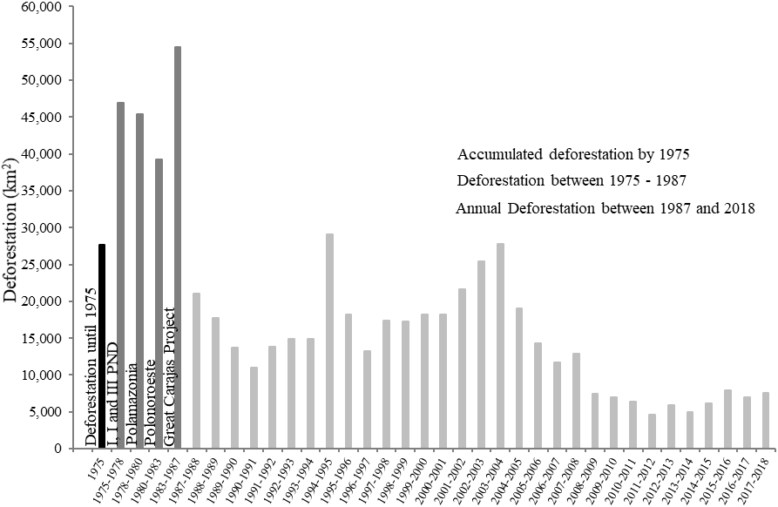
Establishment period of major development projects in Brazilian Amazon

Fig. S1 Historical series of deforestation from 1975 to 2018 in the Brazilian Amazon.

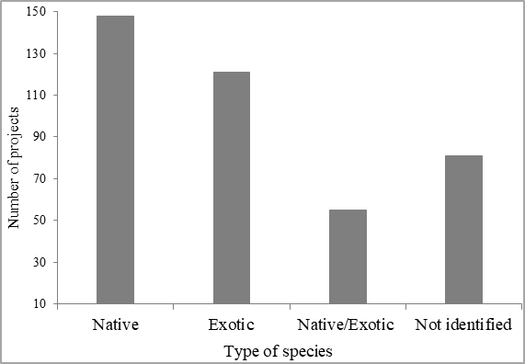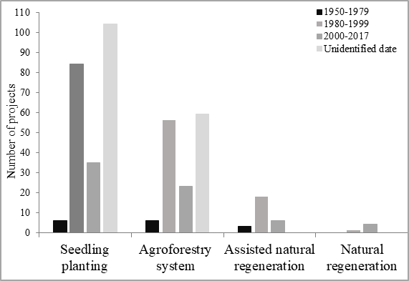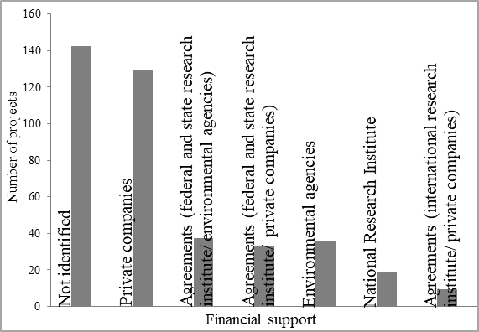 Fig. S2 Forest restoration projects implemented in Brazilian Amazon (1950 to 2017): a) types of technique; b) financial support, and c) type of species.
b)
a)
c)

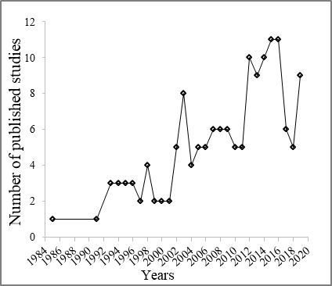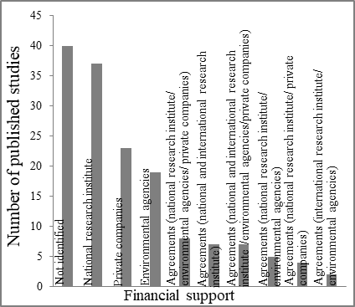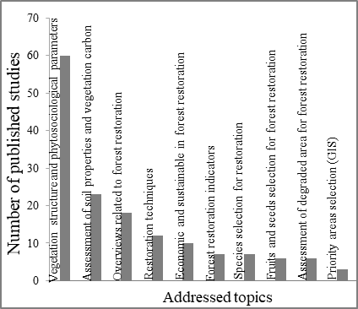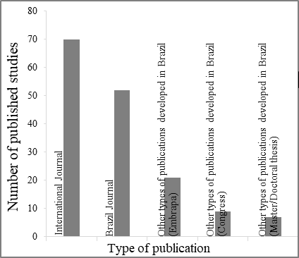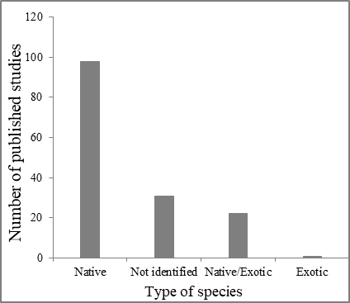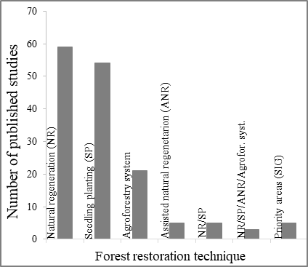
f)
c)
b)
e)
d)
a)
Fig. S3 Published studies related to forest restoration in the Brazilian Amazon: a) years of publication; b) financial support; c) type of publication; d) forest restoration techniques; e) type of species, and f) addressed topics.

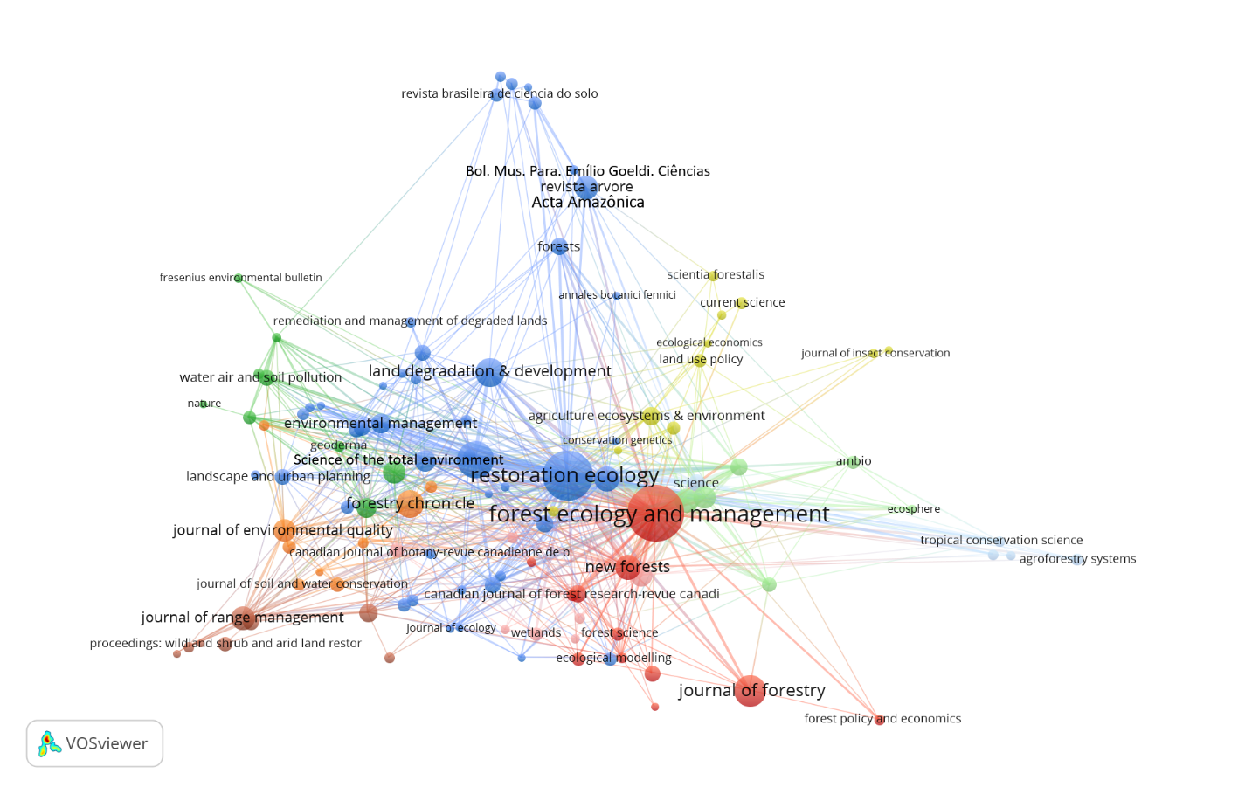
Fig. S4 Connectivity map of forest restoration studies in the Brazilian Amazon based on the journals where they were published. Frequency of studies is proportional to colored balls and font size.

Appendix S1. An overview for legal framework to conserve and restore forests in the Brazilian Amazon
After the deforestation “boom” in the Brazilian Amazon in the 1970s, the demand for forest restoration projects of degraded ecosystems increased, although many of them were unsuccessful (Rodrigues 2009). Thus, the need to establish norms and guidelines for environmental recovery emerged with the creation of legal instruments to compensate and repair damages caused to the environment.
The Brazilian Forest Code of 1934 (Decree 23,793/1934) was one of the first attempts to establish guidelines for the protection and maintenance of Brazilian forests as a common good for all. In 1965, it was reformulated to reinforce restriction to the use and occupation of land. In this reformulation (Federal Law no. 4,771/1965), the forest code has been criticized when dealing with limitations on the use of native forest in private properties, as found in art. 12: “In planted forests not considered as permanent preservation, the extraction of firewood and other forest products or the manufacture of coal is permitted. In other forests, it will depend on the norm established in the act of the Federal or State Power (public), in obedience to the dictated prescriptions of the technique and the local particularities”. Another notable reformulation in the Forest Code was Law No. 7,511/1986, which extends the limits of permanent preservation areas along the rivers or any watercourse. The 1988 Federative Constitution of Brazil empowered the Government to preserve and restore the essential ecological processes and to regulate the management of species and ecosystems, requiring that those who exploit mineral resources must recover the degraded environment. In the following year, the implementation of the Degraded Area Recovery Plan (Plano de Recuperação de Área Degradada - PRAD) was regulated with Decree No. 97,632, of April 1989.
With Law No. 9,605, of February 1998, those who cause damage to ecosystems should suffer penal and administrative sanctions derived from conducts and activities harmful to the environment. In Art. 23, II, the offender is required to recover the degraded environment, the Term of Conduct Adjustment (Termo de Ajustamento de Conduta - TAC) was also created with stipulated obligations, often translated into actions to recover degraded ecosystems.
The terms “restore” and “recover” have caused controversy in Brazil, and still brings doubts. For that reason, Law No. 9,985 of July 18, 2000, in art. 2, came up with the need to define the difference between “restored” and “recovered” ecosystems as follows: recovery is the restitution of a degraded ecosystem or wild population to a non-degraded condition, which may be different from its original condition; and restoration is the restitution of an ecosystem or a degraded wild population as close as possible to its original condition. The Permanent Preservation Area (PPA; Área de Preservação Permanente - APP) is a key issue for forest recovery. CONAMA - National Environment Council (Conselho Nacional de Meio Ambiente) Resolution No. 369, of March 28, 2006, established the legal duty of the land owner to recover the irregularly suppressed or occupied Permanent Preservation Areas, considering the due obligations to comply with the PRAD.
The Brazilian Institute for the Environment and Renewable Natural Resources (Instituto Brasileiro do Meio Ambiente e dos Recursos Naturais Renováveis - IBAMA), by means of the Normative Instruction (IN) no.4 of April 4, 2011, established better procedures for PRAD elaboration. This IN distinguishes two types of PRAD (PRAD and simplified PRAD), applied according to each case specified in the standards, and it is also determined that “PRAD must gather information, diagnoses, surveys and studies that enable evaluating the degradation and the consequent definition of measures suitable for the recovery of the area”.
The most recent change to the Forestry Code was Law No. 12,727/2012, also known as the Native Vegetation Protection Law (Lei de Proteção da Vegetação Nativa - LPVN), which establishes actions in several articles (1-amended, 7, 17, 41, 44, 46, 51, 54, 58, 61-amended, 64, 65 and 66) for the preservation and recovery of degraded areas in the Amazon and other Brazilian biomes.
Over the years, several legal frameworks have emerged with guidelines for implementing restoration projects (Table S3 - List of laws, decrees, normative instructions and resolutions on the recovery of degraded areas in the Brazilian Amazon).

Table S3 List of laws, decrees, normative instructions and resolutions on forest recovery in the Brazilian Amazon, ordered in increasing year
Regulation instrument | Description | Government Level
Law no. 6,938, of 31/08/1981. | Its art. 2 aims to preserve, improve and recover the environmental quality in Brazil. CONAMA and SISNAMA - National System of the Environment (Sistema Nacional do Meio Ambiente) were created from this law. | Federal
Law no. 7,347, of 24/07/1985. | Created instruments to enable the recovery of degraded areas based on a bidding system through a specific fund. | Federal
Resolution no. 001, of 23/01/1986. | CONAMA Resolution, which establishes criteria and guidelines for the Environmental Impact Study (Estudo de Impacto Ambiental - EIA) and Environmental Impact Report (Relatório de Impacto Ambiental - RIMA). | Federal
Brazilian Constitution of 1988. | Its art. 225: Everyone has the right to an ecologically balanced environment. Par. 1 - It is incumbent upon the Government to: I - preserve and restore essential ecological processes and provide for the ecological management of species and ecosystems; Par. 2 - Anyone who exploits mineral resources is obligated to recover the degraded environment. | Federal
Decree no. 97,632, of 10/04/1989. | Regulated the law no. 6,938/81, forcing the recovery of a degraded area as part of the Environmental Impact Report. It instituted the Plan for the Recovery of Degraded Areas (Plano de Recuperação de Áreas Degradadas - PRAD). | Federal
Law no. 8,171, of 17/01/1991 | Chapter VI - Protection of the Environment and Conservation of Natural Resources. The Government shall: (iv) promote and/or stimulate the recovery of areas in the process of desertification | Federal
Law no. 9,605, of 12/02/1998. | Provides criminal and administrative sanctions derived from harmful activities to the environment. Via art. 23, II, obliges the offender to restore the degraded environment. | Federal
Decree no. 3,420, of 20/04/2000. | Provides the creation of the National Forest Program (NFP). In its art. 2: [...] II - Foster reforestation activities, especially in small rural properties; III - Recover forests of permanent preservation, legal reserves and altered areas. | Federal
Law no. 9,985, of 18/07/2000. | In its art. 2, it distinguishes for its purposes a “recovered” ecosystem versus a “restored” ecosystem, as follows: [...] XIII - Recovery: restitution of a degraded ecosystem or wild population to a non-degraded condition, which may be different from its original condition; XIV - Restoration: restitution of a degraded ecosystem or wild population as close as possible to its original condition. | Federal
Resolution no. 302, of 20/03/2002. | Art. 2: III - Environmental Conservation Plan and Use of the Artificial Reservoir Environment: set of guidelines and propositions with the objective of disciplining conservation, recovery, use and occupation of the surroundings of artificial reservoirs. | Federal
Resolution no. 310, of 5/07/2002. | Art. 10: Sustainable Forest Management Plan, will only be approved: I - the proper registration, maintenance and recovery of the Legal Reserve; II - maintenance and recovery of Permanent Preservation Areas and other protected areas. | Federal
Decree no. 4,339, of 22/08/2002. | Establishes principles and guidelines for implementing the National Biodiversity Policy, with incentive mechanisms for the recovery and protection of PPA (APP) and legal reserves provided by Law. | Federal
Law no. 11,284, of 2/03/2006. | Provides for the management of public forests for sustainable production; and in its art. 31, it is incumbent upon the entrepreneur: IV - to recover the degraded areas, when their actions or omissions are identified. | Federal
Resolution no. 369, of 28/03/2006. | CONAMA Resolution, in its art. Paragraph 2 considers the legal duty of the owner or proprietor to recover irregularly suppressed or occupied PPAs (APPs). In Paragraph 8, those entitled with the activities of research and extraction of mineral substances in a PPA are also obliged to recover the degraded environment. | Federal
Resolution no. 387, of 27/12/2006. | CONEMA, provides for environmental recovery actions, through elaboration of the Settlement Recovery Plan, with recovery of legal reserve areas and permanent preservation. | Federal
Decree no. 6,514, of 22/07/2008. | Provides for infractions and administrative sanctions to the environment. In art. 2, any action or omission that violates the legal rules of use, enjoyment, promotion, protection and recovery of the environment is considered an environmental administrative infraction; and in art. 108, provides the embargo of work or irregular activity. | Federal
Decree no. 6,686, of 10/12/2008. | In its art. 17, the embargo of irregularly exploited areas and the objective of the Sustainable Forest Management Plan, does not exempt its holder of the execution of maintenance activities or forest recovery. | Federal
IN ICMBio no. 06 of 01/122009. | In its art. 3, according to this Normative Instruction (IN), a precautionary administrative measure capable of preventing the occurrence of new illicit acts may be applied. In art. 39, the embargo of work or activity and their respective areas. Art. 80, to verify the existence of damages to be repaired, forcing the violator to present the recovery project. Art. 88, charging of a fine by ICMBio. Article 112, provides requests for conversion of fines in preservation services. | Federal
Resolution no. 429, of 28/02/2011. | Provides for the methodology of recovering Permanent Preservation Areas - PPAs (APPs). | Federal
IN IBAMA no. 4, of 13/04/2011. | Establishes procedures for the elaboration of a Degraded Area Recovery Project (Projeto de Recuperação de Área Degradada – PRAD). | Federal
Law no. 12,651, of 25/05/2012. | Provides for the protection of native vegetation and replaces the Forest Code, outlined by several articles (1-A, 7, 17, 41, 44, 46, 51, 54, 58, 61-A, 64, 65 and 66) with organized actions between the public sector and civil society. | Federal
IN ICMBio no. 11, of 11/12/2014. | Establishes procedures for the elaboration, analysis, approval and follow-up of the implementation of a Degraded Area Recovery Project, for the purpose of complying with environmental legislation. | Federal
Decree no. 9,179, of 23/10/2017. | In its art. 140, considers the services of preservation, improvement and reestablishment of the environment, and recovery actions: a) degraded areas for biodiversity conservation; (b) essential ecological processes; c) native vegetation for protection; and d) recharge water supply areas. | Federal
IN ICMBio no. 2, of 02/19/2018. | Provides the procedures related to the conversion of simple fines into services of preservation, improvement and recovery of the environment quality within the Chico Mendes Institute. | Federal
Constitution of the State of Pará | Contains determinations on the recovery of degraded areas in the chapters: III - Agricultural, Agrarian and Land Property Policy, IV - Science and Technology and VI - Environment. Promulgated on October 5, 1989 and updated until the edition of Constitutional Amendment No. 51 of December 14, 2011. | State (Pará)
Constitution of Rondônia | It contains determinations related to the conservation and restoration of natural resources by their rational use in art. 181, subsection III. Promulgated on September 28, 1989 and updated until Constitutional Amendment No. 80/2012. | State (Rondônia)
Constitution of Tocantins | In its art. 103, establishes development guidelines to be followed: VI - the preservation, protection and environmental recovery of the cultural and urban heritage described in art. 110. paragraph 4 and art. 142 paragraph 4. Promulgated on October 10, 1989, with the amendments adopted by Constitutional Amendments Nos. 01/89 to 14/2003. | State (Tocantins)
Constitution of Amazonas | In its art. 174. V - Guide farmers on management techniques for soil recovery. Art. 219. IV - development of management techniques, reforestation with species appropriate to the characteristics of the region and recovery of degraded areas. Art. 230 X - to register, monitor and supervise the concessions of the right of research and exploitation of water and mineral resources, as well as the recovery of the degraded environment. Article 236, Par. 2 - those who use environmental resources are obligated, by law, to contribute to the monitoring, prevention and recovery programs. Published on 05.10.89, updated until Constitutional Amendment No. 96, of 24.03.2017. | State (Amazonas)
Constitution of Roraima | In its art. 32, provides for all matters within the competence of the State: IX - protection, recovery and incentive to preserve and conserve the environment; Art. 166. IV - require mining companies to recover the soil and reforestation in places where mining activities were performed. Promulgated on 12/31/1991, updated until the Constitutional Amendment of 28.08.2012 | State (Roraima)
Constitution of Amapá | In its art. 95, provides for all matters of State competence, especially on protection, recovery and incentive to preserve the environment. Promulgated on December 20, 1991, updated until Constitutional Amendment No. 0056, of 03.05.2017. | State (Amapá)
Constitution of Acre | In its art. 206, paragraph 2: All that exploit mineral resources will obligatorily perform the recovery of the degraded environment, using the technique determined by the competent public organ, according to the form of the law. Text promulgated on October 3, 1989 and updated by Constitutional Amendment n. 19/2000. | State (Acre)
Constitution of Mato Grosso | In its art. 296, the State will apply 5% of that to invest in water resource projects, in the study of water pollution control, floods prevention, silting and recovery of degraded areas. In art. 339, 342 and art. 353 Scientific and Technological Policy shall take respect for human life and health, rational and non-predatory exploitation of natural resources, preservation and recovery of the environment as its principles. Promulgated on 10/10/1989, with the amendments adopted by constitutional amendments nº 01/1991 to 71/2014. | State (Mato Grosso)
Constitution of Maranhão | In its art. 199, proceed to conduct agricultural zoning and implement a policy of support for the preservation and recovery of forest on the slopes, pre-Amazonian Maranhão and protected forests of watersheds/courses. In Article 239, it has the duty to ensure its preservation and recovery for the benefit of present and future generations; and in art. 244, it is mandatory to recover native vegetation in protected areas by law. Define the criteria and methods of recovery and penalties for offenders. Enacted on October 5, 1989, Constitutional Amendment No. 069, of 02/12/2014. | State (Maranhão)

