Towards effective reforestation: growth and commercial value of four commonly planted tropical timber species on infertile soils in Panama
Katherine Sinacore, Edwin H. García, Theodore Howard, Michiel van Breugel, Omar R. Lopez, Alex J. Finkral, Jefferson S. Hall

Supplementary Materials for New Forests

Table S1. Mean net present value (US$ ha⁻¹) of treatments with changing interest rate (%) for Scenario 1. Treatments include: Dr mono (D. retusa monoculture), Dr-Pq mix (D. retusa and P. quinata mixtures), Dr-Ta mix (D. retusa and T. amazonia mixtures), Pq mono (P. quinata monoculture), Pq-Ta mix (P. quinata and T. amazonia mixture), Ta mono (T. amazonia monoculture), and Tg mono (Tectona grandis monoculture). Gray shading represents where NPV changes from positive to negative.
Scenario 1: US$960 ha⁻¹ (teak) US$1,200 ha⁻¹ (natives) establishment costs, maintenance costs years 1-4 (US$640, US$580, US$500, and US$480 ha⁻¹) & $65/m³ harvest costs
Interest | Net Present Value (US $/ha)
Rate (%) | Dr mono | Dr-Pq mix | Dr-Ta mix | Pq mono | Pq-Ta mix | Ta mono | Tg mono
1 | 98,485 | 31,277 | 13,104 | 586 | 6,840 | 21,080 | 2,656
2 | 72,476 | 22,466 | 8,943 | -372 | 4,282 | 14,878 | 1,230
3 | 53,296 | 15,975 | 5,884 | -1,067 | 2,406 | 10,313 | 189
4 | 39,113 | 11,183 | 3,631 | -1,571 | 1,028 | 6,945 | -571
5 | 28,596 | 7,636 | 1,969 | -1,935 | 15 | 4,456 | -1,125
6 | 20,778 | 5,006 | 741 | -2,197 | -729 | 2,613 | -1,527
7 | 14,952 | 3,052 | -166 | -2,382 | -1,275 | 1,246 | -1,818
8 | 10,601 | 1,598 | -836 | -2,513 | -1,675 | 233 | -2,027
9 | 7,344 | 516 | -1,330 | -2,602 | -1,966 | -520 | -2,176
10 | 4,901 | -290 | -1,694 | -2,661 | -2,178 | -1,078 | -2,279
11 | 3,067 | -890 | -1,960 | -2,697 | -2,329 | -1,491 | -2,350
12 | 1,687 | -1,337 | -2,155 | -2,718 | -2,436 | -1,796 | -2,395
13 | 647 | -1,668 | -2,295 | -2,726 | -2,510 | -2,020 | -2,423
14 | -135 | -1,913 | -2,394 | -2,725 | -2,560 | -2,183 | -2,437
15 | -725 | -2,093 | -2,463 | -2,718 | -2,591 | -2,301 | -2,441

Table S2. Mean net present value (US$ ha⁻¹) of treatments with changing interest rate (%) for Scenario 3. Treatments include: Dr mono (D. retusa monoculture), Dr-Pq mix (D. retusa and P. quinata mixtures), Dr-Ta mix (D. retusa and T. amazonia mixtures), Pq mono (P. quinata monoculture), Pq-Ta mix (P. quinata and T. amazonia mixture), Ta mono (T. amazonia monoculture), and Tg mono (Tectona grandis monoculture). Gray shading represents where NPV changes from positive to negative.
Scenario 3 US$1,440 ha⁻¹ (teak) US$1,800 ha⁻¹ (natives) establishment costs, maintenance costs years 1-4 (US$960, US$870, US$750, US$720 ha⁻¹) & $65/m³ harvest costs
Interest | Net Present Value (US $/ha)
Rate (%) | Dr mono | Dr-Pq mix | Dr-Ta mix | Pq mono | Pq-Ta mix | Ta mono | Tg mono
1 | 96,811 | 29,602 | 11,429 | -1,088 | 5,166 | 19,405 | 1,102
2 | 70,826 | 20,816 | 7,293 | -2,021 | 2,632 | 13,228 | -300
3 | 51,670 | 14,349 | 4,258 | -2,693 | 780 | 8,687 | -1,317
4 | 37,509 | 9,580 | 2,027 | -3,174 | -576 | 5,342 | -2,054
5 | 27,015 | 6,055 | 387 | -3,516 | -1,566 | 2,875 | -2,586
6 | 19,218 | 3,446 | -819 | -3,757 | -2,289 | 1,053 | -2,967
7 | 13,412 | 1,512 | -1,705 | -3,922 | -2,815 | -293 | -3,238
8 | 9,081 | 79 | -2,356 | -4,032 | -3,195 | -1,287 | -3,427
9 | 5,843 | -985 | -2,831 | -4,102 | -3,467 | -2,021 | -3,557
10 | 3,419 | -1,772 | -3,176 | -4,143 | -3,660 | -2,560 | -3,642
11 | 1,602 | -2,355 | -3,425 | -4,162 | -3,794 | -2,955 | -3,694
12 | 239 | -2,784 | -3,602 | -4,165 | -3,884 | -3,243 | -3,723
13 | -783 | -3,099 | -3,725 | -4,157 | -3,941 | -3,451 | -3,734
14 | -1,550 | -3,328 | -3,809 | -4,140 | -3,975 | -3,598 | -3,732
15 | -2,124 | -3,493 | -3,863 | -4,117 | -3,990 | -3,700 | -3,720

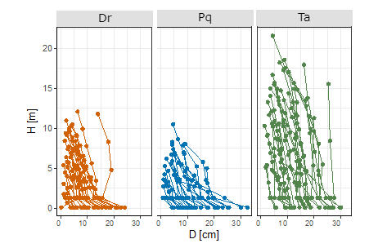
Fig. S1 The diameter of the tree bole along the length of the tree for three species. Dr (Dalbergia retusa), Pq (Pachira quinata), and Ta (Terminalia amazonia). Each point represents the diameter (cm) at a specific height (m) along the length of the trees’ bole. The lines represent individual trees.

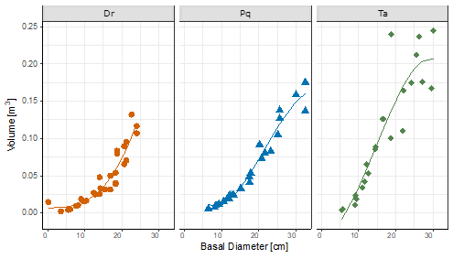
Fig. S2 Relationship between basal diameter tree volume for three species. Dr (Dalbergia retusa), Pq (Pachira quinata), and Ta (Terminalia amazonia). Each point represents the basal diameter (cm) and corresponding tree volume (m³) estimate. The lines show the modeled tree volumes for each species.

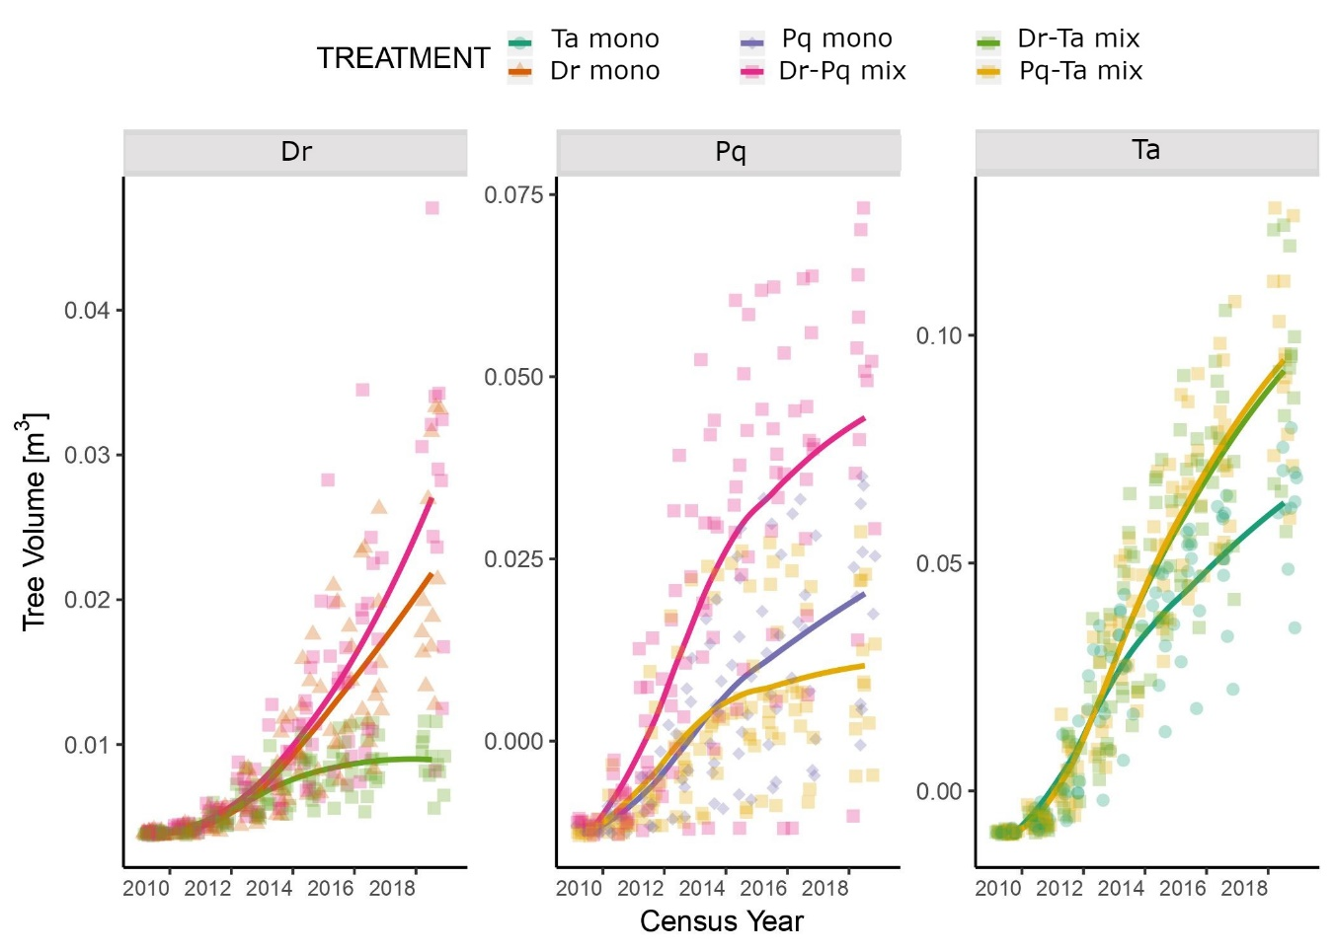
Fig. S3 Individual tree volume (m³) by census year and treatment. Treatments include: Ta mono (T. amazonia monoculture), Dr mono (D. retusa monoculture), Pq mono (P. quinata monoculture), Dr-Pq mix (D. retusa and P. quinata mixtures), Dr-Ta mix (D. retusa and T. amazonia mixtures), and Pq-Ta mix (P. quinata and T. amazonia mixture).
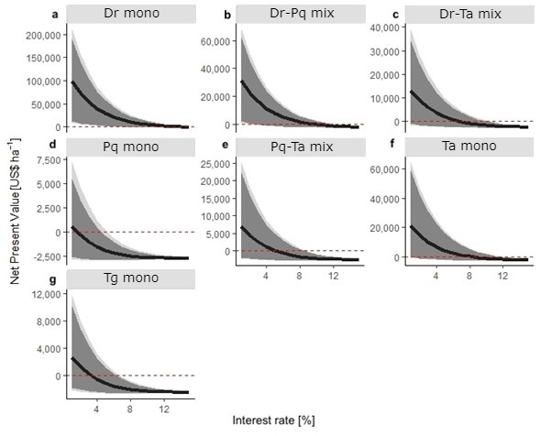
Fig. S4 Modeled net present value (US$ ha⁻¹) by interest rate (%) and treatment for Scenario 1. (a, d, f, g) Monoculture predictions for Dr mono (Dalbergia retusa), Pq mono (Pachira quinata), Ta mono (Terminalia amazonia), and Tg mono (Tectona grandis). (b, c, e) Two species mixtures predictions for Dr-Pq mix (D. retusa and P. quinata), Dr-Ta mix (D. retusa and T. amazonia), and Pq-Ta mix (P. quinata and T. amazonia). Black line is the predicted net present value (NPV) by the interest rate. Light gray shading represents credible interval of 90% and dark gray shading represents confidence interval of 95%. Dashed red line represents where NPV = 0.

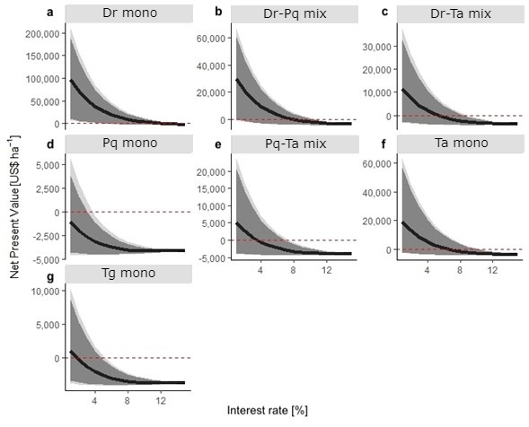

Fig. S5 Modeled net present value (US$ ha⁻¹) by interest rate (%) and treatment for Scenario 3. (a, d, f, g) Monoculture predictions for Dr mono (Dalbergia retusa), Pq mono (Pachira quinata), Ta mono (Terminalia amazonia), and Tg mono (Tectona grandis). (b, c, e) Two species mixtures predictions for Dr-Pq mix (D. retusa and P. quinata), Dr-Ta mix (D. retusa and T. amazonia), and Pq-Ta mix (P. quinata and T. amazonia). Black line is the predicted net present value (NPV) by the interest rate. Light gray shading represents credible interval of 90% and dark gray shading represents confidence interval of 95%. Dashed red line represents where NPV = 0.

