Supplementary information

Table S1. Summary of the Bayesian regression models of growth in diameter, height, and volume of Retrophyllum rospigliosii in plantations by site in Colombia.
Model | Site | Parameter | Estimate | Est. Error
Diameter | La Suecia | k | 0.32 | 0.01
Diameter | La Suecia | w | 3.95 | 0.17
Diameter | La Suecia | A | 21.27 | 0.69
Diameter | Claridad | k | 0.25 | 0.01
Diameter | Claridad | w | 2.99 | 0.22
Diameter | Claridad | A | 28.90 | 0.75
Diameter | Santa Isabel | k | 0.27 | 0.01
Diameter | Santa Isabel | w | 3.97 | 0.18
Diameter | Santa Isabel | A | 16.30 | 0.49
Height | La Suecia | k | 0.12 | 0.01
Height | La Suecia | w | 1.56 | 0.09
Height | La Suecia | A | 14.26 | 0.54
Height | Claridad | k | 0.09 | 0.01
Height | Claridad | w | 1.17 | 0.10
Height | Claridad | A | 16.49 | 1.03
Height | Santa Isabel | k | 0.16 | 0.01
Height | Santa Isabel | w | 1.99 | 0.12
Height | Santa Isabel | A | 9.71 | 0.38
Volume | La Suecia | k | 0.41 | 0.01
Volume | La Suecia | w | 9.46 | 0.53
Volume | La Suecia | A | 154.81 | 6.86
Volume | Claridad | k | 0.26 | 0.04
Volume | Claridad | w | 5.04 | 0.40
Volume | Claridad | A | 199.90 | 11.89
Volume | Santa Isabel | k | 0.27 | 0.01
Volume | Santa Isabel | w | 6.44 | 0.42
Volume | Santa Isabel | A | 117.49 | 7.19

Table S2. Soil taxonomy and physical-chemical characteristics of the soils at the study sites in Colombia.
Site | Soil taxonomy | Depth A_{h}t horizon (cm) | Soil  texture | Bulk density | pH (water) | OM  % | P (ppm) | N  % | K  % | Ca % | Mg  % | CICE
La Suecia | Alic Melanudands | 43.0 | Loam | 0.55 | 4.1 | 24.9 | 2.0 | 0.76 | 0.19 | 0.10 | 0.20 | 6.14
Claridad | Acrudoxic Melanudands | 43.0 | Loam-Clay | 0.44 | 5.5 | 11.2 | 5.0 | 0.72 | 0.20 | 0.50 | 0.30 | 1.81
Santa Isabel | Andic Melanudands | 30 | Loam-Clay | 0.90 | 5.3 | 23.0 | 3.0 | 0.75 | 0.24 | 0.20 | 0.10 | 7.80

Figure S1. Location of the forestry plantations where the growth of Retrophyllum rospigliosii was studied in Colombia.

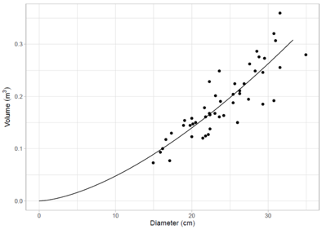
Figure S2. Diameter – volume relationship of Retrophyllum rospigliosii according to the data presented by Cueva et al. (2013).

Figure S3. Predicted lines of the current annual increment (CAI = dY/dt = f (t)) in diameter (D), height (H), and volume (V) of Retrophyllum rospigliosii in stands of three sites in Colombia (black line represents mean CAI).
Figure S4. Predicted lines of the mean annual increment (MAI = D/t = f (t)) for diameter (D), height (H), and volume (V) of Retrophyllum rospigliosii in stands of three sites in Colombia (black line represents mean MAI).

