Supplementary Material

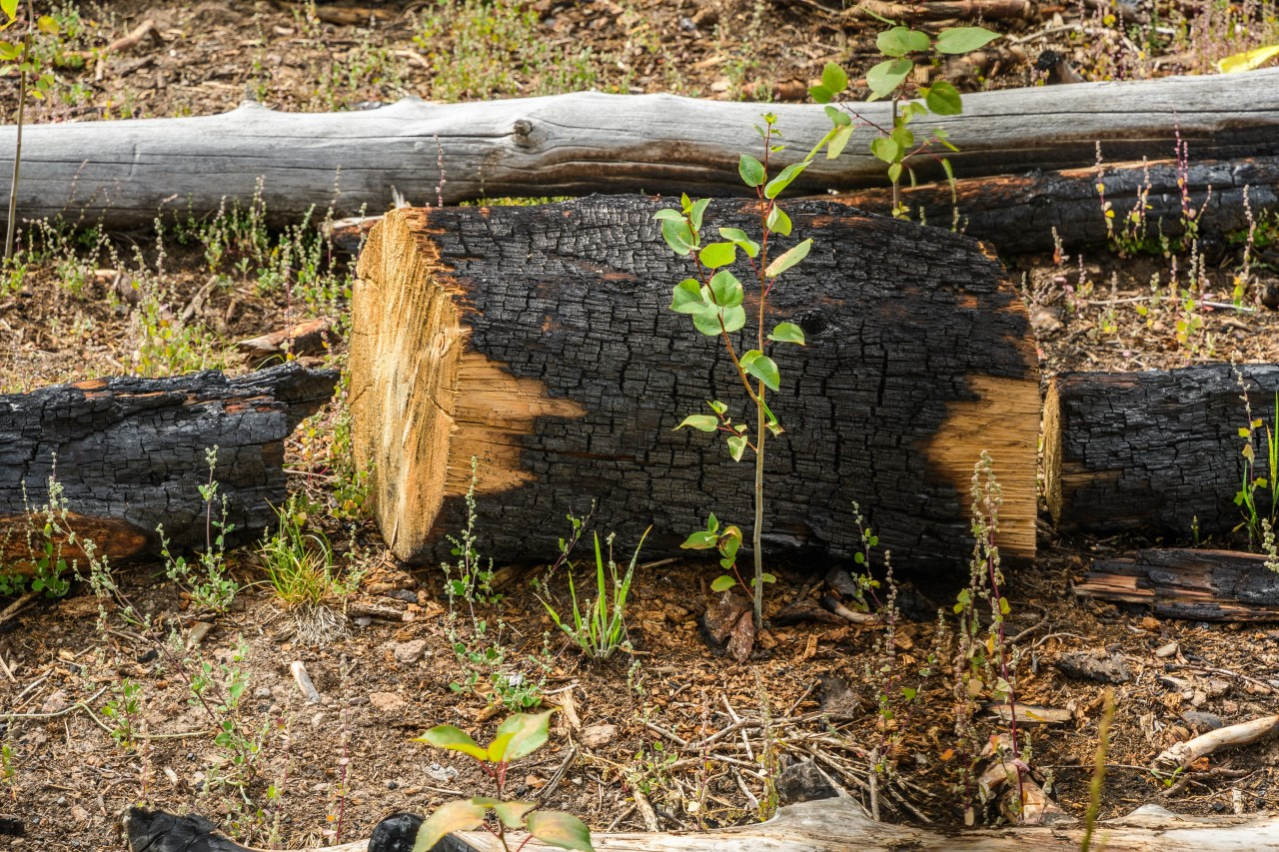
Fig. S1 Representative view of a planted seedling with sparse competing vegetation

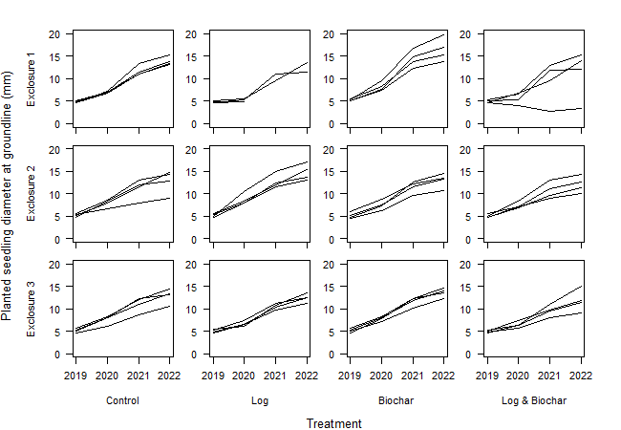
Fig. S2 Planted seedling absolute diameter growth from 2019 through 2022 by exclosure and treatment type

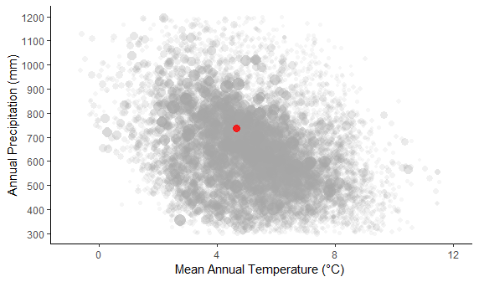
Fig. S3 Red dot is 2018-2022 mean of annual precipitation and temperature at Brian Head (PRISM Climate Group 2024). Gray points are 1981–2010 normals from 10,000 randomly selected points within the modeled distribution of aspen (National Individual Tree Species Atlas [Ellenwood et al. 2015]). Size and transparency of gray points are proportional to the modeled basal area of aspen in that pixel. Script modified from Kreider and Yocom (2021b)

