Online Resource 2. Pre-piloted proforma used to extract data
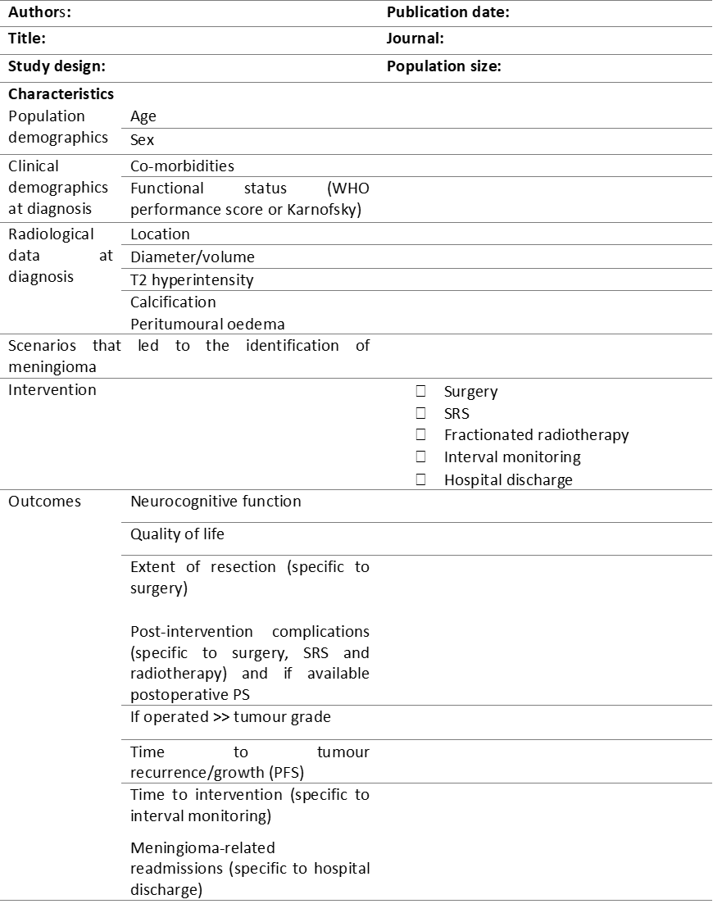

Incidental Intracranial Meningiomas: A Systematic Review and Meta-Analysis of Prognostic Factors and Outcomes
Journal of Neuro-Oncology
Authors and affiliations:

Abdurrahman I. Islim, MPhil ^{1,2,3}
Midhun Mohan, MRes ^{2,3}
Richard D.C. Moon, MB, BChir ^{2,3}
Nisaharan Srikandarajah, MRCS, MBBS ^{1,3}
Samantha J. Mills, PhD ⁴
Andrew R. Brodbelt, PhD ³
Michael D. Jenkinson, PhD ^{1,3}

- Institute of Translational Medicine, University of Liverpool, Liverpool, UK
- Faculty of Health and Life Sciences, University of Liverpool, Liverpool, UK
- Department of Neurosurgery, The Walton Centre NHS Foundation Trust, Liverpool, UK
- Department of Neuroradiology, The Walton Centre NHS Foundation Trust, Liverpool, UK

Corresponding author:
Abdurrahman I Islim
Email: a.islim@liv.ac.uk

