Online Resource 9. Reporting bias assessment results
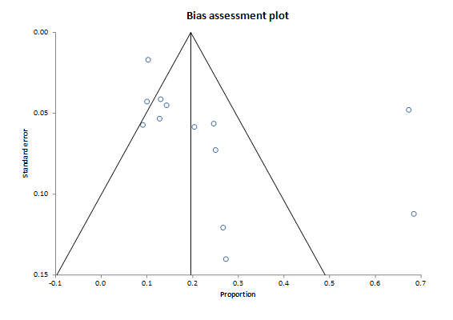
A funnel plot assessing reporting bias for studies contributing to active monitoring outcomes and their reported percentage proportion. Each study is represented by a point and is located at the proportion of intervention against its standard error (SE). Harbord’s test (p=0.710) and Begg’s test (p=0.067) were not statistically significant.
A funnel plot assessing reporting bias for studies contributing to surgery outcomes and their reported percentage proportion. Each study is represented by a point and is located at the proportion of WHO grade I meningioma against its standard error (SE). Harbord’s test (p=0.119) and Begg’s test (p=0.399) were not statistically significant.

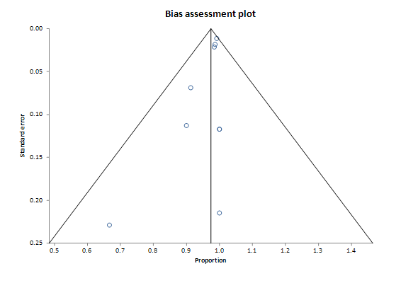

Incidental Intracranial Meningiomas: A Systematic Review and Meta-Analysis of Prognostic Factors and Outcomes
Journal of Neuro-Oncology
Authors and affiliations:

Abdurrahman I. Islim, MPhil ^{1,2,3}
Midhun Mohan, MRes ^{2,3}
Richard D.C. Moon, MB, BChir ^{2,3}
Nisaharan Srikandarajah, MRCS, MBBS ^{1,3}
Samantha J. Mills, PhD ⁴
Andrew R. Brodbelt, PhD ³
Michael D. Jenkinson, PhD ^{1,3}

- Institute of Translational Medicine, University of Liverpool, Liverpool, UK
- Faculty of Health and Life Sciences, University of Liverpool, Liverpool, UK
- Department of Neurosurgery, The Walton Centre NHS Foundation Trust, Liverpool, UK
- Department of Neuroradiology, The Walton Centre NHS Foundation Trust, Liverpool, UK

Corresponding author:
Abdurrahman I Islim
Email: a.islim@liv.ac.uk

