Online Resources
Online Resource 1 Corresponding Kaplan-Meier curve to the log-rank-test for the cohorts of patients with glioblastoma and their control groups comparing their event probabilities for intracranial hemorrhage. AC=anticoagulation, AF=atrial fibrillation, GBM=glioblastoma 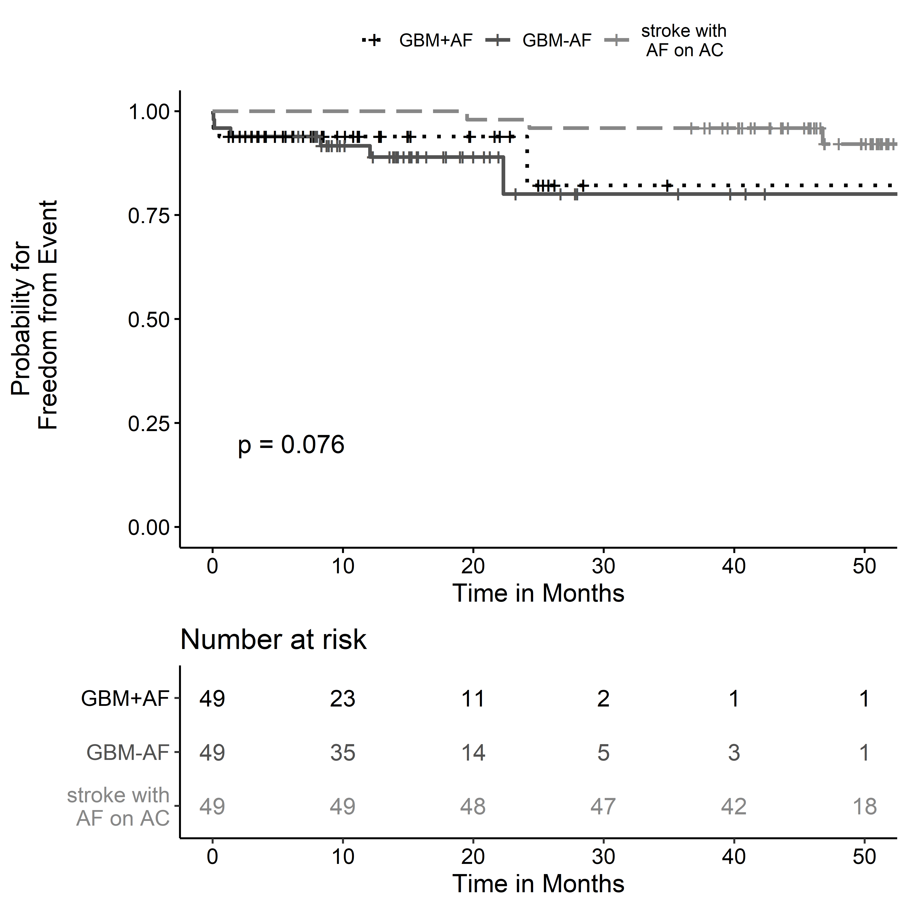

Online Resource 2 Corresponding Kaplan-Meier curve to the log-rank-test for the cohorts of patients with brain metastases and their control groups comparing their event probabilities for intracranial hemorrhage. AC=anticoagulation, AF=atrial fibrillation, MET=brain metastases
