Supplementary Figure 1
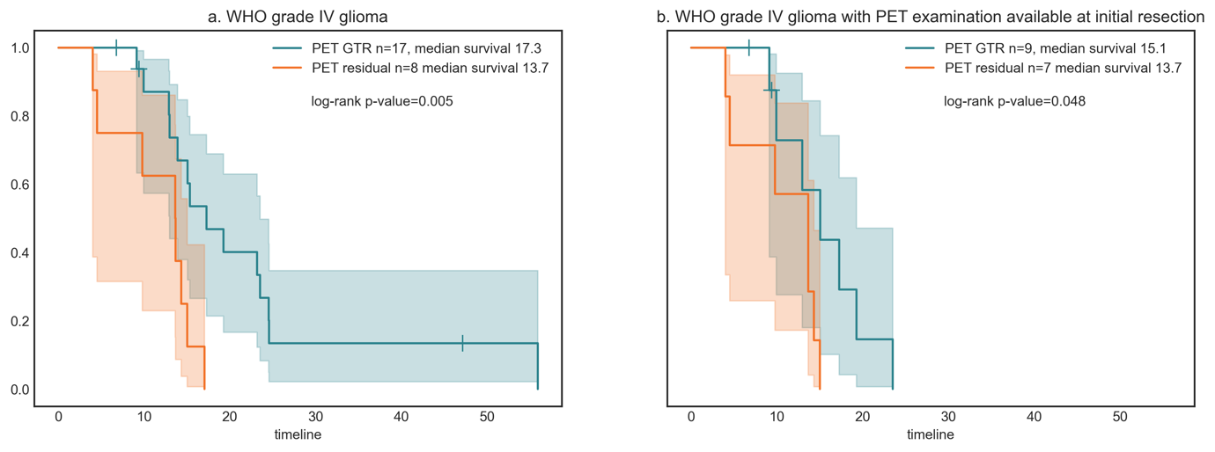
Suppl. Fig 1. Analysis of WHO grade IV glioma subgroups. A. In the subgroup of WHO grade IV glioma (n=25) PET GTR resulted in significantly improved OS. B. This observation was confirmed for patients observed at initial resection only (n=16).

