Appendix 2

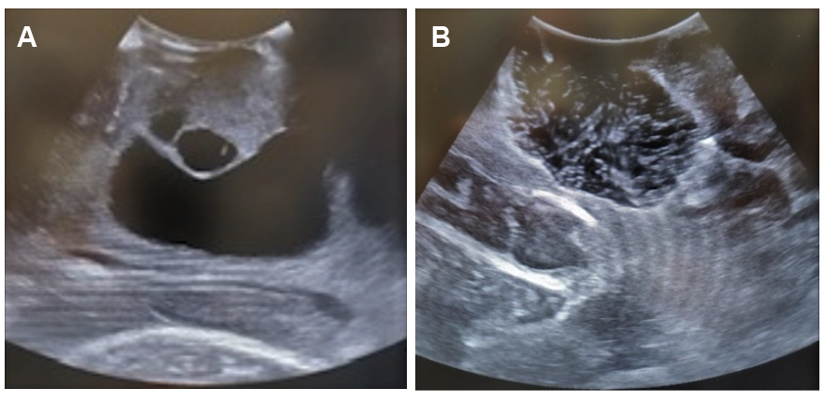

Example of the use of intraoperative ultrasonography (ioUS) to obtain gross total resection of a tumor, that was confirmed as glioblastoma multiforme by pathology. A, the cystic and solid components of the lesion before the resection. B, complete removal of the lesion using ioUS, surgical cavity filled with water.

