Supplementary information

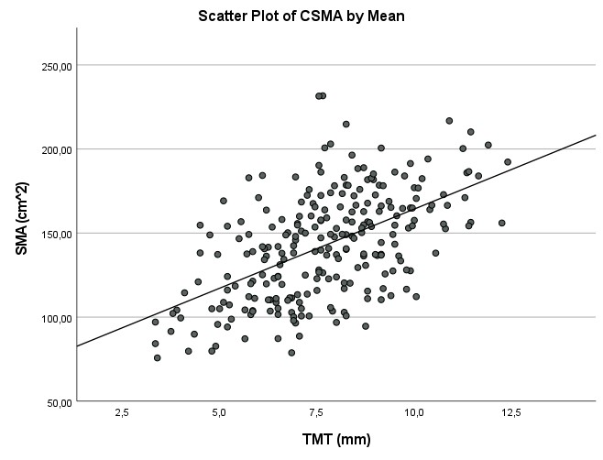
Supplementary figure 1. Scatterplot of the correlation between temporal muscle thickness (TMT) and skeletal muscle area (SMA).

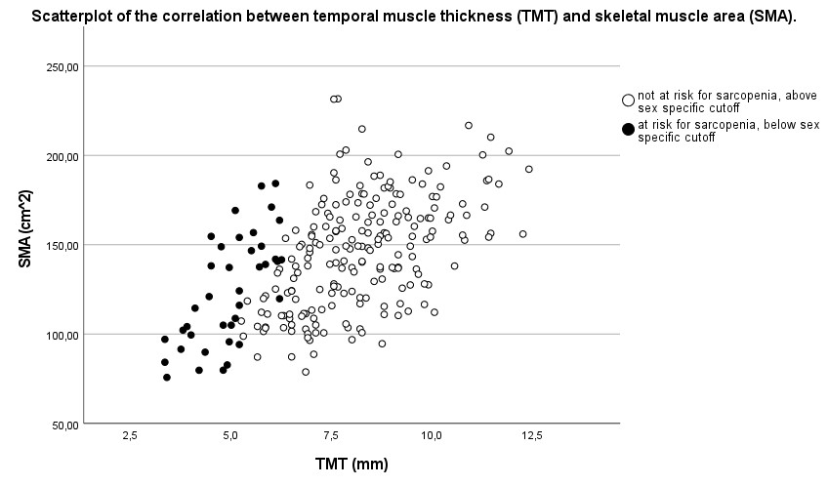
Supplementary figure 2. Scatterplot of the correlation between TMT and SMA. ‘At risk for sarcopenia’ (black) and ‘not at risk for sarcopenia’ (white) according to TMT sex-specific cut-off values.

