SUPPLEMENTAL TABLES AND FIGURES

 | N = 101
Postoperative radiotherapy (%)  - SRS  - WBRT  - SRS + WBRT  - None  - NA | 46 (45)  27 (27)  12 (12)  10 (10)  6 (6)
Additional postoperative local interventions (%)  - Yes  - No | 44 (44)  57 (56)
Postoperative systemic treatment (%)  - Yes  - No  - NA | 76 (75)  21 (21)  4 (4)
Postoperative cytotoxic chemotherapy (%)  - Yes  - No  - NA | 45 (45)  52 (51)  4 (4)
Postoperative HER2+ targeted therapy (%)  - Yes  - No  - NA | 36 (36)  61 (60)  4 (4)
Postoperative endocrine therapy (%)  - Yes  - No  - NA | 34 (34)  63 (62)  4 (4)
Postoperative CDK4/6 targeted therapy (%)  - Yes  - No  - NA | 1 (1)  96 (95)  4 (4)
Postoperative immune checkpoint inhibitor therapy (%)  - Yes  - No  - NA | 2 (2)  95 (94)  4 (4)
Postoperative PARP inhibitor therapy (%)  - Yes  - No  - NA | 3 (3)  94 (93)  4 (4)

Supplemental Table 1. Postoperative treatments.
CDK4/6, cyclin-dependent kinase 4/6; HER2, human epidermal growth factor receptor-2; NA, not available; PARP, poly (ADP-ribose) polymerase; SRS, stereotactic radiosurgery; WBRT, whole-brain radiotherapy.

 | Breast cancer HER2 positive status |  | Breast cancer HER2 negative status
 | HR (95% CI) | P value | HR (95% CI) | P value
Extent of resection (EOR)# | 1.01 (0.61 to 1.66) | >0.90 | 0.94 (0.69 to 1.30) | 0.70
Gross-total resection (GTR)  - Not achieved  - Achieved | -  1.05 (0.61 to 1.66) | >0.90 | -  1.52 (0.81 to 2.85) | 0.20
Postoperative residual tumor volume [cm³]# | 1.12 (0.73 to 1.72) | 0.60 | 1.16 (0.86 to 1.56) | 0.30

Supplemental Table 2. Cox regression analysis of the association between postoperative tumor volume load and overall survival stratified by breast cancer HER2 status.
BM, brain metastasis; HER2, human epidermal growth factor receptor-2; HR, hazard ratio.
Only univariable analysis were performed. #Extent of resection and postoperative residual tumor volume values were scaled before fitting Cox regression model. *p value < 0.05.

 | Extracranial disease positive status |  | Extracranial disease negative status
 | HR (95% CI) | P value | HR (95% CI) | P value
Extent of resection (EOR)# | 1.29 (0.92 to 1.80) | 0.14 | 0.62 (0.41 to 0.94) | 0.024*
Gross-total resection (GTR)  - Not achieved  - Achieved | -  0.96 (0.51 to 1.83) | >0.90 | -  1.32 (0.58 to 3.01) | 0.50
Postoperative residual tumor volume [cm³]# | 0.94 (0.67 to 1.30) | 0.70 | 1.57 (1.03 to 2.39) | 0.035*

Supplemental Table 3. Cox regression analysis of the association between postoperative tumor volume load and overall survival stratified by the presence of extracranial metastases at time of brain metastasis diagnosis.
BM, brain metastasis; HER2, human epidermal growth factor receptor-2; HR, hazard ratio.
Only univariable analysis were performed. #Extent of resection and postoperative residual tumor volume values were scaled before fitting Cox regression model. *p value < 0.05.

 | Breast cancer HER2 positive status |  | Breast cancer HER2 negative status
 | HR (95% CI) | P value | HR (95% CI) | P value
Extent of resection (EOR)# | 0.93 (0.68 to 1.27) | 0.70 | 0.84 (0.62 to 1.14) | 0.30
Gross-total resection (GTR)  - Not achieved  - Achieved | -  0.74 (0.35 to 1.53) | 0.40 | -  1.13 (0.62 to 2.07) | 0.70
Postoperative residual tumor volume [cm³]# | 1.00 (0.76 to 1.32) | >0.90 | 1.23 (0.95 to 1.60) | 0.11

Supplemental Table 4. Cox regression analysis of the association between postoperative tumor volume load and intracranial progression-free survival stratified by breast cancer HER2 status.
BM, brain metastasis; HER2, human epidermal growth factor receptor-2; HR, hazard ratio.
Only univariable analysis were performed. #Extent of resection and postoperative residual tumor volume values were scaled before fitting Cox regression model. *p value < 0.05.

 | Extracranial disease positive status |  | Extracranial disease negative status
 | HR (95% CI) | P value | HR (95% CI) | P value
Extent of resection (EOR)# | 0.84 (0.64 to 1.09) | 0.20 | 0.95 (0.65 to 1.37) | 0.90
Gross-total resection (GTR)  - Not achieved  - Achieved | -  0.92 (0.51 to 1.67) | 0.80 | -  1.05 (0.51 to 2.17) | 0.90
Postoperative residual tumor volume [cm³]# | 1.06 (0.86 to 1.30) | 0.60 | 1.27 (0.87 to 1.86) | 0.20

Supplemental Table 5. Cox regression analysis of the association between postoperative tumor volume load and intracranial progression-free survival stratified by the presence of extracranial metastases at time of brain metastasis diagnosis.
BM, brain metastasis; HER2, human epidermal growth factor receptor-2; HR, hazard ratio.
Only univariable analysis were performed. #Extent of resection and postoperative residual tumor volume values were scaled before fitting Cox regression model. *p value < 0.05.

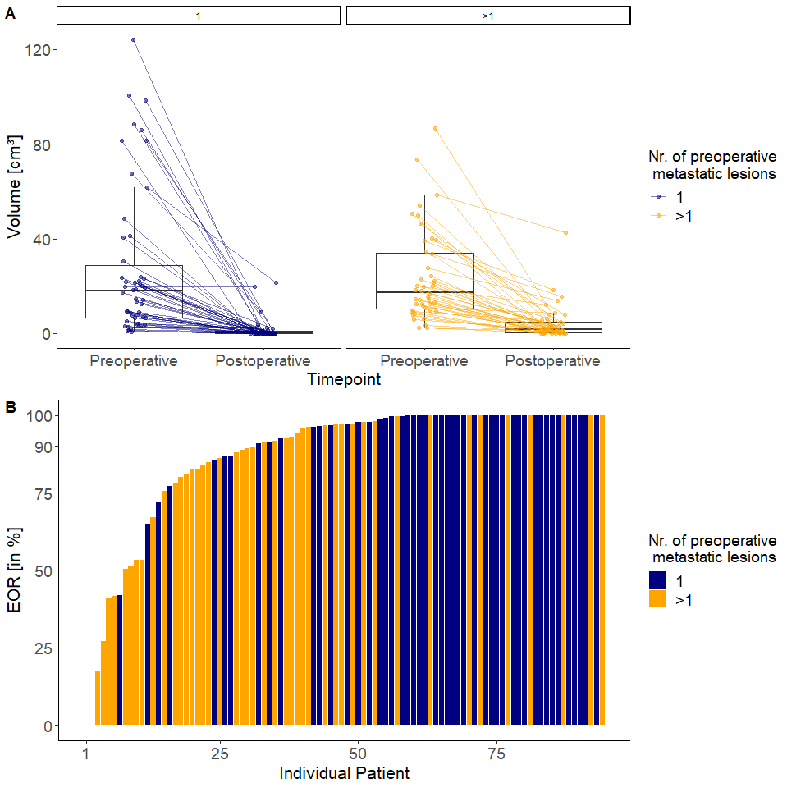
Supplemental Figure 1. Extent of resection and residual tumor volume.
(A) Pre- and postoperative total intracranial tumor volume as well as extent of resection (B) stratified by the number of metastatic lesions (1 or >1) are illustrated. EOR, extent of resection.

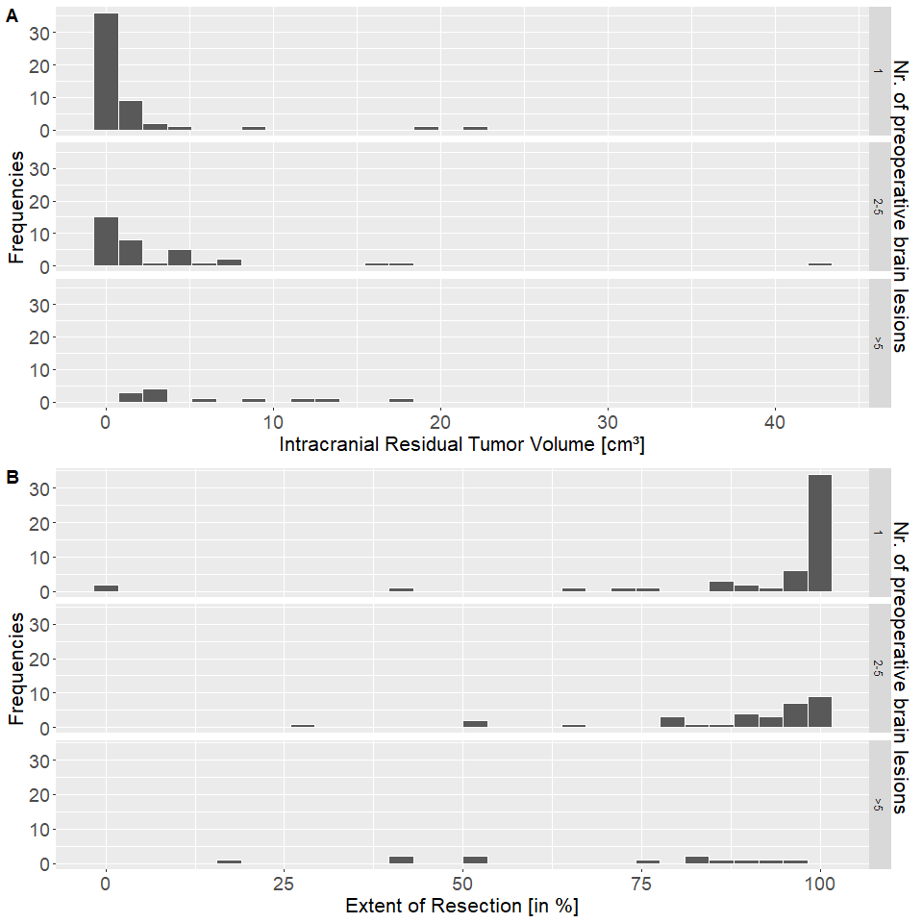
Supplemental Figure 2. Residual tumor volume and extent of resection according to the preoperative number of metastatic lesions.
(A) Postoperative residual intracranial tumor volume in cm³ and extent of resection (B) stratified by the number of metastatic lesion(s): 1, 2-5, >5. EOS, extent of resection.

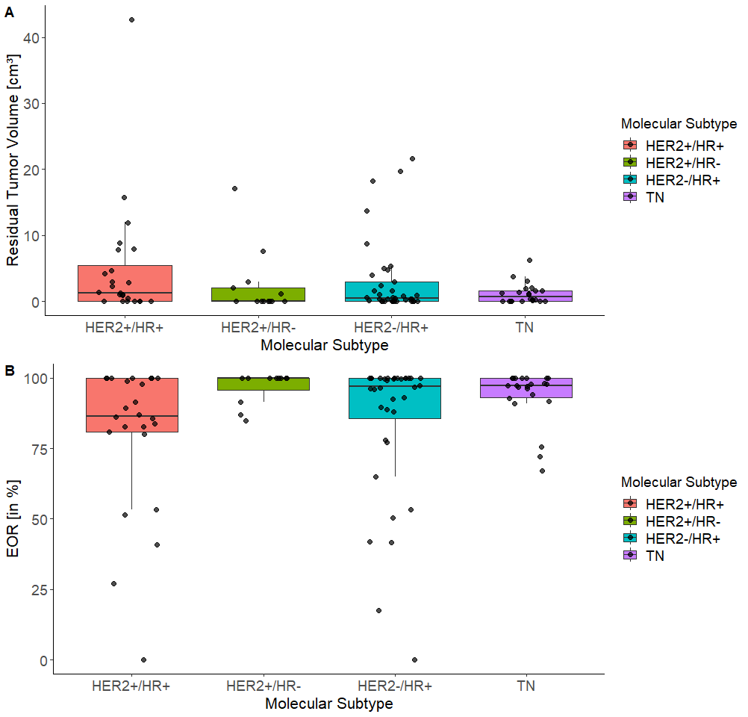
Supplemental Figure 3. Residual tumor volume and extent of resection according to breast cancer molecular subtype.
(A) Postoperative intracranial residual tumor volume and extent of resection (EOR, B) stratified by breast cancer molecular subtype. BC, breast cancer; EOR, extent of resection; HER2, human epidermal growth factor receptor-2; HR, hormone receptor; TN, triple-negative.

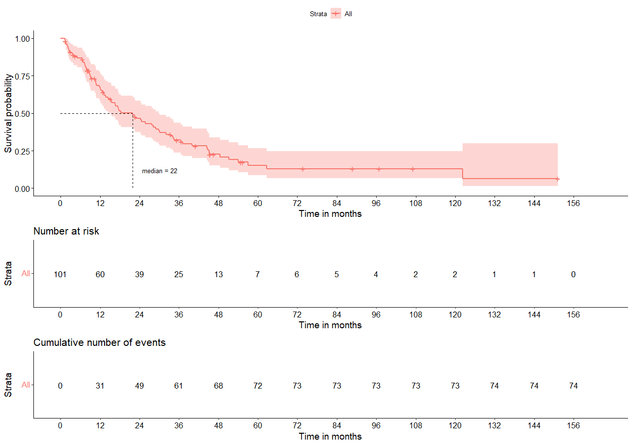
Supplemental Figure 4. Overall survival in the study cohort.
Time is reported in months from surgery.

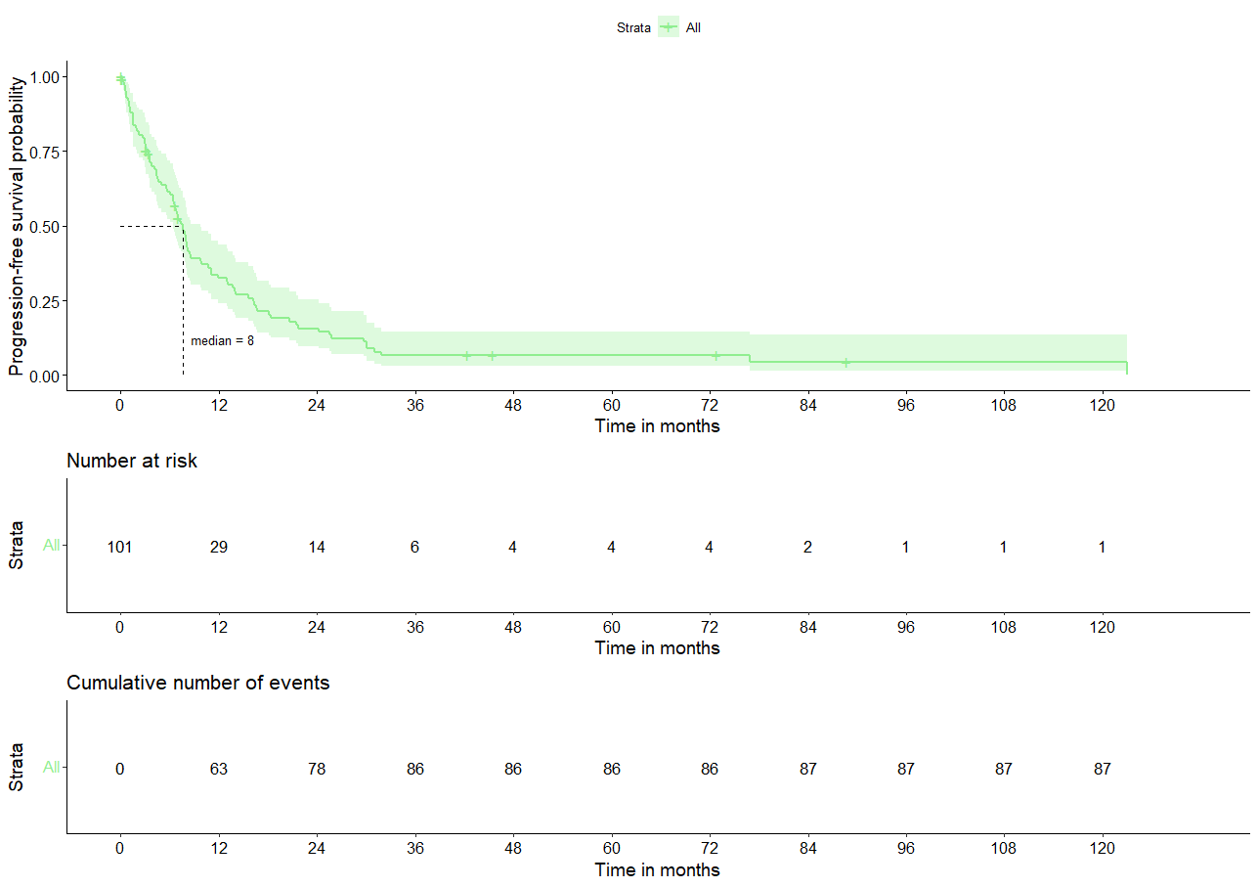

Supplemental Figure 5. Intracranial progression-free survival in the study cohort.
Time is reported in months from surgery.
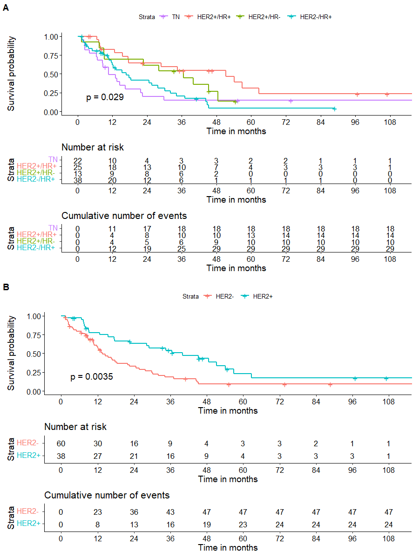
Supplemental Figure 6. Overall survival according to the breast cancer molecular subtype.
Kaplan-Meier curve with log-rank statistic of patients stratified by the breast cancer molecular subtype (A) and by breast cancer HER2 positivity (B). Time is reported in months from surgery; Follow-up time is clipped at 9 years for better readability. BC, breast cancer; HER2, human epidermal growth factor receptor-2; HR, hormone receptor.

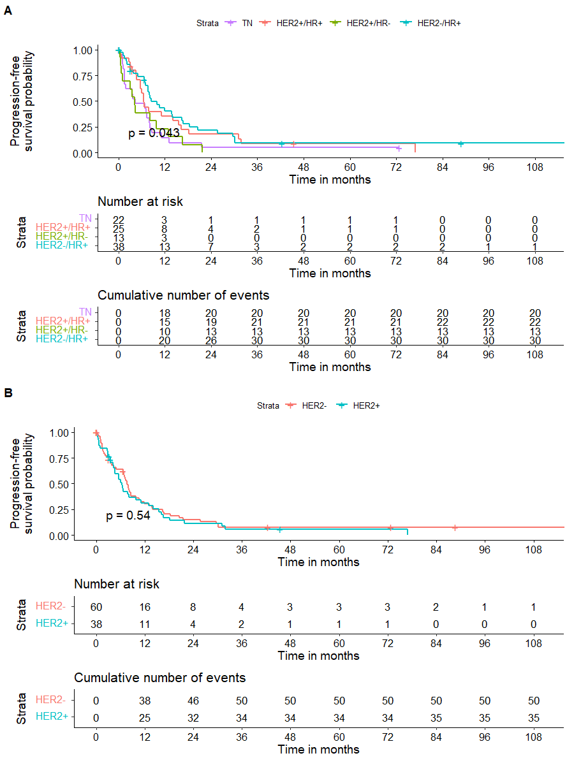
Supplemental Figure 7. Intracranial progression-free survival according to the breast cancer molecular subtype.
Kaplan-Meier curve with log-rank statistic of patients stratified by the breast cancer molecular subtype (A) and by breast cancer HER2 positivity (B). Time is reported in months from surgery; Follow-up time is clipped at 9 years for better readability. BC, breast cancer; HER2, human epidermal growth factor receptor-2; HR, hormone receptor.

