Supplementary materials

Supplementary Table 1. Optimal cut-off values of variables defined by ROC curves

Variables | Cut-off values | AUC | 95% CI | Sensitivity | Specificity | p-value
Age | < 62.5/ ≥ 62.5 | 0.534 | 0.402–0.666 | 63.2% | 51.4% | 0.615
Tumor volume | < 24.55/ ≥ 24.55 | 0.615 | 0.484–0.746 | 54.1% | 75.7% | 0.089
Roundness | < 0.49/ ≥ 0.49 | 0.524 | 0.386–0.661 | 45.9% | 78.4% | 0.070
MIB-1 index | < 5.50/ ≥ 5.50 | 0.549 | 0.417–0.680 | 39.5% | 73.0% | 0.468

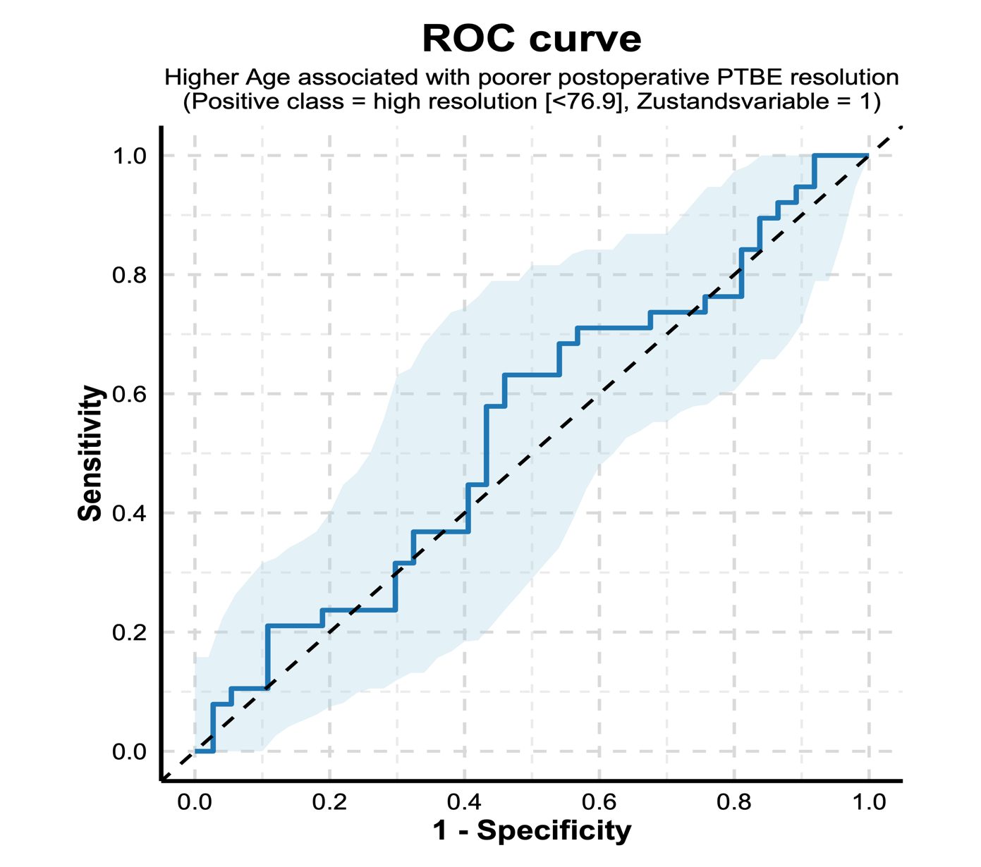
Supplementary Figure 1. Receiver operating characteristic (ROC) curve illustrating the diagnostic performance of age at surgery for predicting postoperative peritumoral brain edema (PTBE) resolution. Age was dichotomized at an optimal cut-off of 62.5 years (<62.5 vs. ≥62.5 years). The area under the curve (AUC) was 0.534 (95% CI: 0.402–0.666; p = 0.615), indicating no discriminative ability. At this cut-off, sensitivity was 63.2% and specificity was 51.4%. The solid blue line represents the ROC curve, the dashed diagonal line indicates no-discrimination performance, and the shaded area denotes the 95% confidence interval.

Cut-off: < 62.5/ ≥ 62.5
Sensitivity: 63.2%
Specificity: 51.4%

ROC Curve (AUC = 0.534, 95% CI: [0.402-0.666])
95% Confidence Interval

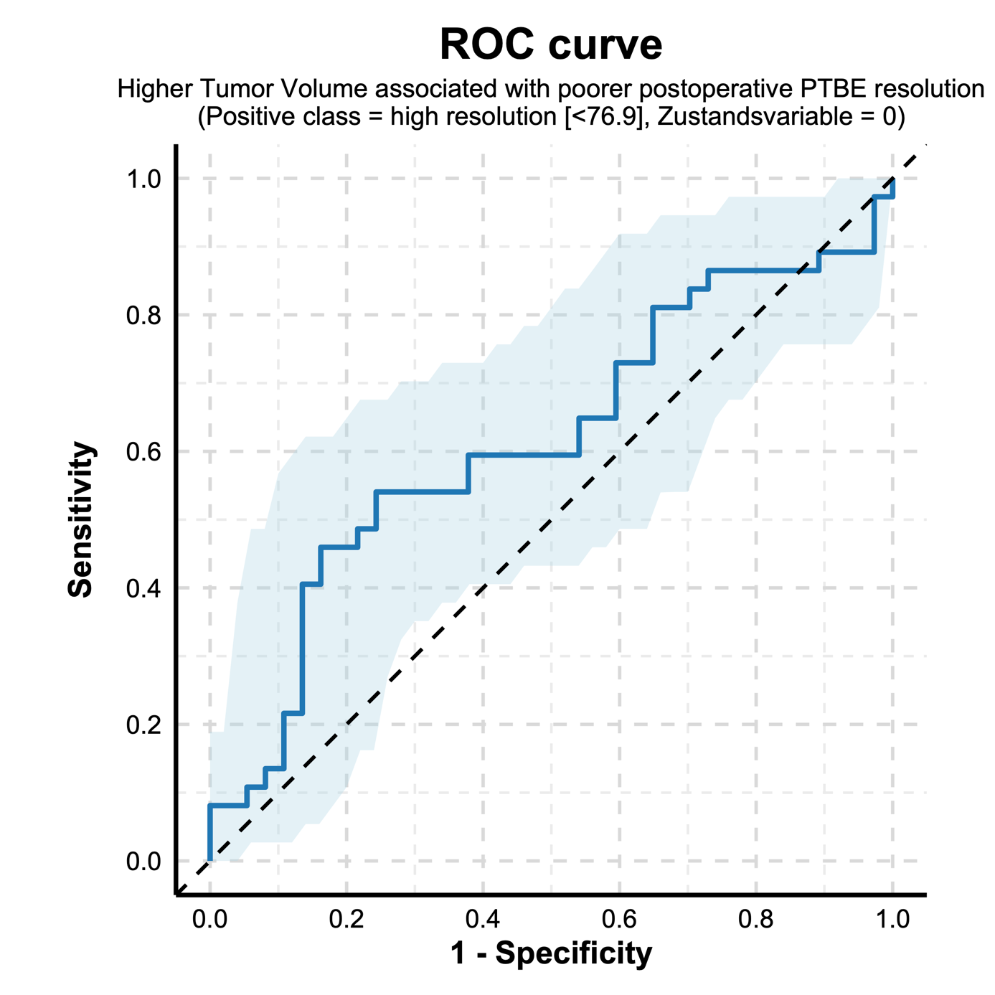
Supplementary Figure 2. Receiver operating characteristic (ROC) curve showing the discriminative performance of tumor volume for predicting postoperative peritumoral brain edema (PTBE) resolution. Tumor volume was dichotomized at an optimal cut-off of 24.55 cm³ (<24.55 vs. ≥24.55 cm³). The area under the curve (AUC) was 0.615 (95% CI: 0.484–0.746; p = 0.089), indicating moderate but non-significant discriminative ability. At this threshold, sensitivity was 54.1% and specificity was 75.7%. The solid blue line represents the ROC curve, the dashed diagonal line indicates chance-level discrimination, and the shaded area denotes the 95% confidence interval.

Cut-off: < 24.55 / ≥ 24.55
Sensitivity: 54.1%
Specificity: 75.7%

ROC Curve (AUC = 0.615, 95% CI: [0.484-0.746])
95% Confidence Interval

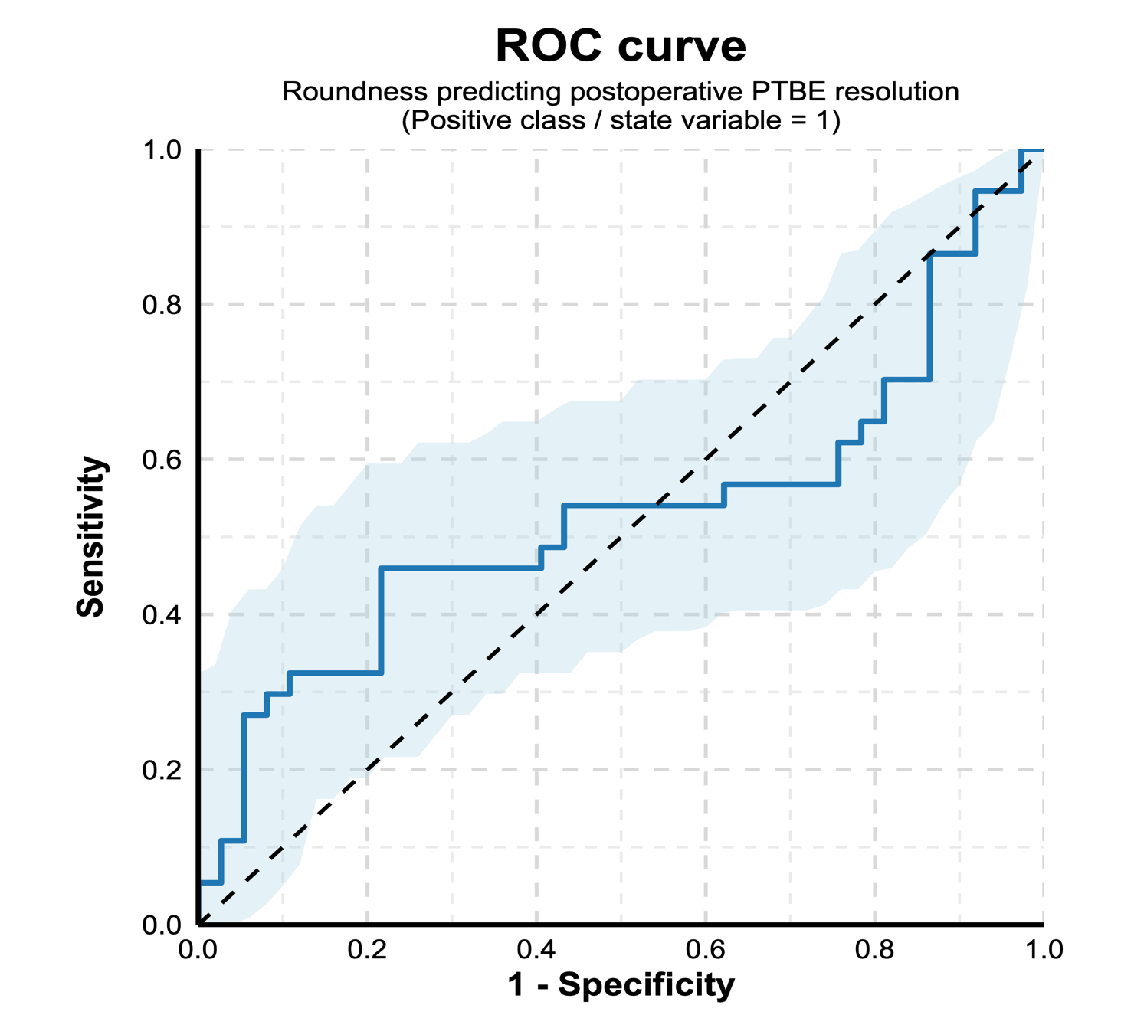
Supplementary Figure 3. Receiver operating characteristic (ROC) curve illustrating the predictive performance of tumor roundness for postoperative peritumoral brain edema (PTBE) resolution. Tumor roundness was dichotomized at an optimal cut-off value of 0.49 (<0.49 vs. ≥0.49). The area under the curve (AUC) was 0.524 (95% CI: 0.386–0.661; p = 0.07), indicating limited and non-significant discriminative ability. At this threshold, sensitivity was 45.9% and specificity was 78.4%. The solid blue line represents the ROC curve, the dashed diagonal line indicates no discrimination, and the shaded area denotes the 95% confidence interval.

Cut-off: < 0.49 / ≥ 0.49
Sensitivity: 45.9%
Specificity: 78.4%

ROC Curve (AUC = 0.524, 95% CI: [0.386-0.661])
95% Confidence Interval

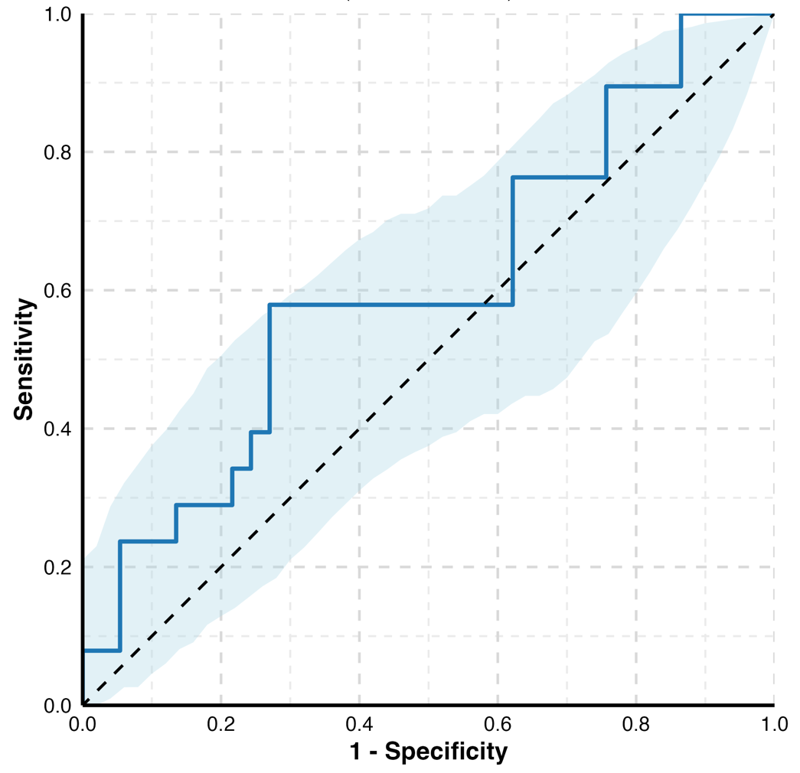
Supplementary Figure 4. Receiver operating characteristic (ROC) curve showing the discriminatory performance of the MIB-1 (Ki-67) index for postoperative peritumoral brain edema (PTBE) resolution. The MIB-1 index was dichotomized at an optimal cut-off value of 5.50 (<5.50 vs. ≥5.50). The area under the curve (AUC) was 0.549 (95% CI: 0.417–0.680; p = 0.468), indicating poor and non-significant discrimination. At this threshold, sensitivity was 39.5.9% and specificity was 73.0%. The solid blue line represents the ROC curve, the dashed diagonal line indicates no discriminative ability, and the shaded area denotes the 95% confidence interval.

ROC Curve (AUC = 0.549, 95% CI: [0.417-0.680])
95% Confidence Interval
Cut-off: < 5.5 / ≥ 5.5
Sensitivity: 39.5%
Specificity: 73.0%

