Supplemental Figure 1 Overall (A) and Event-Free Survival (B) of all patients confirmed as ependymoma by methylation array excluding three patients with low calibration scores
A
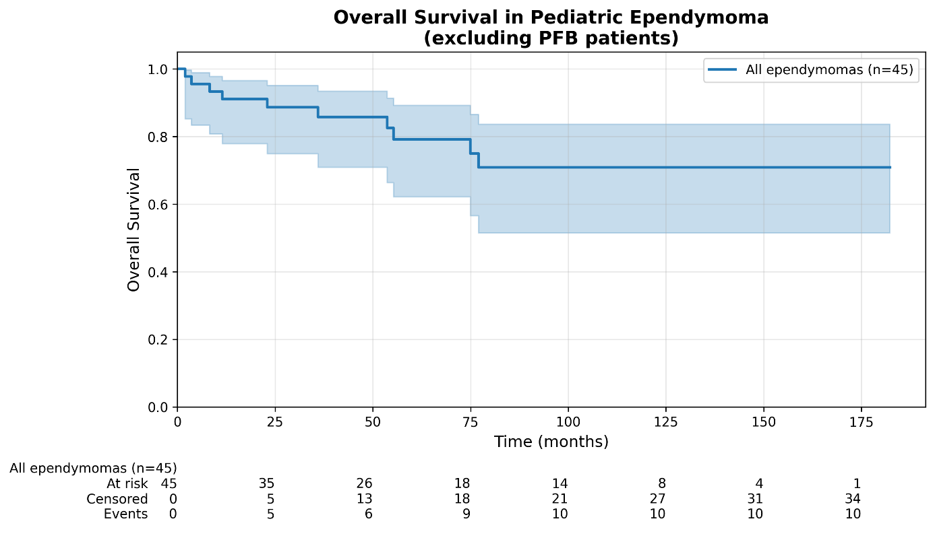
B
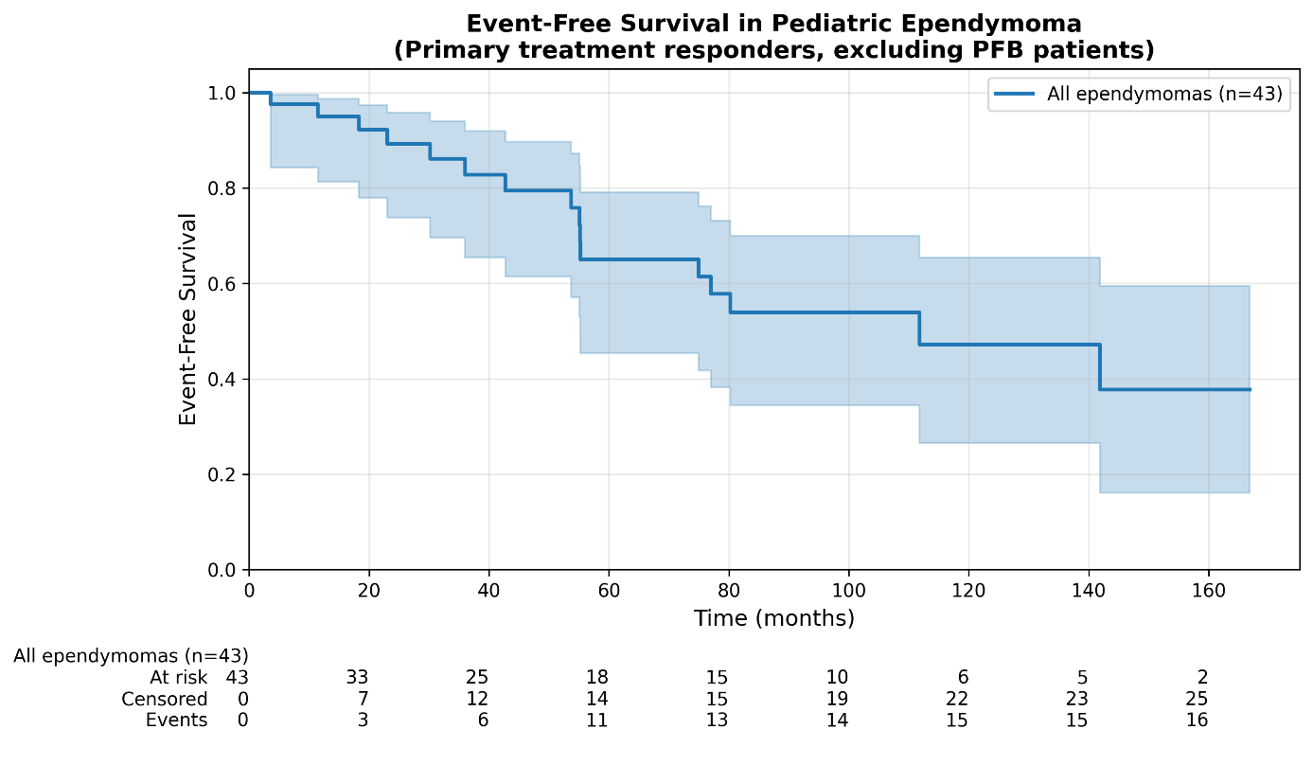

Supplemental Figure 2 Overall Survival of ependymomas by methylation class (curves for ST-YAP1, MPE and Spinal overlap (all alive)
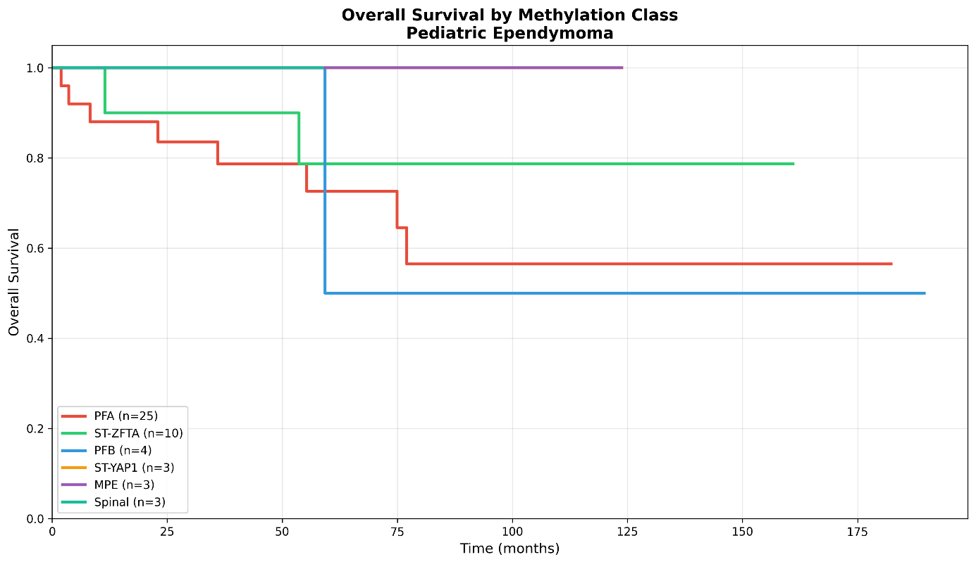
p=0.062

