Figure S1. Participant flow
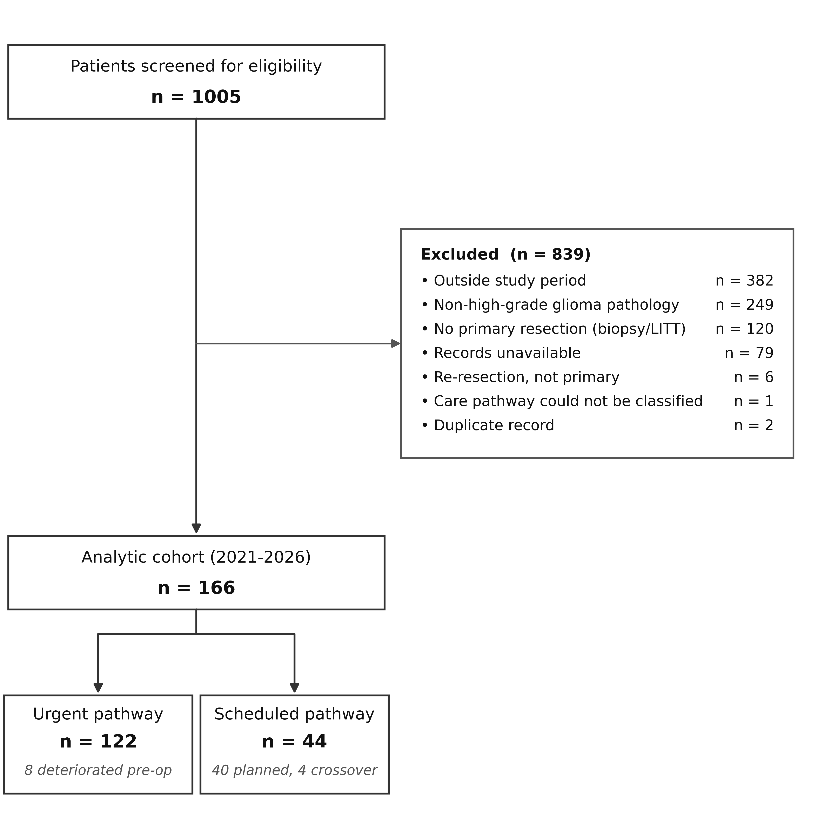

Screening, exclusions, and pathway assignment. Analytic cohort n = 166 (urgent 122, scheduled 44). The scheduled arm comprises 40 patients who underwent surgery as planned and 4 who required earlier unplanned resection.

Table S1. Pathway effect on overall survival: primary and prespecified sensitivity analyses
Analysis | Patients / deaths | Scale | Estimate (95% CI) | p
Kaplan–Meier, log-rank (primary) | 166 / 94 | Median OS, months | 15.4 vs 19.0 | 0.758
Crude Cox model | 166 / 94 | HR | 1.08 (0.68–1.72) | 0.758
Adjusted Cox model | 154 / 88 | HR | 0.64 (0.38–1.10) | 0.105
Per-protocol (crossovers reclassified as urgent) | 154 / 88 | HR | 0.77 (0.43–1.38) | 0.384
WHO grade 4 only | 144 / 86 | HR | 0.64 (0.37–1.10) | 0.107
Diagnosis-anchored (left-truncated) | 154 / 88 | HR | 0.67 (0.39–1.14) | 0.137
Adjusted RMST difference at 24 months | 154 / 88 | months | +0.34 (−2.48 to +3.17) | 0.813

HR, hazard ratio (urgent versus scheduled); values below 1 indicate lower hazard in the urgent group. Adjusted models include age, KPS, extent of resection, and MGMT methylation, with baseline hazard stratified by IDH status; no IDH-mutant patient died, so an IDH hazard ratio was not estimable. Adjusted analyses are complete-case (MGMT untested in 12 patients). The per-protocol analysis reclassified the four scheduled patients who required earlier surgery as urgent. The diagnosis-anchored model measured survival from diagnosis with left truncation at surgery. RMST, restricted mean survival time to 24 months (urgent minus scheduled, months), estimated by regression on jackknife pseudo-observations with robust (HC3) standard errors, adjusted for the same covariates. p values are not adjusted for multiplicity. KPS, Karnofsky Performance Status; OS, overall survival.

Table S2. Adjusted and overlap-weighted estimates for complications and healthcare utilization
Outcome | Analysis | Scale | Estimate (95% CI)
Index length of stay | Adjusted | rate ratio | 2.30 (1.85–2.86)
Index length of stay | Overlap-weighted | difference in means, days | 4.6 (3.4–5.8)
DAH-30 | Adjusted | difference in medians, days | −8.9 (−12.9 to −4.8)
DAH-30 | Overlap-weighted | difference in means, days | −7.6 (−10.8 to −4.3)
Non-home discharge | Adjusted | odds ratio | 2.25 (1.00–5.06)
Non-home discharge | Overlap-weighted | odds ratio | 1.71 (0.75–3.90)
Any 30-day complication | Adjusted | odds ratio (Firth) | 1.15 (0.52–2.62)
Any 30-day complication | Overlap-weighted | odds ratio | 1.03 (0.45–2.36)

All estimates compare urgent with scheduled patients; for these adverse outcomes, ratios above 1, longer stays, and fewer days at home indicate less favorable values in the urgent group. Adjusted models: any 30-day complication, Firth-penalized logistic regression (age, KPS, tumor diameter, mFI-5, eloquent location); non-home discharge, logistic regression (age, KPS, mFI-5); index LOS, negative binomial regression (age, KPS, tumor diameter, mFI-5); DAH-30, median regression with bootstrap standard errors (2,000 replicates; age, KPS, tumor diameter, mFI-5, ASA IV). Overlap-weighted estimates use propensity-score overlap weights from a logistic model including age, KPS, tumor diameter, mFI-5, midline shift, and ASA IV. The adjusted and overlap-weighted DAH-30 rows estimate a difference in medians and in means, respectively. ASA, American Society of Anesthesiologists; DAH-30, days alive and at home within 30 days; KPS, Karnofsky Performance Status; LOS, length of stay; mFI-5, 5-item modified frailty index.

Table S3. Proportional-hazards diagnostics for the adjusted Cox models
Model | Term | χ² | df | p
Overall survival | Pathway | 2.613 | 1 | 0.106
 | Age | 1.643 | 1 | 0.200
 | KPS | 13.491 | 1 | <0.001
 | Extent of resection | 1.357 | 1 | 0.244
 | MGMT | 0.655 | 1 | 0.418
 | Global test | 14.517 | 5 | 0.013
Progression-free survival | Pathway | 0.242 | 1 | 0.623
 | Age | 0.124 | 1 | 0.725
 | KPS | 9.946 | 1 | 0.002
 | Extent of resection | 6.764 | 1 | 0.009
 | MGMT | 0.669 | 1 | 0.413
 | Global test | 14.213 | 5 | 0.014

Scaled Schoenfeld residual tests (n = 154, complete case). The pathway term did not violate proportional hazards in either model; the global test was significant, driven by KPS (and extent of resection for progression-free survival). The restricted mean survival time difference (Table S1) is therefore reported as an absolute measure that does not assume proportional hazards. KPS, Karnofsky Performance Status.

Table S4. Adjusted and overlap-weighted estimates in patients with IDH-wildtype grade 4 glioblastoma
Outcome | Analysis | Scale | Estimate (95% CI)
Index length of stay | Adjusted | rate ratio | 2.31 (1.84–2.91)
Index length of stay | Overlap-weighted | difference in means, days | 4.8 (3.6–6.0)
DAH-30 | Adjusted | difference in medians, days | −6.4 (−10.1 to −2.7)
DAH-30 | Overlap-weighted | difference in means, days | −7.0 (−10.4 to −3.6)
Non-home discharge | Adjusted | odds ratio | 2.06 (0.87–4.85)
Non-home discharge | Overlap-weighted | odds ratio | 1.48 (0.62–3.51)
Any 30-day complication | Adjusted | odds ratio (Firth) | 1.05 (0.46–2.49)
Any 30-day complication | Overlap-weighted | odds ratio | 0.94 (0.39–2.29)
Overall survival | Kaplan–Meier | median, months | 15.2 vs 15.9
Overall survival | Crude Cox model | hazard ratio | 0.85 (0.53–1.36)
Overall survival | Adjusted Cox model | hazard ratio | 0.64 (0.37–1.10)
Overall survival | Diagnosis-anchored (left-truncated) | hazard ratio | 0.65 (0.38–1.12)
Overall survival | Adjusted RMST difference at 24 months | months | +0.65 (−2.44 to +3.74)

All estimates compare urgent with scheduled patients among the 152 patients with IDH-wildtype grade 4 glioblastoma (115 urgent, 37 scheduled; 92 deaths). Models and covariates are those of Tables S1 and S2, without IDH stratification; adjusted Cox models are complete-case (n = 141, 86 deaths). For adverse outcomes, ratios above 1, longer stays, and fewer days at home indicate less favorable values in the urgent group; hazard ratios below 1 indicate lower hazard in the urgent group. DAH-30, days alive and at home within 30 days; RMST, restricted mean survival time.

