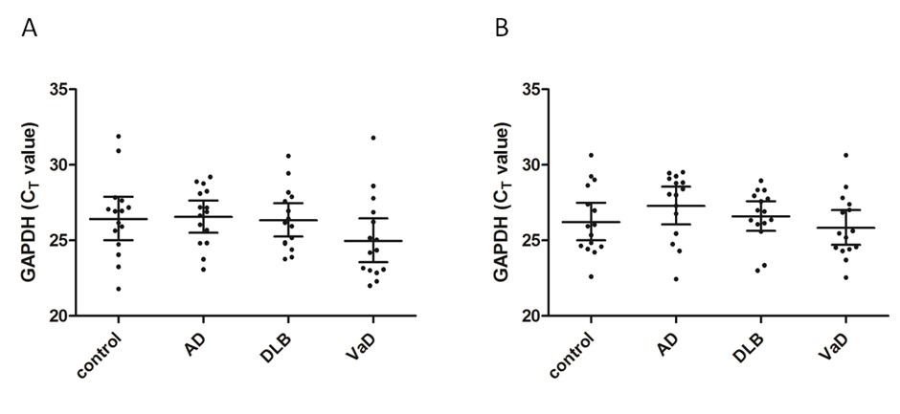

Supplementary Figure 1 GAPDH mRNA levels measured by real-time PCR in frontal and temporal cortex. GAPDH transcripts were measured by real-time PCR in frontal (A) and temporal cortex (B). Interval plots show the mean and 95% confidence intervals of the average C_{T} values in AD, DLB, VaD and control groups and average C_{T} values for each case are shown. GAPDH mRNA levels were similar in all cohorts in both frontal and temporal regions.

