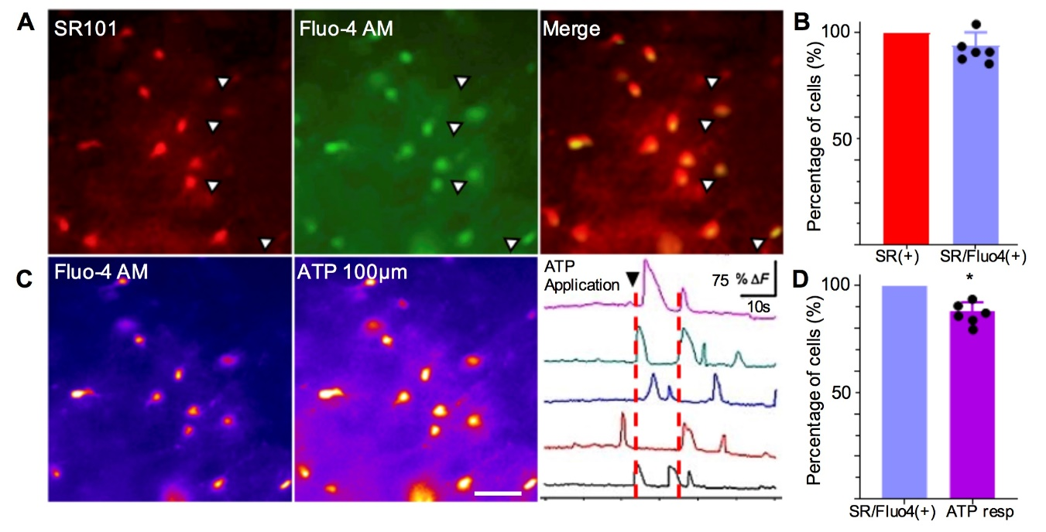
Suppl. Fig. 1. Identification of striatal astrocytes with sulforhodamine 101 (SR101) labeling. (A) Representative brain slice containing the dorsal striatum stained with SR101 after preloading with Fluo-4AM. Merge of both images shows co-localization of SR101+ cells with Fluo-4AM. Scale bar: 50 µm. (B) Summary of SR101+ and SR101+/Fluo-4AM cells. The majority of SR101+ cells uploaded Fluo-4AM (94%; 378/404 cells, n=12, N=6). (C) Cells pre-loaded with Fluo-4AM (left image) showed calcium transients evoked by ATP (100 uM) (right image). Five representative cells (1-5) were selected to illustrate calcium transients evoked by ATP. (D) Summary of SR101+/Fluo-4AM cells show that 88% responded to ATP (312/355 cells, n=12, N=6). Data analyzed by one-way ANOVA (B, p=0.074; D, *p=0.02). Values are mean ± S.E.M.

