Supplementary data

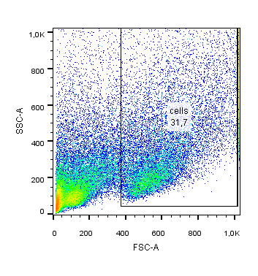
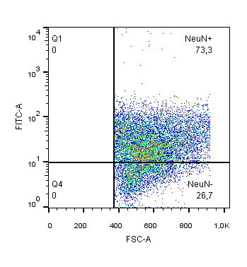
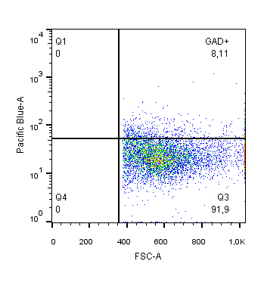
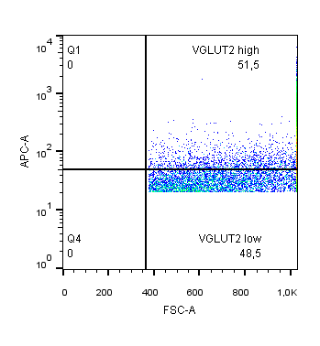
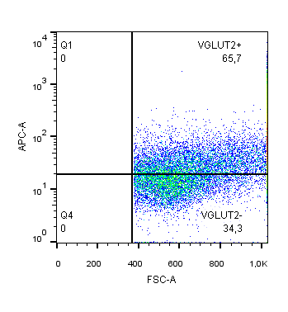
A) All events
B) NeuN – positive cells
C) VGLUT2 positive neurons
D) VGLUT2 intensity
E) GAD65/67 - positive neurons

Supplementary Figure 1. Gating strategy for flow cytometry of hippocampal neurons. Flow cytometry plots showing (A) all events with gating of total cells population, (B) NeuN - positive cells (NeuN⁺) - neurons, C) all VGLUT2-positive neurons (VGLUT2⁺), D) VGLUT2^{high} and VGLUT2^{low} populations distinguished on the base of VGLUT2 signal intensity, E) percentage of GAD65/67-positive (GAD⁺) neurons gated from VGLUT2-negative (VGLUT2⁻) population.

