Supplementary Data File 1
A

A

B

Figure 3: Percentage of body weight gain per day in males (A) and females (B) in control and MPH-treated Wistar Kyoto (WKY) rats across the entire experiment. Results in percentage of initial weight, in gr/day. Statistical analysis was conducted using two-way ANOVA.B

Figure SF1: Percentage of body weight gain per day in males (A) and females (B) in control and MPH-treated Wistar Kyoto (WKY) rats across the entire experiment. Results in percentage of initial weight, in gr/day. Statistical analysis was conducted using two-way ANOVA.

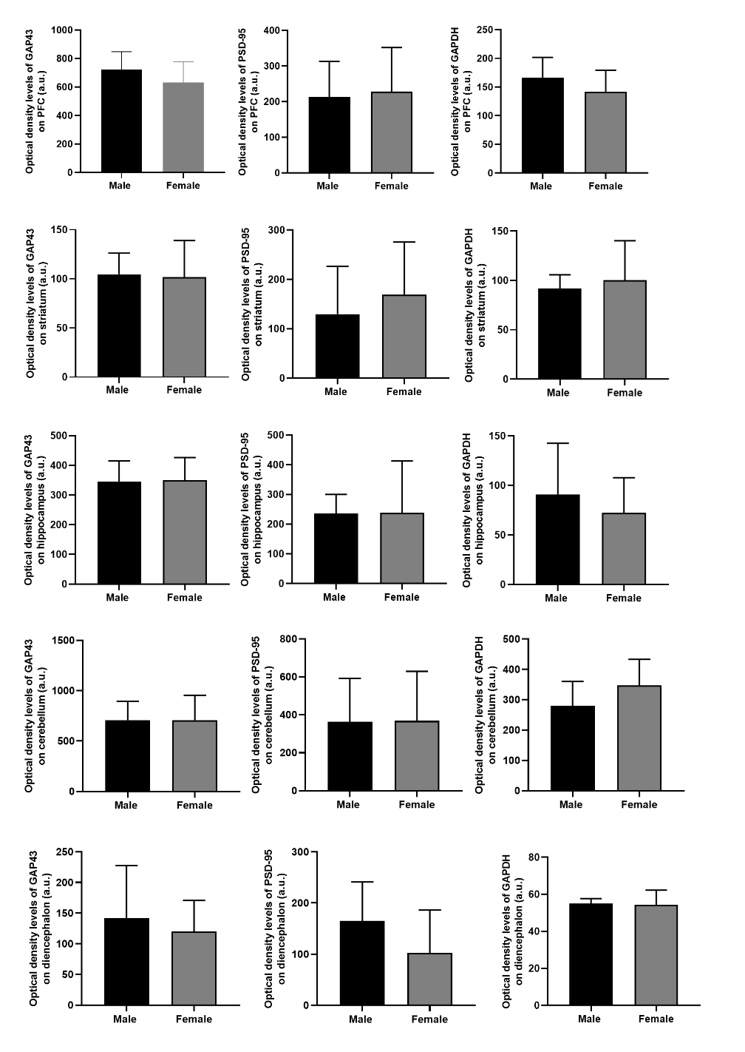
A
B
C
D
E
F
G
HA
I
J
K
L
M
N
O

Figure SF2: Comparative analysis of protein levels of GAP43 (A, D, G, J, M), PSD-95 (B, E, H, K, N) and GAPDH (C, F, I, L, O), obtained by western blot, between juvenile male [control n=8] and female [control n=8] Wistar Kyoto rats (WKY) rats, across key brain regions, including the prefrontal cortex (PFC) (A, B, C), striatum (D, E, F), hippocampus (G, H, I), cerebellum (J, K , L), and diencephalon (M, N, O). The values obtained were presented as optic density (OD), expressed in arbitrary units (a.u.). Statistical comparisons were conducted using the t-test: male versus female animals. Protein loading was confirmed by the Ponceau S staining.

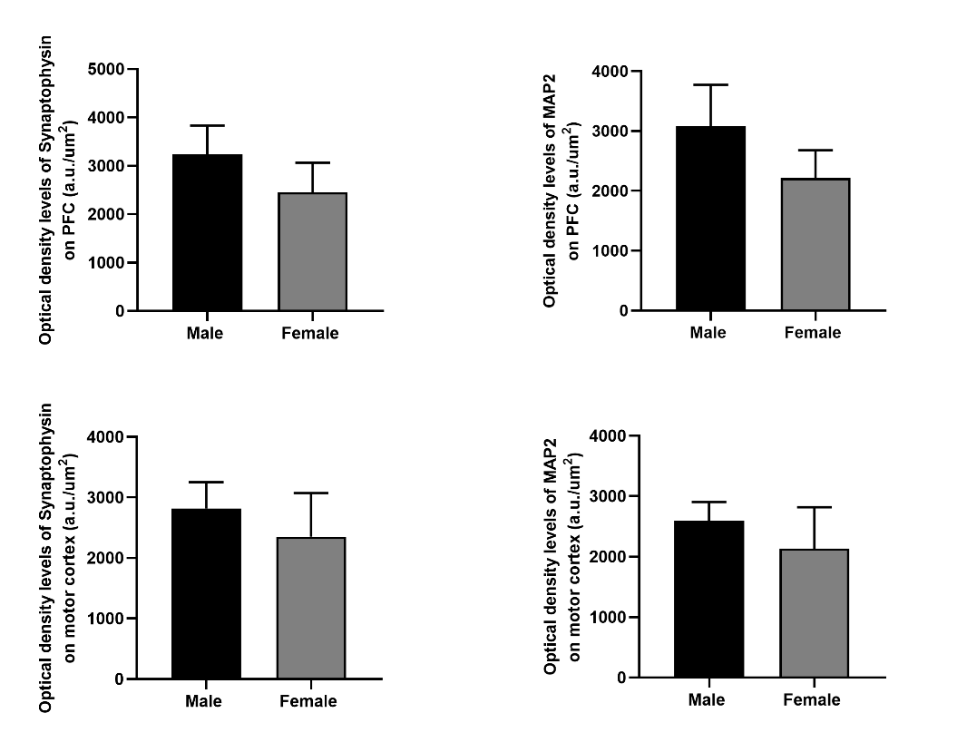
C
A
B

D

Figure SF3: Comparative analysis of protein levels of synaptophysin, and MAP2, obtained by immunochemistry, between juvenile male [control n=4] and female [control n=5] Wistar Kyoto rats (WKY) rats, across cortex regions, namely the prefrontal cortex (PFC) (A, B), and motor cortex (C, D). The values obtained are presented as optic density (OD) per area, expressed in arbitrary units (a.u.)/µm². Statistical comparisons were conducted using the t-test: male versus female animals.

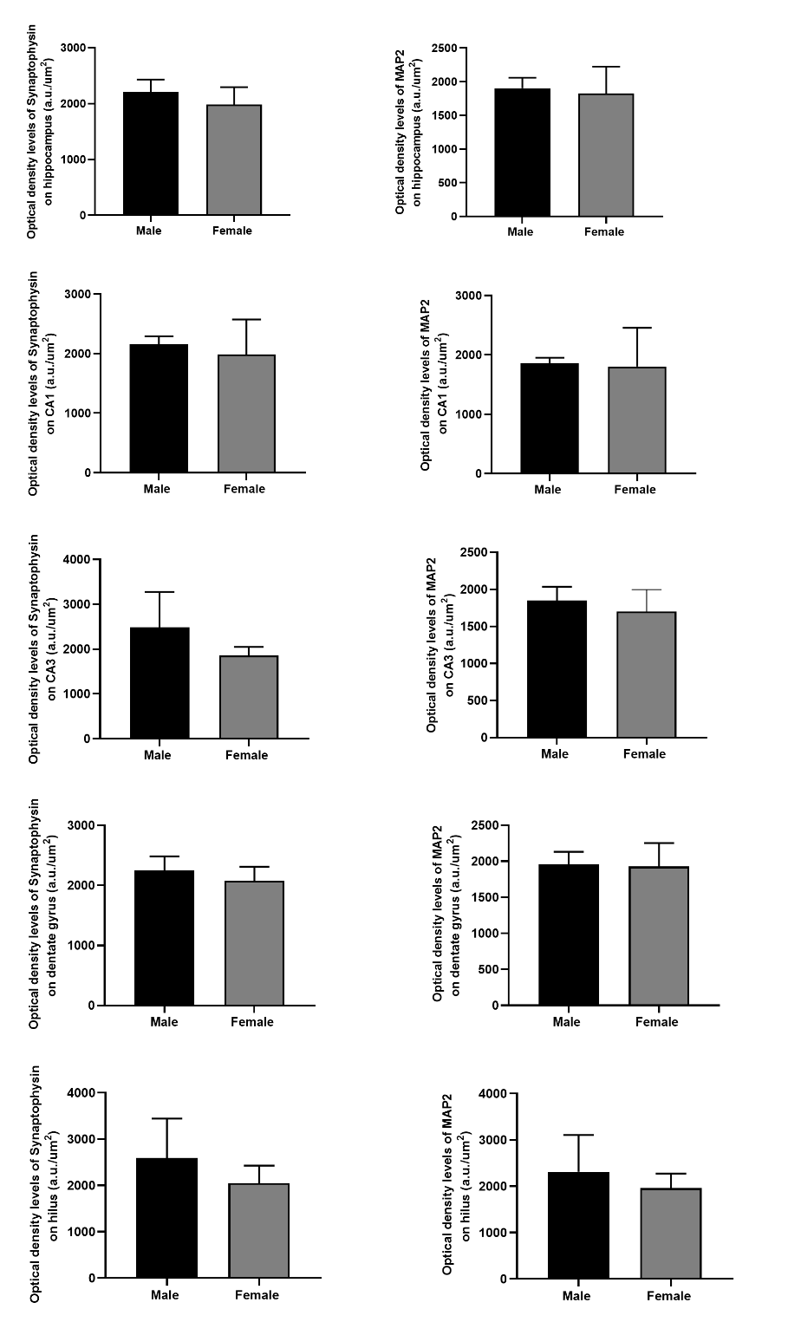
B
A

D
C

E
F

G
H

J
I

Figure SF4: Comparative analysis of protein levels of synaptophysin, and MAP2, obtained by immunochemistry, between juvenile male [control n=5] and female [control n=5] Wistar Kyoto (WKY) rats, across hippocampus regions (A, B), and in the CA1 (C, D), CA3 (E, F), dentate gyrus (G, H), and hilus (I, J). The values obtained are presented as optic density (OD) per area, expressed in arbitrary units (a.u.)/µm². Statistical comparisons were conducted using the t-test: male versus female animals.

