Supplementary Data File 2

Ponceau S

PFC Ponceau S
- Males (n=10) | - Females (n=10) | - Males (n=5) and Females (n=5)
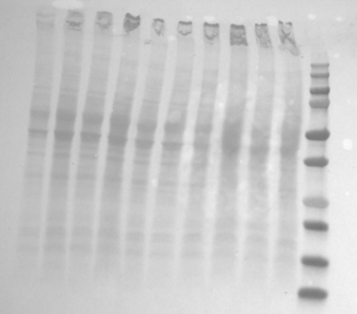 | 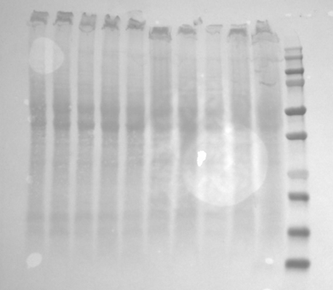 | 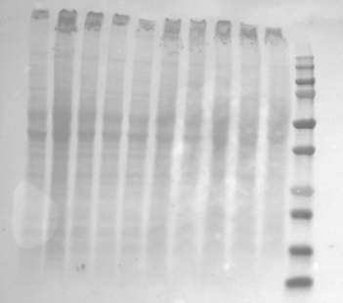
Figure SF1: Loading control of Ponceau S staining from cortex prefrontal (PFC) samples used for GAP43 (43 kDa), PSD-95 (95 kDa), and GAPDH (37 kDa) detection. Membrane A: Male WKY samples; Membrane B: Female WKY samples; Membrane C: Male and female WKY samples. A1,3,5,7,9: Male control. A2,4,6,8,10: Male MPH. B1,3,5,7,9: Female control. B2,4,6,8,10: Female MPH. C1,4,5: Male control. C2,3: Male MPH. C6,8,10: Female control. C7,9: Female MPH. A, B, C11: Molecular weight control. WKY: Wistar Kyoto.

1 2 3 4 5 6 7 8 9 10 11
1 2 3 4 5 6 7 8 9 10 11
1 2 3 4 5 6 7 8 9 10 11

GAP43  Protein  (43KDa) | Males
GAP43  Protein  (43KDa) | 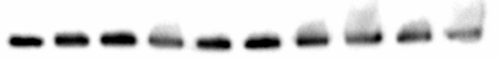
GAP43  Protein  (43KDa) | 1 | 2 | 3 | 4 | 5 | 6 | 7 | 8 | 9 | 10
GAP43  Protein  (43KDa) | Females
GAP43  Protein  (43KDa) | 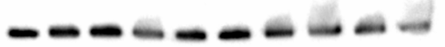
GAP43  Protein  (43KDa) | 1 | 2 | 3 | 4 | 5 | 6 | 7 | 8 | 9 | 10
GAP43  Protein  (43KDa) | Males and Females
GAP43  Protein  (43KDa) | 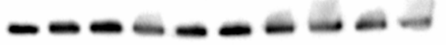
GAP43  Protein  (43KDa) | 1 | 2 | 3 | 4 | 5 | 6 | 7 | 8 | 9 | 10
PSD-95  Protein  (95KDa) | Males
PSD-95  Protein  (95KDa) | 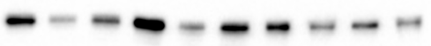
PSD-95  Protein  (95KDa) | 1 | 2 | 3 | 4 | 5 | 6 | 7 | 8 | 9 | 10
PSD-95  Protein  (95KDa) | Females
PSD-95  Protein  (95KDa) | 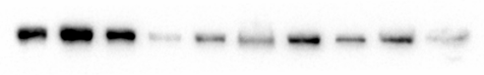
PSD-95  Protein  (95KDa) | 1 | 2 | 3 | 4 | 5 | 6 | 7 | 8 | 9 | 10
PSD-95  Protein  (95KDa) | Males and Females
PSD-95  Protein  (95KDa) | 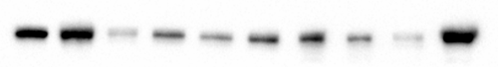
PSD-95  Protein  (95KDa) | 1 | 2 | 3 | 4 | 5 | 6 | 7 | 8 | 9 | 10

PFC Blots

GAPDH  Protein  (37KDa) | Males
GAPDH  Protein  (37KDa) | 1 | 2 | 3 | 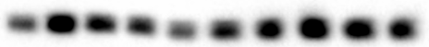  4 | 5 | 6 | 7 | 8 | 8 | 10
GAPDH  Protein  (37KDa) | 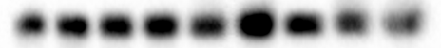  Females
GAPDH  Protein  (37KDa) | 1 | 2 | 3 | 4 | 5 | 6 | 7 | 8 | 9 | 10
GAPDH  Protein  (37KDa) | 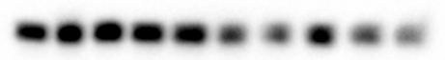  Males and Females
GAPDH  Protein  (37KDa) | 1 | 2 | 3 | 4 | 5 | 6 | 7 | 8 | 9 | 10

Figure SF2: Blots from cortex prefrontal (PFC) males and female WKY samples used for (A) GAP43 (43 kDa), (B) PSD-95 (95 kDa), and (C) GAPDH (37 kDa) detection.
WKY: Wistar Kyoto.

Striatum Ponceau S

- Males (n=10) | - Females (n=10) | - Males (n=4) and Females (n=5)
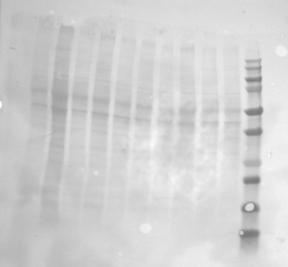 | 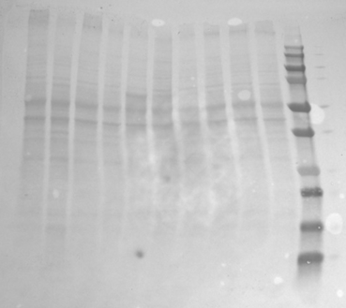 | 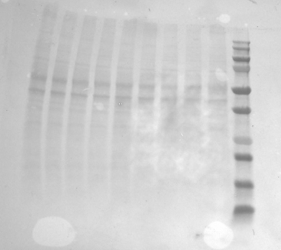
Figure SF3: Loading control of Ponceau S staining from striatum samples used for GAP43 (43 kDa), PSD-95 (95 kDa), and GAPDH (37 kDa) detection. Membrane A: Male WKY samples; Membrane B: Female WKY samples; Membrane C: Male and female WKY samples. A1,3,5,7,9: Male control. A2,4,6,8,10: Male MPH. B1,3,5,7,9: Female control. B2,4,6,8,10: Female MPH. C1,3,4: Male control. C2: Male MPH. C5,7,9: Female control. C6,8: Female MPH. A, B11, C10: Molecular weight control. WKY: Wistar Kyoto.

1 2 3 4 5 6 7 8 9 10 11
1 2 3 4 5 6 7 8 9 10 11
1 2 3 4 5 6 7 8 9 10 11
GAP43  A.  Protein  (43KDa) | Males
GAP43  A.  Protein  (43KDa) | 1 | 2 |  | 3 |  | 4 |  | 5 |  | 6 |  | 7 |  | 8 |  | 9 |  | 10
GAP43  A.  Protein  (43KDa) | Females
GAP43  A.  Protein  (43KDa) | 1 | 2 |  | 3 |  | 4 |  | 5 |  | 6 |  | 7 |  | 8 |  | 9 |  | 10
GAP43  A.  Protein  (43KDa) | Males and Females
GAP43  A.  Protein  (43KDa) | 1 |  | 2 |  | 3 |  | 4 |  | 5 |  | 6 |  | 7 |  | 8 |  | 9
PSD-95  B.  Protein  (95KDa) | Males
PSD-95  B.  Protein  (95KDa) | 1 | 2 |  | 3 |  | 4 |  | 5 |  | 6 |  | 7 |  | 8 |  | 9 | 10
PSD-95  B.  Protein  (95KDa) | Females
PSD-95  B.  Protein  (95KDa) | 1 | 2 |  | 3 |  | 4 |  | 5 |  | 6 |  | 7 |  | 8 |  | 9 | 10
PSD-95  B.  Protein  (95KDa) | Males and Females
PSD-95  B.  Protein  (95KDa) | 1 |  | 2 |  | 3 |  | 4 |  | 5 |  | 6 |  | 7 |  | 8 |  |  | 9

Striatum: Blots
C.
GAPDH  Protein  (37KDa) | Males
GAPDH  Protein  (37KDa) | 1 | 2 |  | 3 |  | 4 |  | 5 |  | 6 |  | 7 |  | 8 |  | 9 |  | 10
GAPDH  Protein  (37KDa) | Females
GAPDH  Protein  (37KDa) | 1 | 2 |  | 3 |  | 4 |  | 5 |  | 6 |  | 7 |  | 8 |  | 9 |  | 10
GAPDH  Protein  (37KDa) | Males and Females
GAPDH  Protein  (37KDa) | 1 |  | 2 |  | 3 |  | 4 |  | 5 |  | 6 |  | 7 |  | 8 |  | 9

Figure SF4: Blots from striatum male and female WKY samples used for (A) GAP43 (43 kDa), (B) PSD-95 (95 kDa), and (C) GAPDH (37 kDa) detection. WKY: Wistar Kyoto.

Hippocampus Ponceau S
1 2 3 4 5 6 7 8 9 10 11
- Males (n=10) | - Females (n=10) | - Males (n=5) and Females (n=5)
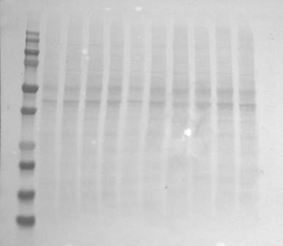 | 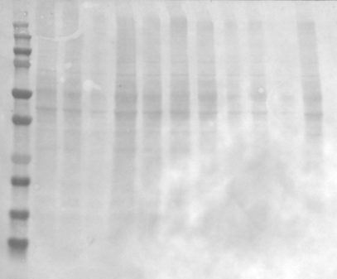
Figure SF5: Loading control of Ponceau S staining from hippocampus samples used for GAP43 (43 kDa), PSD-95 (95 kDa), and GAPDH (37 kDa) detection. Membrane A: Male WKY samples; Membrane B: Female WKY samples; Membrane C: Male and female WKY samples. A1,3,5,7,9: Male control. A2,4,6,8,10: Male MPH. B1,3,5,7,9: Female control. B2,4,6,8,10: Female MPH. C1,4,5: Male control. C2,3: Male MPH. C6,8,10: Female control. C7,9: Female MPH. A, B, C11: Molecular weight control. WKY: Wistar Kyoto.

1 2 3 4 5 6 7 8 9 10 11
1 2 3 4 5 6 7 8 9 10 11

Hippocampus Blots
GAP43  A.  Protein  (43KDa) | Males
GAP43  A.  Protein  (43KDa) | 2 | 3 | 4 | 5 | 6 | 7 | 8 | 9 | 10 | 11
GAP43  A.  Protein  (43KDa) | 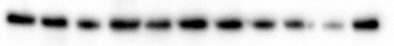  Females
GAP43  A.  Protein  (43KDa) | 2 | 3 | 4 | 5 | 6 | 7 | 8 | 9 | 10 | 11
GAP43  A.  Protein  (43KDa) | Males and Females
GAP43  A.  Protein  (43KDa) | 2 | 3 | 4 | 5 | 6 | 7 | 8 | 9 | 10 | 11
PSD-95  B.  Protein  (95KDa) | Males
PSD-95  B.  Protein  (95KDa) | 2 | 3 | 4 | 5 | 6 | 7 | 8 | 9 | 10 | 11
PSD-95  B.  Protein  (95KDa) | Females
PSD-95  B.  Protein  (95KDa) | 2 | 3 | 4 | 5 | 6 | 7 | 8 | 9 | 10 | 11
PSD-95  B.  Protein  (95KDa) | Males and Females
PSD-95  B.  Protein  (95KDa) | 2 | 3 | 4 | 5 | 6 | 7 | 8 | 9 | 10 | 11

GAPDH  C.  Protein  (37KDa) | Males
GAPDH  C.  Protein  (37KDa) | 2 | 3 | 4 | 5 | 6 | 7 | 8 | 9 | 10 | 11
GAPDH  C.  Protein  (37KDa) | Females
GAPDH  C.  Protein  (37KDa) | 2 | 3 | 4 | 5 | 6 | 7 | 8 | 9 | 10 | 11
GAPDH  C.  Protein  (37KDa) | Males and Females
GAPDH  C.  Protein  (37KDa) | 2 | 3 | 4 | 5 | 6 | 7 | 8 | 9 | 10 | 11

Figure SF6: Blots from hippocampus male and female WKY samples used for (A) GAP43 (43 kDa), (B) PSD-95 (95 kDa), and (C) GAPDH (37 kDa) detection. WKY: Wistar Kyoto.

Cerebellum Ponceau S

- Males (n=10) | - Females (n=10) | - Males (n=4) and Females (n=5)
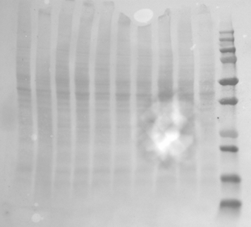 | 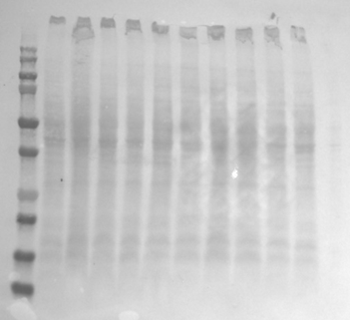 | 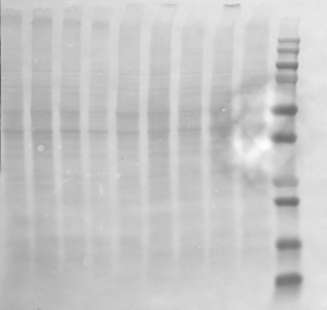
Figure SF7: Loading control of Ponceau S staining from cerebellum samples used for GAP43 (43 kDa), PSD-95 (95 kDa), and GAPDH (37 kDa) detection. Membrane A: Male WKY samples; Membrane B: Female WKY samples; Membrane C: Male and female WKY samples. A1,3,5,7,9: Male control. A2,4,6,8,10: Male MPH. B1,3,5,7,9: Female control. B2,4,6,8,10: Female MPH. C1,3,4: Male control. C2: Male MPH. C5,7,9: Female control. C6,8: Female MPH. A, B11, C10: Molecular weight control. WKY: Wistar Kyoto.

1 2 3 4 5 6 7 8 9 10 11
1 2 3 4 5 6 7 8 9 10 11
1 2 3 4 5 6 7 8 9 10

Cerebellum Blots
GAP43  A.  Protein  (43KDa) | Males
GAP43  A.  Protein  (43KDa) | 1 | 2 |  | 3 |  | 4 |  | 5 |  | 6 |  | 7 |  | 8 |  | 9 |  | 10
GAP43  A.  Protein  (43KDa) | Females
GAP43  A.  Protein  (43KDa) | 2 | 3 |  | 4 |  | 5 |  | 6 |  | 7 |  | 8 |  | 9 |  | 10 |  | 11
GAP43  A.  Protein  (43KDa) | Males and Females
GAP43  A.  Protein  (43KDa) | 1 |  | 2 |  | 3 |  | 4 |  | 5 |  | 6 |  | 7 |  | 8 |  | 9
PSD-95  B.  Protein  (95KDa) | Males
PSD-95  B.  Protein  (95KDa) | 1 | 2 |  | 3 |  | 4 |  | 5 |  | 6 |  | 7 |  | 8 |  | 9 | 10
PSD-95  B.  Protein  (95KDa) | Females
PSD-95  B.  Protein  (95KDa) | 2 | 3 |  | 4 |  | 5 |  | 6 |  | 7 |  | 8 |  | 9 |  | 10 | 11
PSD-95  B.  Protein  (95KDa) | Males and Females
PSD-95  B.  Protein  (95KDa) | 1 |  | 2 |  | 3 |  | 4 |  | 5 |  | 6 |  | 7 |  | 8 |  |  | 9

GAPDH  C.  Protein  (37KDa) | Males
GAPDH  C.  Protein  (37KDa) | 2 | 3 |  | 4 |  | 5 |  | 6 |  | 7 |  | 8 |  | 9 |  | 10 |  | 11
GAPDH  C.  Protein  (37KDa) | Females
GAPDH  C.  Protein  (37KDa) | 2 | 3 |  | 4 |  | 5 |  | 6 |  | 7 |  | 8 |  | 9 |  | 10 |  | 11
GAPDH  C.  Protein  (37KDa) | Males and Females
GAPDH  C.  Protein  (37KDa) | 1 |  | 2 |  | 3 |  | 4 |  | 5 |  | 6 |  | 7 |  | 8 |  | 9

Figure SF8: Blots from male and female WKY samples used for (A) GAP43 (43 kDa), (B) PSD-95 (95 kDa), and (C) GAPDH (37 kDa) detection. WKY: Wistar Kyoto.

Diencephalon Ponceau S

- Males (n=14) | - Male (n=1) and Females (n=11) | - Females (n=3)
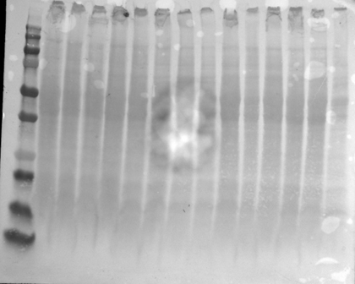 | 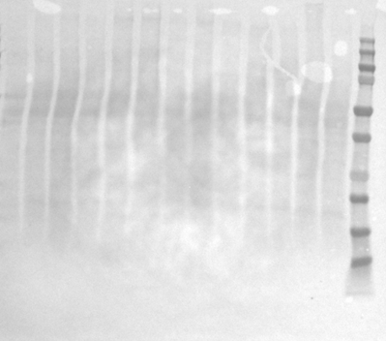  1 2 3 4 5 6 7 8 9 10 11 12 13 | 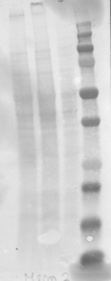
Figure SF9: Loading control of Ponceau S staining from diencephalon samples used for GAP43 (43 kDa), PSD-95 (95 kDa), and GAPDH (37 kDa) detection. Membrane A: Male WKY samples; Membrane B: Female WKY samples; Membrane C: Male and female WKY samples. A2,4,6,9,11,13,15: Male control. A3,5,7,8,10,12,14: Male MPH. B1: Male MPH. B,3,5,7,9,11,13: Female control. B2,4,6,8,10,12: Female MPH. C1,3: Female control. C2 Female MPH. A1, B14, C4: Molecular weight control. WKY: Wistar Kyoto.
.

1 2 3 4
1 2 3 4 5 6 7 8 9 10 11 12 13 14 15

Diencephalon Blots

GAP43  Protein  (43KDa) | Males
GAP43  Protein  (43KDa) | A.
GAP43  Protein  (43KDa) | 2 | 3 |  |  | 4 |  |  | 5 |  | 6 |  |  | 7 |  |  | 8 |  | 9 |  | 10 |  |  | 11 |  |  | 12 |  | 13 |  |  | 14 |  |  | 15
GAP43  Protein  (43KDa) | Male and Females
GAP43  Protein  (43KDa) | 1 |  | 2 |  |  | 3 |  |  | 4 |  |  | 5 |  | 6 |  |  |  |  | 7 |  |  | 8 |  | 9 |  |  | 10 |  |  | 11 |  |  | 12
GAP43  Protein  (43KDa) | Females
GAP43  Protein  (43KDa) |  |  |  |  |  |  |  |  |  |  | 1 |  |  |  | 2 |  |  | 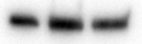  3
PSD-95  B.  Protein  (95KDa) | Males
PSD-95  B.  Protein  (95KDa) | 2 | 3 |  |  | 4 |  |  | 5 |  | 6 |  |  | 7 |  |  | 8 |  |  | 9 |  | 10 |  |  | 11 |  |  | 12 | 13 |  | 14 | 15
PSD-95  B.  Protein  (95KDa) | Male and Females
PSD-95  B.  Protein  (95KDa) | 1 |  | 2 |  |  | 3 |  |  | 4 |  |  | 5 |  | 6 |  |  |  |  |  | 7 |  |  | 8 |  |  | 9 | 10 | 11 |  | 12
PSD-95  B.  Protein  (95KDa) | Females
PSD-95  B.  Protein  (95KDa) |  |  |  |  |  |  |  |  |  |  | 1 |  |  |  | 2 |  |  | 3
C.

GAPDH  Protein  (37KDa) | Males
GAPDH  Protein  (37KDa) | 2 | 3 |  |  | 4 |  |  | 5 |  | 6 |  |  | 7 |  |  | 8 |  | 9 |  | 10 |  |  | 11 |  |  | 12 |  |  |  | 13 |  | 14 | 15
GAPDH  Protein  (37KDa) | Male and Females
GAPDH  Protein  (37KDa) | 1 |  | 2 |  |  | 3 |  |  | 4 |  |  | 5 |  | 6 |  |  |  |  | 7 |  |  | 8 |  | 9 |  |  | 10 |  | 11 |  |  | 12
GAPDH  Protein  (37KDa) | Females
GAPDH  Protein  (37KDa) |  |  |  |  |  |  |  |  |  |  | 1 |  |  |  | 2 |  |  | 3

Figure SF10: Blots from diencephalon male and female WKY samples used for (A) GAP43 (43 kDa), (B) PSD-95 (95 kDa), and (C) GAPDH (37 kDa) detection. WKY: Wistar Kyoto.

Figure Legends
Figure SF1: Loading control of Ponceau S staining from cortex prefrontal (PFC) samples used for GAP43 (43 kDa), PSD-95 (95 kDa), and GAPDH (37 kDa) detection. Membrane A: Male WKY samples; Membrane B: Female WKY samples; Membrane C: Male and female WKY samples. A1,3,5,7,9: Male control. A2,4,6,8,10: Male MPH. B1,3,5,7,9: Female control. B2,4,6,8,10: Female MPH. C1,4,5: Male control. C2,3: Male MPH. C6,8,10: Female control. C7,9: Female MPH. A, B, C11: Molecular weight control. WKY: Wistar Kyoto.

Figure SF2: Blots from cortex prefrontal (PFC) males and female WKY samples used for (A) GAP43 (43 kDa), (B) PSD-95 (95 kDa), and (C) GAPDH (37 kDa) detection.
WKY: Wistar Kyoto.

Figure SF3: Loading control of Ponceau S staining from striatum samples used for GAP43 (43 kDa), PSD-95 (95 kDa), and GAPDH (37 kDa) detection. Membrane A: Male WKY samples; Membrane B: Female WKY samples; Membrane C: Male and female WKY samples. A1,3,5,7,9: Male control. A2,4,6,8,10: Male MPH. B1,3,5,7,9: Female control. B2,4,6,8,10: Female MPH. C1,3,4: Male control. C2: Male MPH. C5,7,9: Female control. C6,8: Female MPH. A, B11, C10: Molecular weight control. WKY: Wistar Kyoto.

Figure SF4: Blots from striatum male and female WKY samples used for (A) GAP43 (43 kDa), (B) PSD-95 (95 kDa), and (C) GAPDH (37 kDa) detection. WKY: Wistar Kyoto.

Figure SF5: Loading control of Ponceau S staining from hippocampus samples used for GAP43 (43 kDa), PSD-95 (95 kDa), and GAPDH (37 kDa) detection. Membrane A: Male WKY samples; Membrane B: Female WKY samples; Membrane C: Male and female WKY samples. A1,3,5,7,9: Male control. A2,4,6,8,10: Male MPH. B1,3,5,7,9: Female control. B2,4,6,8,10: Female MPH. C1,4,5: Male control. C2,3: Male MPH. C6,8,10: Female control. C7,9: Female MPH. A, B, C11: Molecular weight control. WKY: Wistar Kyoto.

Figure SF6: Blots from hippocampus male and female WKY samples used for (A) GAP43 (43 kDa), (B) PSD-95 (95 kDa), and (C) GAPDH (37 kDa) detection. WKY: Wistar Kyoto.

Figure SF7: Loading control of Ponceau S staining from cerebellum samples used for GAP43 (43 kDa), PSD-95 (95 kDa), and GAPDH (37 kDa) detection. Membrane A: Male WKY samples; Membrane B: Female WKY samples; Membrane C: Male and female WKY samples. A1,3,5,7,9: Male control. A2,4,6,8,10: Male MPH. B1,3,5,7,9: Female control. B2,4,6,8,10: Female MPH. C1,3,4: Male control. C2: Male MPH. C5,7,9: Female control. C6,8: Female MPH. A, B11, C10: Molecular weight control. WKY: Wistar Kyoto.

Figure SF8: Blots from male and female WKY samples used for (A) GAP43 (43 kDa), (B) PSD-95 (95 kDa), and (C) GAPDH (37 kDa) detection. WKY: Wistar Kyoto.

Figure SF9: Loading control of Ponceau S staining from diencephalon samples used for GAP43 (43 kDa), PSD-95 (95 kDa), and GAPDH (37 kDa) detection. Membrane A: Male WKY samples; Membrane B: Female WKY samples; Membrane C: Male and female WKY samples. A2,4,6,9,11,13,15: Male control. A3,5,7,8,10,12,14: Male control. B1,3,5,7,9,11,13: Female control. B2,4,6,8,10,12: Female MPH. C1,3: Female control. C2 Female MPH. A1, B14, C4: Molecular weight control. WKY: Wistar Kyoto.

Figure SF10: Blots from diencephalon male and female WKY samples used for (A) GAP43 (43 kDa), (B) PSD-95 (95 kDa), and (C) GAPDH (37 kDa) detection. WKY: Wistar Kyoto.

