Appendix

Figure A1: Distribution of hospital beds per 10,000 inhab. across Italian provinces in 2010 (panel (a)) and 2021 (panel (b)).
- (b)

Figure A2: Distribution of hospital beds per 10,000 inhab. by type of care (acute, rehabilitation, and long-term) across Italian provinces in 2010 (panel (a, b, and c, respectively)) and 2021 (panel (d, e, and f, respectively)).
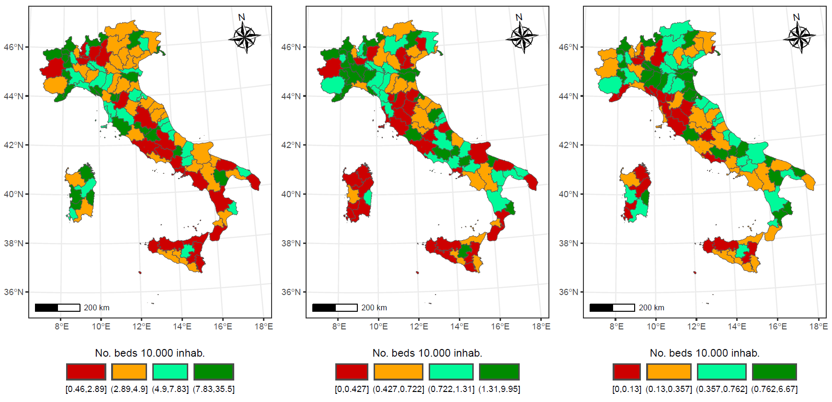
- (b) (c)

- (e) (f)

Table A1: Correlation matrix
 | GE(-1) | GE(0) | GE(1) | GE(2) | Gini
GE(-1) | 1
GE(0) | 0.847 | 1
GE(1) | 0.614 | 0.918 | 1
GE(2) | 0.473 | 0.848 | 0.982 | 1
Gini | 0.686 | 0.953 | 0.995 | 0.961 | 1

Table A2: Top contributing provinces to hospital bed inequality (Theil GE(1)), by year (2010–2021).
Year | Rank | Province | Abs. contribution to Theil | Share of total Theil (%)
2010 | 1 | Isernia | 0.0358 | 4.8633
2010 | 2 | Verbano-Cusio-Ossola | 0.0227 | 3.0844
2010 | 3 | Trieste | 0.0223 | 3.0304
2010 | 4 | Belluno | 0.0200 | 2.7154
2010 | 5 | Piacenza | 0.0199 | 2.7031
2010 | 6 | Aosta | 0.0198 | 2.6923
2010 | 7 | Savona | 0.0194 | 2.6378
2010 | 8 | Enna | 0.0167 | 2.2717
2010 | 9 | Roma | 0.0166 | 2.2508
2010 | 10 | Rovigo | 0.0145 | 1.9727
2011 | 1 | Isernia | 0.0321 | 4.3737
2011 | 2 | Verbano-Cusio-Ossola | 0.0265 | 3.6046
2011 | 3 | Trieste | 0.0219 | 2.9890
2011 | 4 | Aosta | 0.0203 | 2.7706
2011 | 5 | Belluno | 0.0203 | 2.7693
2011 | 6 | Piacenza | 0.0184 | 2.5094
2011 | 7 | Savona | 0.0180 | 2.4529
2011 | 8 | Roma | 0.0161 | 2.1862
2011 | 9 | Rovigo | 0.0149 | 2.0273
2011 | 10 | Enna | 0.0147 | 2.0017
2012 | 1 | Isernia | 0.0343 | 4.6806
2012 | 2 | Verbano-Cusio-Ossola | 0.0276 | 3.7689
2012 | 3 | Trieste | 0.0228 | 3.1113
2012 | 4 | Aosta | 0.0207 | 2.8319
2012 | 5 | Belluno | 0.0182 | 2.4810
2012 | 6 | Piacenza | 0.0175 | 2.3929
2012 | 7 | Savona | 0.0174 | 2.3766
2012 | 8 | Roma | 0.0158 | 2.1521
2012 | 9 | Rovigo | 0.0156 | 2.1351
2012 | 10 | Enna | 0.0144 | 1.9643
2013 | 1 | Isernia | 0.0354 | 4.8819
2013 | 2 | Verbano-Cusio-Ossola | 0.0278 | 3.8332
2013 | 3 | Trieste | 0.0237 | 3.2693
2013 | 4 | Aosta | 0.0219 | 3.0121
2013 | 5 | Belluno | 0.0198 | 2.7264
2013 | 6 | Piacenza | 0.0176 | 2.4226
2013 | 7 | Enna | 0.0169 | 2.3235
2013 | 8 | Rovigo | 0.0160 | 2.2012
2013 | 9 | Roma | 0.0158 | 2.1820
2013 | 10 | Savona | 0.0146 | 2.0054
2014 | 1 | Isernia | 0.0362 | 4.9543
2014 | 2 | Verbano-Cusio-Ossola | 0.0275 | 3.7572
2014 | 3 | Trieste | 0.0246 | 3.3625
2014 | 4 | Aosta | 0.0213 | 2.9100
2014 | 5 | Belluno | 0.0201 | 2.7503
2014 | 6 | Enna | 0.0174 | 2.3758
2014 | 7 | Rovigo | 0.0165 | 2.2590
2014 | 8 | Roma | 0.0160 | 2.1878
2014 | 9 | Piacenza | 0.0153 | 2.0959
2014 | 10 | SV | 0.0151 | 2.0700
2015 | 1 | Isernia | 0.0370 | 5.0781
2015 | 2 | Verbano-Cusio-Ossola | 0.0284 | 3.8941
2015 | 3 | Trieste | 0.0253 | 3.4687
2015 | 4 | Aosta | 0.0222 | 3.0488
2015 | 5 | Belluno | 0.0185 | 2.5373
2015 | 6 | Enna | 0.0167 | 2.2922
2015 | 7 | RO | 0.0160 | 2.1950
2015 | 8 | Roma | 0.0159 | 2.1857
2015 | 9 | Piacenza | 0.0155 | 2.1200
2015 | 10 | Savona | 0.0154 | 2.1146
2016 | 1 | Isernia | 0.0377 | 5.2384
2016 | 2 | Verbano-Cusio-Ossola | 0.0264 | 3.6753
2016 | 3 | Trieste | 0.0213 | 2.9638
2016 | 4 | Aosta | 0.0199 | 2.7619
2016 | 5 | Belluno | 0.0182 | 2.5383
2016 | 6 | Enna | 0.0168 | 2.3397
2016 | 7 | Savona | 0.0159 | 2.2099
2016 | 8 | Roma | 0.0159 | 2.2074
2016 | 9 | Piacenza | 0.0152 | 2.1186
2016 | 10 | Rovigo | 0.0135 | 1.8760
2017 | 1 | Isernia | 0.0362 | 4.8319
2017 | 2 | Verbano-Cusio-Ossola | 0.0269 | 3.5933
2017 | 3 | Belluno | 0.0255 | 3.4070
2017 | 4 | Aosta | 0.0212 | 2.8270
2017 | 5 | Trieste | 0.0208 | 2.7803
2017 | 6 | Rovigo | 0.0177 | 2.3637
2017 | 7 | Enna | 0.0169 | 2.2493
2017 | 8 | Roma | 0.0163 | 2.1791
2017 | 9 | Savona | 0.0158 | 2.1120
2017 | 10 | Piacenza | 0.0157 | 2.0998
2018 | 1 | Isernia | 0.0320 | 4.2646
2018 | 2 | Verbano-Cusio-Ossola | 0.0283 | 3.7768
2018 | 3 | Belluno | 0.0254 | 3.3874
2018 | 4 | Aosta | 0.0209 | 2.7881
2018 | 5 | Trieste | 0.0204 | 2.7261
2018 | 6 | Rovigo | 0.0177 | 2.3638
2018 | 7 | Enna | 0.0169 | 2.2602
2018 | 8 | Roma | 0.0164 | 2.1892
2018 | 9 | Piacenza | 0.0157 | 2.0998
2018 | 10 | Savona | 0.0156 | 2.0826
2019 | 1 | Isernia | 0.0324 | 4.2919
2019 | 2 | Verbano-Cusio-Ossola | 0.0273 | 3.6141
2019 | 3 | Belluno | 0.0257 | 3.3978
2019 | 4 | Aosta | 0.0209 | 2.7672
2019 | 5 | Rovigo | 0.0180 | 2.3868
2019 | 6 | Trieste | 0.0178 | 2.3625
2019 | 7 | Enna | 0.0177 | 2.3468
2019 | 8 | Roma | 0.0165 | 2.1796
2019 | 9 | Savona | 0.0156 | 2.0723
2019 | 10 | Piacenza | 0.0156 | 2.0650
2020 | 1 | Isernia | 0.0329 | 4.3550
2020 | 2 | Verbano-Cusio-Ossola | 0.0281 | 3.7232
2020 | 3 | Belluno | 0.0260 | 3.4440
2020 | 4 | Aosta | 0.0243 | 3.2192
2020 | 5 | Rovigo | 0.0189 | 2.4977
2020 | 6 | Trieste | 0.0176 | 2.3293
2020 | 7 | Enna | 0.0176 | 2.3248
2020 | 8 | Savona | 0.0163 | 2.1549
2020 | 9 | Roma | 0.0159 | 2.1045
2020 | 10 | Piacenza | 0.0157 | 2.0732
2021 | 1 | Verbano-Cusio-Ossola | 0.0352 | 4.5919
2021 | 2 | Isernia | 0.0290 | 3.7910
2021 | 3 | Aosta | 0.0222 | 2.9021
2021 | 4 | Biella | 0.0201 | 2.6190
2021 | 5 | Ancona | 0.0192 | 2.5104
2021 | 6 | Belluno | 0.0189 | 2.4714
2021 | 7 | Enna | 0.0163 | 2.1279
2021 | 8 | Trieste | 0.0157 | 2.0486
2021 | 9 | Fermo | 0.0134 | 1.7505
2021 | 10 | Alessandria | 0.0128 | 1.6677
Note: This table reports, for each year $t$, the ten provinces $j$with the largest contribution to national inequality in hospital bed endowment. Inequality is measured using the Theil index (GE(1)) computed over hospitals, where the hospital-level outcome is beds per 10,000 inhabitants.

Table A3: Within-province healthcare inequality and COVID-19 mortality: Regression results
 | Specification I  Coeff.  (Std. Err.) | Specification II  Coeff.  (Std. Err.) | Specification III  Coeff.  (Std. Err.)
Within province inequality | 2.395* | 2.403** | 2.392**
 | (1.242) | (1.112) | (1.119)
Beds for acute care services | -0.070*** | -0.105*** | -0.105***
 | (0.015) | (0.015) | (0.015)
Elderly (%) |  | 0.858*** | 0.857***
 |  | (0.165) | (0.166)
Unemployement rate |  |  | -0.006
 |  |  | (0.035)
Constant | 3.940*** | -15.922*** | -15.831***
 | (0.537) | (3.855) | (3.904)
Observations | 214 | 214 | 214
R-squared | 0.182 | 0.351 | 0.351
Note: The dependent variable is the logarithm of the provincial mortality gap, defined as the difference between the mortality rate observed in 2020-2021 and the average mortality rate recorded in the same province during the pre-pandemic period. Within province inequality is the Theil index – GE(1) – computed at the provincial level. All specifications are estimated using province fixed-effects models. Standard errors are reported in parentheses.
* p < 0.10, ** p < 0.05, *** p < 0.01

