Prospects for seasonal forecasting of iceberg distributions in the North Atlantic

Robert Marsh¹, Grant Bigg², Yifan Zhao³, Matt Martin⁴, Jeff Blundell¹, Simon Josey⁵, Edward Hanna²

1 University of Southampton
2 University of Sheffield
3 Cranfield University
4 UK Met Office
5 National Oceanography Centre

Corresponding Author: rm12@soton.ac.uk, +44 23 8059 6214

Supplementary Material for section 2.2 NARMAX predictions
The NARMAX model developed in Zhao et al. (2016) for modeling the I48N iceberg variable, shown in Figure 2, was extended to cover an additional 7 years. It now covers the period 1900-2015, with monthly forcing data for the three input variables: the North Atlantic Oscillation (NAO); the Greenland Ice Sheet Surface Mass Balance (SMB); and the mean Labrador Sea Surface Temperature (LSST). The monthly NAO time-series is the principal component-based version of this atmospheric circulation index (Hurrell and Deser (2009); https://climatedataguide.ucar.edu/climate-data/hurrell-north-atlantic-oscillation-nao-index-pc-based). By the nature of the principal component calculation technique, the individual monthly values change slightly every time the online dataset is extended, meaning the values used here over 1900-2008 are slightly different to those used in Zhao et al. (2016). The Greenland SMB model calculation is described in Hanna et al. (2011), and is originally based on the runoff code of Janssens & Huybrechts (2000) with subsequent modification, but the values from 1980-2015 have been re-calculated/extended using the most recent ERA-Interim atmospheric reanalysis. This also means that the 1980-2008 SMB values differ slightly from those used in Zhao et al. (2016). The final input variable of the LSST comes from averaging the updated Kaplan v2 SST (Kaplan et al., 1998) over (67-55ºN, 65-45ºW). The Kaplan v2 SST is available from NOAA’s Physical Sciences Division (http://www.esrl.noaa.gov/psd).
A full description of the NARMAX model used here, and tests of its sensitivity, are given in Zhao et al. (2016) and Zhao et al. (2017). Briefly, the NARMAX system identification model uses a forward regression orthogonal least squares algorithm to build models term by term from recorded datasets. This is achieved here by using the Windowed Error Reduction Ratio (WERR) which shows the contribution that each selected model term makes to the variance of the dependent variable (I48N here), expressed as a percentage, taking account of the noise in the data. The model has a 30 year window moving through the time series, to allow the relationship between inputs and outputs to evolve over time if appropriate. The NARMAX method searches through an initial library of model terms, which typically includes linear and non-linear lagged variables, and selects the most significant terms to include in the final model for each window. Maximum lags of 48 months in our three input variables (LSST, NAO and SMB) were allowed, with the maximum model order of the non-linear terms being 2.
The NARMAX model’s fit to I48N over 1900-2015 is shown in Figure S1, for both annual mean forcing, and for monthly forcing. Both annual and monthly inputs lead to models that fit the I48N series well, particularly over the past decade. A 30-year sliding window was used for this calculation, as described in Zhao et al. (2017), to allow for changes to the relative importance of the various input terms on the model over the time period of the model fit. This change in relative importance is shown in Figure S2. Note that while the atmospheric input of the NAO plays a minor role throughout the last century, in recent decades both the SMB and LSST contribute significantly to the model fit.
As described, in Zhao et al. (2017), a range of model terms are allowed to build up the NARMAX model, including both non-linear terms, and terms involving extensive lags. Figure S3 shows the magnitude of the computed contributions of different lag terms from each of the three input variables to the I48N model. In the last few decades the dominant lags have been from around 10 months in the oceanic LSST input variable, and 6-8 months in the ice sheet-dominated SMB input variable. This is showing a very different lag relationship to that found in the first half of the twentieth century, when SMB was dominant (Figure S2), with a lag of almost 2 years. Thus, change in iceberg flux affecting the NW Atlantic is now occurring with a shorter response time, but still with 6-10 months notice, allowing the possibility of iceberg hazard prediction. This would involve using the latest window’s model’s terms involving LSST, the NAO and the Greenland SMB with this lag to estimate the likely I48N numbers, and hence the starting iceberg flux for the ocean model predictions.

Supplementary References
Hanna E., Huybrechts, P., Cappelen, J., Steffen, K., Bales, R.C., Burgess, E., McConnell, J., Steffensen, J.P., Van den Broeke ,M., Wake, L., Bigg, G.R., Griffiths, M., and D. Savas (2011). Greenland Ice Sheet surface mass balance 1870 to 2010 based on Twentieth Century Reanalysis, and links with global climate forcing. J. Geophys. Res. – Atmos., 116, D24121.
Hurrell, J.W, and C. Deser (2009). North Atlantic climate variability, The role of the North Atlantic Oscillation. J. Mar. Sys., 78, 28-41.
Janssens, I., and P. Huybrechts (2000). The treatment of meltwater retention in mass-balance parameterizations of the Greenland ice sheet. Annals of Glaciology 31, 133 – 140.
Kaplan, A., Cane, M., Kushnir, Y., Clement, A., Blumenthal, M., and B. Rajagopalan (1998). Analyses of global sea surface temperature 1856-1991. J. Geophys. Res. – Oceans, 103, 18567-18589.
Zhao, Y., Hanna, E., and G.R. Bigg (2017). Tracking nonlinear correlation for complex systems using a Windowed Error Reduction Ratio method. Submitted to Automatica.
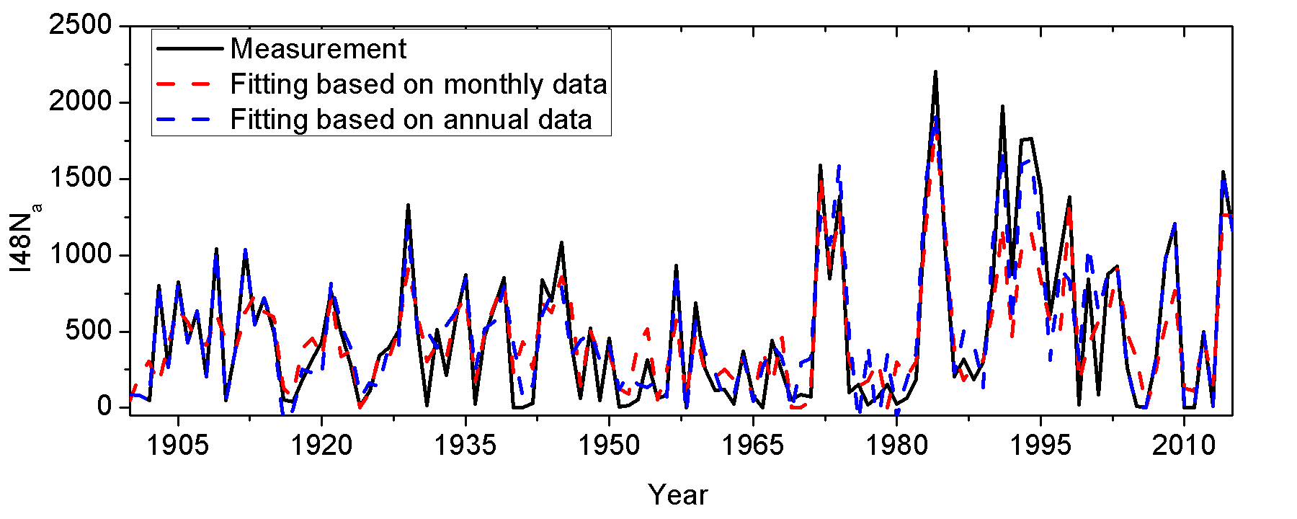
Figure S1. A comparison of two model outputs (I48N) of NARMAX models based on monthly and annual data, respectively. Three input variables (SMB, NAO, and LSST) were considered. The black solid curve depicts the observed annual total I48N; the red dash curve depicts the model output based on the monthly data, and the blue dash-dot curve depicts the model output based on the annual data.

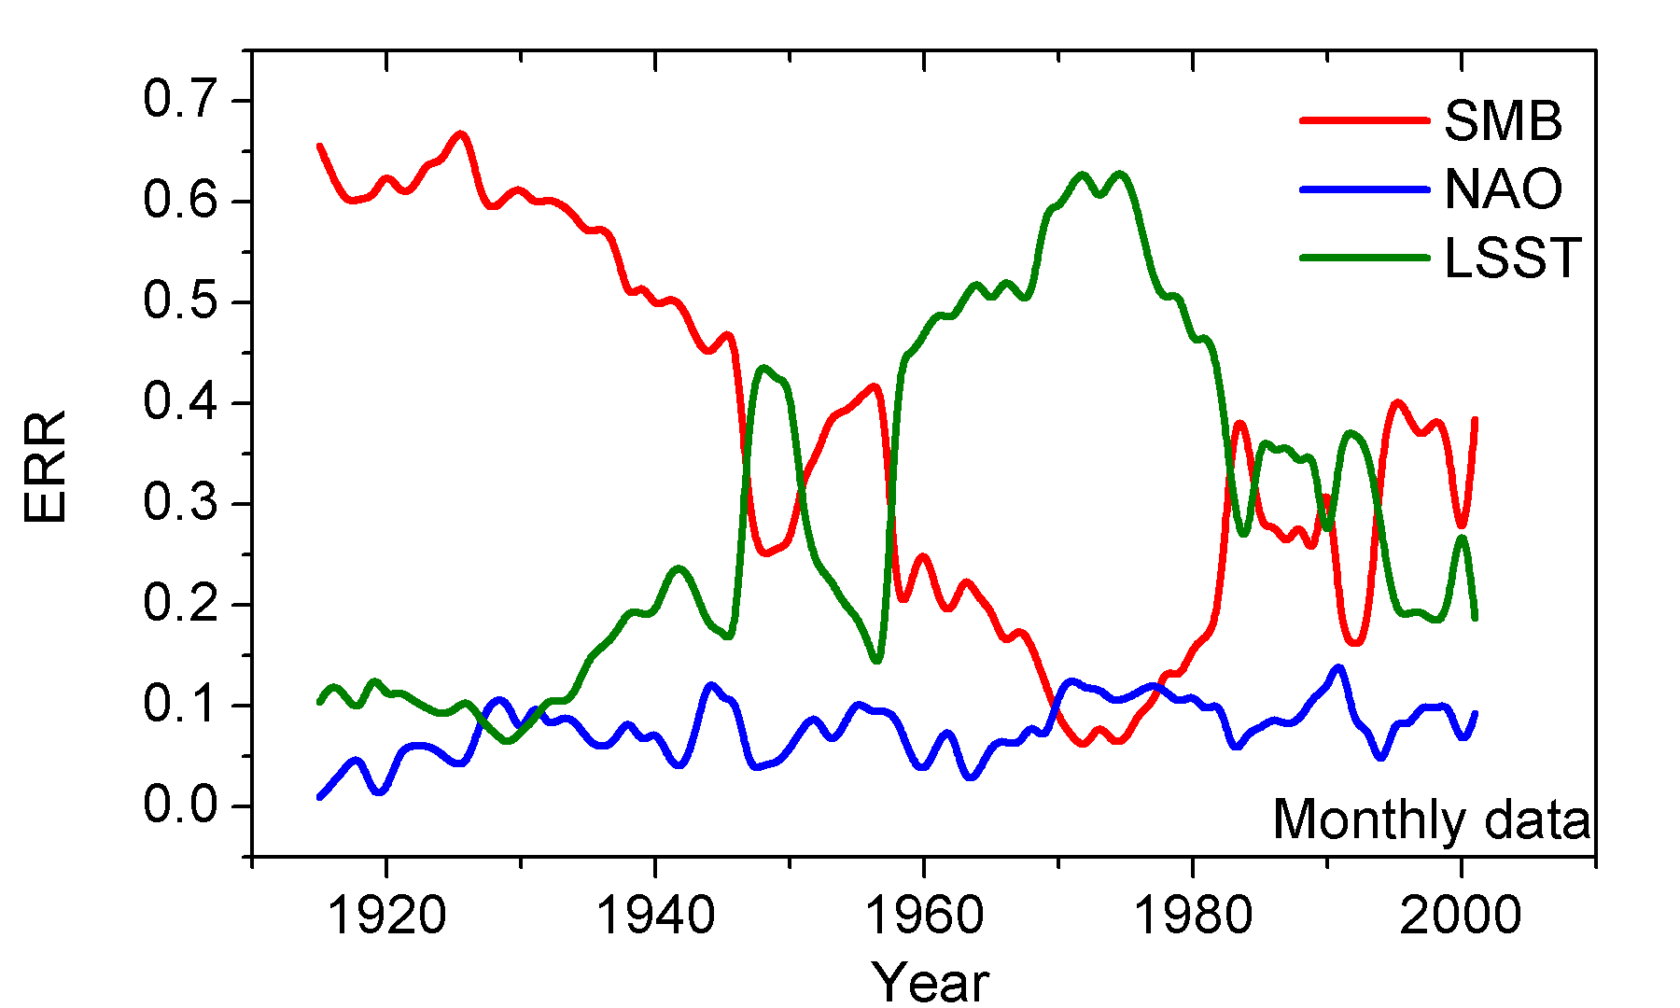

Figure S2. Computed contributions of input variables to I48N over time from1900 to 2015, based on the ERR values for a 30-year sliding window which is incremented 1 year at a time, using the monthly input time series. ERR is a normalized measure of the variance explained by each input, as explained in detail in Zhu et al. (2016).

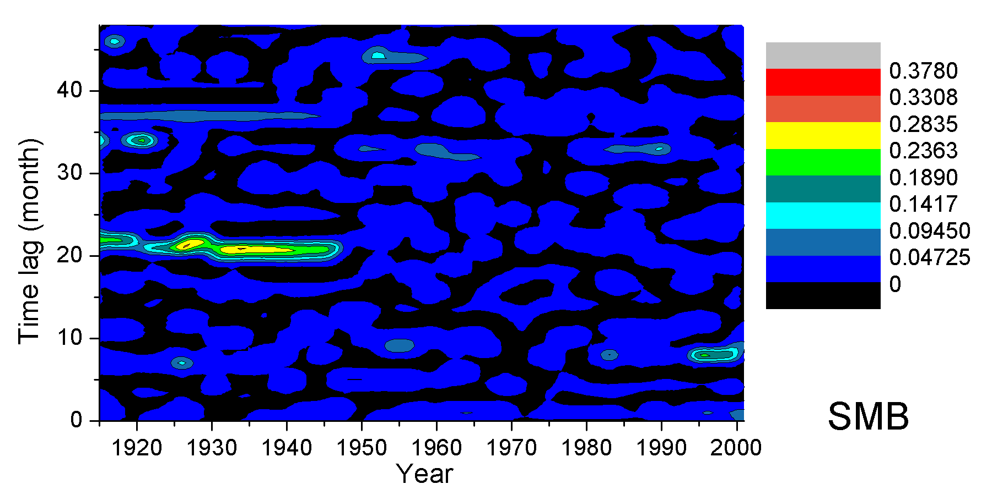
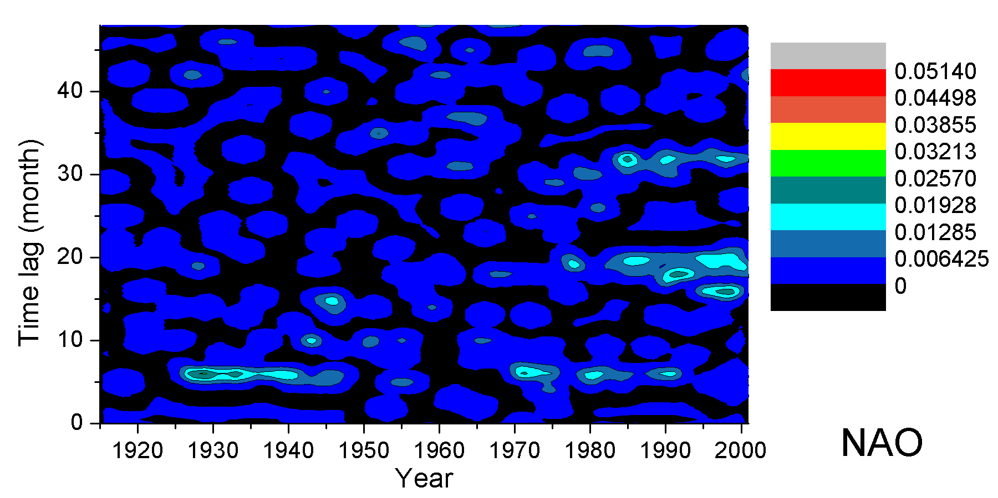
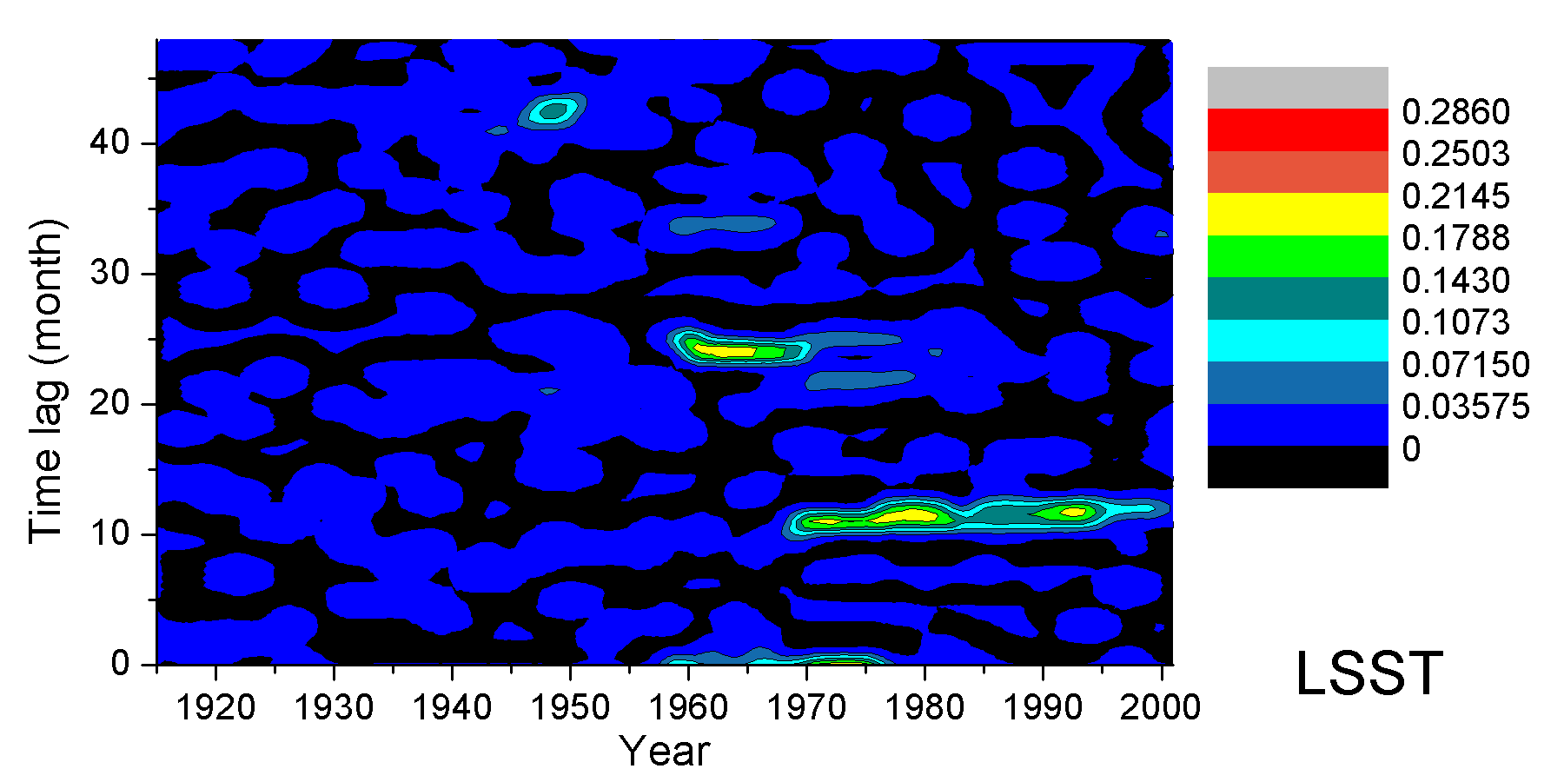
Figure S3. Computed contributions to the monthly I48N NARMAX model over 1900–2015 of the lags of the input variables: a) SMB, b) NAO, and c) LSST. These lags are based on the ERR values for a 30-year sliding window, incremented 1 year at a time, where all three variables were considered together as the inputs.

