SUPPLEMENT MATERIAL

Evaluation of the temperature and precipitation gradient
For considering the vertical range of the Vögelsberg landslide’s hydrological catchment in the water balance modelling framework, the vertical gradients of air temperature and precipitation were evaluated. For that, daily time series of mean air temperature and precipitation sum were used, recorded at six meteorological stations close to the landslide at different elevation, covering the period 1981/01/01 to 2010/12/31 (Figure 1a, Table S1).
Table S1: Metadata of the considered meteorological stations. The numbers of the stations are shown in Figure 1a.
No. | Name | Latitude | Longitude | Elevation
1 | Kleinvolderberg | 47.2736°N | 11.5413°E | 660 m a.s.l.
2 | St. Martin | 47.3216°N | 11.5616°E | 875 m a.s.l.
3 | Weerberg | 47.3063°N | 11.7055°E | 928 m a.s.l.
4 | Lanersbach | 47.1622°N | 11.7441°E | 1250 m a.s.l.
5 | Innerschmirn Obern | 47.1097°N | 11.6044°E | 1632 m a.s.l.
6 | Wattener Lizum | 47.1719°N | 11.6394°E | 1970 m a.s.l.

Linear models were fitted on a daily basis, correlating air temperature and precipitation, respectively, with elevation. Figure S1 shows the resulting daily gradients grouped per month, representing vertical changes in air temperature and precipitation due to elevation effects. Gradients of air temperature (Figure S1a) are generally negative, suggesting a temperature decrease with increasing elevation. The temperature gradients are more pronounced in the spring and summer season with median values up to -0.71°C/100m in April and less variation compared to the fall and winter seasons. This is particularly due to frequent temperature inversion during the winter months, when cool air in the valleys is overlain by a layer of warmer air. This behaviour leads to a less pronounced gradient of 0.36°C/100m in December. On the other hand, the monthly vertical gradients of precipitation are mostly positive, but minor (Figure S1b). Median gradients are in the order of 0.1mm/100m and do not show significant seasonal variation. However, more pronounced gradients either positive or negative can be observed during the summer months.
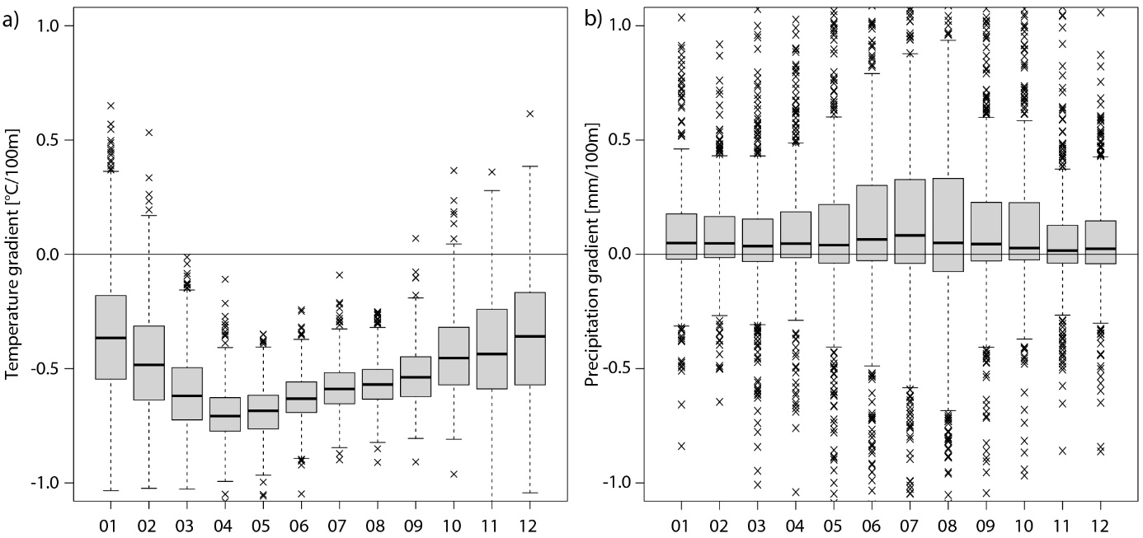
Figure S1: Daily vertical gradients of mean air temperature (a) and precipitation (b) grouped per month. The gradients are based on meteorological time series derived from six stations located in the vicinity of the Vögelsberg landslide at different elevations, covering the period from 1981 to 2010. Data source: Hydrographic service of Austria.

