Supplementary Materials
Figure S1. Global temperature pattern during the time period of data collection (January to April 2022) (Source: https://www.ncdc.noaa.gov/sotc/global/202204 )
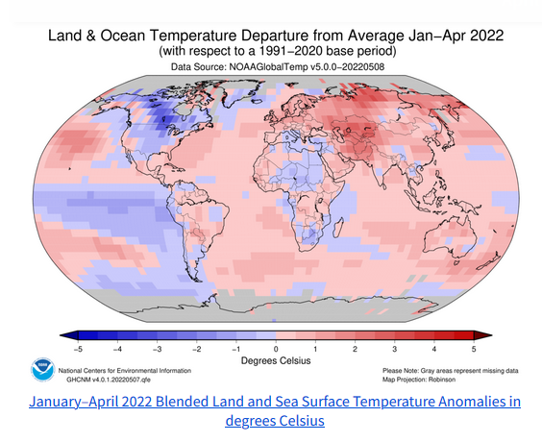
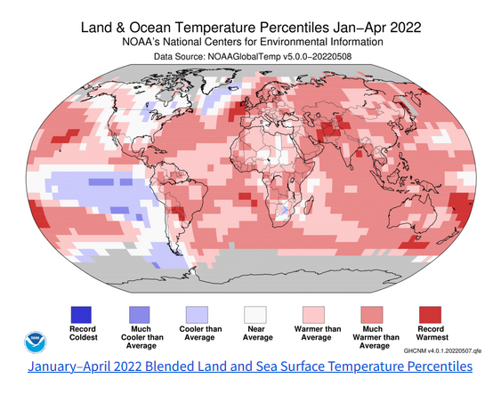
Figure S2. Average coherence scores for different values of k
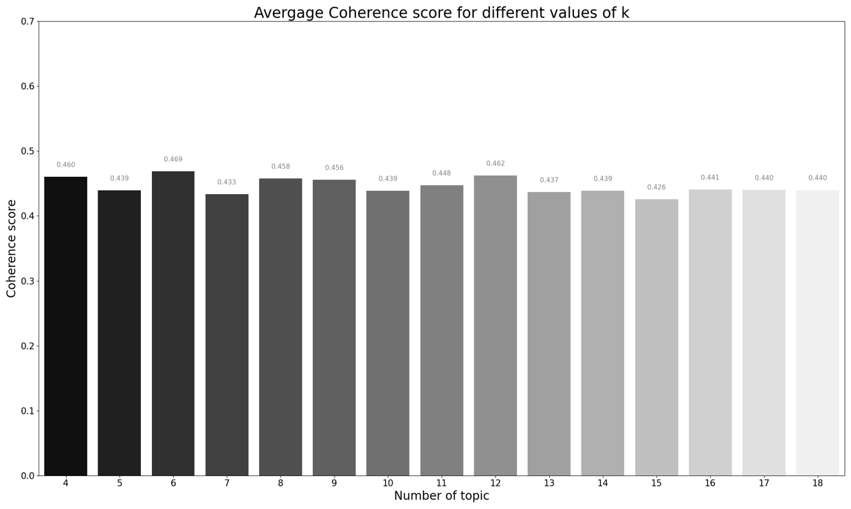

Table S1. Information and variables downloaded for each heat-related tweet
Variable name | Description
Date | The date and time (UTC format) when the tweet was created
Id | Unique id of the tweet
Content | Main content of the tweet
User | Contains several other sub-attributes, including username, display name, location, friends Count, followers Count
replyCount | Count of replies to the tweet
retweetCount | Count of retweets of the tweet
likeCount | Count of likes of the tweet
Lang | Language of the tweet generated by machine learning
Source | How the tweet was published (from which device)
retweetedTweet | The id of the original tweet if retweeted
mentionedUsers | Users mentioned in the tweet
Place | Place associated with the tweet
Hashtags | Hashtags contained in the tweet

Data processing steps
We applied common standards for processing Twitter text data with some adjustments to suit our data set (Xue et al. 2020). The steps were as follows:
- Removing duplicates: We removed all duplicate tweets and only kept the first entry of each tweet. The purpose of this step was to ensure that duplicate tweets did not inflate the frequency count of each term in the tweets. This step deleted 27,053 records from the dataset.
- Filtering tweets in English: We filtered out tweets that were either in English (denoted as ‘en’) or Undetected (denoted as ‘und’) language. We discovered that snscrape classified the language of English tweets that begin with special characters as ‘Undetected’ and thus, tweets that have ‘und’ language were also included in the data set. The result of this step is a dataset containing 59,129 records.
- Creating two new columns to store hashtags and mentions: We created two functions to extract and store hashtags and mentions from the tweets. This was because it was discovered that snscrape failed to extract all hashtags and mentions from the tweets.
- Removing special characters: We removed all hashtags, mentions, URLs, non-ASCII characters, numbers, punctuations, multiple white spaces, HTML tags and emoticons from the tweets \. This step was also applied to several other columns in the data set, including ‘user.displayname’, ‘source’ and ‘user.location’.
- Removing texts that are less than 3 characters in length: We further removed 415 tweets that contain fewer than three characters.
- Tokenizing, deaccenting and converting text to lower case: We converted the texts to lower case using gensim’s simple_processing function as many Natural Language Processing (NLP) models regard upper- and lower-case words as different words (Řehůřek and Sojka 2010).
- Creating bigrams, trigrams and a text corpus: Bigrams refer to two words that frequently appear together in a text corpus, while trigrams refer to three words frequently appearing. We generated bigrams, trigrams and the text corpus using the gensim library with the min_count parameter set to 5 and the threshold parameter set to 10.
- Removing stop words: Common English stop words are commonly used words that carry little information for analysis and thus need to be removed from the tweets. Examples of stop words include ‘and’, ‘or’, ‘the’, ‘a’, ‘an’.
- Applying text lemmatization: Lemmatization involves reducing a word to its base form with consideration to the context of the word and its Part-Of-Speech (POS) (Jivani 2011). spaCy was used for this step and we specified Noun, Verb and Adverb as POS tags to include in the text corpus.

References for Supplementary Materials
Jivani AG. 2011. A comparative study of stemming algorithms. Int J Comp Tech Appl 2:1930-1938.
Řehůřek R, Sojka P. 2010. Software framework for topic modelling with large corpora. Proceedings of the LREC 2010 Workshop on New Challenges for NLP Frameworks, 45-50. Valletta, Malta: ELRA.
Xue J, Chen J, Chen C, Zheng C, Li S, Zhu T. 2020. Public discourse and sentiment during the COVID 19 pandemic: using Latent Dirichlet Allocation for topic modeling on Twitter. PloS One 15:e0239441.

