List of supplementary material:
Supplementary Equations: Estimating first, second, and third effects in the four-way ANOVA analysis

List of supplementary figures:
Supplementary Fig. 1: Schematic illustrating the downscaling procedure of inundation water depth obtained at 0.25 degree to a fine 3 arcsec spatial resolution.
Supplementary Fig. 2: Schematic depicting the upscale procedure applied to the derive inundation depth and flooded fraction at a spatial resolution of 30 arcsec.
Supplementary Fig. 3: Schematic depicting the use of lookup table to derive flood damage in method 2
Supplementary Fig. 4: Reference world region category defined by the World Bank.
Supplementary Fig. 5: Current flood protection level given by the FLOPROS database.
Supplementary Figure 6: Global average difference in EAD between method 2 and method 1 as a function of adaptation level.
Supplementary Fig. 7: Same as Fig. 3 but for ssp126.
Supplementary Fig. 8: Same as Fig. 4 but for ssp126.

List of supplementary Tables:
Supplementary Table 1: List and availability of the nine AOGCMs used in this study.
Supplementary Table 2: Default and alternatives values of the economic factors used in the cost-benefit analysis.

Supplementary Equations: Estimating first, second, and third effects in the four-way ANOVA analysis
The equations for estimating the first and second-order effects are as follow:
$$\begin{aligned}{SS}_{met*dis}=N_{uni}N_{mai}\sum_{i=1}^{N_{met}}{\sum_{j=1}^{N_{dis}}{{\left({\overline{X}}_{ij}-{\overline{X}}_{i}-{\overline{X}}_{j}+\overline{X}\right)}^{2}}} \#\left(1\right)\end{aligned}$$
$$\begin{aligned}{SS}_{met*dis*uni}=N_{mai}\sum_{i=1}^{N_{met}}{\sum_{j=1}^{N_{dis}}{\sum_{k=1}^{N_{uni}}{{\left({\overline{X}}_{ijk}-{\overline{X}}_{ij}-{\overline{X}}_{ik}-{\overline{X}}_{jk}+{\overline{X}}_{i}+{\overline{X}}_{j}+{\overline{X}}_{k}-\overline{X}\right)}^{2}}}} \#\left(2\right)\end{aligned}$$
where $\overline{X_{i}}$ is the mean over indices j, k, and $l$ for flood damage method i. Finally, the third-order effect was estimated as the residual following equation 3:
$$\begin{aligned}{SS}_{met*dis*uni*mai}=\begin{matrix}SST-({SS}_{met}+{SS}_{dis}+{SS}_{uni}+{SS}_{mai}+{SS}_{met*dis}+{SS}_{met*uni}+ \\ {SS}_{met*mai}+{SS}_{dis*uni}+{SS}_{dis*mai}+{SS}_{uni*mai}+{SS}_{met*dis*uni}+ \\ {SS}_{met*dis*mai}+{SS}_{met*uni*mai}+{SS}_{dis*uni*mai})\end{matrix} \#\left(3\right)\end{aligned}$$

Supplementary Fig. 1: Schematic illustrating the downscaling procedure of inundation water depth obtained at 0.25 degree to a fine 3 arcsec spatial resolution.
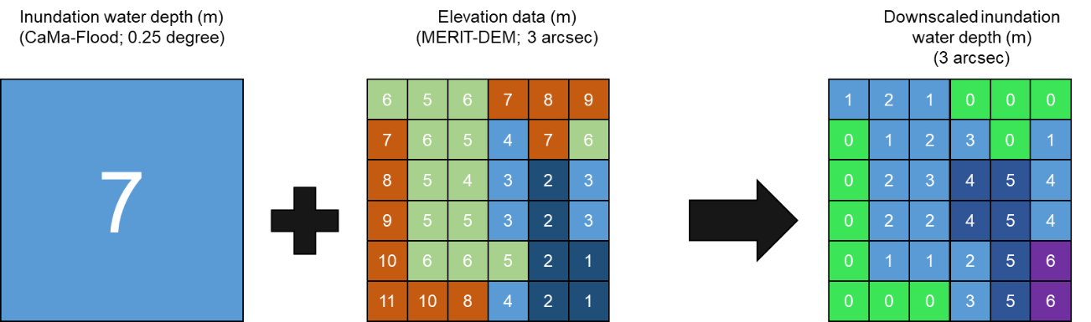
When the elevation of the subpixel is greater than the flooded depth, it is not flooded. In contrast, when the elevation of a pixel is below that of inundation depth, the subpixel is submerged and downscaled inundation depth is calculated as the difference between the subpixel elevation and the original inundation depth.

Supplementary Fig. 2: Schematic depicting the upscale procedure applied to the derive inundation depth and flooded fraction at a spatial resolution of 30 arcsec.
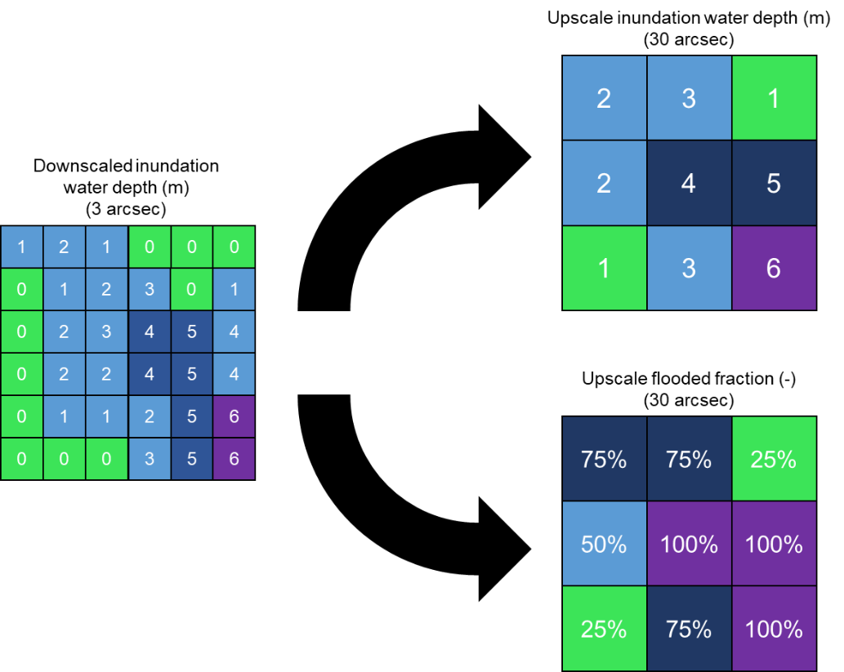
The inundation depth at a 3 arcsec spatial resolution are upscaled to a spatial resolution of 30 arcsec. The inundation depth (m) in the grid cell of the upscale file consist of the maximum inundation depth found in corresponding subpixels. The flooded fraction of an upscale grid is the percentage of subpixel with an inundation depth higher than zero.

Supplementary Fig. 3: Schematic depicting the use of lookup table to derive flood damage in method 2
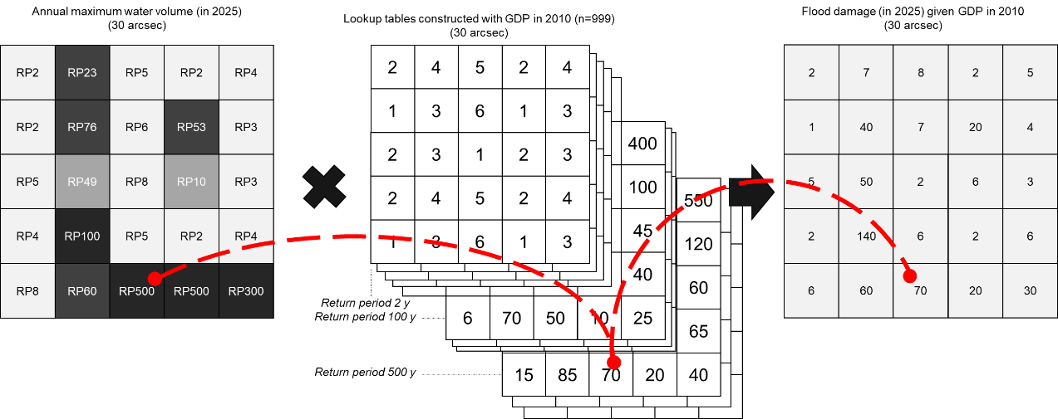

Supplementary Fig. 4: Reference world region category defined by the World Bank.
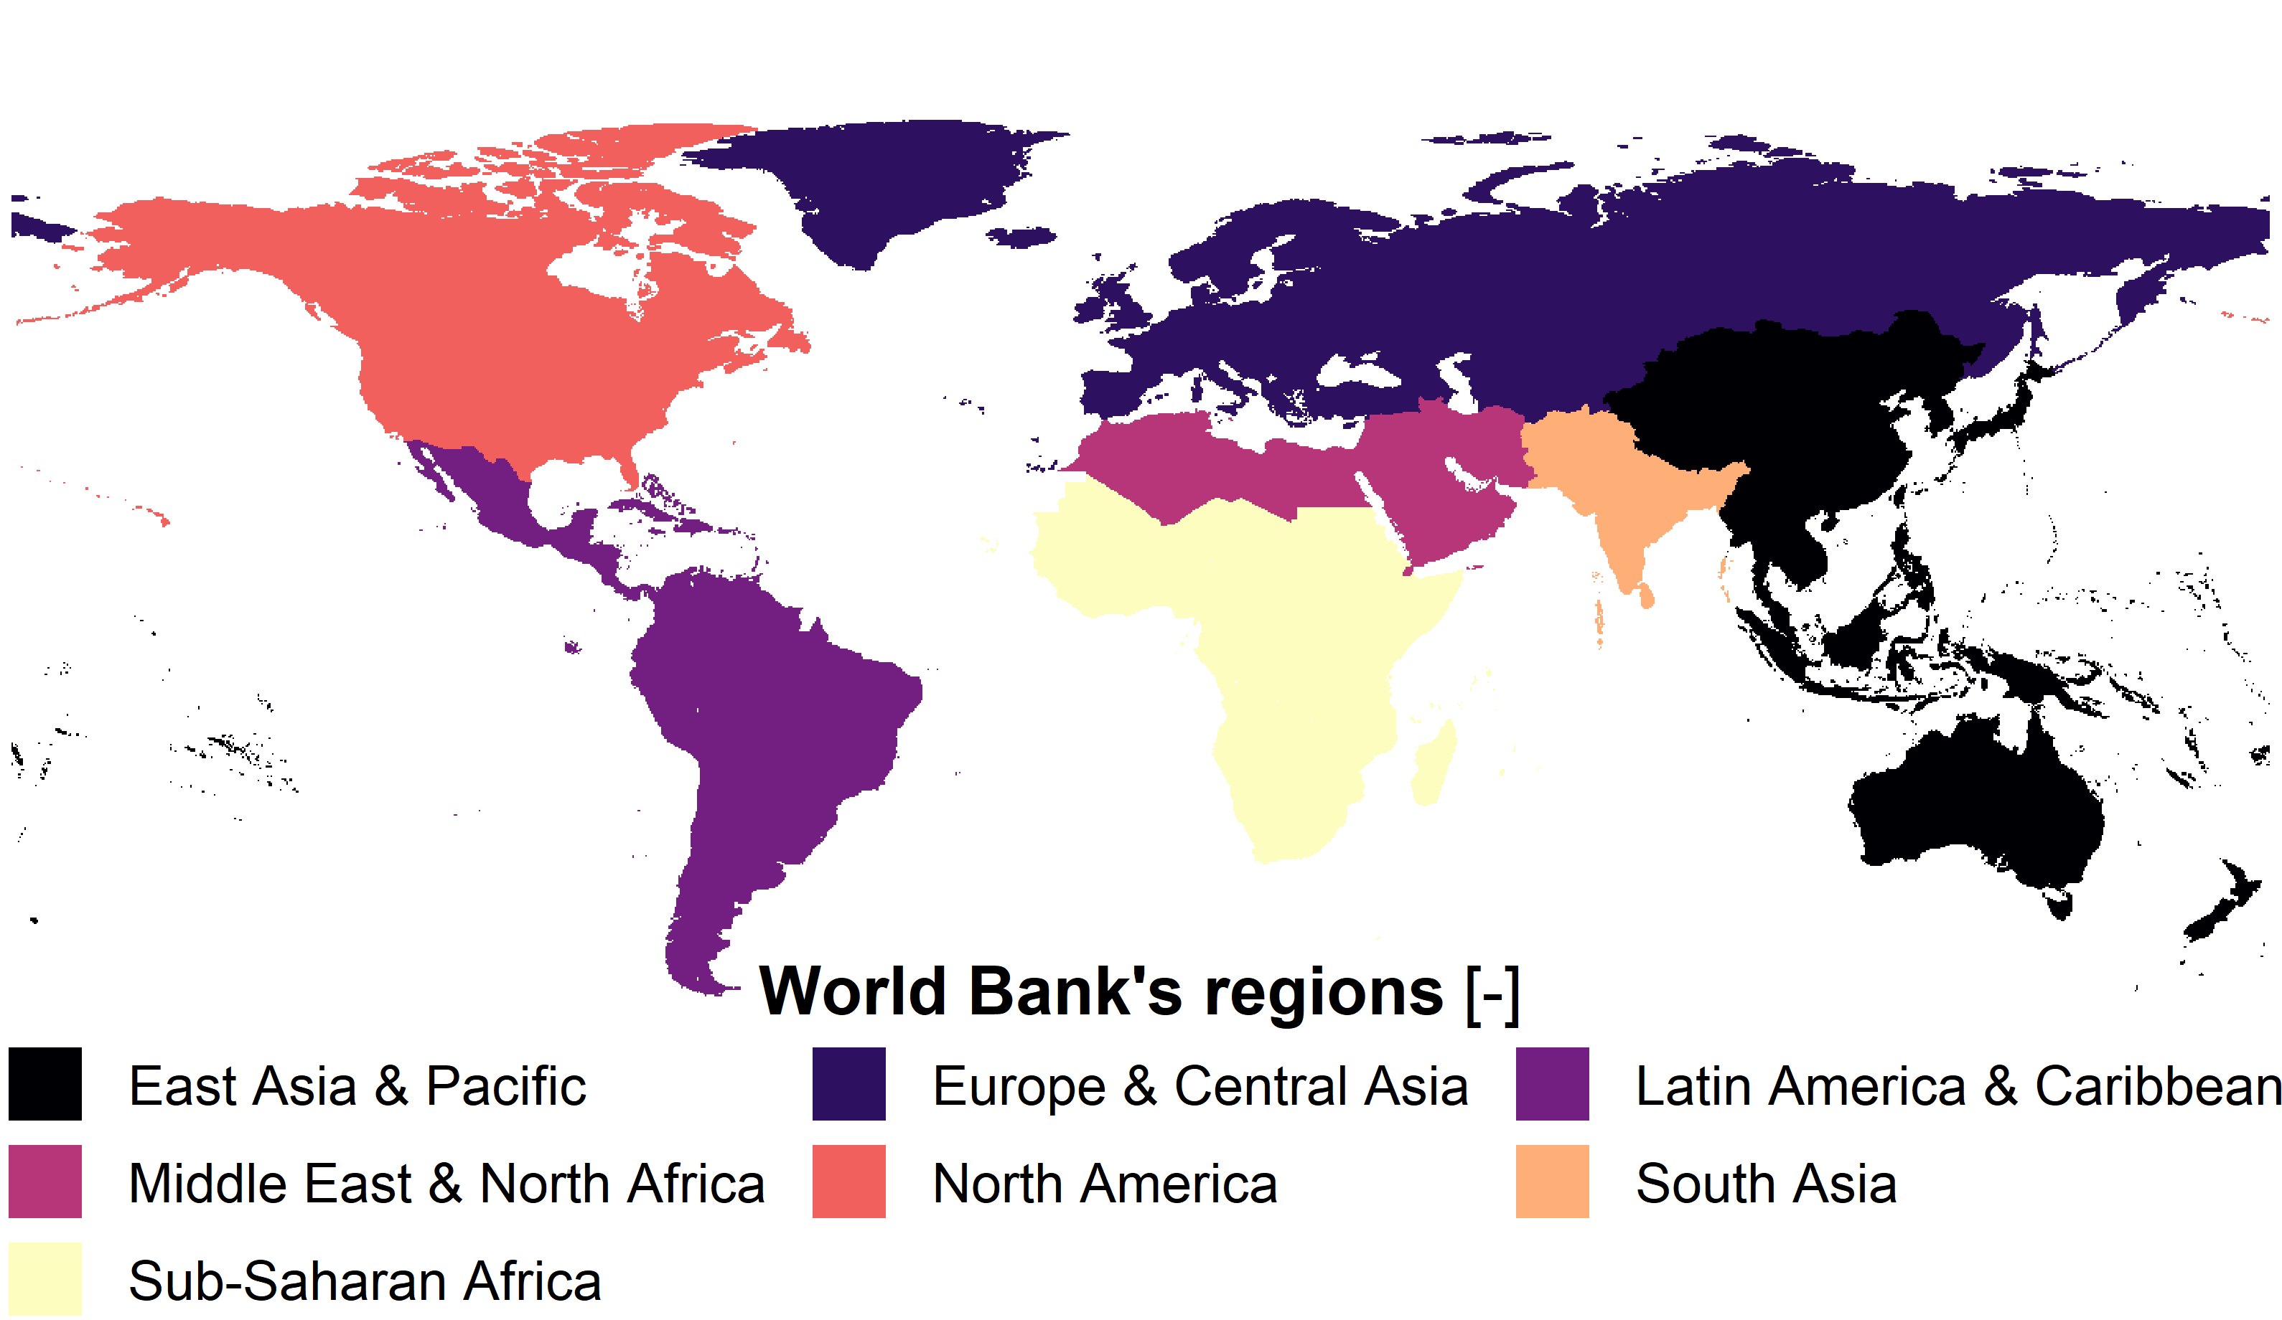

Supplementary Figure 5: The number of flood events causing economical damage during 1971–2000 aggregated for the seven World Bank regions.
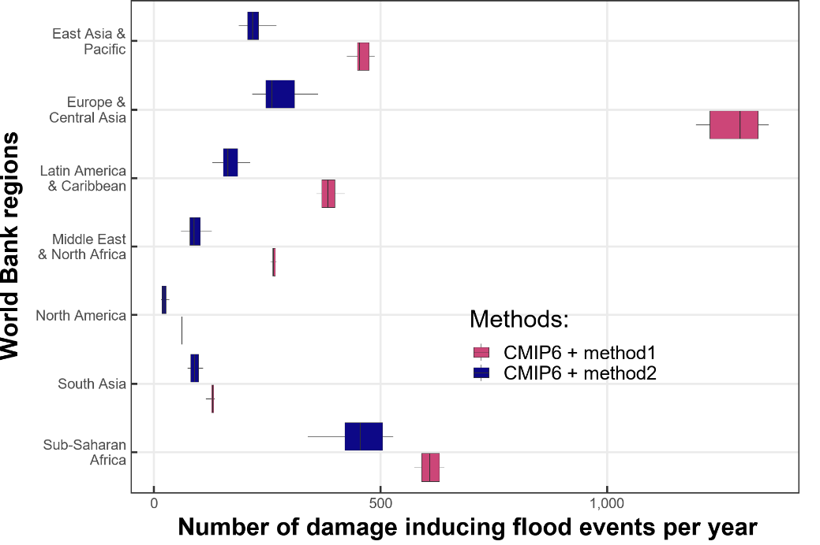

Supplementary Fig. 6: Current flood protection level given by the FLOPROS database.
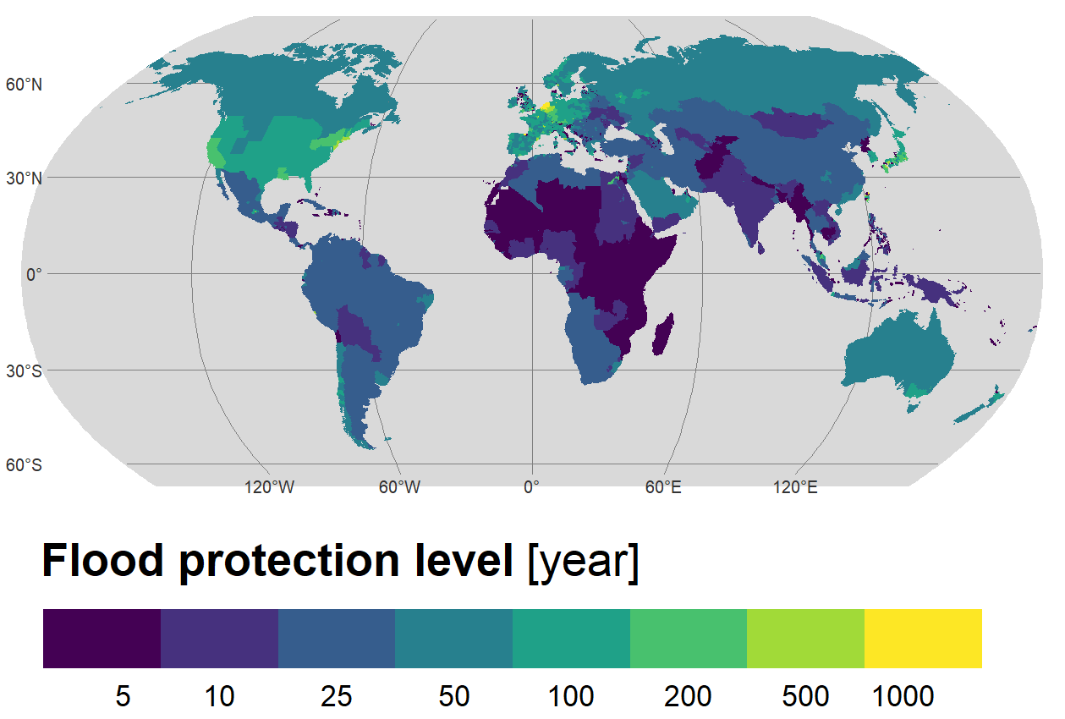

Supplementary Fig. 7: Evolution of annual GDP per capita among the seven regions defined by the World Bank under five socio-economic scenarios.
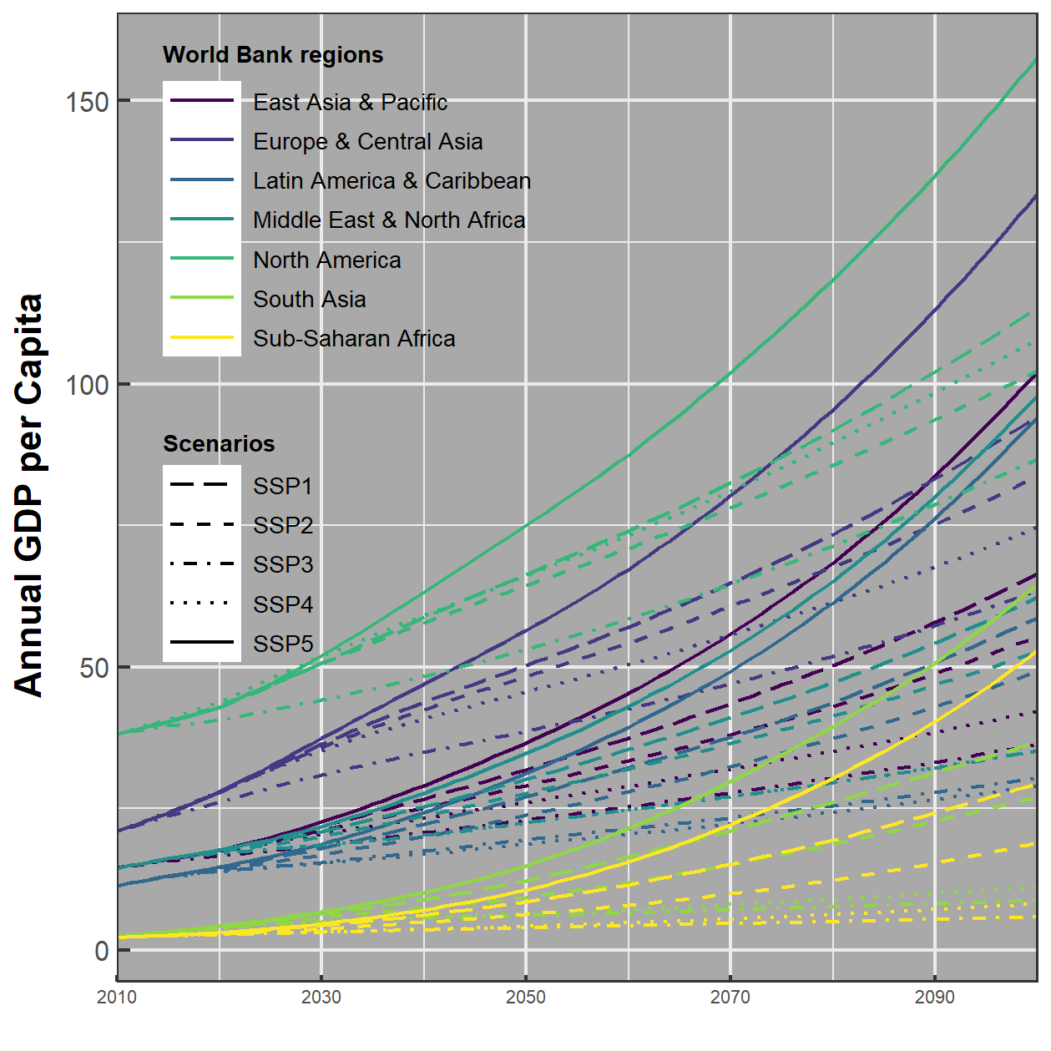

Supplementary Fig. 8: Same as Fig. 3 but for ssp126. Note, EAP: East Asia & Pacific, ECA: Europe & Central Asia, LAC: Latin America & Caribbean, MENA: Middle East & North Africa, NA: North America, SA: South Asia, SSA: Sub-Saharan Africa.
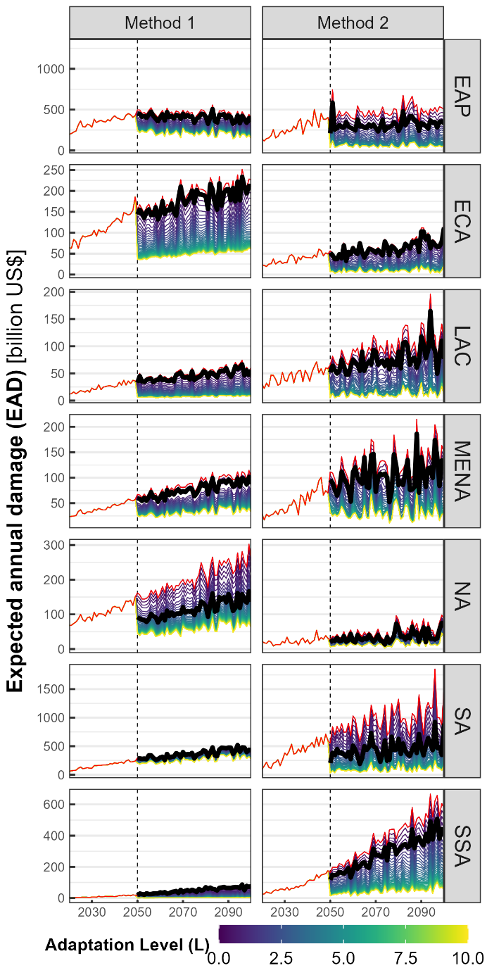

Supplementary Fig. 9: Difference in EAD between method 2 and method 1 averaged across all administrative unit as a function of adaptation level (L). Results for the (a) low emission scenario and (b) high emission scenario. The pink area indicates the first and thirst quartiles range.
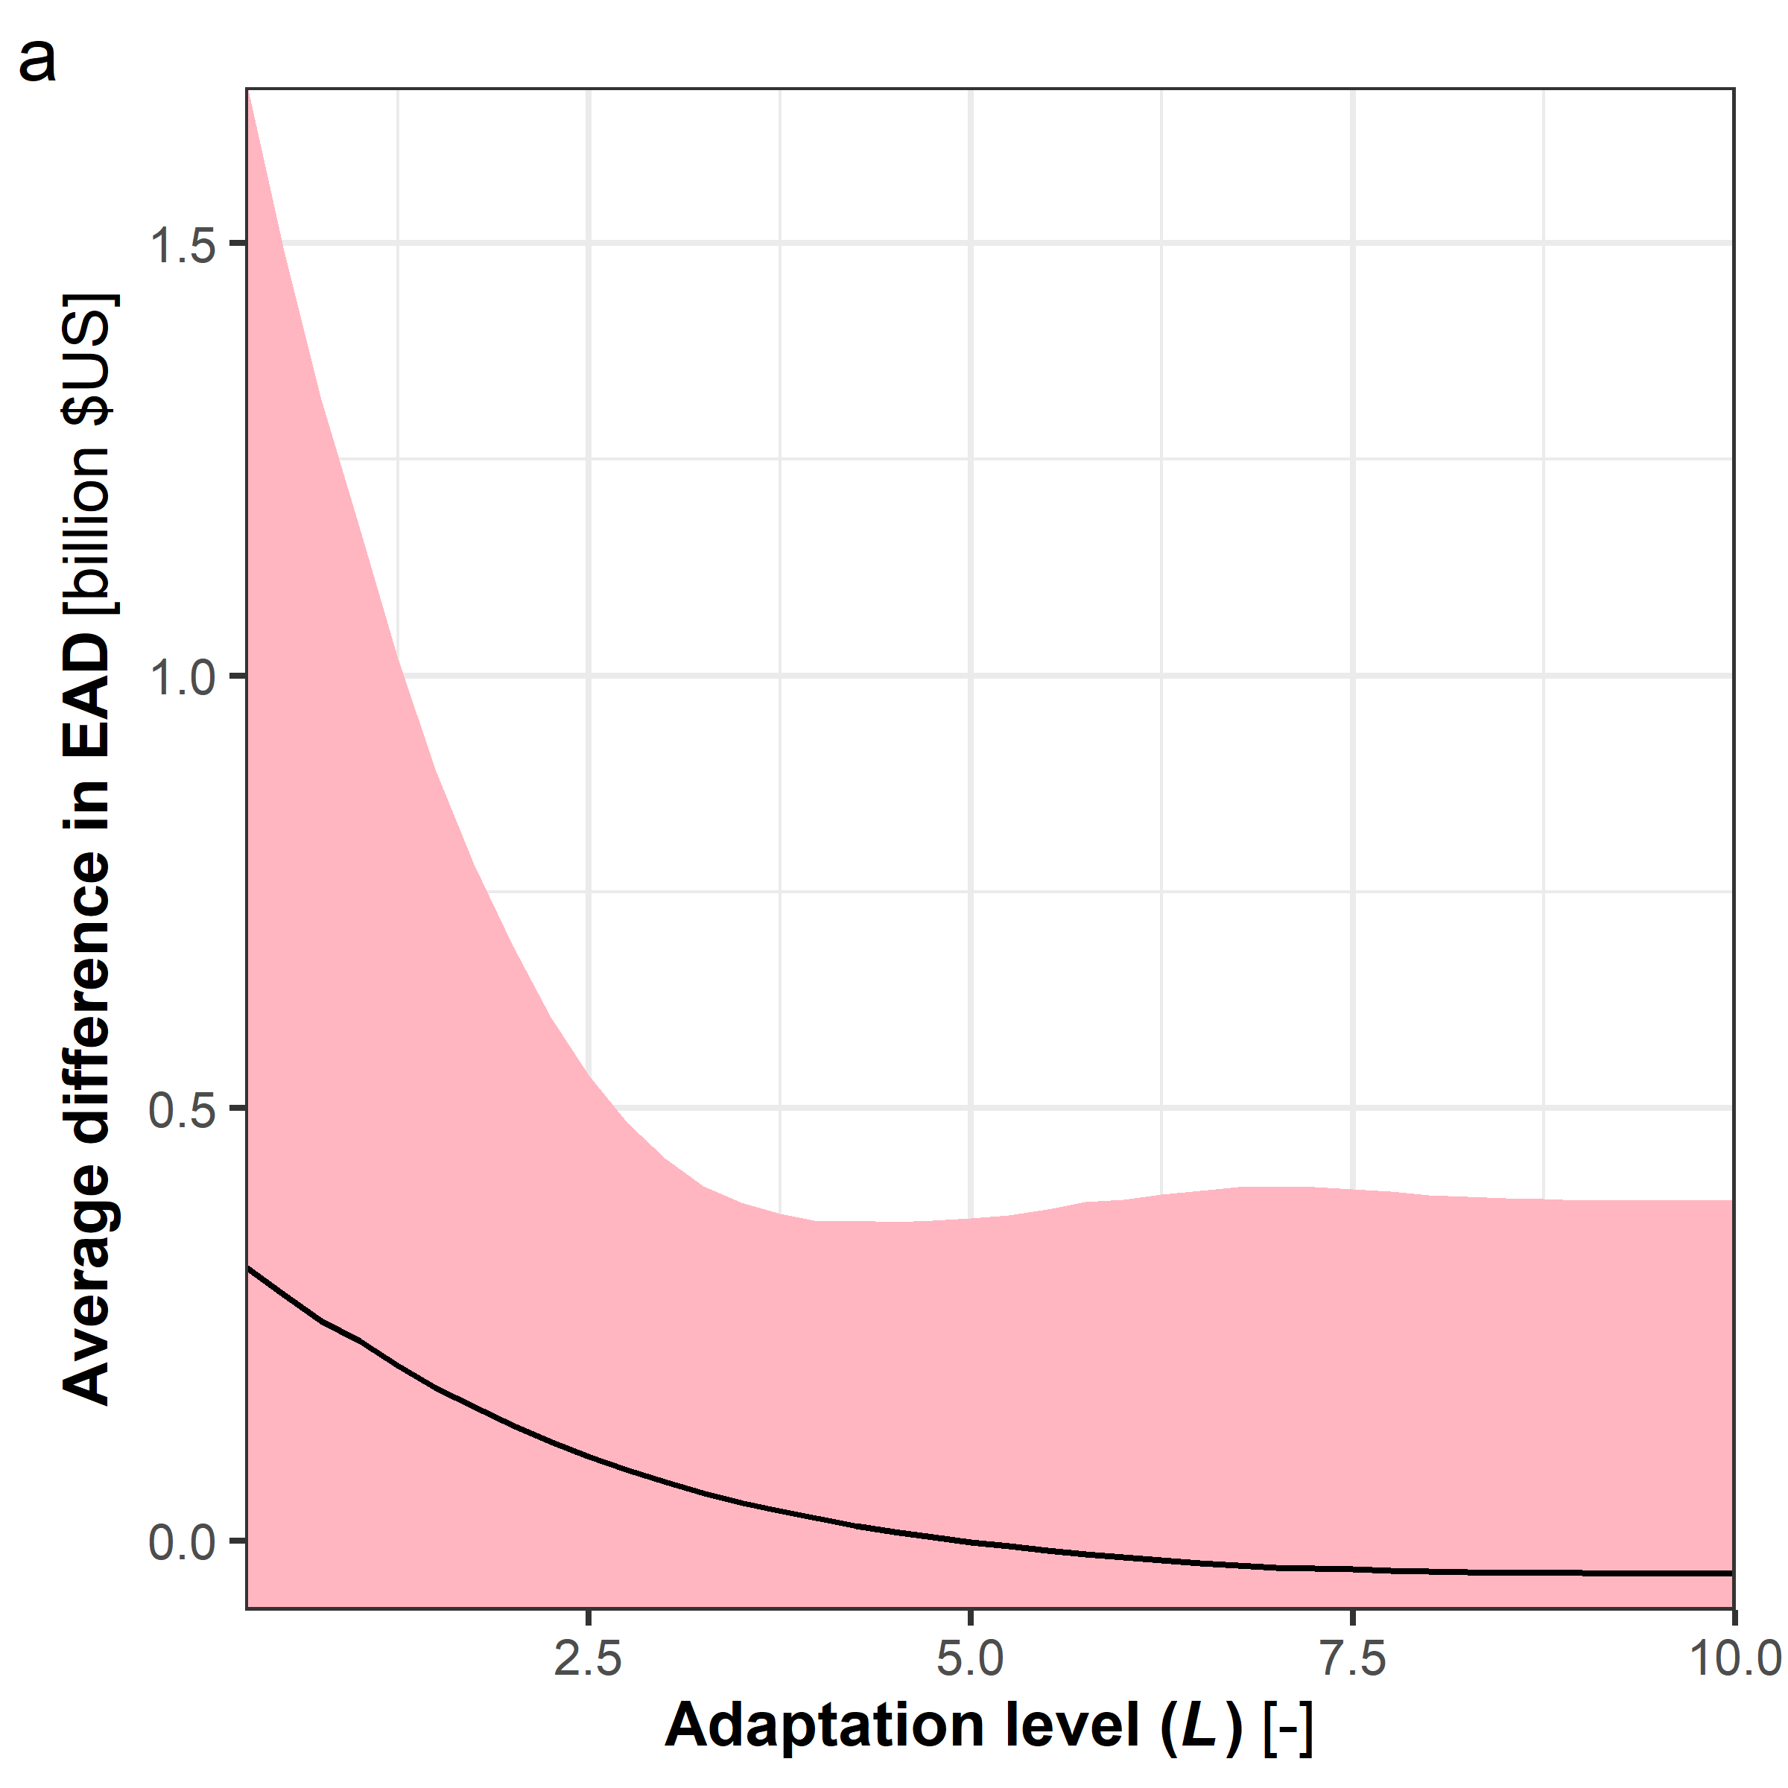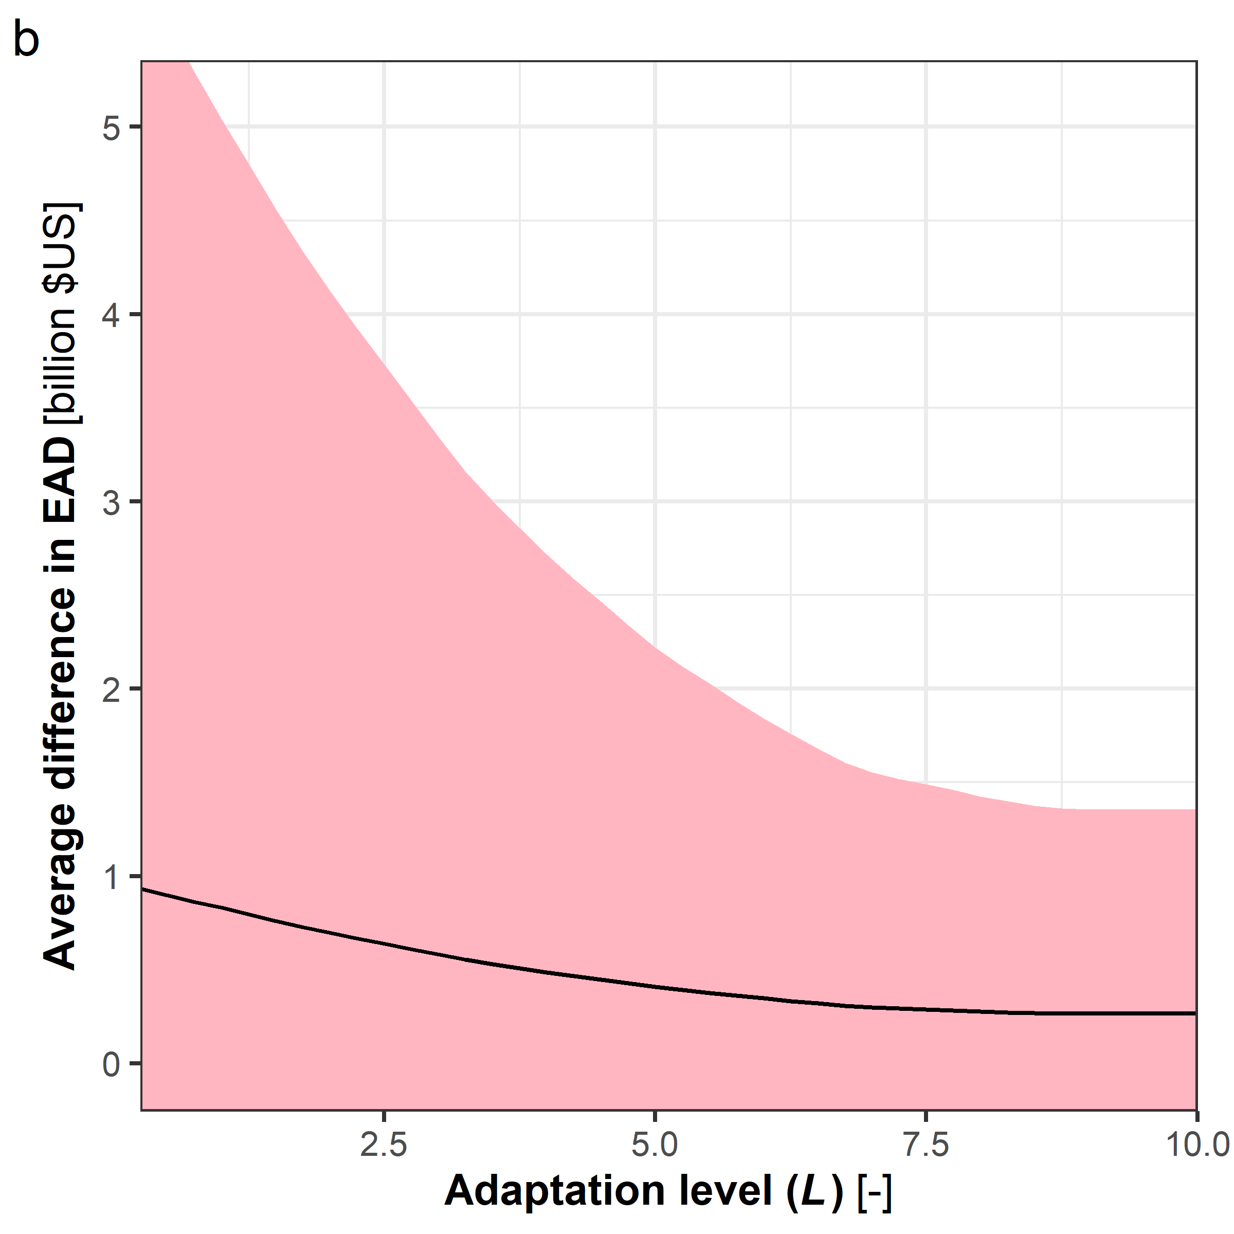

Supplementary Fig. 10: Same as Fig. 4 but for ssp126.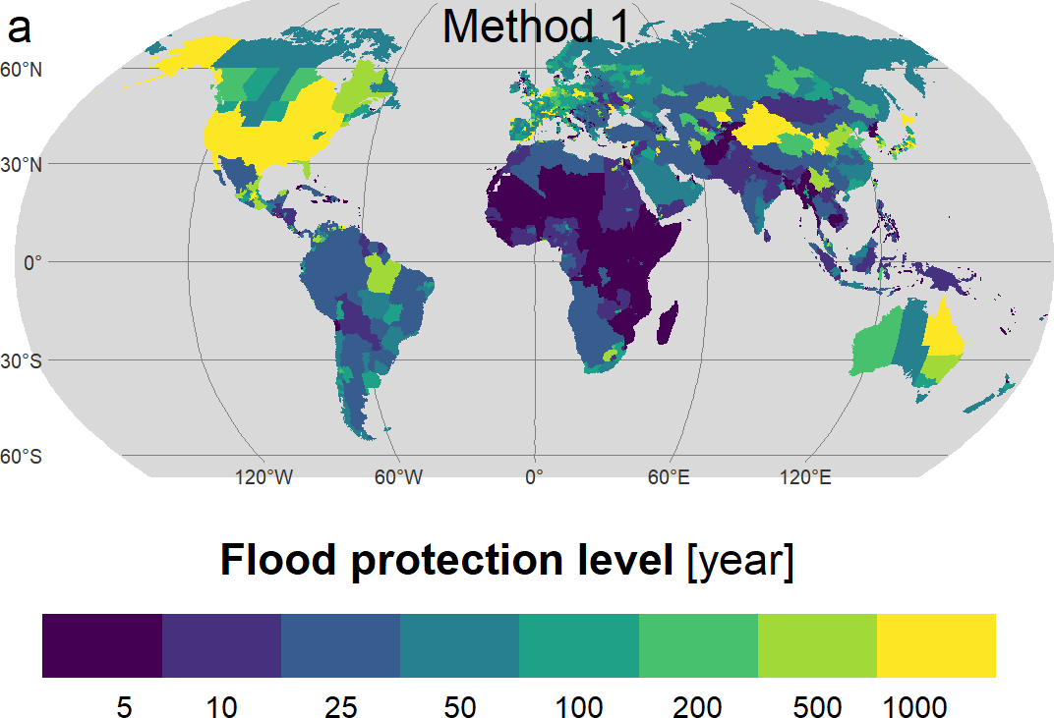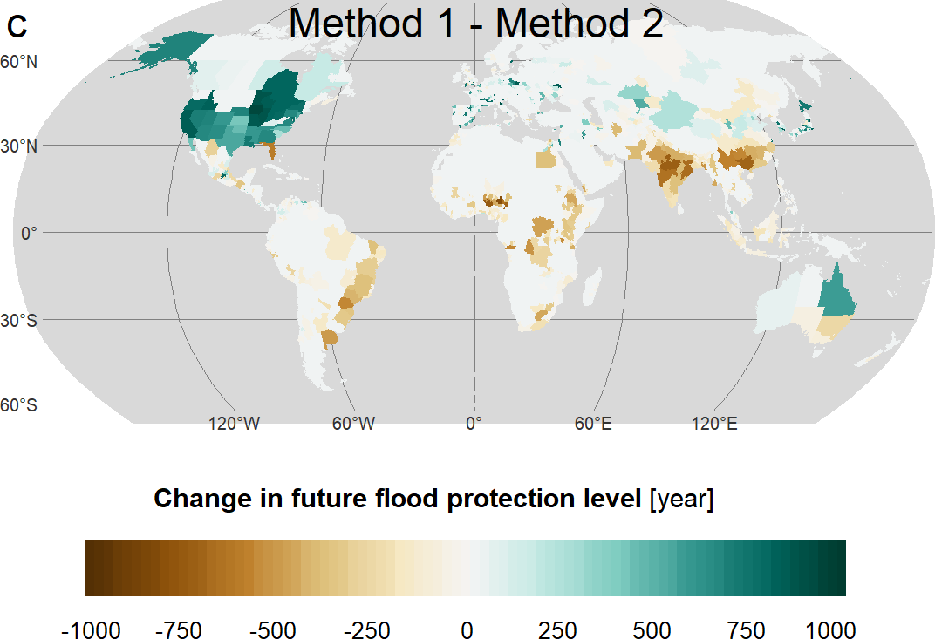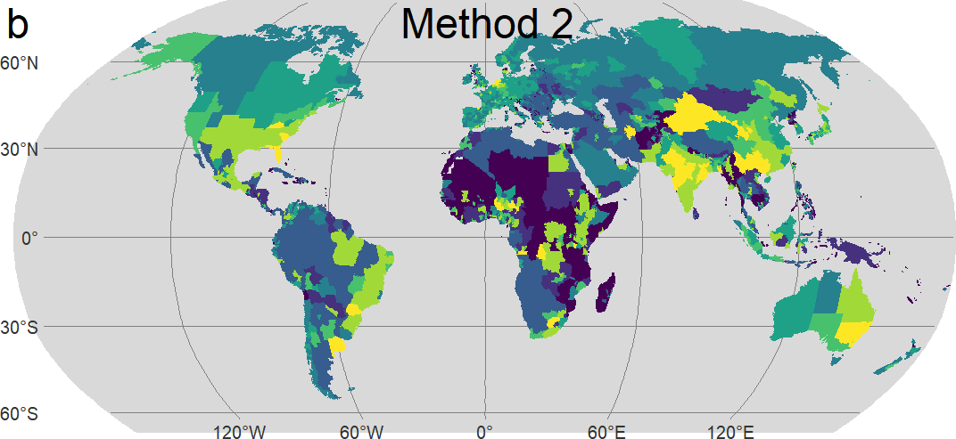

Supplementary Fig. 11: Same as Fig. 5 but for ssp126
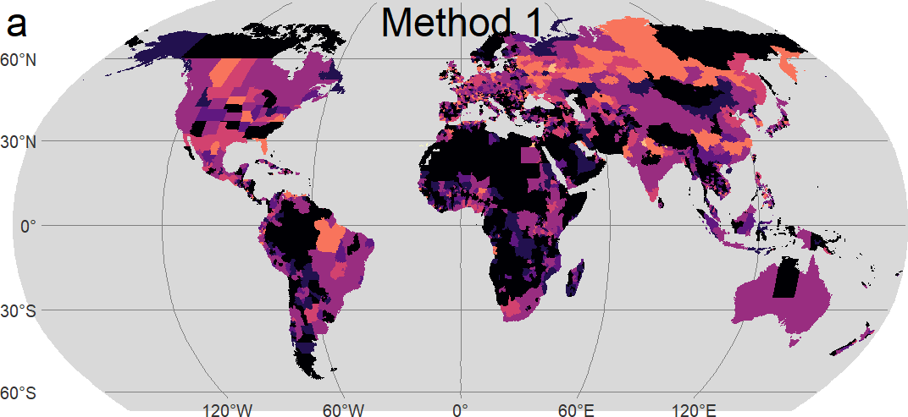
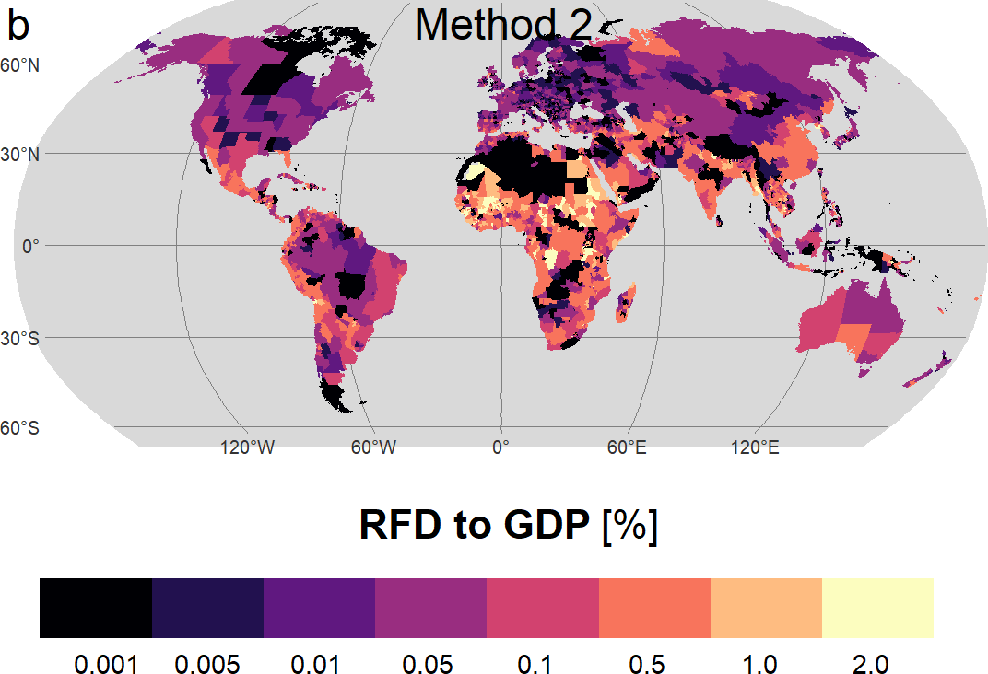

Supplementary Fig. 12: Same as Fig. 6 but for ssp126.
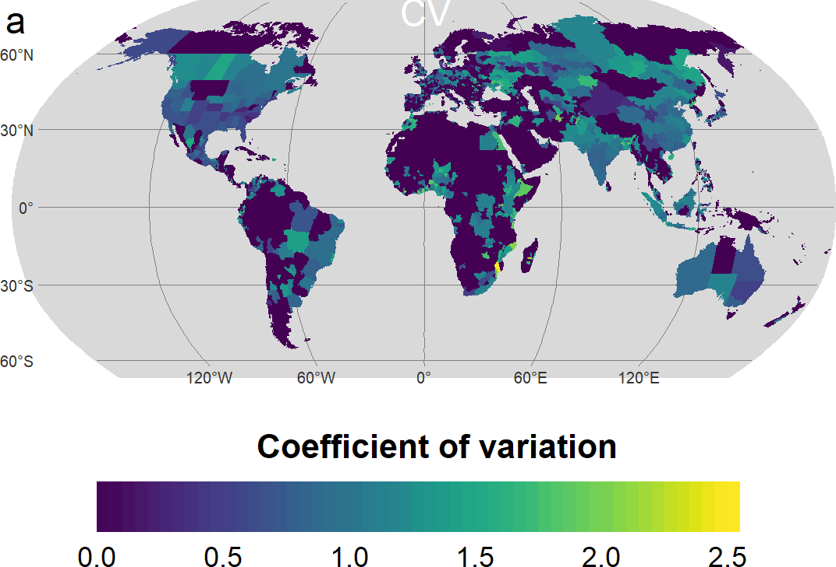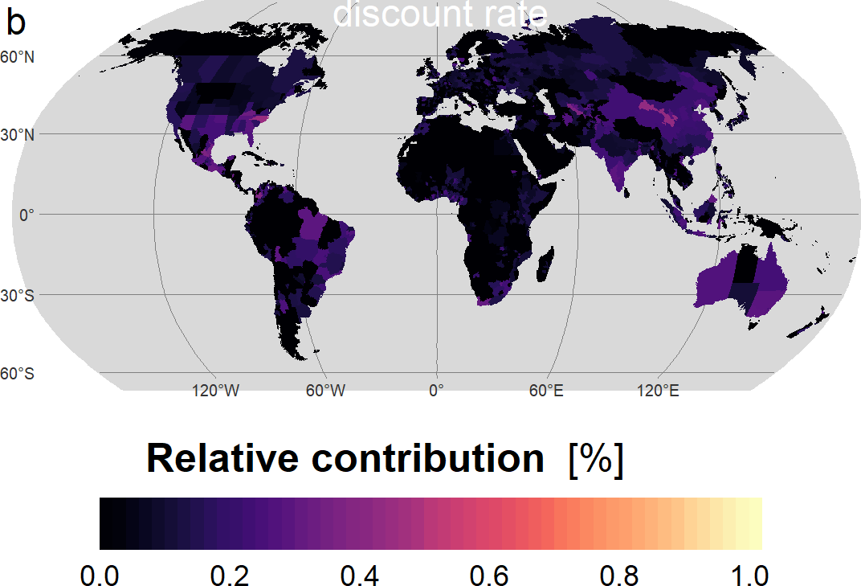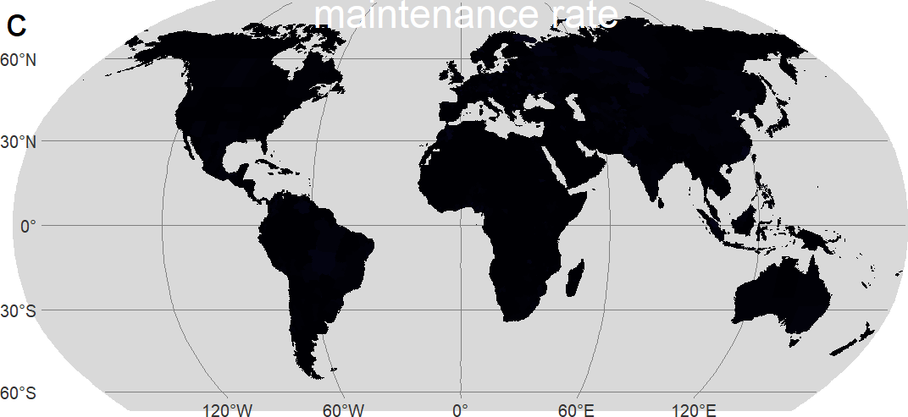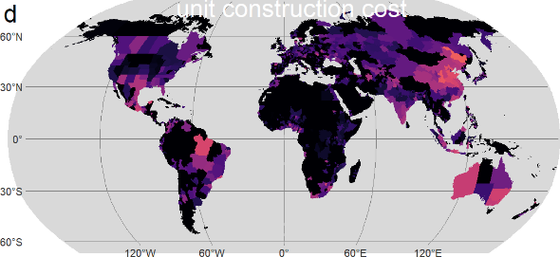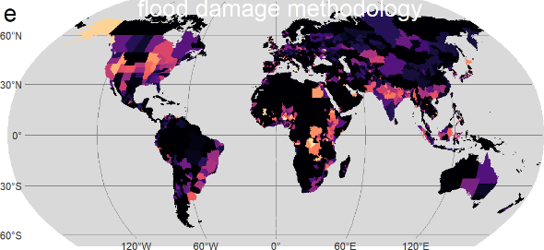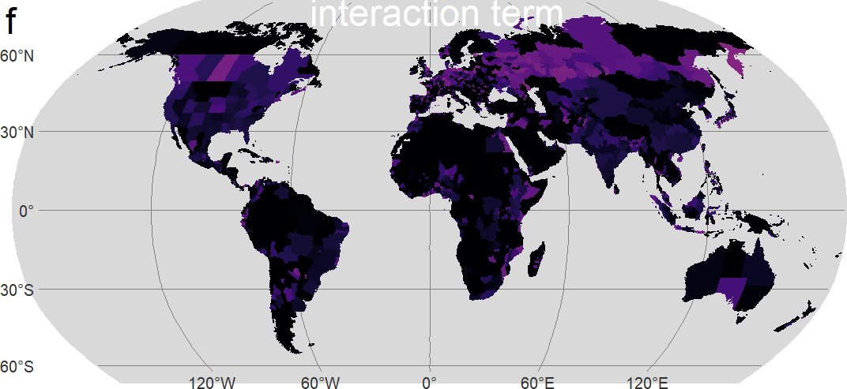

List of Supplementary Tables:
Supplementary Table 1: List and availability of the nine AOGCMs used in this study.
AOGCMs | Origin | Grid | Scenarios
AOGCMs | Origin | Grid | Historical | ssp126 | ssp585
ACCESS-CM2 | Australia | 192 × 144 | ○ | ○ | ○
EC-Earth3 | Europe | 512 × 256 | ○ | ○ | ○
GFDL-CM4 | U.S. | 288 × 180 | ○ | × | ○
INM-CM5-0 | Russia | 180 × 120 | ○ | ○ | ○
IPSL-CM6A-LR | France | 144 × 143 | ○ | ○ | ○
MIROC6 | Japan | 256 × 128 | ○ | ○ | ○
MPI-ESM1-2-HR | Germany | 384 × 192 | ○ | ○ | ○
MRI-ESM2-0 | Japan | 320 × 160 | ○ | ○ | ○
NorESM2-MM | Norway | 288 × 192 | ○ | ○ | ○

Supplementary Table 2: Default and alternatives values of the economic factors used in the cost-benefit analysis.
 |  | Default value | Alternative values
Unit construction cost† |  | 2.399 million US$ | 0.7996 and 7.196 million US$ (1/3 and 3 times the default value, respectively)
Maintenance |  | 1% of total cost | 3% and 5%
Discount rate |  | 5% | 0%, 1%, 2%, 3% and 8%
† cost per km per log2(protection level)

