Supplementary Information for “Meteorological analysis of an extreme pyroconvective wildfire at Dunalley-Forcett, Australia” by Čavlina Tomašević, Fox-Hughes, Cheung, Beggs*, Vučetić, Marsden-Smedley, and Telišman Prtenjak

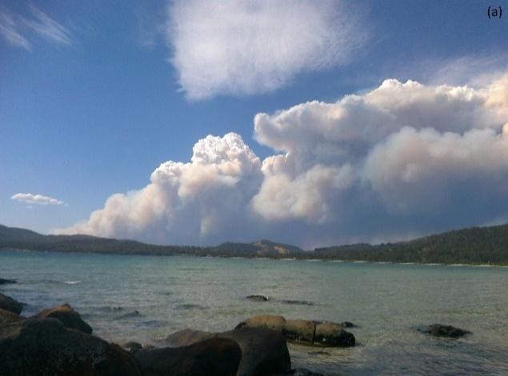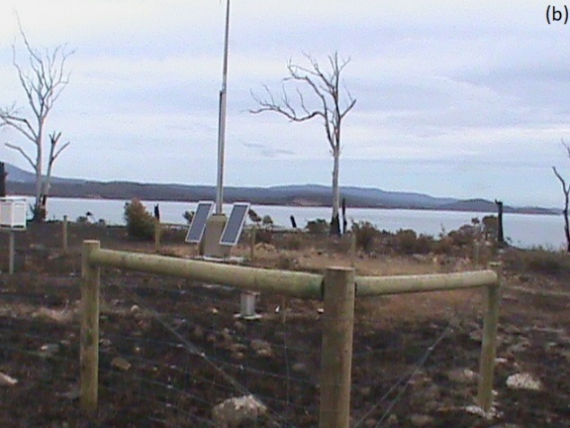

Figure S1. a) Pyrocumulonimbus cloud during the Forcett-Dunalley wildfire at 16:00 AEDT (photographed by Janice James) and b) weather station enclosure in Dunalley burnt in the wildfire between 16:19 AEDT and 18:06 AEDT, both on 4 January 2013 (photo from BoM, 2013a).

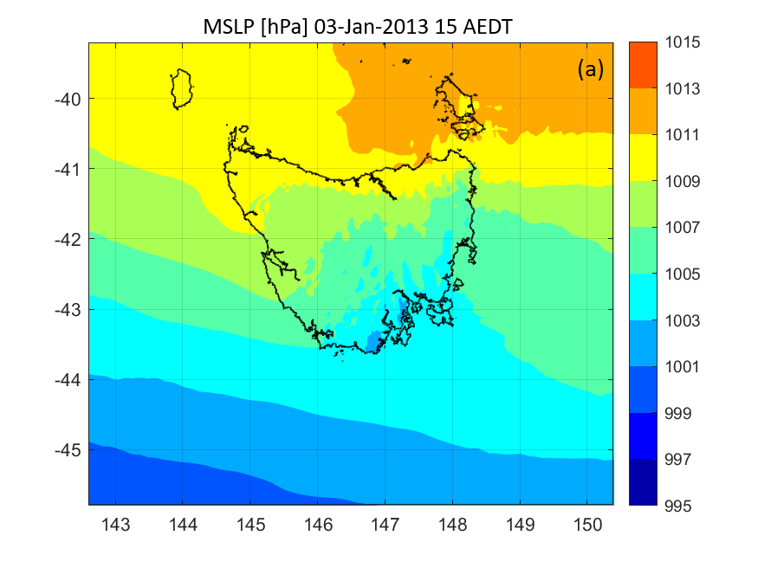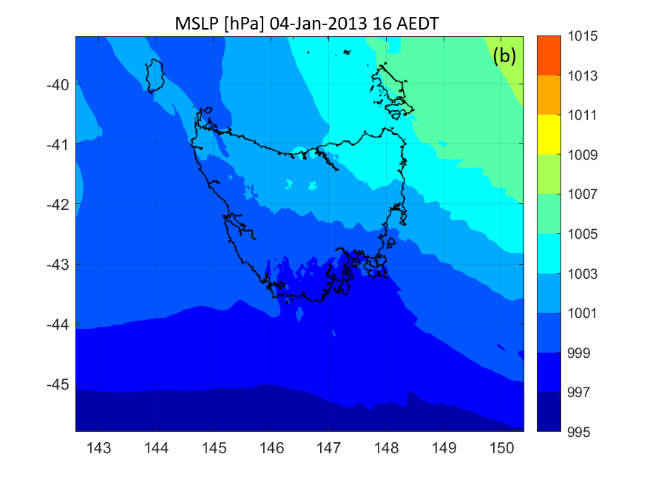
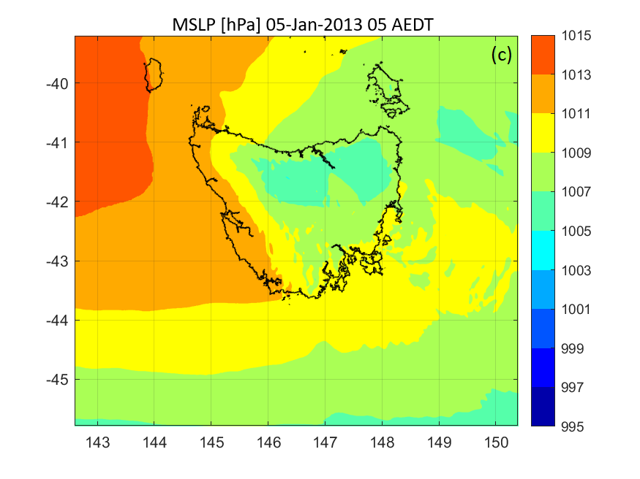

Figure S2. Mean sea level pressure (hPa) at a) 14:00 AEDT on 3 January, b) 16:00 AEDT on 4 January, and c) 05:00 AEDT on 5 January 2013 from BARRA reanalysis.

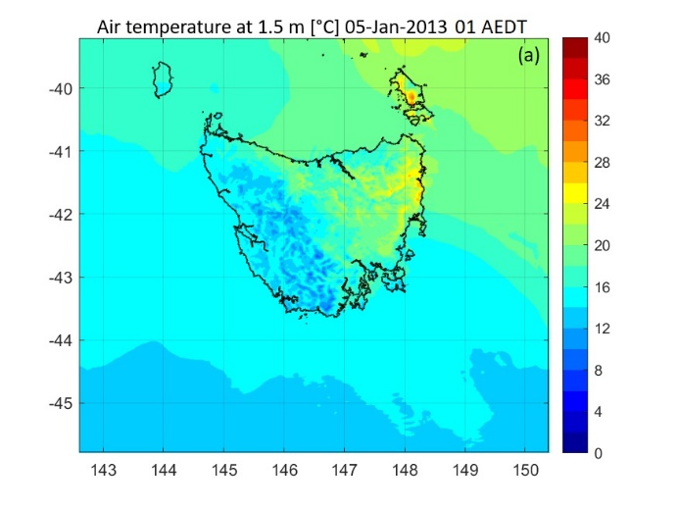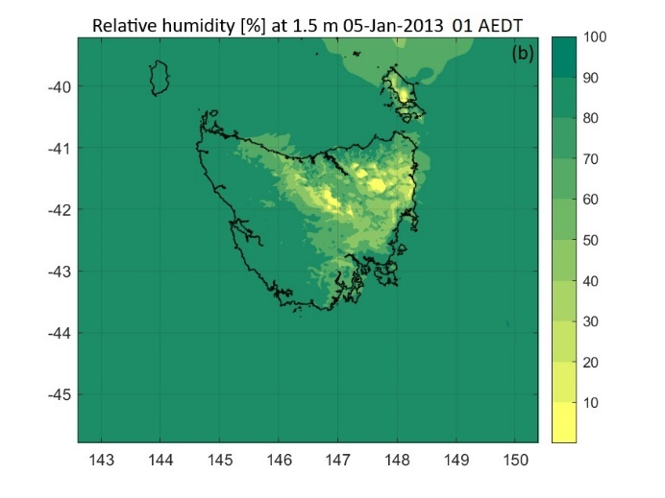

Figure S3. a) Air temperature (°C) and b) relative humidity (%) at 01:00 AEDT on 5 January 2013 from BARRA reanalysis.

