Supplementary materials
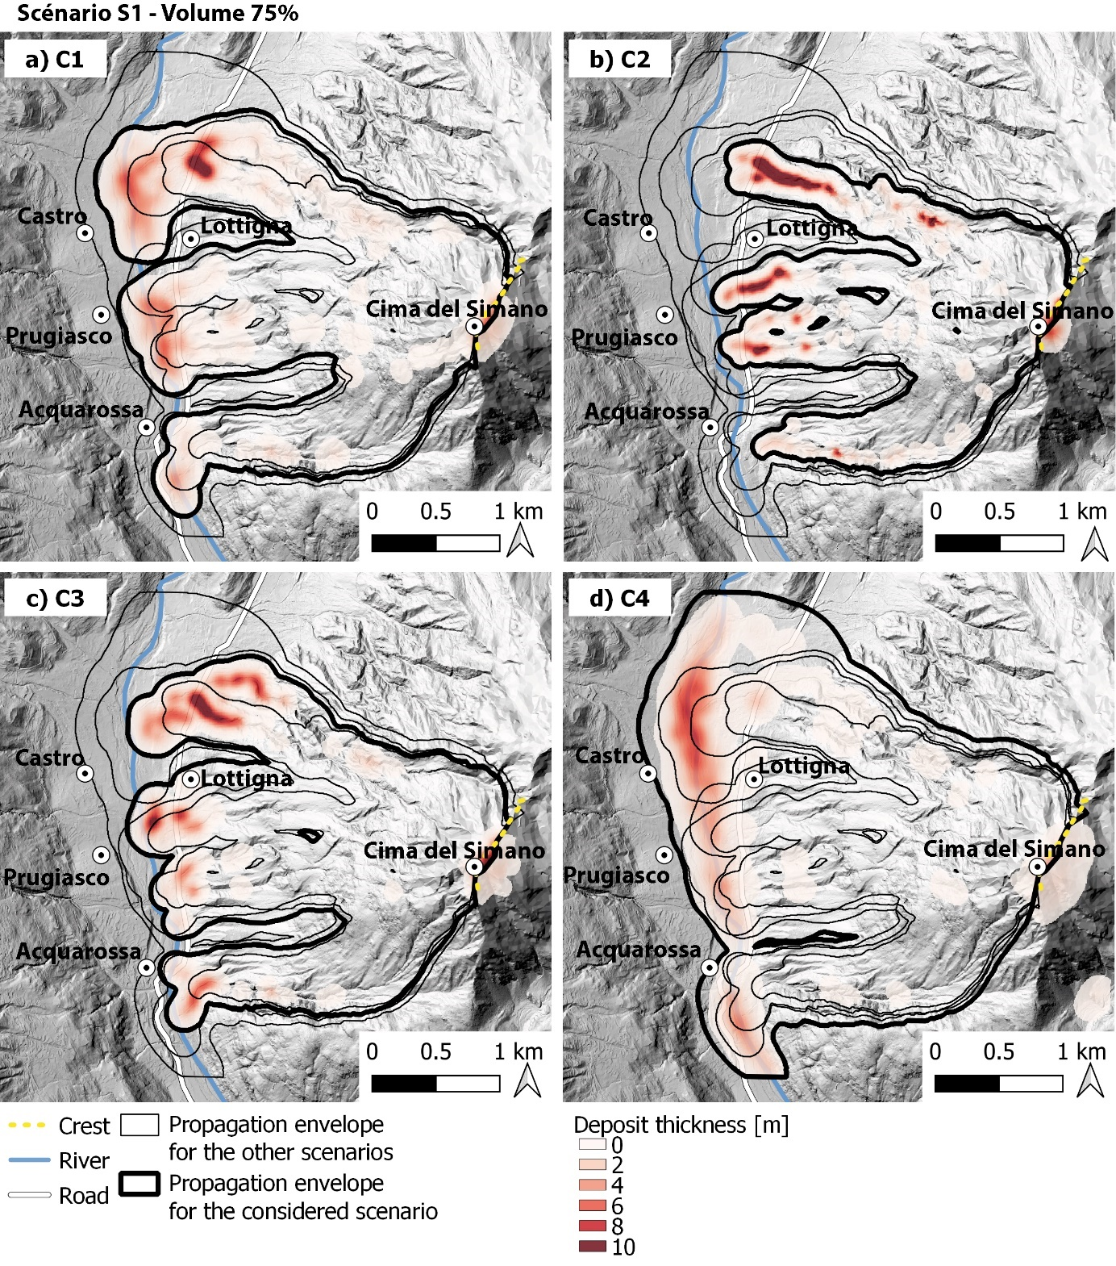
Fig. S1: Dan3D numerical simulations of the rock avalanche propagation for the scenario of rupture S1, considering 75% of the released material (4.30$×$10⁶ m³) and for four pairs of μ and ξ. (a) C1 (0.035, 100). (b) C2(0.22, 100). (c) C3(0.22, 750). (d) C4(0.035, 750)
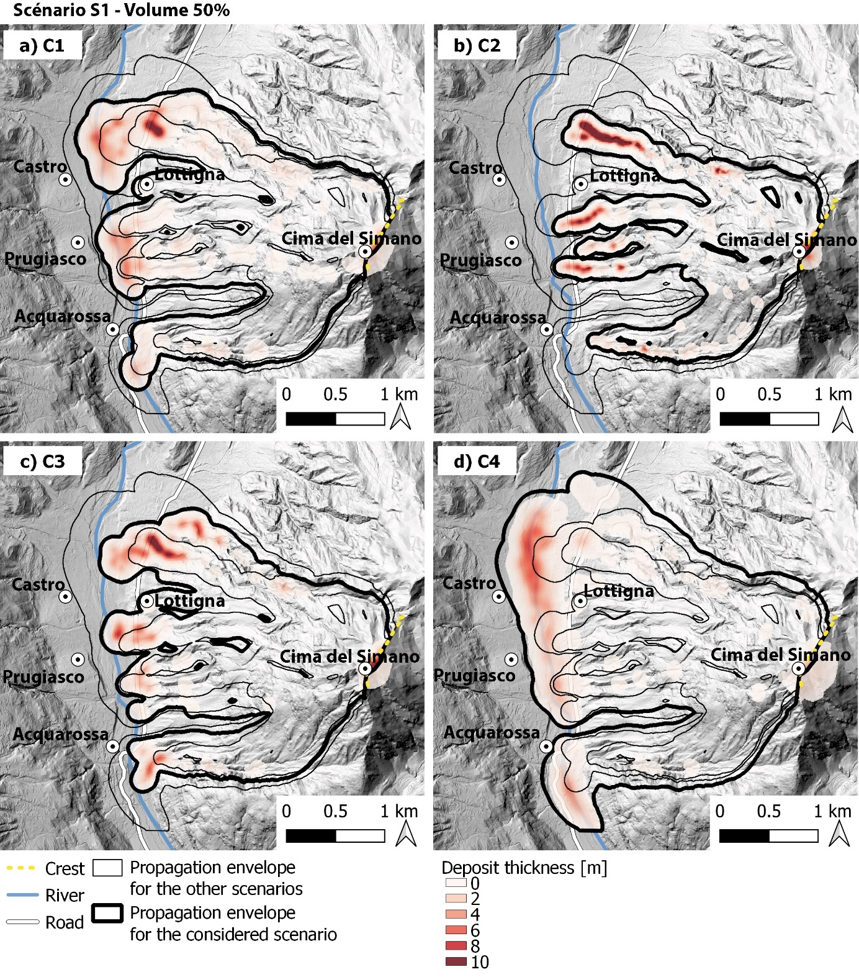
Fig. S2: Dan3D numerical simulations of the rock avalanche propagation for the scenario of rupture S1, considering 50% of the released material (4.30$×$10⁶ m³) and for four pairs of μ and ξ. (a) C1 (0.035, 100). (b) C2(0.22, 100). (c) C3(0.22, 750). (d) C4(0.035, 750)
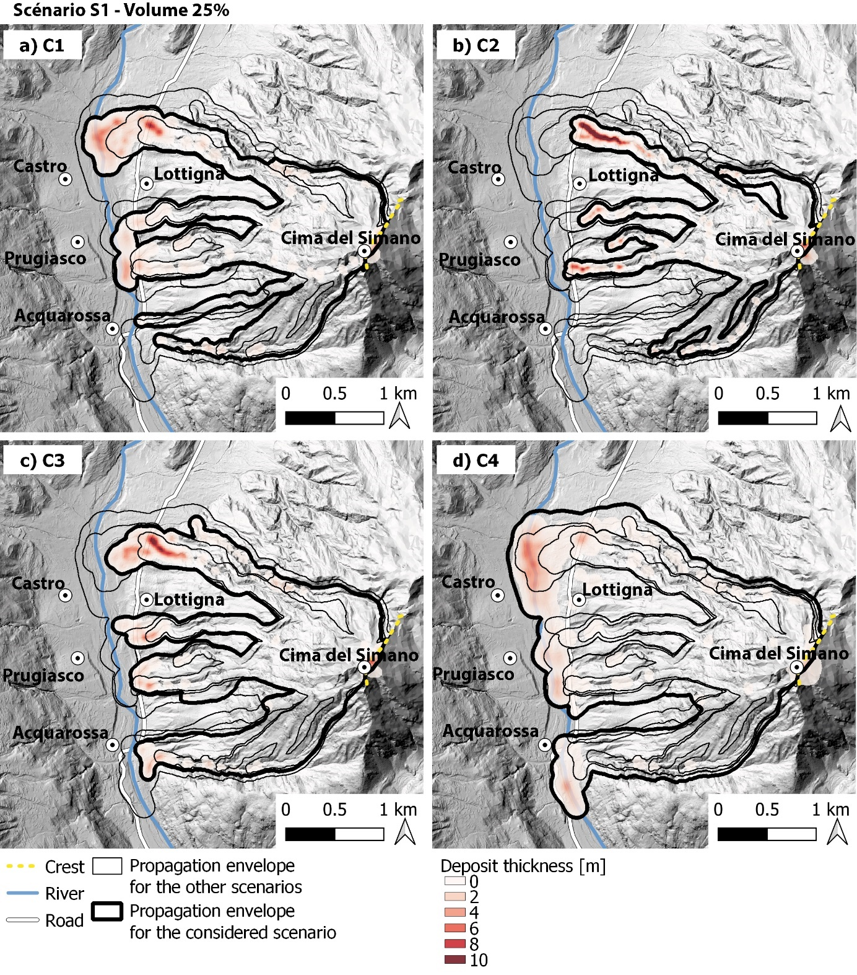
Fig. S3: Dan3D numerical simulations of the rock avalanche propagation for the scenario of rupture S1, considering 25% of the released material (4.30$×$10⁶ m³) and for four pairs of μ and ξ. (a) C1 (0.035, 100). (b) C2(0.22, 100). (c) C3(0.22, 750). (d) C4(0.035, 750)

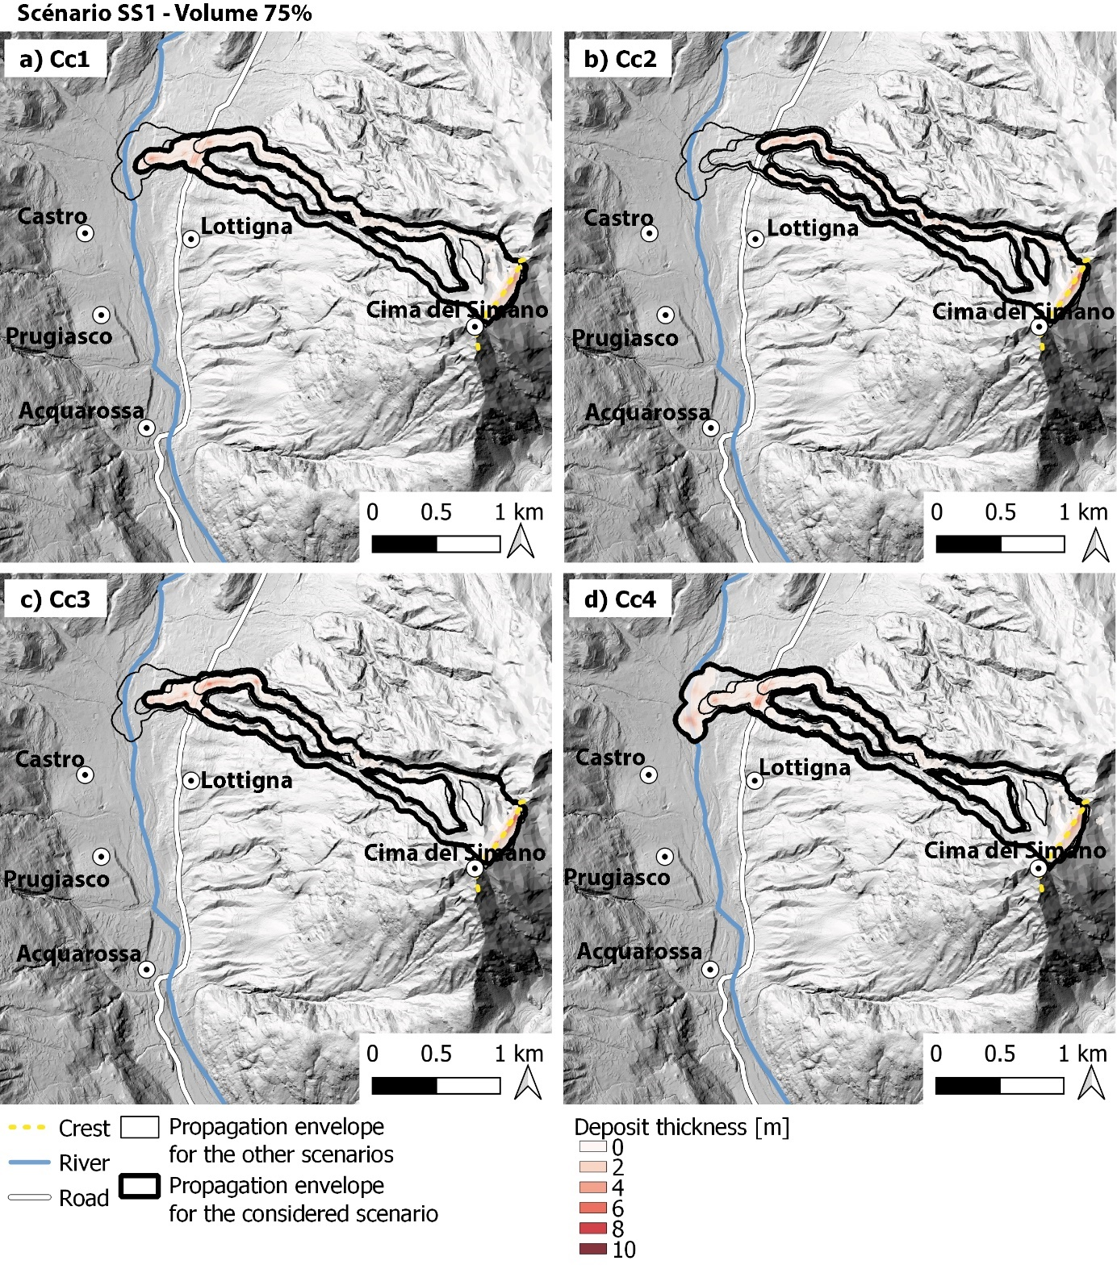
Fig. S4: Dan3D numerical simulations of the rock avalanche propagation for the scenario of rupture SS1, considering 75% of the released material (2.30$×$10⁵ m³) and for four pairs of μ and ξ. (a) Cc1 (0.05, 200). (b) Cc2(0.11, 200). (c) Cc3(0.11, 700). (d) Cc4(0.05, 700)
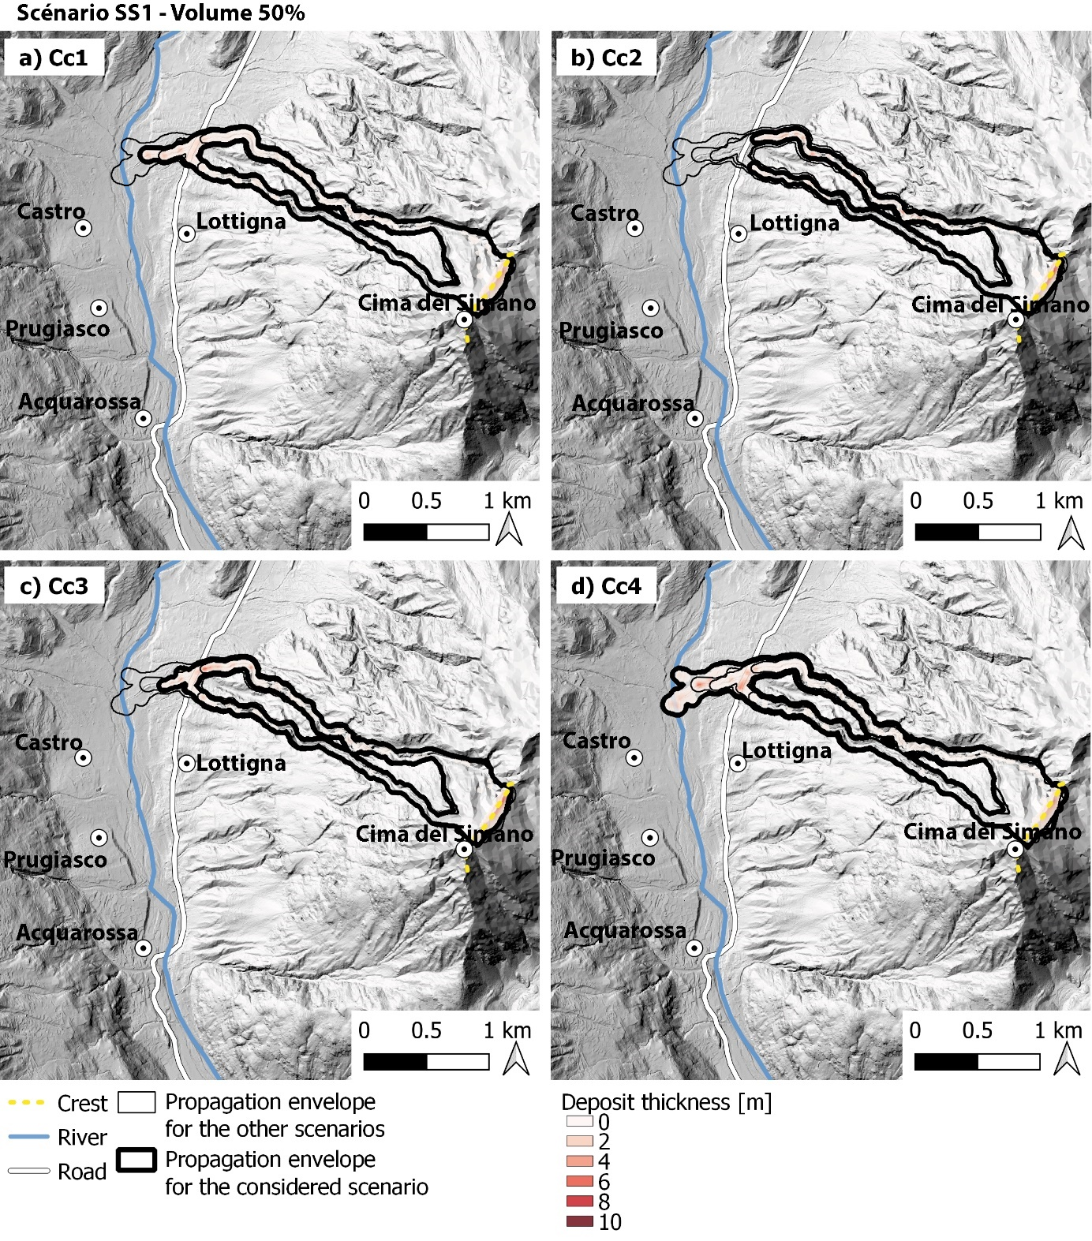
Fig. S5: Dan3D numerical simulations of the rock avalanche propagation for the scenario of rupture SS1, considering 50% of the released material (2.30$×$105 m³) and for four pairs of μ and ξ. (a) Cc1 (0.05, 200). (b) Cc2(0.11, 200). (c) Cc3(0.11, 700). (d) Cc4(0.05, 700)
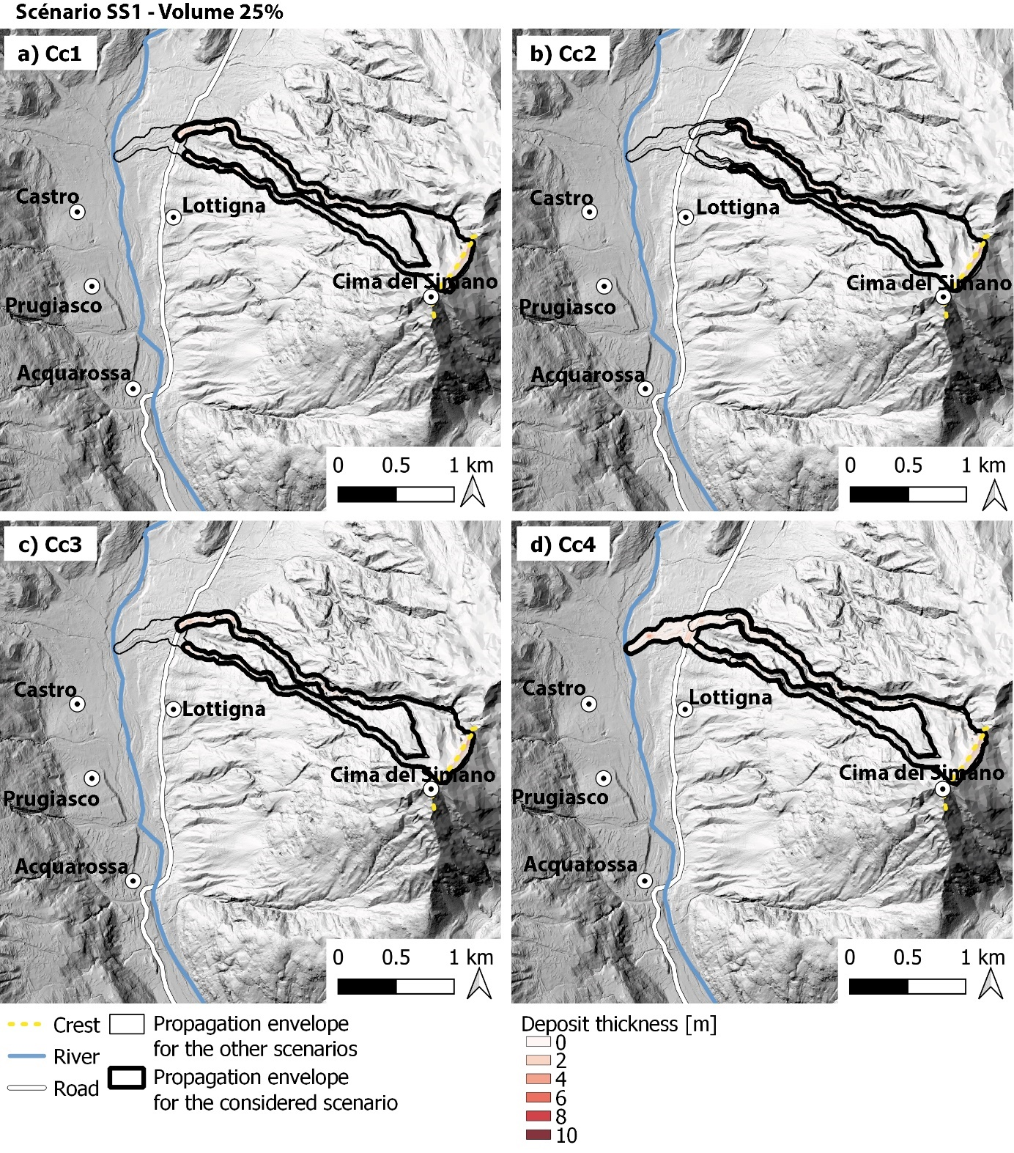
Fig. S6: Dan3D numerical simulations of the rock avalanche propagation for the scenario of rupture SS1, considering 25% of the released material (2.30$×$10⁵ m³) and for four pairs of μ and ξ. (a) Cc1 (0.05, 200). (b) Cc2(0.11, 200). (c) Cc3(0.11, 700). (d) Cc4(0.05, 700)
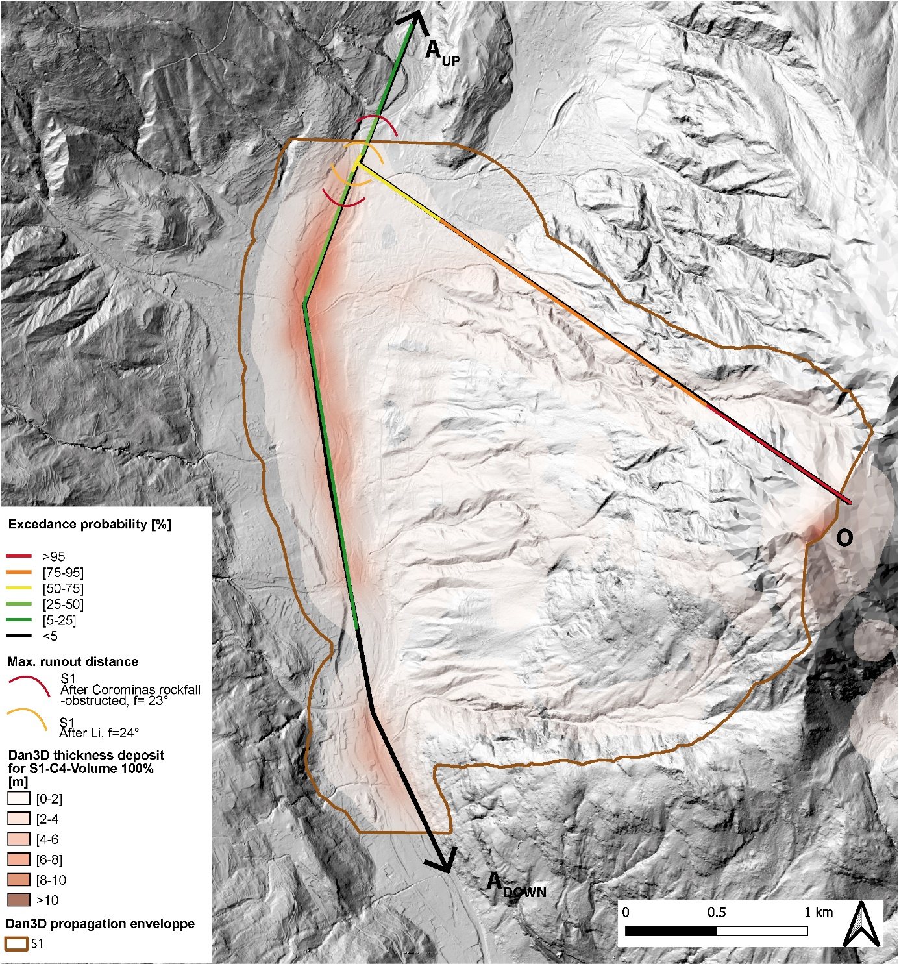
Fig. S7: Run-out exceedance probability along A_{UP} and A_{DOWN} for propagation of 100% of the unstable volume of scenario S1 and comparison with the maximum run-out distance empirically estimated (in red and orange) and with the run-out distance from the numerical simulation with Dan3D (parameters C4, in brown)
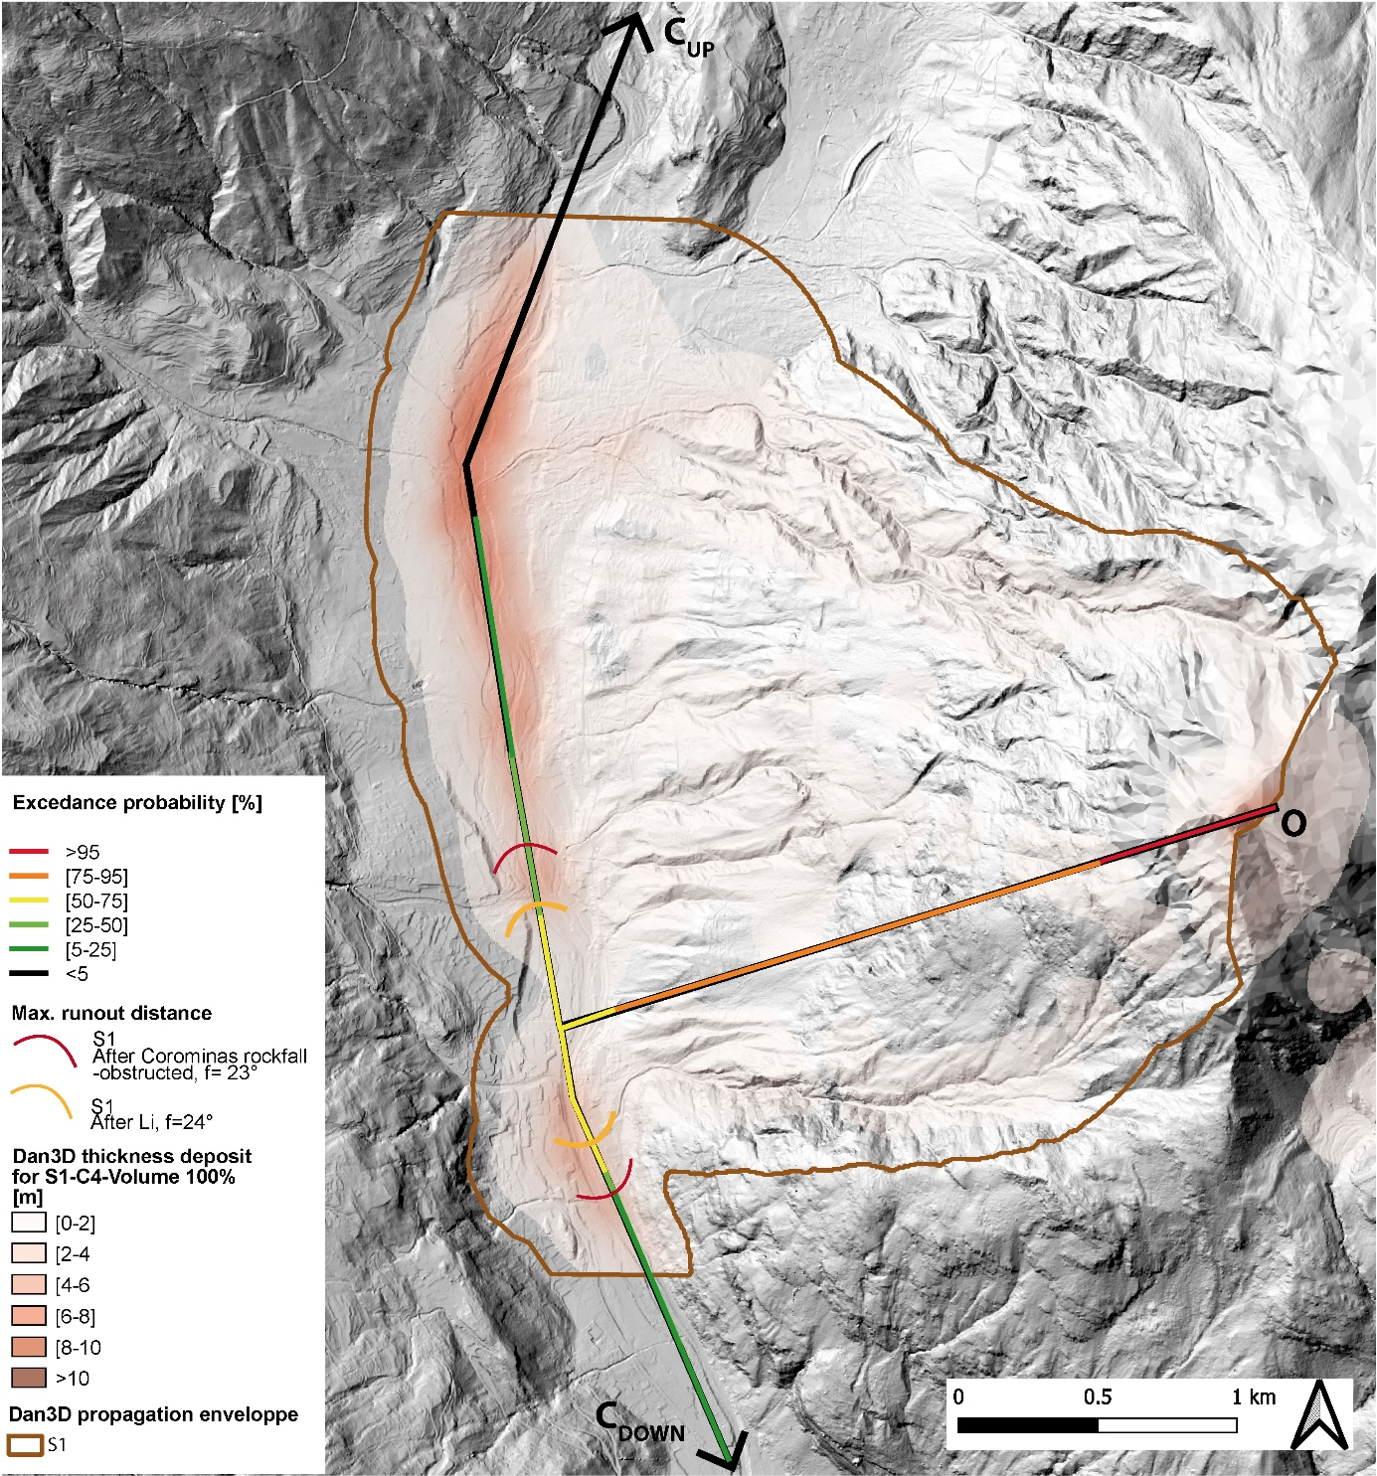
Fig. S8: Run-out exceedance probability along C_{UP} and C_{DOWN} for propagation of 100% of the unstable volume of scenario S1 and comparison with the maximum run-out distance empirically estimated (in red and orange) and with the run-out distance from the numerical simulation with Dan3D (parameters C4, in brown)
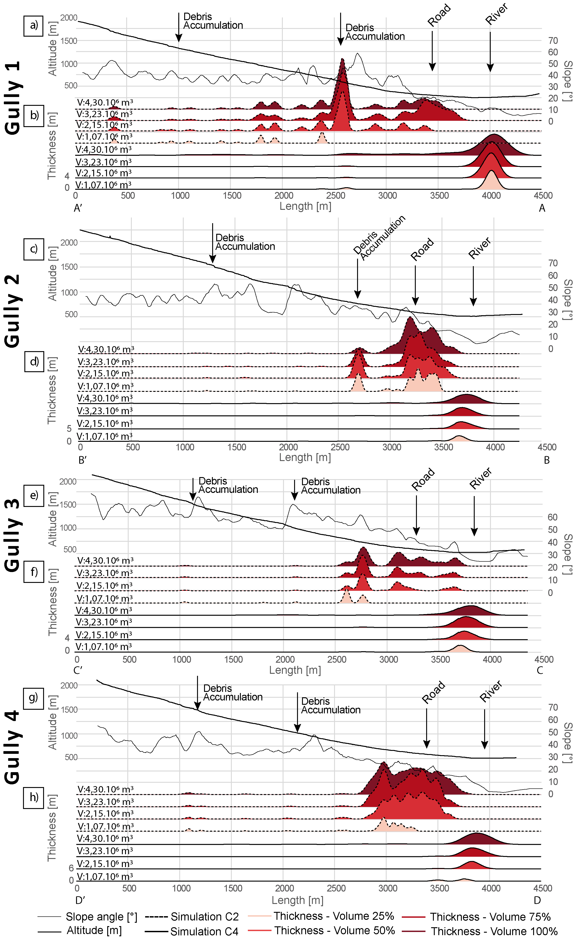
Fig. S9: Topography, slope dip and thickness deposits profile for the propagation simulations C2 and C4 of the S1 rupture scenario in the different gullies presented Fig. 13. (a) Topographical profile of gully R1. (b) Thickness deposits profile in gully R1. (c) Topographical profile of gully R2. (d) Thickness deposits profile in gully R2. (e) Topographical profile of gully R3. (f) Thickness deposits profile in gully R3. (g) Topographical profile of gully R4. (h) Thickness deposits profile in gully R4. In each gully, the two zones with accumulation of debris taken as sources for potential subsequent debris flow events are marked with an arrow.

