Supplementary information
Assessing the impact of coastal flooding along the northern Yucatan Peninsula associated to sea level rise under different Shared Socio-economic Pathways
Wilmer Rey^{1, 2, 4}, Paulo Salles^{2, 3}, José Carlos Pintado-Patiño⁴, Mark Stacey⁵, Alec Torres-Freyermuth^{2, 3}, Pablo Ruiz-Salcines^{2, 5}, Bismarck Jigena-Antelo⁶
¹CONAHCYT, Consejo Nacional de Humanidades Ciencias y Tecnologías, Ciudad de México 03940, Mexico.
²Laboratorio de Ingeniería y Procesos Costeros, Instituto de Ingeniería, UNAM, México. Puerto de abrigo s/n, 92718 Sisal, Mexico.
³Laboratorio Nacional de Resiliencia Costera, CONAHCyT, Yucatán, Mexico.
⁴Escuela Nacional de Estudios Superiores, Unidad Mérida, Universidad Nacional Autónoma de México, Carretera Mérida-Tetiz, km 4, 97357 Ucu, Yucatán, Mexico.
⁵ Department of Civil and Environmental Engineering, University of California, Berkeley, CA, USA.
⁵Centre for Climate Change, Geography Department, Universitat Rovira i Virgili, Tarragona, Spain.
⁶University of Cadiz, School of Marine, Nautical and Radioelectronic Engineering, Puerto Real Campus, CASEM, 11510 Puerto Real, Cadiz, Spain.

Correspondence to Paulo Salles psallesa@iingen.unam.mx; Wilmer Rey wreys@iingen.unam.mx

This supplementary material corresponds to results found for the other coastal towns along the Northern Yucatan Coast, namely Celestun, Sisal and Telchac (see Figure 1 of the manuscript for the location).

I] CELESTUN:
Hydrodynamic results indicate that the Southwestern part of Celestun is the most exposed to flooding under any SLR scenario (Figure S1), particularly near the sheltered port and the back-barrier Celestun lagoon. The area around the sheltered port is primarily inhabited by low-income families living in informal settlements lacking formal urban planning. The urban community of Celestun comprises 8,366 residents across 157 city blocks, underscoring the socio-economic vulnerabilities in these flood-prone zones.
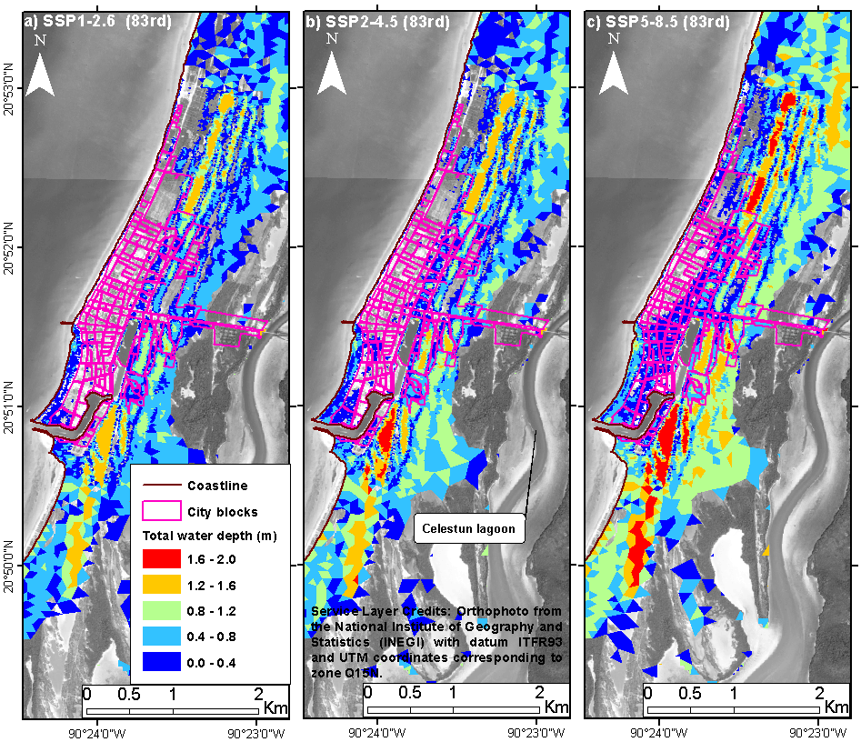
Figure S2. Inundation threat maps from SLR projection, using different SSP scenarios for 2100 in Celestun. a) SSP1-2.6 for the 83rd percentile. b) SSP2-4.5 for the 83rd percentile. c) SSP5-8.5 for the 83rd percentile.
From 2010 to 2020, Celestun’s population grew by 22.84%. Flood projections for the 83rd percentile under SSP1-2.6, SSP2-4.5, and SSP5-8.5 indicate that42, 55, and 101 city blocks would be affected, respectively, representing 26.75 %, 35.03 %, and 64.33 % of total city blocks, as shown in Figure S2.Under the 17th percentile projections for SSP1-2.6 and SSP2-4.5, the number of blocks impacted would be 30 and 37, or 19.10 % and 23.56 %, respectively (Figure S3).
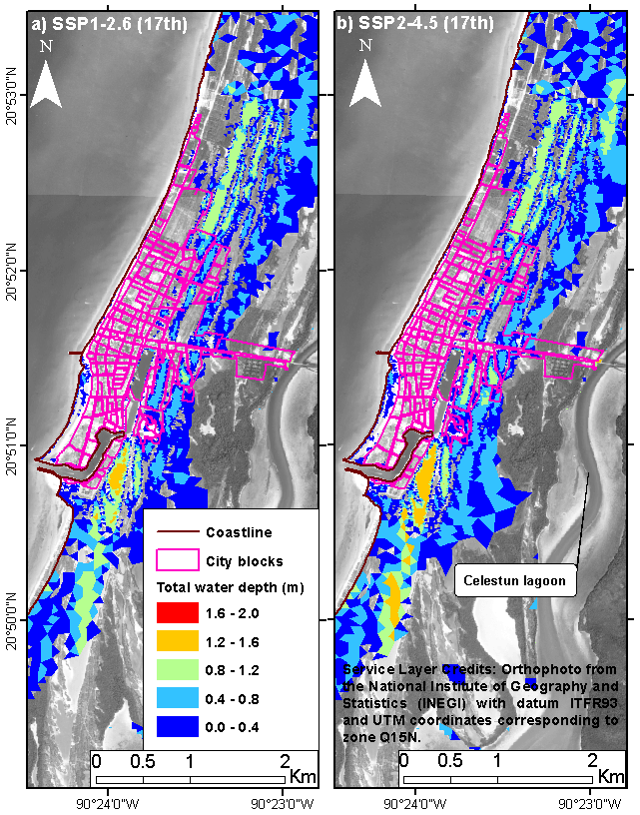
Figure S3. Inundation threat maps from SLR projection, using different SSP scenarios for 2100 in Celestun. a) SSP1-2.6 for the 17th percentile. b) SSP2-4.5 for the 17th percentile.

II] SISAL
Sisal Port, a rural community with 2,078 residents distributed across 113 city blocks (Figure S4), experienced a population growth of 13.11% from 2010 to 2020. The western part of Sisal and the adjacent back-barrier wetland are the more exposed to flood under any SLR projections. Only three small culverts connect this wetland to the sheltered port during spring high tides.
The beachfront area of Sisal’s flood-prone western section contains no city blocks. However, there is a small but important campus of the National University of Mexico (not shown) in this area, which may be affected under most of these flood scenarios, as well as the only road linking Sisal to Merida, the State capital both of which may face flood risks under most scenarios.
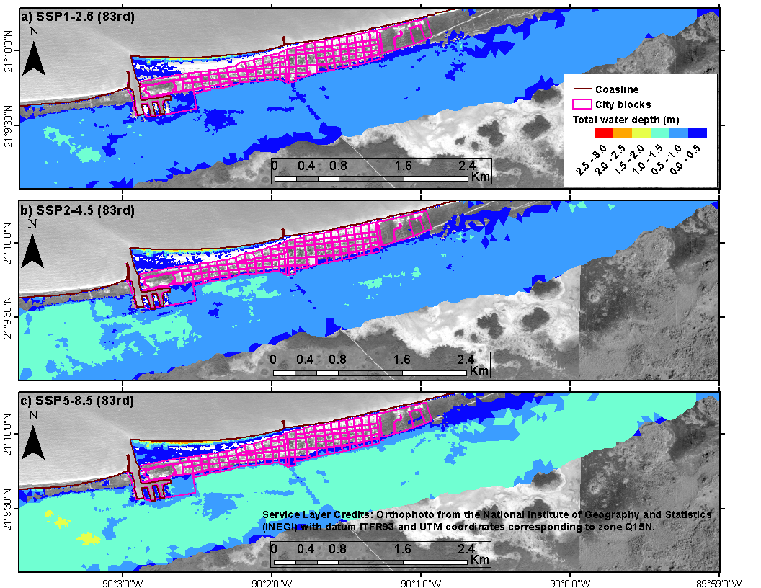
Figure S5. Inundation threat maps from SLR projection, using different SSP scenarios for 2100 in Sisal. a) SSP1-2.6 for the 83rd percentile. b) SSP2-4.5 for the 83rd percentile. c) SSP5-8.5 for the 83rd percentile.
In terms of city blocks, the number at risk in Sisal Port under the 83rd percentile SLR projections would be 14 (12.38 %), 20 (17.69), and 27 ( 23.89 %) under SSP1-2.6, SSP2-4.5, and SSP5-8.5, respectively (Figure S5), and for the 17th percentile projections of SSP1-2.6 and SSP2-4.5, the blocks affected would be 5 (4.42 %) and (9.73%) (Figure S6). Most of these affected blocks are located along the southern margin of the barrier.
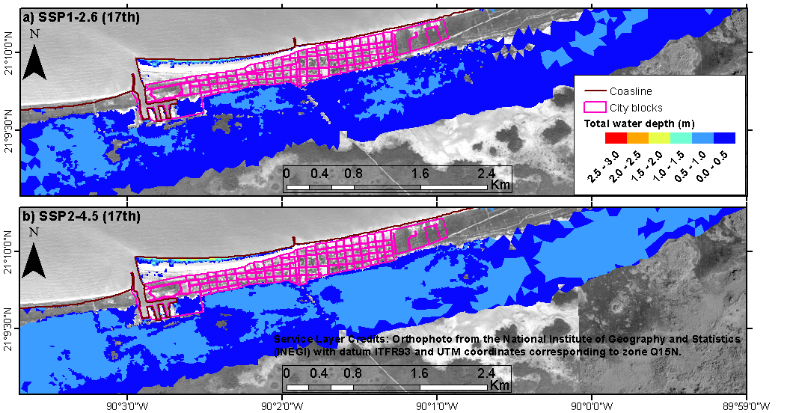
Figure S6. Inundation threat maps from SLR projection, using different SSP scenarios for 2100 in Sisal. a) SSP1-2.6 for the 17th percentile. b) SSP2-4.5 for the 17th percentile.

III] TELCHAC

Telchac Port, with a population of 1913 spread over 232 city blocks (Figure S7), saw an 11.09% increase in inhabitants between 2010 and 2020.
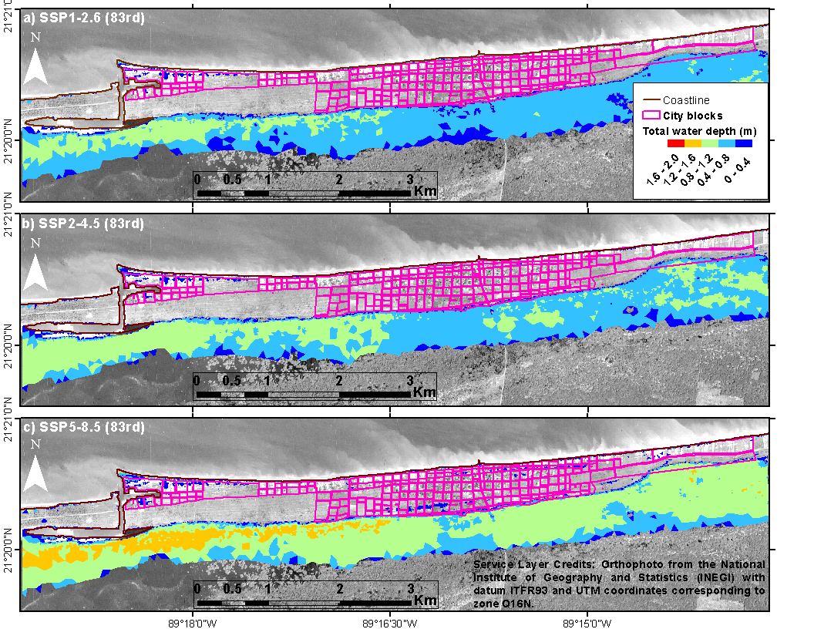
Figure S8. Inundation threat maps from SLR projection, using different SSP scenarios for 2100 in Telchac. a) SSP1-2.6 for the 83rd percentile. b) SSP2-4.5 for the 83rd percentile. c) SSP5-8.5 for the 83rd percentile.
In Telchac Port, projections indicate that flood impacts vary significantly depending on the SLR scenario. Under the SSP1-2.6, SSP2-4.5, and SSP5-8.5 scenarios at the 83rd percentile, 24, 30, and 63 city blocks, respectively, would be affected, corresponding to 10.34 %, 12.93, % and 27.15% of Telchac's total city blocks (Figure S8). In a lower-risk scenario (17th percentile) for SSP1-2.6 and SSP2-4.5, the number of impacted blocks would decrease to 15 and 21, representing 6.46 and 9.05% (Figure S9). Most of the affected blocks are concentrated at the Western part of Telchac and along the back-barrier southern margin, a pattern similar to Sisal Port.
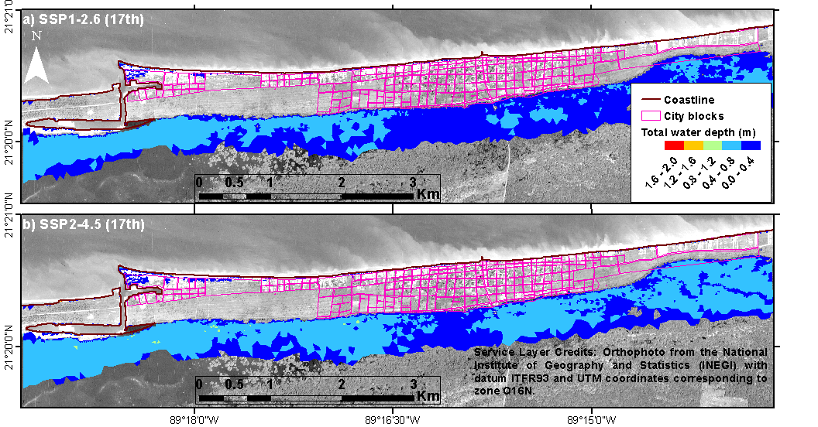
Figure S9. Inundation threat maps from SLR projection, using different SSP scenarios for 2100 in Telchac. a) SSP1-2.6 for the 17th percentile. b) SSP2-4.5 for the 17th percentile.

