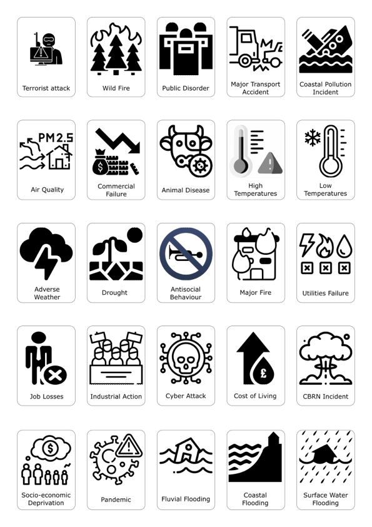
Supplementary Information: Hazards (Stressors and Shocks) presented to LRF Participants during the research workshop

Supplementary Information: Hazards (Stressors and Shocks) presented to Community Participants during the research workshop
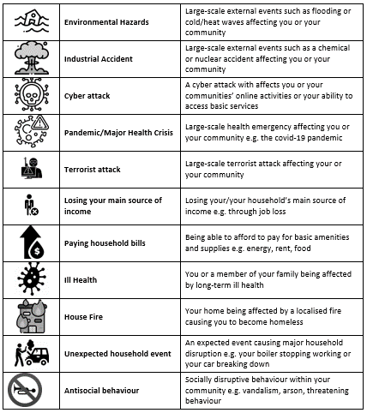
Note – community participants were provided with additional contextual information so that they had greater confidence in interpreting the individual cards.

