Supplementary Information for Natural Hazards article

Vulnerability of People in Wood-Frame Buildings to Rapid Flow-Type Landslides
Philip LeSueur^{1,2} (ORCID 0000-0002-3028-4329), Sophia Zubrycky³ (ORCID 0000-0002-0274-6573), Scott McDougall² (ORCID 0000-0003-4261-5911), Vincenzo Coia³ (ORCID 0000-0002-2930-0723), Alex Strouth⁴ (ORCID 0000-0002-3678-3276), Michael Porter³ (ORCID 0009-0003-2063-2507)
¹ Natural Resources Canada, Vancouver, British Columbia, Canada
² The University of British Columbia, Vancouver, British Columbia, Canada
³ BGC Engineering Inc., Vancouver, British Columbia, Canada
⁴ BGC Engineering Inc., Golden, Colorado, USA

Introduction
This supplementary material summarizes the methods used to assign landslide velocities and depths to buildings damaged by the following landslides:
- The 1970 Summerland silt fall
- The 2014 Oso Landslide
- The 2018 Montecito debris flows
Methods used to assign velocities and depths to buildings impacted by other study landslides are summarized in the database at this link: https://github.com/plesueur/landslide-vulnerability/tree/main. The above cases are included in this supplementary material because detailed analyses were carried out that could not be easily summarized there.

1970 Summerland Silt Fall
On September 27, 1970, a block of glaciolacustrine silt fell from an over-steepened section of slope above Lakeshore Drive, Summerland, British Columbia (Figure 1), then flowed as a dry cohesionless mass into three houses below (Geological Survey of Canada 2002). The landslide destroyed two buildings, pushed one 3 m from its foundation, killed one person, and buried about 60 m of road in up to 4 m of debris (Musgrove 1970).
Two of the impacted buildings were occupied during the event and were included in the empirical building and occupant dataset. Back-analysis with the numerical runout model Dan3D was used to estimate the landslide impact pressures on these buildings. The building locations were identified using air photographs of the site collected in 1969.
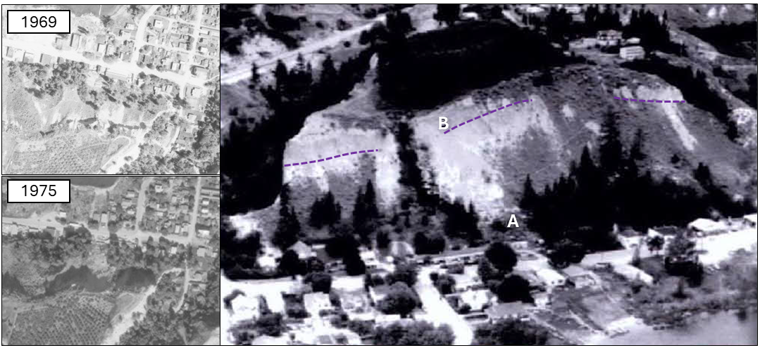
Figure 1. Location of 1970 Summerland silt fall. Air photographs (left) are from the BC air photo catalogue (Province of British Columbia, 2025a). Aerial view (right) was taken in 1976 (Geological Survey of Canada 2002). Point A shows the approximate building location where an occupant was killed, and Point B shows the approximate silt fall source. Both A and B were plotted by the Geological Survey of Canada (2002). The purple lines divide over-steepened areas of the slope and the colluvial apron below.
Dan3D Inputs and Results
The model was run using a 1 m by 1 m digital elevation model derived from 2019 lidar data (Province of British Columbia, 2025b). No large landslides are known to have released from the same source area since the 1970 event (Ecora and Clarke Geoscience Ltd. 2021), so we assumed that the slope topography from 2019 is representative of the post-event landslide surface.
The landslide source area was delineated by comparing air photographs collected before (circa 1969) and after (circa 1975) the event to identify the landslide head scarp and over-steepened area of the slope where the landslide is reported to have been sourced (see Figure 1). The source area thickness was mapped by delineating the 1969 slope crest from air photos, then projecting a surface from this line to the existing ground at -55°. This angle corresponds with the approximate average angle of existing over-steepened slopes near the bluff crest, based on the digital elevation model. The landslide source volume was estimated to be about 3,000 m³.
The silt fall was modelled as a dry frictional material for its entire run-out length, and we assumed that no entrainment occurred as it travelled over the colluvial apron. Material parameters were selected so that the simulated landslide runout distance approximately matched that of the event. We assumed that this landslide crossed Lakeshore Drive and reached the houses beyond, but did not pass the footprint of those buildings. Reports of the event indicate that buildings on the far side of Lakeshore Drive were only partly inundated, and trees surrounding those houses were identified to be present before and after the event in available air photographs. Calibrated parameters for the frictional material included an internal friction angle of 30° and a bulk basal friction angle of 23°. The simulated deposit depth compared to the interpreted landslide boundary is shown in Figure 2.
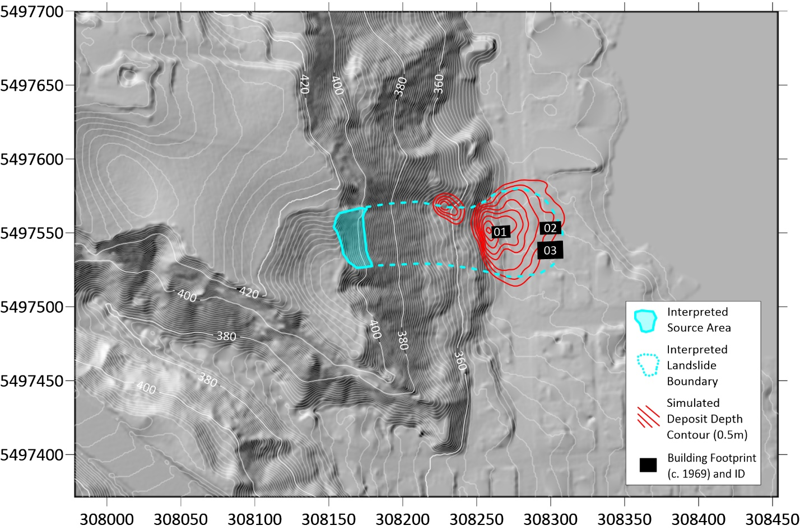
Figure 2. Dan3D simulated deposit depth of the 1970 Summerland, BC, silt fall.

2014 Oso Landslide
On March 22, 2014, a flow slide released from natural terrain upslope of the community of Oso, Washington. This high-mobility event ran across the valley floor and over the community, damaging several buildings and killing 43 people (Wartman et al. 2016).
Several buildings damaged by the Oso landslides were included in the empirical data by: 1) identifying the locations of each impacted building; and 2) intersecting the building centroids with numerical modelling results by Aaron et al. (2017) to extract flow depth and velocity pairs corresponding with the maximum impact pressure simulated at each building location.
The building locations were identified based on publicly available land permits from Snohomish County, and a map of lots impacted by the Oso Landslide (Snohomish County 2014). The permits included information about the site layout, building type(s), building age(s), building height(s), number of outbuildings, and landowner name(s). Buildings identified as outbuildings or manufactured homes were excluded. In total, we identified 67 buildings impacted by the Oso Landslide, including 28 study buildings and 39 outbuildings or manufactured homes (Figure 3).
Orthoimagery collected shortly after the event shows that no buildings within the landslide area were standing after the event (WSDOT 2024), so we assumed that all buildings were completely damaged.
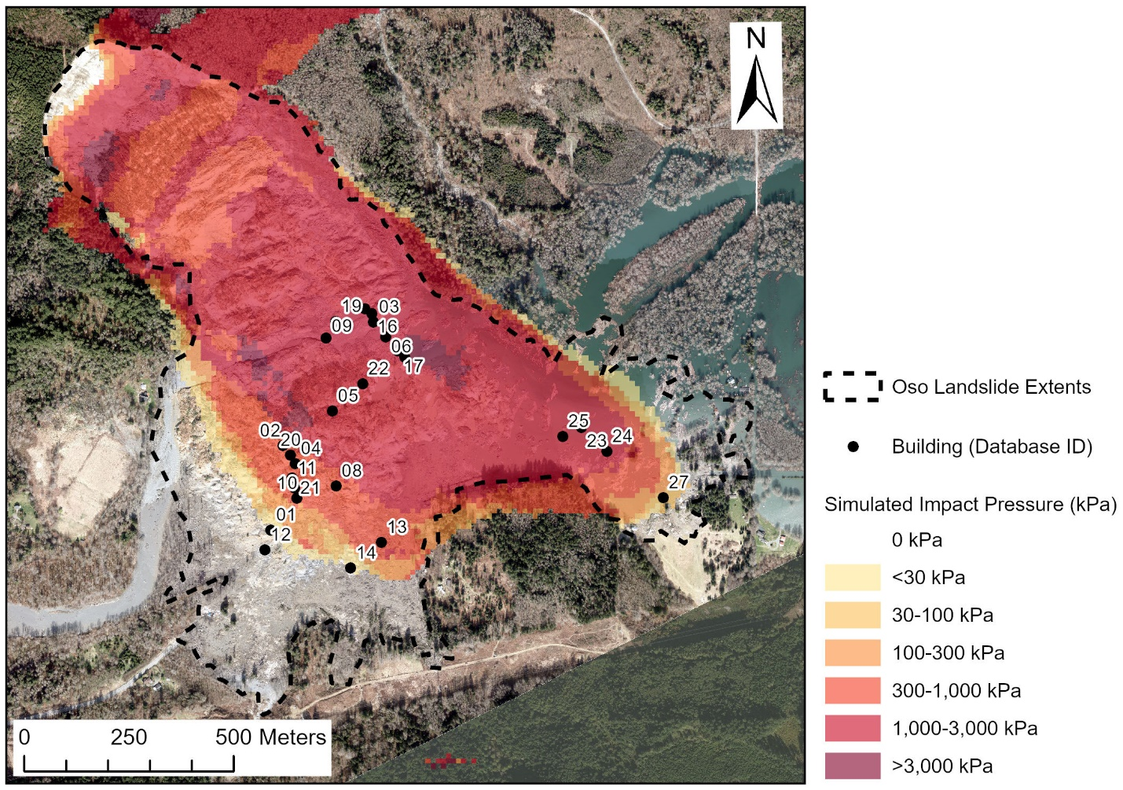
Figure 3. Locations of wood buildings impacted by the 2014 Oso Landslide. Simulated impact pressures are from Aaron et al. (2017). Satellite image from WSDOT (2024).

2018 Montecito Debris Flows
On January 9, 2018, intense rainfall triggered debris flows from wildfire-burned terrain upslope of Montecito, California. These landslides cascaded down urbanized alluvial fans and damaged 408 homes, killed 23 people, and injured at least 167 people (Kean et al. 2019a).
Kean et al (2019b) inventoried buildings damaged by these events, collecting information about each building’s location, size (e.g. area, weight), level of damage, and level of landslide intensity exposure (e.g. inundation depth, velocity, momentum flux). Much of this information was obtained from a post-event survey of building damage carried out by the California Department of Forestry and Fire Protection within 12 days of the debris flows (CAL FIRE, 2018).
Several buildings from Kean et al (2019b) were included in the building dataset, and each was assigned a damage state, flow velocity, and flow depth based on available information. Buildings were assigned a structural damage state based on the reported level of damage in Kean et al. (2019b), and a review of photographs showing building damage extent. Flow velocities were assigned to buildings based on numerical modelling results from Barnhart et al. (2024), who used three numerical models (RAMMS, D-CLAW, FLO-2D) to simulate runout of the Montecito debris flows considering a range of event volumes and mobilities. The study outputs included a list of the maximum flow depth and momentum flux (i.e. depth times velocity squared) at each building for each model run (Barnhart 2023). We calculated median flow velocities at each building from this dataset by considering model runs with initial volumes similar to the event volumes (i.e. those classified as ‘unbiased’) (1,960 model runs). Flow depths were assigned to buildings based on numerical modelling results from Barnhart et al. (2024), and observations of flow depths at buildings from Kean et al (2019b). Median flow depths were estimated using the same approach carried out to estimate median flow velocities. In cases where the median flow depth from modelling exceeded observed values from Kean et al (2019b), the observed value was used.
Buildings from Kean et al (2019b) that met the following criteria were excluded from the building dataset:
- The building was not a detached wood-frame structure.
- The building was under construction at the time of the debris flows.
- The building was damaged by the debris flows and a secondary process (e.g. explosion).
- The building damage state could not be confirmed from available information. For example, some of the available photographs documenting building damage were of poor quality or only showed a small fraction of the building.
- The flow depths or velocities assigned from available information were interpreted to be unrealistic. For example, in some cases the assigned depth or velocity from modelling was zero, but the building had experienced significant structural damage from the debris flows. In other cases, the modelled flow depths were more than 4x the observed values, indicating the model likely overestimated the hazard.

References
Aaron J, Hungr O, Stark TD, and Baghdady AK (2017) Oso, Washington, Landslide of March 22, 2014: dynamic analysis. Journal of Geotechnical and Geoenvironmental Engineering 143(9): 05017005. doi:10.1061/(ASCE)GT.1943- 5606.0001748.
Barnhart KR (2023) Select model results and model input parameters for debris-flow runout model simulations of the 9 January 2018 Montecito debris flow runout event, U.S. Geol. Surv. data release [data set], https://doi.org/10.5066/P9X18F2H.
CAL FIRE (California Department of Forestry and Fire Protection) (2018) Damage inspection database (DINS): Sacramento, California, California Department of Forestry and Fire Protection, Office of the State Fire Marshall, ArcGIS files dated 26 April 2018.
Ecora and Clarke Geoscience Ltd. (2021). Greater West Bench Geotechnical Review. Report prepared for Okanagan-Similkameen Regional District. December 22, 2021.
Geological Survey of Canada. (2002). Catastrophic Landslides and Related Processes in the Southern Cordillera: Analysis of Impact on Lifelines and Communities. Prepared for Public Safety and Emergency Preparedness Canada.
Kean JW, Staley DM, Lancaster JT, Rengers FK, Swanson BJ, Coe JA, Hernandez JL, Sigman AJ, Allstadt KE and Lindsay DN (2019a) Inundation, flow dynamics, and damage in the 9 January 2018 Montecito debris-flow event, California, USA: Opportunities and challenges for post-wildfire risk assessment. Geosphere 15:1140–1163. https://doi.org/10.1130/GES02048.1, 2019a.
Kean JW, Staley DM, Lancaster JT, Rengers FK, Swanson BJ, Coe JA, Hernandez JL, Sigman AJ, Allstadt K and Lindsay DN (2019b) Debris-flow inundation and damage data from the 9 January 2018 Montecito debris-flow event, U.S. Geological Survey data release, http://doi.org/10.5066/P9JQJU0E
Musgrove, P. (1970, September 28). Landslide 'like explosion' kills Summerland resident. The Sun, A10.
Province of British Columbia (2025a). Digital air photos of B.C. Online. Located at https://www2.gov.bc.ca/gov/content/data/geographic-data-services/digital-imagery/air-photos
Province of British Columbia (2025b). LidarBC. Online. Located at https://lidar.gov.bc.ca/
Snohomish County (2014) North Snohomish County, Affected Lots in Landslide Area. Produced by Snohomish County Planning and Development Services, dated March 31, 2014. Available at:
Wartman, J., Montgomery, D.R., Anderson, S.A., Keaton, J.R., Benoît, J., dela Chapelle, J., and Gilbert, R. 2016. The 22 March 2014 Oso landslide, Washington, USA. Geomorphology, 253(May 2014): 275–288. doi:10.1016/j. geomorph.2015.10.022
Washington State Department of Transportation (WSDOT) (2024) Aerial Photography over slide area near Oso Washington. Accessed on: July 13, 2023. Available at: ftp://ftp.wsdot.wa.gov/public/Photogrammetry/SR530%202014%20Slide/

