Appendix S1
The Major Land Resource Area (MLRA) classification system provides a regional framework for understanding soil, climate, and land use patterns across the United States. In Maryland, the dataset captures eight distinct MLRAs: Northern Piedmont, Northern Coastal Plain, Northern Tidewater Area, Northern Appalachian Ridges and Valleys, Mid-Atlantic Coastal Plain, Northern Blue Ridge, Tidewater Area, and Eastern Allegheny Plateau and Mountains. These classifications are part of a national land resource inventory developed by the USDA Natural Resources Conservation Service, which groups areas based on similarities in geology, climate, water resources, soils, and land use. The delineation of these MLRAs is typically based on a combination of field surveys, soil maps, satellite imagery, and ecological region data. Each MLRA represents a region with a characteristic pattern of soils and associated vegetation, which is critical for land use planning, agricultural practices, and environmental management in Maryland.
Model | AUC | Best Parameters based on GridSearchCV
XGBoost | 0.81 | learning_rate': 0.1, 'max_depth': 6, 'n_estimators': 50
Feed Forward Neural Network | 0.77 | batch_size': 32, 'epochs': 20, 'model__hidden_layers': 2, 'model__learning_rate': 0.01, 'model__neurons': 32
TabNet | 0.78 | 'gamma': 1.3, 'epoch': 32, 'lambda_sparse': 0.001, 'n_d': 8, 'n_steps': 3
CatBoost | 0.76 | 'depth': 6, 'iterations': 200, 'l2_leaf_reg': 3, 'learning_rate': 0.1
Convolutional Neural Network | 0.77 | batch_size': 32, 'epochs': 50, 'model__dense_units': 64, 'model__dropout_rate': 0.2, 'model__filters': 64, 'model__kernel_size': 3, 'model__learning_rate': 0.001
Multi-layer Perceptron | 0.77 | 'batch_size': 16, 'epochs': 10, 'model__learning_rate': 0.01, 'model__second_layer': False, 'model__units': 32
Random Forest | 0.84 | 'max_depth': 30, 'max_features': 'sqrt', 'min_samples_leaf': 1, 'min_samples_split': 10, 'n_estimators': 300
Support Vector Classifier | 0.73 | 'C': 1, 'gamma': 1, 'kernel': 'rbf'

Table S1: Evaluation of Machine Learning models in predicting flood susceptibility across the Census Blocks in Maryland

Table S2: Sensitivity analysis in selecting optimal threshold in for creating labels of stations with overflow potential
Threshold | Positives | Negatives | AUC
60% | 49 | 71 | 0.743
70% | 36 | 84 | 0.821
75% | 31 | 89 | 0.897
80% | 24 | 96 | 0.868
90% | 13 | 107 | 0.713

Table S3: Percentage of CBGs with high flood susceptibility (>70%) and percentage of CBGs with social vulnerability (>0.7)
county_name | total_cbgs | flood_prob_cbgs | flood_prob_pct | high_vuln_cbgs | high_vuln_pct
Allegany | 53 | 0 | 0 | 4 | 7.5
Anne Arundel | 340 | 6 | 1.8 | 4 | 1.2
Baltimore County | 562 | 8 | 1.4 | 82 | 14.6
Calvert | 41 | 0 | 0 | 0 | 0.0
Caroline | 22 | 0 | 0 | 0 | 0.0
Carroll | 100 | 0 | 0 | 0 | 0.0
Cecil | 65 | 0 | 0 | 0 | 0.0
Charles | 88 | 0 | 0 | 5 | 5.7
Dorchester | 30 | 11 | 36.7 | 8 | 26.7
Frederick | 200 | 0 | 0 | 4 | 2.0
Garrett | 24 | 0 | 0 | 0 | 0.0
Harford | 171 | 0 | 0 | 7 | 4.1
Howard | 166 | 0 | 0 | 0 | 0.0
Kent | 18 | 1 | 5.6 | 0 | 0.0
Montgomery | 664 | 0 | 0 | 93 | 14.0
Prince George's | 538 | 1 | 0.2 | 320 | 59.5
Queen Anne's | 35 | 3 | 8.6 | 0 | 0.0
St. Mary's | 63 | 0 | 0 | 1 | 1.6
Somerset | 22 | 12 | 54.5 | 0 | 0.0
Talbot | 27 | 2 | 7.4 | 0 | 0.0
Washington | 105 | 0 | 0 | 12 | 11.4
Wicomico | 72 | 1 | 1.39 | 18 | 25.0
Worcester | 55 | 9 | 16.36 | 3 | 5.5
Baltimore City | 618 | 1 | 0.16 | 398 | 64.4
Table S4: Percentage of total population and total home median value in high risk CBGs (flood risk>70%)
county_name | totalcbgs | high_risk_cbgs | high_risk_pct | total_home_value ($) | total_population
Allegany | 53 | 5 | 9.4 | 812200 | 10572
Anne Arundel | 340 | 8 | 2.4 | 5348300 | 17450
Baltimore City | 618 | 5 | 0.8 | 634100 | 6754
Baltimore County | 562 | 36 | 6.4 | 8287500 | 61432
Charles | 88 | 7 | 8.0 | 2763100 | 24155
Dorchester | 30 | 12 | 40.0 | 3752400 | 11439
Frederick | 200 | 9 | 4.5 | 2589500 | 17997
Garrett | 24 | 2 | 8.3 | 383300 | 3108
Harford | 171 | 6 | 3.5 | 1561900 | 12549
Howard | 166 | 8 | 4.8 | 2978400 | 22222
Kent | 18 | 1 | 5.6 | 304500 | 1260
Montgomery | 664 | 19 | 2.9 | 9422800 | 48870
Prince George's | 538 | 41 | 7.6 | 15007700 | 94178
Queen Anne's | 35 | 8 | 22.9 | 4521600 | 16582
Somerset | 22 | 16 | 72.7 | 2589800 | 18545
St. Mary's | 63 | 7 | 11.1 | 2449500 | 16117
Talbot | 27 | 4 | 14.8 | 2442600 | 5765
Washington | 105 | 4 | 3.8 | 1225600 | 9842
Wicomico | 72 | 2 | 2.8 | 414200 | 1812
Worcester | 55 | 18 | 32.7 | 6552400 | 22186

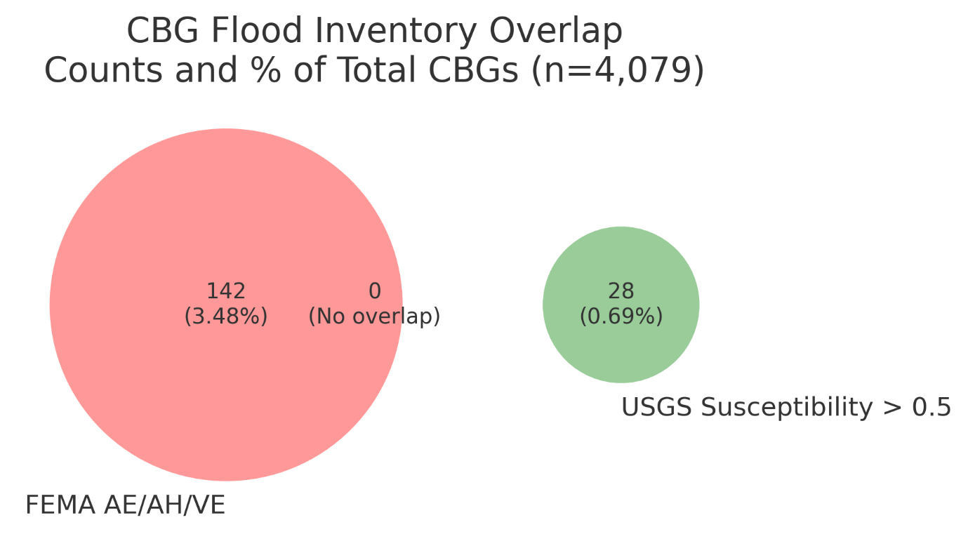
Figure S1: Venn diagram for the flood inventory showing count and percentage of Census Block Groups from the FEMA and USGS stream overflow potential scenarios

