Supplementary materials to:

Risk awareness characterisation in multi-hazard, high-tourist-interest sites: the case of Stromboli Volcano during the 2019 eruptive crisis (Aeolian Islands UNESCO site, Italy)

Agnese Turchi¹*, Federico Di Traglia^{2,3}, Riccardo Fanti³

¹PLINIVS-LUPT Study Centre, University of Naples Federico II, Via Toledo 402, 80134, Naples, Italy
² Istituto Nazionale di Geofisica e Vulcanologia, Osservatorio Vesuviano, Via Diocleziano 328, 80124 Naples, Italy
³Department of Earth Sciences, University of Florence, Via La Pira 4, 50121, Florence, Italy

*Correspondence: agnese.turchi@unina.it; Tel: +39 3299383098

Keywords: multi-hazard; risk awareness; semi-structured interviews; questionnaires; Stromboli volcano.
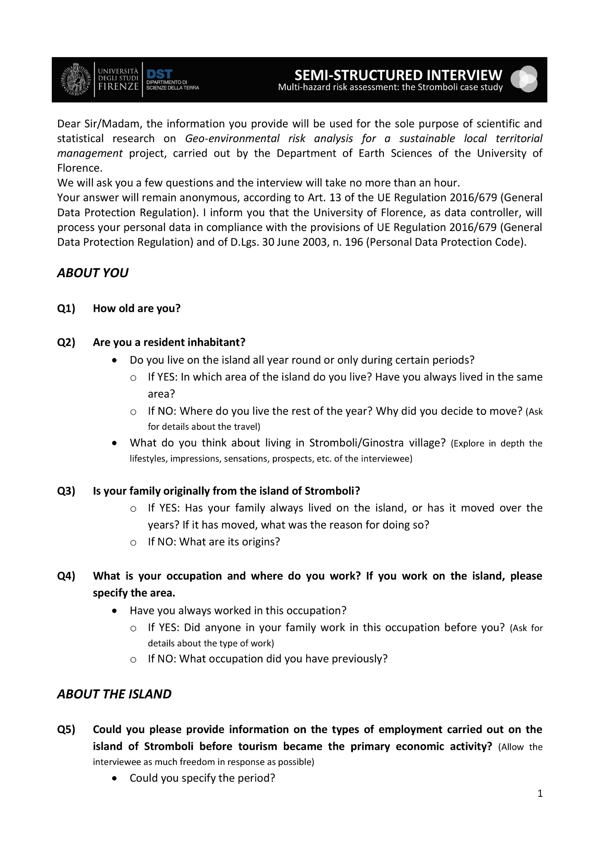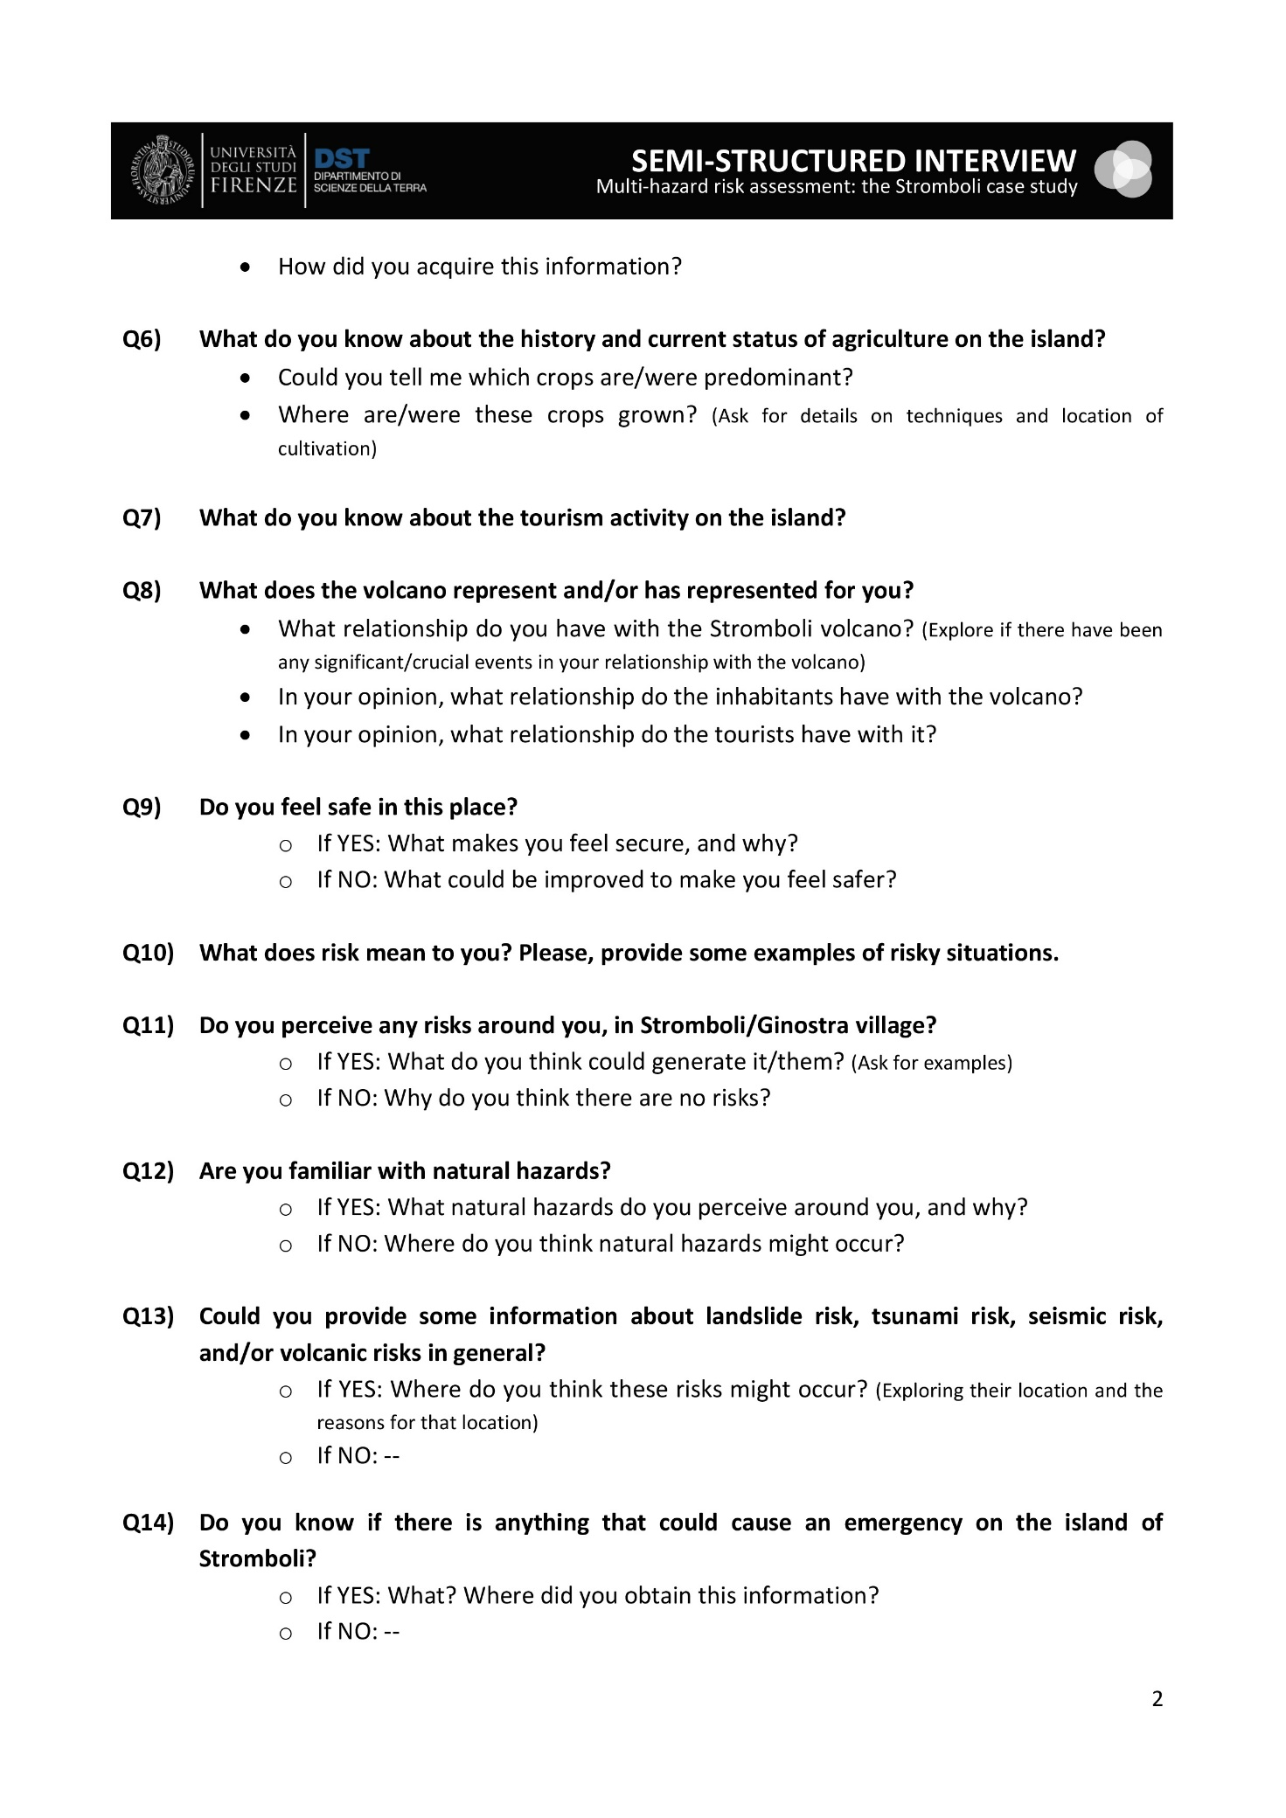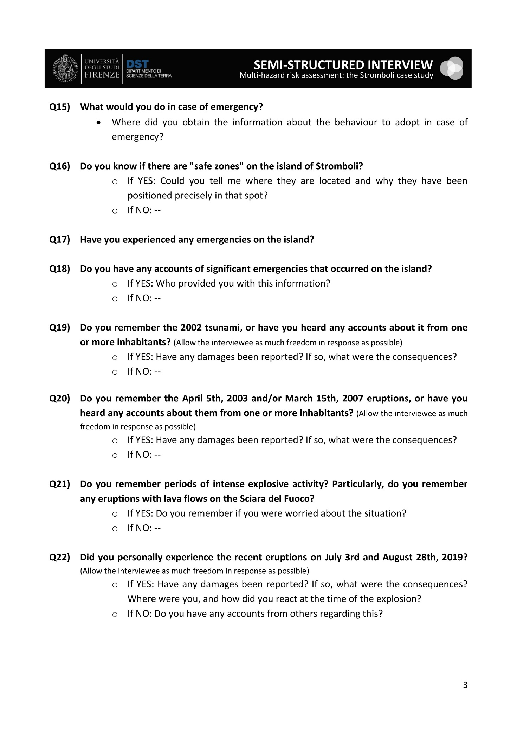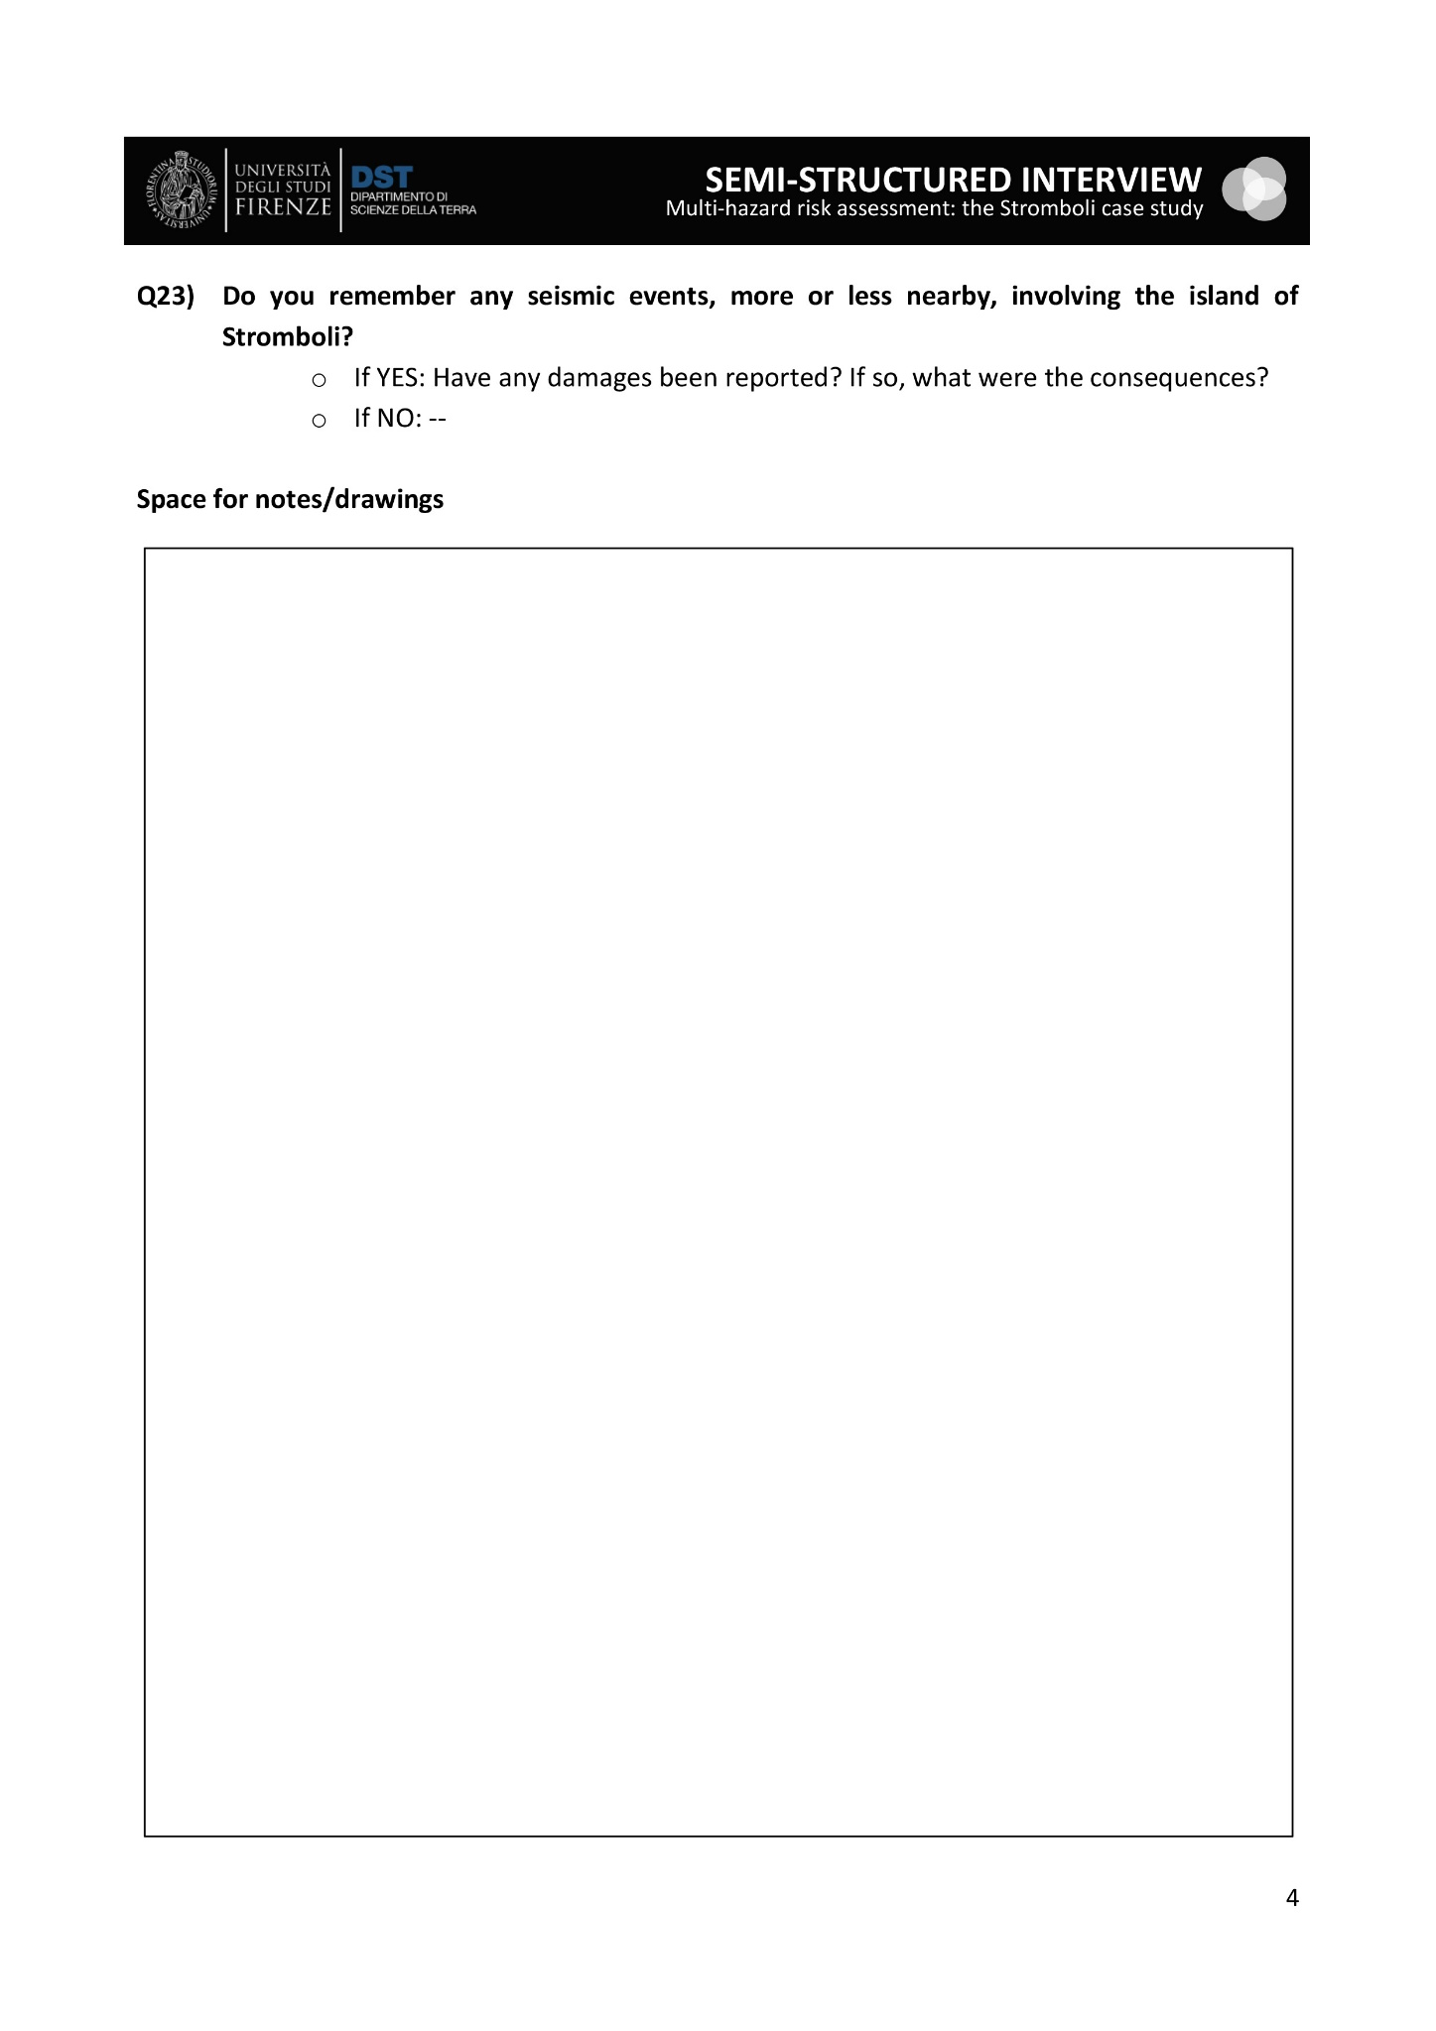
Fig. S1 Semi-structured interviews conducted with inhabitants on the island of Stromboli between August 29th and September 7th, 2019, and aimed at providing a preliminary characterisation of their risk awareness

