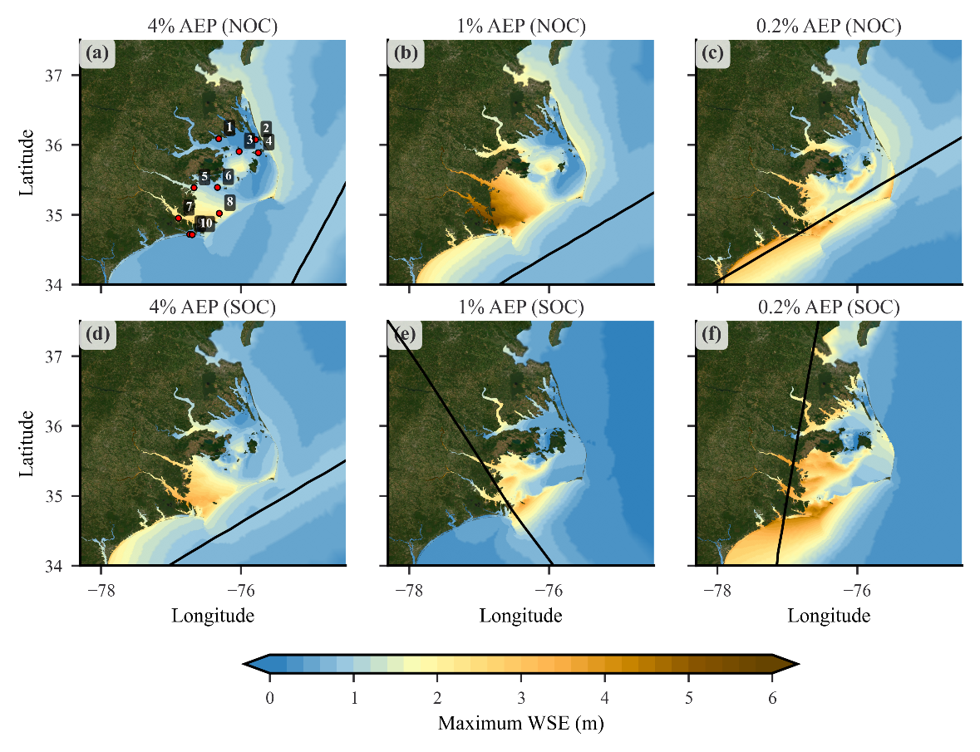
Figure S1 Maximum water-surface elevation (WSE) for all six synthetic storms under the SIR scenario: (a) Storm 290, (b) Storm 237, (c) Storm 297, (d) Storm 276, (e) Storm 432, and (f) Storm 620. Black lines represent storm tracks.
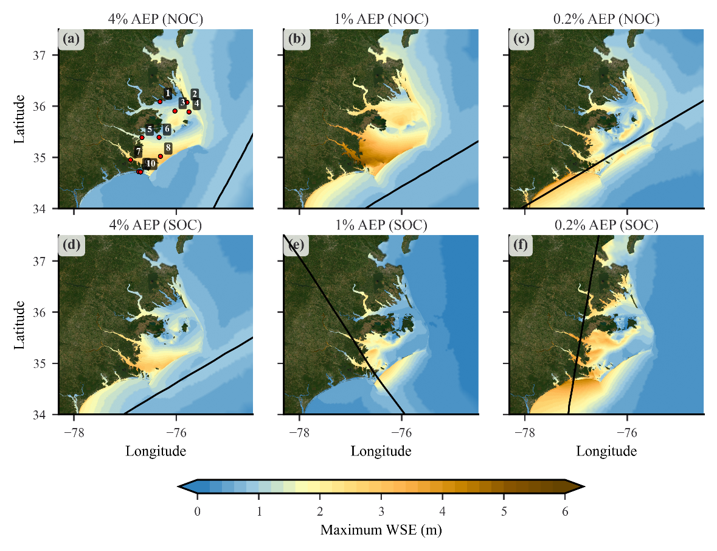
Figure S2 Maximum water-surface elevation (WSE) for all six synthetic storms under the NIR scenario: (a) Storm 290, (b) Storm 237, (c) Storm 297, (d) Storm 276, (e) Storm 432, and (f) Storm 620. Black lines represent storm tracks.

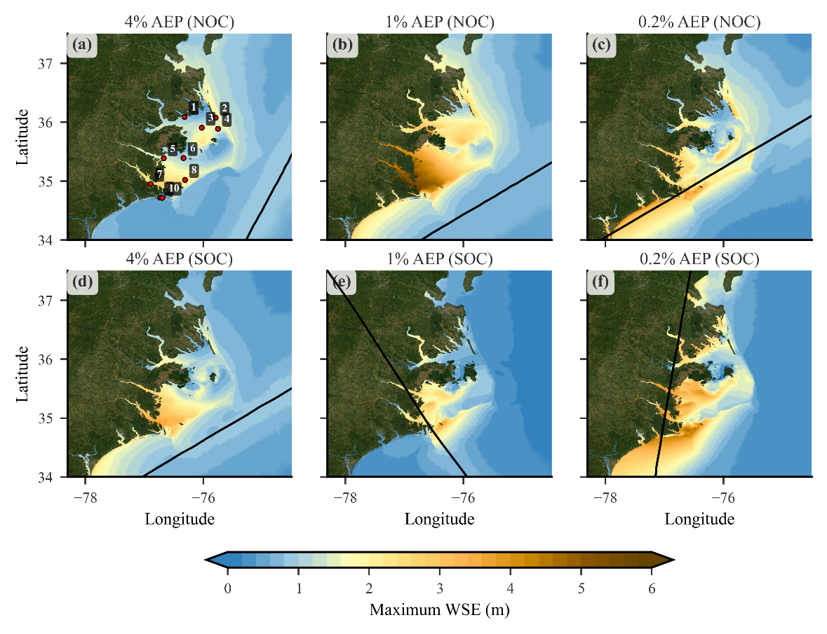
Figure S3 Maximum water-surface elevation (WSE) for all six synthetic storms under the AIR scenario: (a) Storm 290, (b) Storm 237, (c) Storm 297, (d) Storm 276, (e) Storm 432, and (f) Storm 620. Black lines represent storm tracks.

