Supplementary Information
Table SI-1: Coastal Vulnerability Model input data - description and sources
Input | Publication Date / Temporal Range | Variables | Source Data Format | Source
Shoreline Type | 2021 | Quaternary sediments | Shapefile - polygon | Geological Survey Ireland (GSI) - https://data.gov.ie/dataset/quaternary-sediments-150000-ireland-roi-itm
Relief | 2021 | Digital Terrain Model (DTM) | CSV - point file | Tailte Éireann
Coastal habitats | 2018 | 1310_Salicornia_mud | Shapefile - polygon | National Parks and Wildlife Service (NPWS) - https://www.npws.ie/maps-and-data/habitat-and-species-data/article-17/2019/habitats/coastal-habitats
Coastal habitats | 2018 | 1330AtlanticSaltMeadows | Shapefile - polygon
Coastal habitats | 2018 | 1410_Mediterranean_Salt_Meadows | Shapefile - polygon
Coastal habitats | 2018 | 1420_Halophilous_Scrub | Shapefile - polygon
Coastal habitats | 2018 | 2110_Embryonic_Shifting_Dunes | Shapefile - polygon
Coastal habitats | 2018 | 2120_Marram_Dunes_(White_Dunes) | Shapefile - polygon
Coastal habitats | 2018 | 2130_Fixed_Dunes_(Grey_Dunes) | Shapefile - polygon
Coastal habitats | 2018 | 2190_Humid_Dune_Slacks | Shapefile - polygon
Coastal habitats | 2018 | 21A0_Machair | Shapefile - polygon
Coastal habitats | 2024 | Seagrass_2023 | Shapefile - polygon | Beca-Carretero et al. (2024)
Wind | 1995-2024 | Daily records of 10m wind speed and direction at 3 hourly intervals | NetCDF | CERRA sub-daily regional reanalysis data for Europe on single levels from 1984 to present. Copernicus Climate Change Service. - https://cds.climate.copernicus.eu/datasets/reanalysis-cerra-single-levels?tab=download
Wave | 1995-2024 | Sea surface wave significant height (VHM0 [m]); Sea surface wave from direction (VMDR [°]); and Wave period at spectral peak (VTPK [s]) at 3 hourly intervals | NetCDF | Atlantic- European North-West Shelf- Wave Physics Reanalysis. European Union-Copernicus Marine Service - https://data.marine.copernicus.eu/product/NWSHELF_REANALYSIS_WAV_004_015/services
Storm Surge | 1985-2014 | Storm surge absolute value - reanalysis - 100 year Return Period - best fit | NetCDF | Global sea level change indicators from 1950 to 2050 derived from reanalysis and high resolution CMIP6 climate projections. Copernicus Climate Change Service - https://cds.climate.copernicus.eu/datasets/sis-water-level-change-indicators-cmip6?tab=download
Sea Level Change | 1985-2014 | Annual Mean Sea Level | NetCDF | Global sea level change time series from 1950 to 2050 derived from reanalysis and high resolution CMIP6 climate projections https://cds.climate.copernicus.eu/datasets/sis-water-level-change-timeseries-cmip6?tab=download
Total Water Level | 1985-2021 | Extreme water level values from a 100-year RP storm event | CSV – point file | Cotrim et al. (2026)

Table SI-2: Additional data for coastal exposure assessment – descriptions and sources
Input | Publication Date | Variables | Source Data Format | Source
Population | 2023 | Census 2022 Small Area Population Statistics | csv | Central Statistics Office https://www.cso.ie/en/census/census2022/census2022smallareapopulationstatistics/
Population | 2023 | Census 2022 Small Area Boundary | File Geodatabase | Central Statistics Office https://data-osi.opendata.arcgis.com/datasets/osi::cso-small-areas-national-statistical-boundaries-2022-ungeneralised/about
Population | 2023 | Buildings | csv | GeoDirectory database, An Post / Tailte Éireann
Cultural Heritage | 2023 | All classes included except "Redundant Records" | Shapefile - point | National Monuments Service - Archaeological Survey of Ireland https://data.gov.ie/dataset/national-monuments-service-archaeological-survey-of-ireland

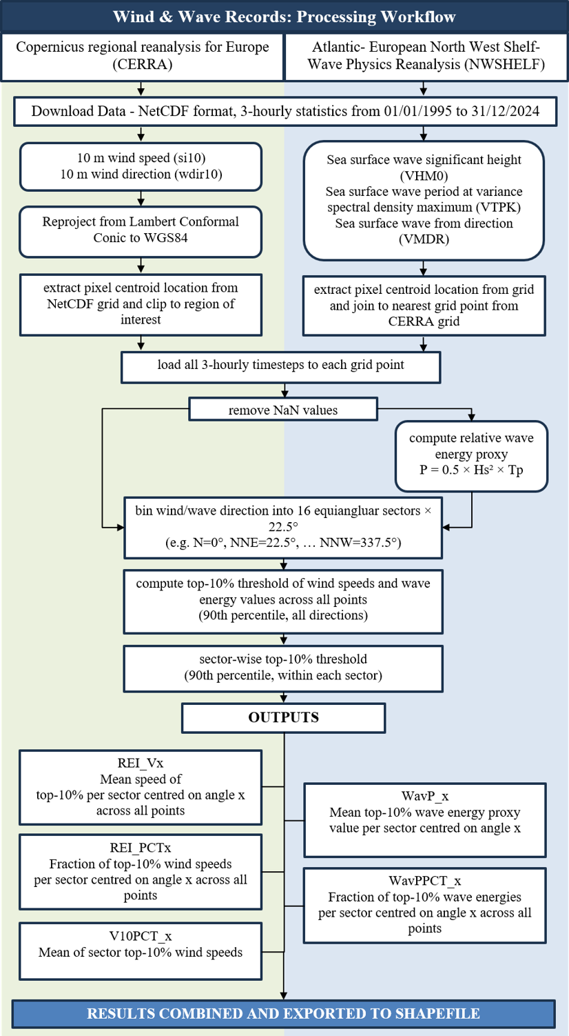
Figure SI-1: Workflow for processing wind and wave records from NetCDF files and formatting for use in the InVEST® Coastal Vulnerability Model

Table SI-2: Quintile ranges of continuous value variables utilised in the Coastal Exposure Index
 | Coastal Exposure Index
 | Very Low | Low | Moderate | High | Very High
 | 1 | 2 | 3 | 4 | 5
Relief (m) - relative to Malin Head OD | 13.4 - 485.2 | 6.3 - 13.4 | 3.7 - 6.3 | 2.2 - 3.7 | -7.1 - 2.2
Relative Wind Exposure (REI) | 0 - 1082 | 1082 - 5220 | 5220 - 15869 | 15869 - 41388 | 41388 - 143737
Relative Wave Energy (P) | 0 - 0.002 | 0.002 - 0.025 | 0.025 - 0.223 | 0.223 - 16.481 | 16.481 - 305.158
Storm Surge (m) | 1 - 1.11 | 1.11 - 1.25 | 1.25 - 1.38 | 1.38 - 1.51 | 1.51 - 1.74
Sea Level Rise (mm yr⁻¹) | <1.58 | <1.98 | 1.98 | <2.08 | <2.21
Total Water Level (m) | 1.51 - 3 | 3 - 3.42 | 3.42 - 3.6 | 3.6 - 3.68 | 3.68 - 3.97

Table SI-3: Coastal habitat ranking table with potentially protective distances applied in the Coastal Exposure Index
Habitat | Exposure rank | Potentially protective distance (m)
High, wide dunes | 1 | 250
High, narrow dunes | 2 | 250
Low, wide dunes | 3 | 250
Wide saltmarsh | 3 | 500
Machair | 3 | 250
Low, narrow dunes | 4 | 250
Narrow saltmarsh | 4 | 500
Seagrass | 4 | 500

Table SI-3: Summary Statistics for relative coastal exposure levels for Irelands Coastal Local Authorities
Local Authority | Coastal Exposure Index – Relative Exposure Value |  |  |  | Length of coastline (km) |  |  |  |  | Percentage of total (%)
Local Authority | Min | Max | Mean | Std Dev | Very Low | Low | Moderate | High | Very High | Very Low | Low | Moderate | High | Very High
Clare | 1.69 | 4.50 | 2.91 | 0.50 | 29.5 | 32.0 | 72.8 | 78.3 | 76.8 | 10 | 11 | 25 | 27 | 27
Cork County | 1.50 | 4.25 | 2.49 | 0.44 | 484.8 | 434.8 | 293.3 | 209.8 | 92.3 | 32 | 29 | 19 | 14 | 6
Donegal | 1.31 | 4.25 | 2.63 | 0.49 | 405.5 | 326.0 | 275.8 | 288.3 | 205.3 | 27 | 22 | 18 | 19 | 14
Dublin City | 2.15 | 3.61 | 2.84 | 0.35 | 5.0 | 5.5 | 13.5 | 19.5 | 8.3 | 10 | 11 | 26 | 38 | 16
Dun Laoghaire-Rathdown | 1.72 | 3.36 | 2.62 | 0.37 | 7.8 | 7.5 | 6.0 | 9.3 | 1.0 | 25 | 24 | 19 | 29 | 3
Fingal | 1.47 | 3.50 | 2.64 | 0.37 | 33.8 | 28.3 | 32.5 | 35.0 | 11.0 | 24 | 20 | 23 | 25 | 8
Galway City | 2.19 | 4.50 | 3.39 | 0.64 | 0.8 | 4.8 | 3.3 | 4.3 | 20.5 | 2 | 14 | 10 | 13 | 61
Galway County | 1.71 | 4.37 | 2.83 | 0.50 | 260.8 | 238.3 | 297.3 | 330.0 | 395.0 | 17 | 16 | 20 | 22 | 26
Kerry | 1.58 | 4.25 | 2.63 | 0.51 | 296.0 | 278.0 | 292.8 | 150.0 | 173.5 | 25 | 23 | 25 | 13 | 15
Leitrim | 2.26 | 4.25 | 3.40 | 0.57 | 0.5 | 0.0 | 0.3 | 1.0 | 3.8 | 9 | 0 | 5 | 18 | 68
Louth | 1.69 | 3.73 | 3.04 | 0.45 | 12.5 | 10.3 | 10.8 | 26.0 | 53.5 | 11 | 9 | 10 | 23 | 47
Mayo | 1.62 | 4.65 | 2.97 | 0.53 | 130.5 | 211.5 | 252.0 | 306.8 | 414.5 | 10 | 16 | 19 | 23 | 32
Meath | 2.82 | 3.50 | 3.22 | 0.19 | 0.0 | 0.0 | 0.3 | 6.3 | 4.5 | 0 | 0 | 2 | 57 | 41
Sligo | 1.75 | 4.25 | 3.10 | 0.45 | 15.3 | 20.3 | 33.8 | 75.8 | 115.8 | 6 | 8 | 13 | 29 | 44
Waterford | 1.53 | 4.25 | 2.66 | 0.50 | 51.3 | 56.3 | 58.5 | 34.8 | 32.3 | 22 | 24 | 25 | 15 | 14
Wexford | 1.69 | 3.85 | 2.75 | 0.42 | 54.3 | 35.8 | 69.8 | 85.8 | 37.0 | 19 | 13 | 25 | 30 | 13
Wicklow | 1.63 | 3.83 | 2.87 | 0.52 | 18.5 | 9.8 | 7.3 | 16.8 | 29.0 | 23 | 12 | 9 | 21 | 36
All Local Authorities | 1.31 | 4.65 | 2.74 | 0.52 | 1806.5 | 1698.8 | 1719.5 | 1677.3 | 1673.8 | 21 | 20 | 20 | 20 | 20

Table SI-4: Ranked relative exposure levels for Shoreline Type and intermediate values for Wind Exposure and Relative Wave Energy
Local Authority | Shoreline Type Ranking |  |  | Wind Exposure (REI) |  |  | Relative Wave Energy (P)
Local Authority | Min | Max | Mean | Min | Max | Mean | Min | Max | Mean
Clare | 1 | 5 | 1.7 | 5 | 129155 | 39038 | 0.0 | 249.5 | 51.3
Cork County | 1 | 5 | 1.6 | 1 | 131414 | 21142 | 0.0 | 267.8 | 14.2
Donegal | 1 | 5 | 2.4 | 2 | 143737 | 19067 | 0.0 | 254.1 | 19.4
Dublin City | 2 | 5 | 4.5 | 1 | 47464 | 10493 | 0.0 | 3.2 | 0.5
Dun Laoghaire-Rathdown | 1 | 5 | 2.5 | 67 | 56985 | 15828 | 0.0 | 8.6 | 2.3
Fingal | 1 | 5 | 3.1 | 7 | 87409 | 17859 | 0.0 | 13.9 | 1.9
Galway City | 1 | 5 | 3.3 | 0 | 115629 | 25463 | 0.0 | 11.3 | 1.0
Galway County | 1 | 5 | 2.0 | 0 | 139380 | 17241 | 0.0 | 284.3 | 11.9
Kerry | 1 | 5 | 2.1 | 1 | 143453 | 23985 | 0.0 | 305.2 | 23.3
Leitrim | 1 | 5 | 2.8 | 27 | 60192 | 28908 | 0.0 | 85.1 | 26.2
Louth | 1 | 5 | 3.9 | 6 | 106080 | 29985 | 0.0 | 10.9 | 2.5
Mayo | 1 | 5 | 2.9 | 5 | 139603 | 20599 | 0.0 | 293.8 | 20.3
Meath | 3.33 | 5 | 4.9 | 11579 | 59358 | 41483 | 0.8 | 8.1 | 6.0
Sligo | 1 | 5 | 3.1 | 9 | 102215 | 23890 | 0.0 | 161.1 | 24.7
Waterford | 1 | 5 | 2.2 | 4 | 129267 | 34440 | 0.0 | 71.4 | 15.1
Wexford | 1 | 5 | 3.6 | 2 | 143668 | 38011 | 0.0 | 89.6 | 14.7
Wicklow | 1 | 5 | 3.5 | 19 | 100599 | 27858 | 0.0 | 17.3 | 6.3
All Local Authorities | 1 | 5 | 2.3 | 0 | 143737 | 22093 | 0.0 | 305.2 | 17.9

Table SI-5: Ranked relative exposure levels for Coastal Habitats and intermediate values for Relief, Storm Surge, and Sea Level Rise (SLR) exposure
Local Authority | Habitat Exposure Ranking |  |  | Relief (m) |  |  | 100-yr RP Storm Surge (m) |  |  | SLR rates (mm/yr)
Local Authority | Min | Max | Mean | Min | Max | Mean | Min | Max | Mean | Min | Max | Mean
Clare | 1.4 | 5 | 4.7 | -2.0 | 156.6 | 14.0 | 1.0 | 1.7 | 1.3 | 2.0 | 2.1 | 2.0
Cork County | 1.4 | 5 | 4.8 | -2.8 | 74.4 | 11.7 | 1.0 | 1.2 | 1.1 | 2.0 | 2.2 | 2.1
Donegal | 1.1 | 5 | 4.3 | -2.0 | 194.2 | 10.6 | 1.5 | 1.7 | 1.6 | 0.3 | 1.6 | 1.0
Dublin City | 1.5 | 5 | 4.1 | 0.0 | 6.5 | 2.5 | 1.4 | 1.4 | 1.4 | 1.2 | 1.2 | 1.2
Dun Laoghaire-Rathdown | 2.5 | 5 | 4.8 | 0.3 | 28.1 | 6.1 | 1.3 | 1.4 | 1.3 | 1.2 | 1.2 | 1.2
Fingal | 1.3 | 5 | 3.9 | -0.2 | 70.3 | 7.2 | 1.4 | 1.4 | 1.4 | 1.2 | 1.2 | 1.2
Galway City | 3.9 | 5 | 4.4 | 0.2 | 13.6 | 2.9 | 1.6 | 1.7 | 1.6 | 2.0 | 2.0 | 2.0
Galway County | 1.3 | 5 | 4.3 | -7.1 | 73.0 | 4.6 | 1.3 | 1.7 | 1.4 | 2.0 | 2.0 | 2.0
Kerry | 1.4 | 5 | 4.5 | -1.8 | 161.7 | 13.3 | 1.0 | 1.2 | 1.1 | 2.1 | 2.2 | 2.1
Leitrim | 5.0 | 5 | 5.0 | 1.1 | 13.5 | 5.4 | 1.5 | 1.5 | 1.5 | 1.6 | 1.6 | 1.6
Louth | 1.8 | 5 | 4.2 | -0.9 | 20.3 | 3.5 | 1.4 | 1.5 | 1.5 | 0.6 | 1.2 | 1.1
Mayo | 1.3 | 5 | 4.4 | -1.6 | 485.2 | 12.2 | 1.2 | 1.4 | 1.3 | 1.6 | 2.1 | 1.9
Meath | 1.8 | 5 | 3.5 | 0.9 | 7.5 | 4.0 | 1.4 | 1.4 | 1.4 | 1.2 | 1.2 | 1.2
Sligo | 1.3 | 5 | 4.0 | -0.5 | 27.2 | 4.3 | 1.4 | 1.6 | 1.5 | 1.6 | 1.6 | 1.6
Waterford | 1.4 | 5 | 4.6 | 0.1 | 49.3 | 12.2 | 1.1 | 1.2 | 1.1 | 1.7 | 2.0 | 1.9
Wexford | 1.4 | 5 | 3.9 | -1.8 | 29.0 | 5.0 | 1.1 | 1.2 | 1.1 | 1.7 | 1.7 | 1.7
Wicklow | 1.4 | 5 | 4.1 | -0.5 | 50.1 | 8.6 | 1.1 | 1.3 | 1.2 | 1.2 | 1.7 | 1.5
All Local Authorities | 1.1 | 5 | 4.4 | -7.1 | 485.2 | 9.9 | 1.0 | 1.7 | 1.3 | 0.3 | 2.2 | 1.8

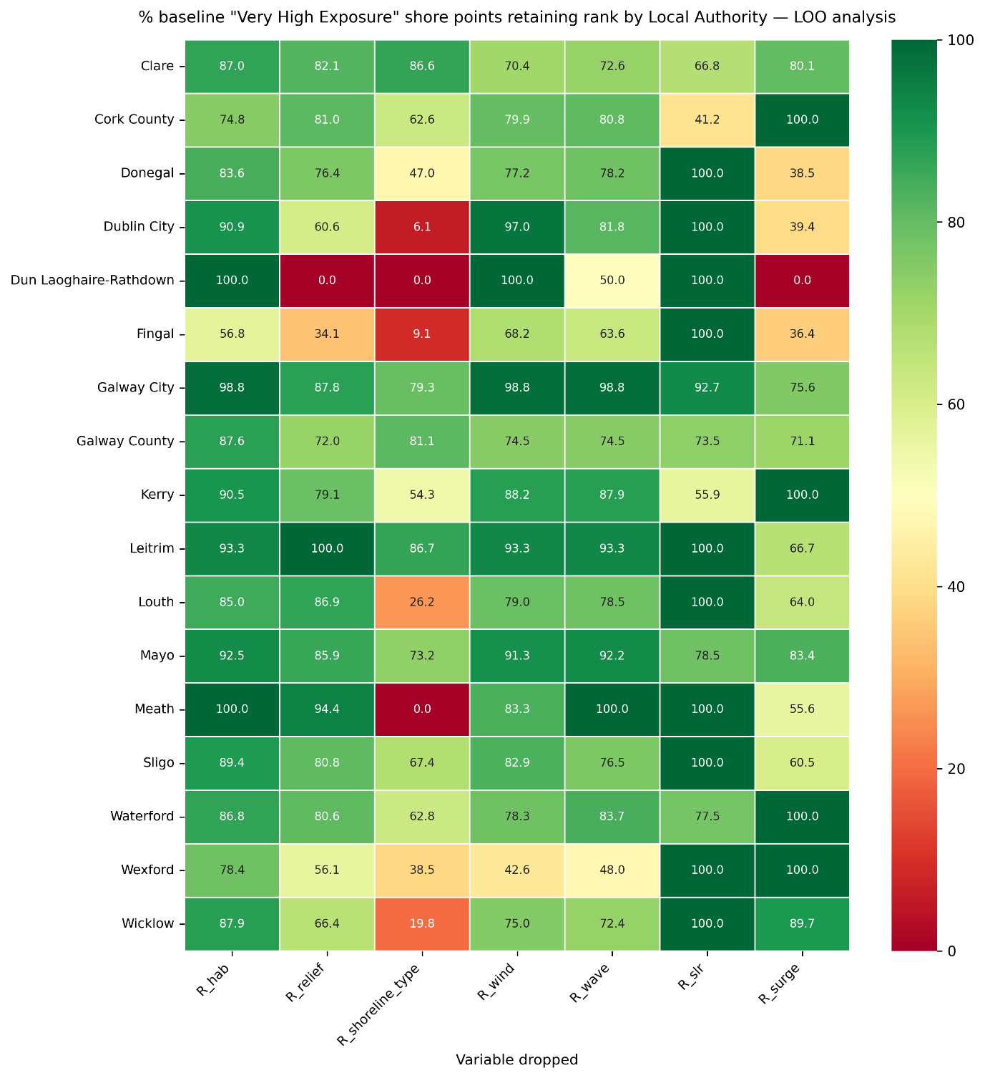
Figure SI-2: Percentage of points retaining rank of ”Very High Exposure” per Local Authority for each scenario in the Leave-one-out Analysis

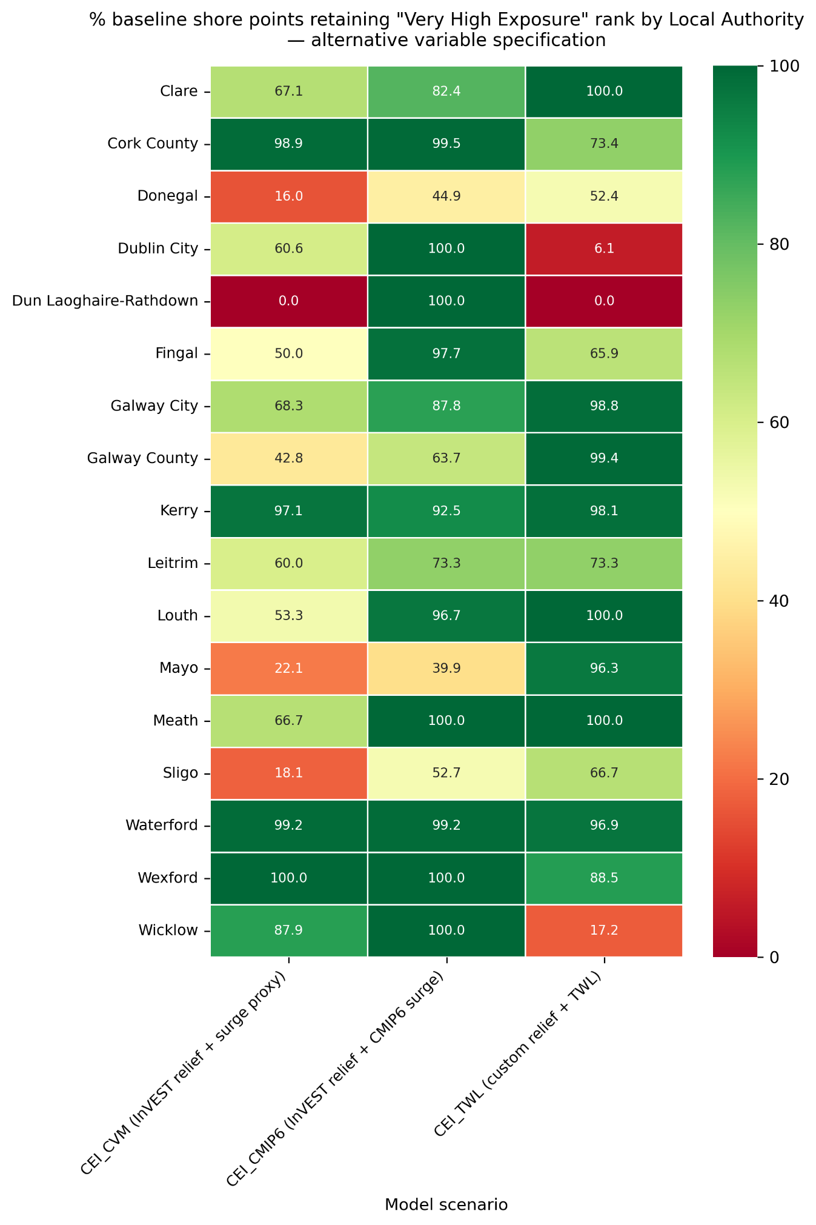
Figure SI-3: Percentage of shoreline points retaining "Very High Exposure" rank from the baseline model for each Local Authority under Alternative Variable scenarios

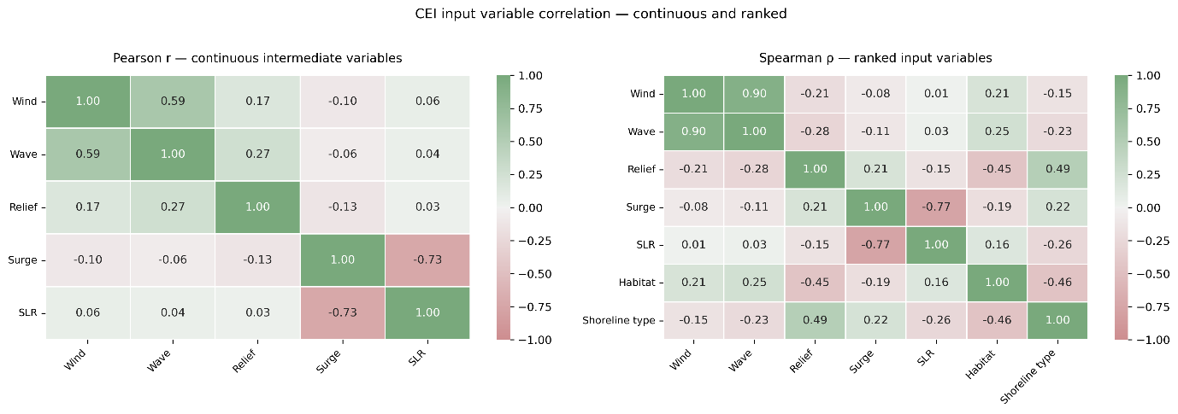
Figure SI-4: Pearson and Spearman correlation matrices for variables within the baseline Coastal Exposure Index
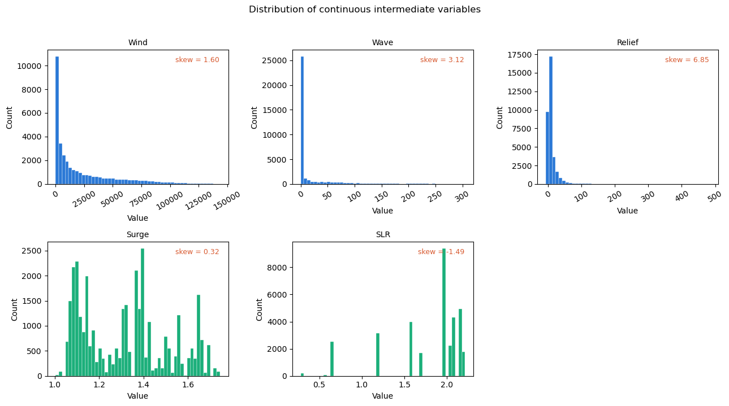
Figure SI-5: Histograms for the five continuous variables utilised within the Coastal Exposure Index

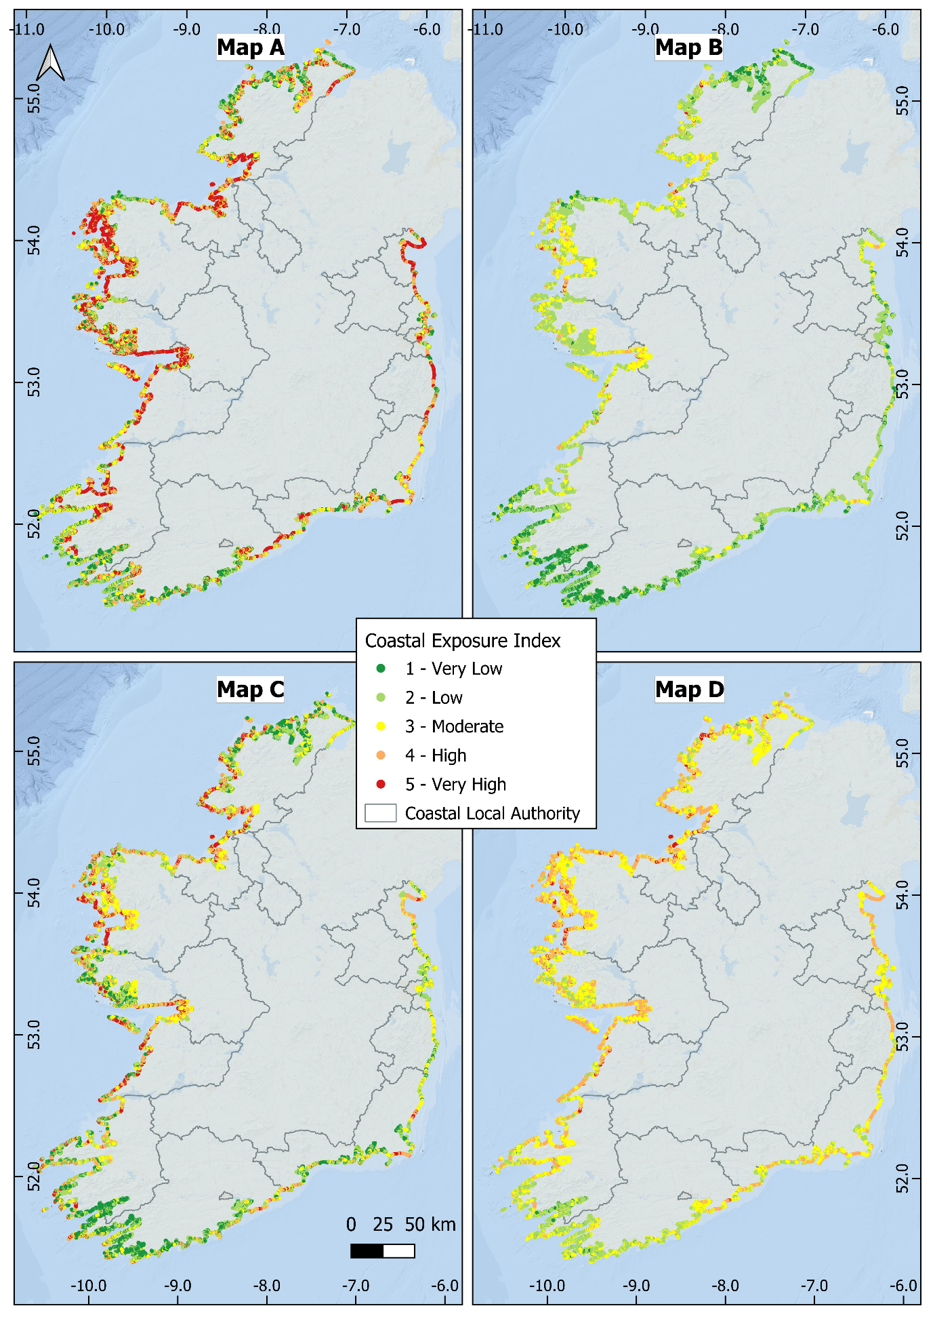
Figure SI-6: Distribution of coastal exposure ranks for the quintile (Map A); equal interval (Map B); Jenks natural breaks (Map C); and geometric interval (Map D) ranking methods
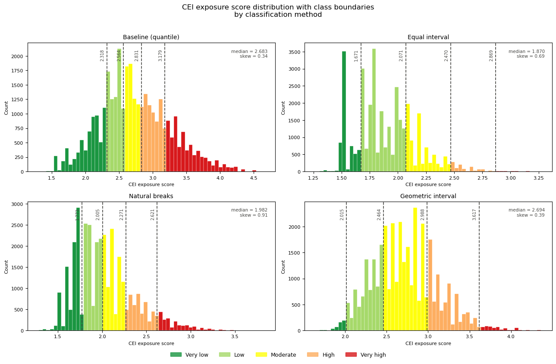
Figure SI-7: Histograms of relative exposure values for the quintile; equal interval; Jenks natural breaks); and geometric interval ranking methods

Table SI-6 Summary Statistics for relative coastal exposure levels for Irelands Coastal Local Authorities in the no-habitat scenario
Local Authority | Coastal Exposure Index |  |  |  | Length of coastline (km) |  |  |  |  | Percentage of total (%)
Local Authority | Min | Max | Mean | Std Dev | Very Low | Low | Moderate | High | Very High | Very Low | Low | Moderate | High | Very High
Clare | 1.69 | 4.50 | 2.95 | 0.53 | 29.3 | 27.3 | 74.8 | 71.8 | 86.3 | 10 | 9 | 26 | 25 | 30
Cork County | 1.53 | 4.25 | 2.51 | 0.45 | 458.3 | 435.3 | 298.3 | 220.8 | 102.3 | 30 | 29 | 20 | 15 | 7
Donegal | 1.53 | 4.39 | 2.71 | 0.52 | 337.8 | 306.5 | 286.5 | 293.8 | 276.3 | 23 | 20 | 19 | 20 | 18
Dublin City | 2.24 | 3.61 | 2.94 | 0.37 | 2.0 | 6.0 | 10.0 | 17.8 | 16.0 | 4 | 12 | 19 | 34 | 31
Dun Laoghaire-Rathdown | 1.72 | 3.36 | 2.64 | 0.39 | 7.5 | 7.3 | 5.3 | 9.5 | 2.0 | 24 | 23 | 17 | 30 | 6
Fingal | 1.47 | 3.61 | 2.77 | 0.41 | 25.3 | 26.8 | 29.3 | 30.0 | 29.3 | 18 | 19 | 21 | 21 | 21
Galway City | 2.26 | 4.50 | 3.46 | 0.64 | 0.8 | 2.0 | 5.3 | 4.0 | 21.5 | 2 | 6 | 16 | 12 | 64
Galway County | 1.72 | 4.50 | 2.90 | 0.52 | 237.3 | 195.3 | 291.3 | 335.5 | 462.0 | 16 | 13 | 19 | 22 | 30
Kerry | 1.58 | 4.25 | 2.69 | 0.56 | 273.3 | 243.0 | 311.3 | 155.3 | 207.5 | 23 | 20 | 26 | 13 | 17
Leitrim | 2.26 | 4.25 | 3.40 | 0.57 | 0.5 | 0.0 | 0.3 | 1.0 | 3.8 | 9 | 0 | 5 | 18 | 68
Louth | 1.69 | 3.73 | 3.12 | 0.46 | 9.0 | 10.0 | 10.0 | 19.3 | 64.8 | 8 | 9 | 9 | 17 | 57
Mayo | 1.63 | 4.65 | 3.04 | 0.58 | 112.0 | 195.3 | 231.5 | 303.8 | 472.8 | 9 | 15 | 18 | 23 | 36
Meath | 3.17 | 3.73 | 3.43 | 0.13 | 0.0 | 0.0 | 0.0 | 1.3 | 9.8 | 0 | 0 | 0 | 11 | 89
Sligo | 1.75 | 4.39 | 3.24 | 0.48 | 9.5 | 15.3 | 28.8 | 59.5 | 147.8 | 4 | 6 | 11 | 23 | 57
Waterford | 1.53 | 4.25 | 2.71 | 0.52 | 43.0 | 54.5 | 66.5 | 32.3 | 36.8 | 18 | 23 | 29 | 14 | 16
Wexford | 1.69 | 3.85 | 2.87 | 0.46 | 37.5 | 41.3 | 54.0 | 77.0 | 72.8 | 13 | 15 | 19 | 27 | 26
Wicklow | 1.63 | 3.85 | 2.98 | 0.57 | 17.3 | 10.0 | 6.0 | 9.0 | 39.0 | 21 | 12 | 7 | 11 | 48
All Local Authorities | 1.47 | 4.65 | 2.80 | 0.56 | 1600.0 | 1575.5 | 1708.8 | 1641.3 | 2050.3 | 19 | 18 | 20 | 19 | 24

Table SI-7: Total number of residents per each relative exposure category for Irelands Coastal Local Authorities
 | 125 m Buffer |  |  |  |  | 250 m Buffer |  |  |  |  | 500 m Buffer
Local Authority | Very Low | Low | Moderate | High | Very High | Very Low | Low | Moderate | High | Very High | Very Low | Low | Moderate | High | Very High
Clare | 41 | 140 | 135 | 247 | 396 | 73 | 252 | 208 | 623 | 938 | 135 | 508 | 340 | 1141 | 2192
Cork County | 2279 | 2197 | 2527 | 2942 | 1364 | 4422 | 4891 | 4801 | 5597 | 3088 | 6857 | 9660 | 8653 | 11253 | 6013
Donegal | 1479 | 851 | 953 | 1202 | 1132 | 3175 | 2207 | 2171 | 2526 | 2700 | 6493 | 4589 | 4446 | 4703 | 5819
Dublin City | 205 | 606 | 1011 | 1297 | 1982 | 1140 | 1188 | 2216 | 3520 | 5007 | 5129 | 4296 | 5504 | 9856 | 9575
Dun Laoghaire-Rathdown | 905 | 660 | 597 | 657 | 117 | 2815 | 1972 | 1521 | 2568 | 427 | 5815 | 3479 | 3224 | 8657 | 1483
Fingal | 900 | 1658 | 1399 | 1866 | 1592 | 2934 | 3900 | 3749 | 5447 | 4789 | 9322 | 6356 | 9130 | 14670 | 9004
Galway City | 0 | 15 | 40 | 235 | 1150 | 6 | 92 | 72 | 654 | 3176 | 66 | 1394 | 347 | 2147 | 9791
Galway County | 1016 | 711 | 865 | 940 | 678 | 1861 | 2056 | 1728 | 1988 | 1978 | 3286 | 4048 | 3023 | 3854 | 5835
Kerry | 434 | 430 | 597 | 691 | 964 | 1211 | 910 | 1393 | 1364 | 2056 | 2105 | 1951 | 2759 | 2371 | 4421
Leitrim | 0 | 0 | 0 | 0 | 25 | 3 | 0 | 8 | 12 | 134 | 12 | 0 | 20 | 39 | 243
Louth | 256 | 449 | 569 | 631 | 1059 | 729 | 847 | 1309 | 1513 | 1911 | 1992 | 1661 | 2595 | 3918 | 4164
Mayo | 512 | 751 | 823 | 627 | 650 | 889 | 1497 | 1541 | 1320 | 1360 | 1361 | 2703 | 2635 | 2342 | 2804
Meath | 0 | 0 | 0 | 93 | 491 | 0 | 0 | 0 | 567 | 1246 | 0 | 0 | 117 | 1931 | 2887
Sligo | 139 | 103 | 133 | 251 | 271 | 291 | 313 | 339 | 641 | 788 | 978 | 658 | 748 | 1464 | 2167
Waterford | 636 | 165 | 232 | 333 | 798 | 1709 | 317 | 621 | 1038 | 2089 | 4257 | 866 | 1388 | 2449 | 4447
Wexford | 325 | 333 | 794 | 874 | 202 | 1026 | 877 | 1880 | 2343 | 470 | 2813 | 2374 | 4237 | 4801 | 975
Wicklow | 859 | 316 | 500 | 267 | 801 | 1740 | 758 | 1017 | 524 | 2039 | 5123 | 1774 | 1828 | 1150 | 6694
All Local Authorities | 9986 | 9385 | 11174 | 13152 | 13671 | 24025 | 22076 | 24574 | 32244 | 34194 | 55742 | 46318 | 50994 | 76746 | 78512

Table SI-8: Total number of residents per each relative exposure category for Irelands Coastal Local Authorities in the no-habitat scenario
 | 125 m Buffer |  |  |  |  | 250 m Buffer |  |  |  |  | 500 m Buffer
Local Authority | Very Low | Low | Moderate | High | Very High | Very Low | Low | Moderate | High | Very High | Very Low | Low | Moderate | High | Very High
Clare | 41 | 130 | 137 | 221 | 429 | 73 | 238 | 201 | 562 | 1021 | 135 | 482 | 329 | 1005 | 2364
Cork County | 2098 | 2268 | 2554 | 2931 | 1458 | 4149 | 5003 | 4798 | 5555 | 3294 | 6480 | 9842 | 8547 | 11189 | 6379
Donegal | 1201 | 896 | 896 | 1297 | 1328 | 2620 | 2208 | 2134 | 2602 | 3214 | 5417 | 4358 | 4613 | 4777 | 6884
Dublin City | 205 | 414 | 740 | 1615 | 2126 | 1140 | 679 | 1725 | 3566 | 5962 | 5129 | 2921 | 4859 | 10364 | 11088
Dun Laoghaire-Rathdown | 776 | 696 | 568 | 711 | 186 | 2485 | 2039 | 1607 | 2425 | 745 | 5395 | 3277 | 3439 | 7732 | 2815
Fingal | 702 | 1069 | 1846 | 1163 | 2634 | 2038 | 3484 | 4171 | 3728 | 7398 | 6531 | 7251 | 8848 | 9553 | 16300
Galway City | 0 | 0 | 41 | 163 | 1236 | 6 | 0 | 137 | 504 | 3354 | 66 | 25 | 1646 | 1305 | 10703
Galway County | 920 | 560 | 933 | 909 | 887 | 1695 | 1540 | 2074 | 1780 | 2521 | 2988 | 2643 | 4200 | 3234 | 6983
Kerry | 410 | 359 | 621 | 635 | 1091 | 1162 | 694 | 1521 | 1258 | 2299 | 1972 | 1476 | 3095 | 2064 | 4999
Leitrim | 0 |  | 0 | 0 | 25 | 3 |  | 8 | 12 | 134 | 12 |  | 20 | 39 | 243
Louth | 197 | 243 | 532 | 626 | 1364 | 511 | 620 | 846 | 1883 | 2448 | 1598 | 1187 | 1324 | 4617 | 5603
Mayo | 489 | 702 | 806 | 640 | 724 | 842 | 1384 | 1525 | 1319 | 1538 | 1264 | 2473 | 2650 | 2376 | 3082
Meath |  |  |  | 2 | 582 |  |  |  | 2 | 1811 |  |  |  | 9 | 4925
Sligo | 57 | 127 | 169 | 189 | 355 | 191 | 237 | 431 | 492 | 1020 | 837 | 405 | 817 | 1142 | 2815
Waterford | 631 | 169 | 233 | 236 | 895 | 1704 | 318 | 602 | 723 | 2427 | 4178 | 928 | 1354 | 2120 | 4826
Wexford | 290 | 283 | 737 | 848 | 370 | 945 | 710 | 1734 | 2422 | 785 | 2659 | 1724 | 3957 | 5289 | 1572
Wicklow | 852 | 319 | 496 | 264 | 812 | 1733 | 762 | 1005 | 493 | 2085 | 5117 | 1778 | 1811 | 1024 | 6839
All Local Authorities | 8868 | 8236 | 11311 | 12451 | 16502 | 21299 | 19913 | 24520 | 29327 | 42055 | 49775 | 40770 | 51509 | 67838 | 98420

Table SI-9: Total number of National Monuments per each relative exposure category for Irelands Coastal Local Authorities
 | 125 m Buffer |  |  |  |  | 250 m Buffer |  |  |  |  | 500 m Buffer
Local Authority | Very Low | Low | Moderate | High | Very High | Very Low | Low | Moderate | High | Very High | Very Low | Low | Moderate | High | Very High
Clare | 18 | 13 | 35 | 36 | 47 | 18 | 18 | 44 | 53 | 69 | 31 | 28 | 79 | 110 | 116
Cork County | 242 | 170 | 94 | 73 | 34 | 331 | 283 | 135 | 114 | 51 | 457 | 390 | 201 | 169 | 100
Donegal | 112 | 115 | 75 | 96 | 72 | 156 | 160 | 113 | 140 | 112 | 251 | 228 | 149 | 184 | 148
Dublin City | 5 |  | 2 | 3 | 3 | 8 | 3 | 2 | 6 | 4 | 8 | 3 | 4 | 7 | 4
Dun Laoghaire-Rathdown | 13 | 7 | 8 | 6 |  | 13 | 8 | 9 | 9 |  | 21 | 14 | 9 | 22
Fingal | 13 | 16 | 42 | 24 | 8 | 28 | 25 | 53 | 29 | 11 | 47 | 31 | 68 | 65 | 21
Galway City | 1 | 1 | 2 | 1 | 19 | 1 | 4 | 2 | 6 | 21 | 1 | 4 | 3 | 6 | 30
Galway County | 182 | 84 | 126 | 131 | 111 | 206 | 110 | 177 | 185 | 161 | 240 | 154 | 302 | 239 | 226
Kerry | 233 | 142 | 172 | 75 | 71 | 369 | 272 | 371 | 127 | 131 | 502 | 416 | 600 | 205 | 256
Leitrim | 1 |  |  | 4 | 8 | 1 |  | 1 | 5 | 22 | 1 |  | 1 | 8 | 32
Louth | 7 | 10 | 2 | 6 | 8 | 8 | 21 | 4 | 10 | 16 | 23 | 24 | 11 | 24 | 40
Mayo | 75 | 148 | 126 | 127 | 156 | 89 | 203 | 175 | 205 | 217 | 124 | 250 | 228 | 255 | 282
Meath |  |  |  | 1 | 3 |  | 1 |  | 4 | 10 |  | 2 |  | 10 | 13
Sligo | 35 | 8 | 37 | 67 | 208 | 44 | 20 | 50 | 89 | 291 | 61 | 46 | 81 | 163 | 383
Waterford | 40 | 35 | 25 | 11 | 19 | 44 | 47 | 30 | 17 | 53 | 52 | 58 | 43 | 23 | 90
Wexford | 27 | 28 | 22 | 22 | 6 | 57 | 36 | 48 | 44 | 13 | 74 | 47 | 74 | 84 | 21
Wicklow | 17 | 6 | 3 | 7 | 7 | 22 | 8 | 6 | 9 | 10 | 32 | 9 | 8 | 10 | 35
All Local Authorities | 1021 | 783 | 771 | 690 | 780 | 1395 | 1219 | 1220 | 1052 | 1192 | 1925 | 1704 | 1861 | 1584 | 1797

Table SI-10: Total number of National Monuments per each relative exposure category for Irelands Coastal Local Authorities in the no-habitat scenario
 | 125 m Buffer |  |  |  |  | 250 m Buffer |  |  |  |  | 500 m Buffer
Local Authority | Very Low | Low | Moderate | High | Very High | Very Low | Low | Moderate | High | Very High | Very Low | Low | Moderate | High | Very High
Clare | 18 | 12 | 36 | 31 | 52 | 18 | 14 | 48 | 48 | 74 | 31 | 24 | 81 | 105 | 123
Cork County | 237 | 162 | 100 | 77 | 37 | 323 | 272 | 147 | 117 | 55 | 441 | 384 | 210 | 176 | 106
Donegal | 103 | 103 | 71 | 104 | 89 | 134 | 142 | 117 | 144 | 144 | 196 | 195 | 193 | 178 | 198
Dublin City | 5 |  | 1 | 4 | 3 | 8 | 3 | 1 | 5 | 6 | 8 | 3 | 2 | 7 | 6
Dun Laoghaire-Rathdown | 13 | 6 | 6 | 8 | 1 | 13 | 6 | 8 | 11 | 1 | 21 | 12 | 8 | 24 | 1
Fingal | 11 | 12 | 43 | 27 | 10 | 25 | 22 | 51 | 30 | 18 | 43 | 29 | 65 | 54 | 41
Galway City | 1 |  | 3 | 1 | 19 | 1 | 3 | 3 | 2 | 25 | 1 | 3 | 3 | 3 | 34
Galway County | 157 | 75 | 129 | 137 | 136 | 176 | 93 | 185 | 195 | 190 | 205 | 119 | 305 | 259 | 273
Kerry | 226 | 136 | 162 | 82 | 87 | 356 | 268 | 362 | 130 | 154 | 481 | 408 | 587 | 201 | 302
Leitrim | 1 |  |  | 4 | 8 | 1 |  | 1 | 5 | 22 | 1 |  | 1 | 8 | 32
Louth | 7 | 10 | 2 | 4 | 10 | 8 | 21 | 4 | 6 | 20 | 23 | 22 | 11 | 14 | 52
Mayo | 72 | 137 | 121 | 126 | 176 | 84 | 168 | 186 | 207 | 244 | 118 | 212 | 235 | 259 | 315
Meath |  |  |  | 1 | 3 |  |  |  | 3 | 12 |  |  |  | 6 | 19
Sligo | 30 | 11 | 28 | 47 | 239 | 39 | 19 | 38 | 67 | 331 | 48 | 47 | 66 | 131 | 442
Waterford | 29 | 45 | 26 | 10 | 20 | 33 | 55 | 33 | 15 | 55 | 41 | 66 | 45 | 22 | 92
Wexford | 21 | 29 | 23 | 23 | 9 | 50 | 38 | 42 | 38 | 30 | 66 | 50 | 57 | 82 | 45
Wicklow | 17 | 6 | 2 | 6 | 9 | 22 | 8 | 3 | 10 | 12 | 32 | 9 | 5 | 11 | 37
All Local Authorities | 948 | 744 | 753 | 692 | 908 | 1291 | 1132 | 1229 | 1033 | 1393 | 1756 | 1583 | 1874 | 1540 | 2118

Table SI-11: Percentage of coastline within each relative exposure category when compared against Office of Public Works national coastal monitoring and modelling studies (OPW, 2010,2018) and GSI shoreline change categories for the Co. Wicklow and Co. Dublin region (Caloca et al., 2025; Monteys et al., 2024)
 |  | Percentage of coastline in each Coastal Exposure Index rank
 |  | Very Low | Low | Moderate | High | Very High
Office of Public Works (OPW) data | Sites of recorded erosion (OPW, 2010) | 4% | 5% | 10% | 24% | 56%
Office of Public Works (OPW) data | Areas potentially vulnerable to wave overtopping (OPW, 2018) | 3% | 7% | 9% | 22% | 59%
GSI Shoreline Change Study - Shoreline status (2000-2021) | Accretion (≤9.56 m/yr) | 7% | 4% | 8% | 59% | 21%
GSI Shoreline Change Study - Shoreline status (2000-2021) | High Erosion (≤1 m/yr) | 1% | 0% | 16% | 68% | 14%
GSI Shoreline Change Study - Shoreline status (2000-2021) | Moderate Erosion (0.25-1 m/yr) | 11% | 9% | 29% | 48% | 3%
GSI Shoreline Change Study - Shoreline status (2000-2021) | Stable | 6% | 16% | 24% | 46% | 7%

